Style.css

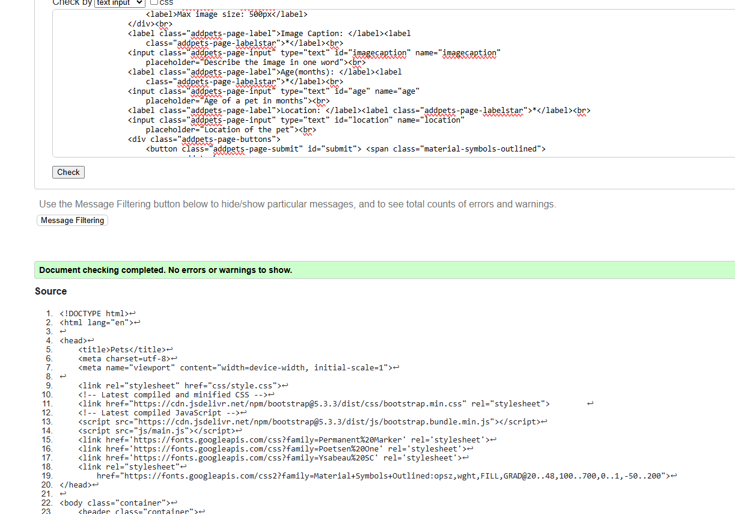

Add.php

Index.php

Pets.php

Gallery.php

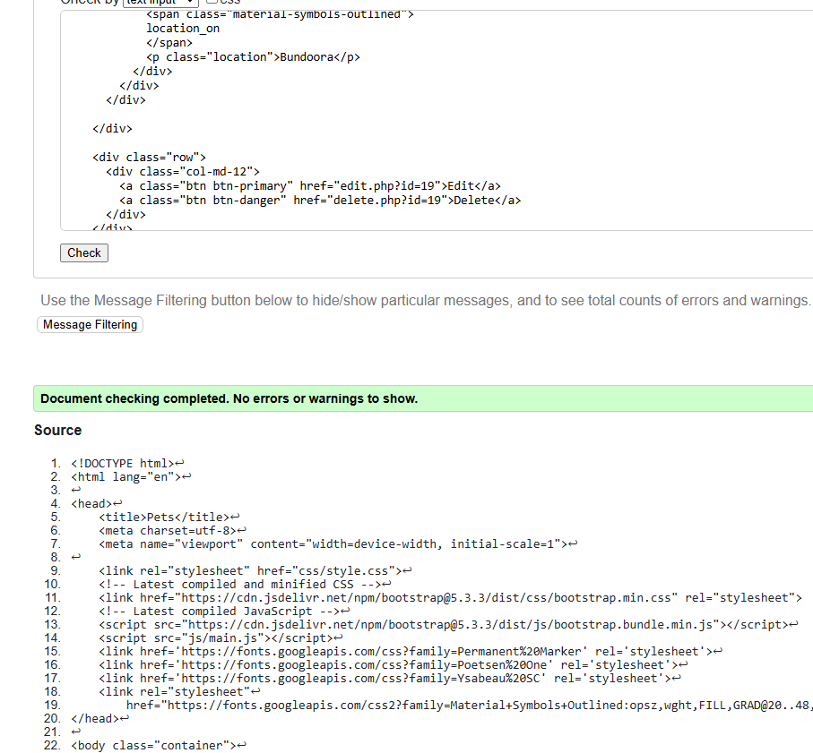

Details.php

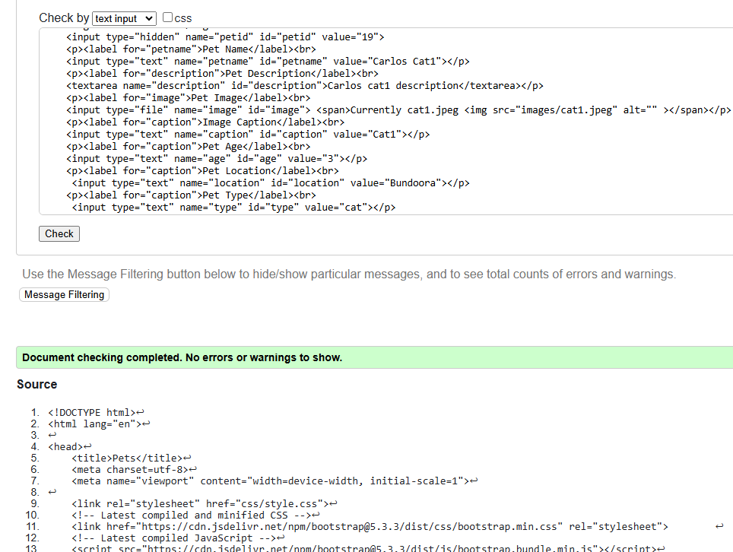

Edit.php

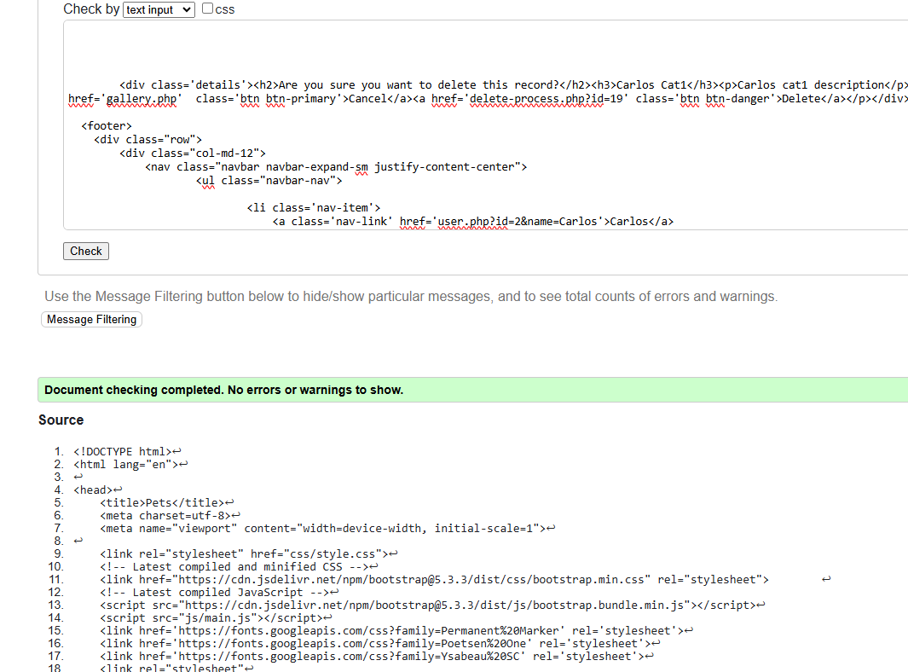

Delete.php

Search.php

User.php

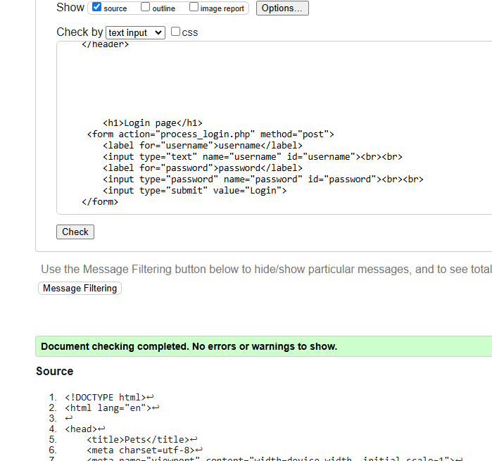

Login.php

Register.php