**There are following screenshots for validation of HTML page and CSS file:**  
  
**1)index.html:**  
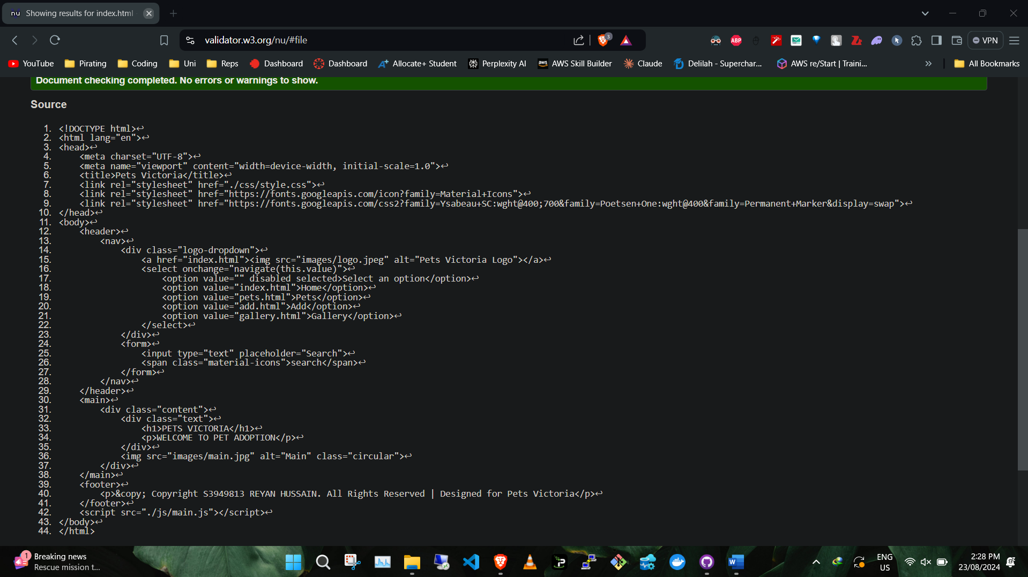

**2) pets.html:**

**3)gallery.html:**

**4)add.html:**

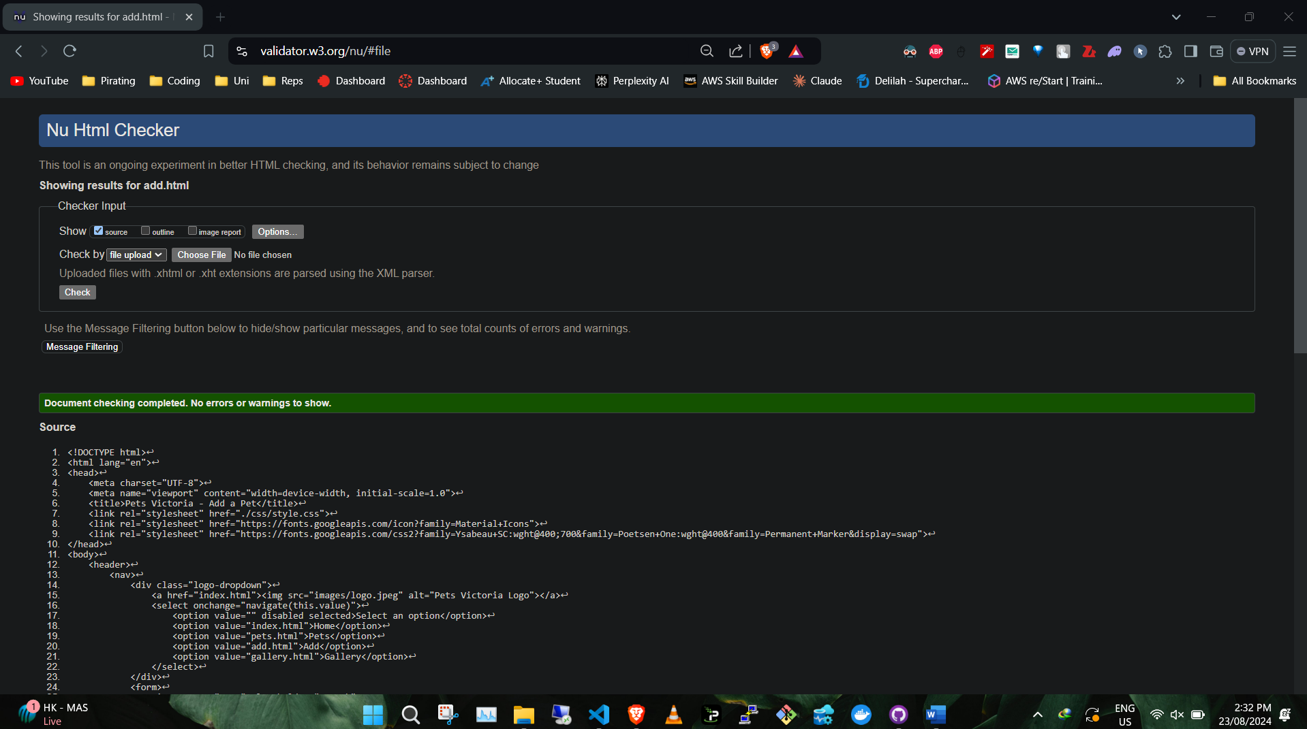

**5)style.css:**

