Index.html

Pet.html

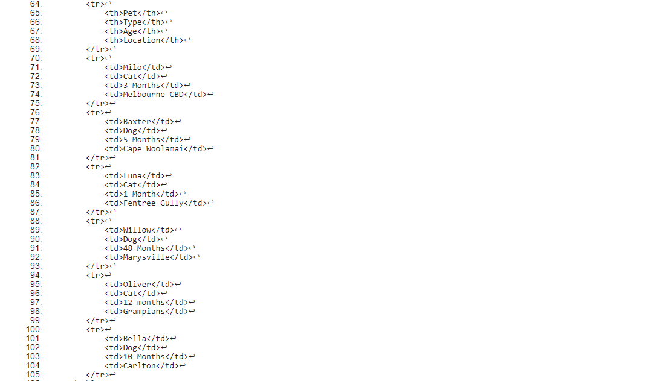

Add.html

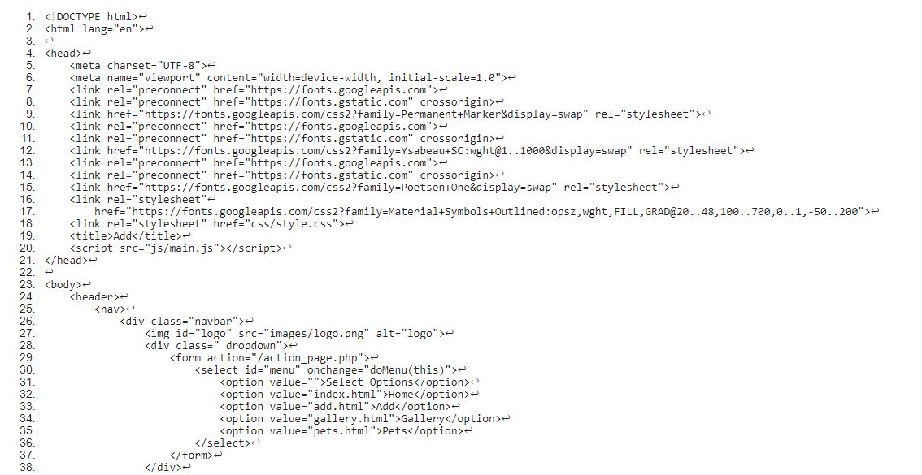

Gallery.html

Style.css

