CSS style

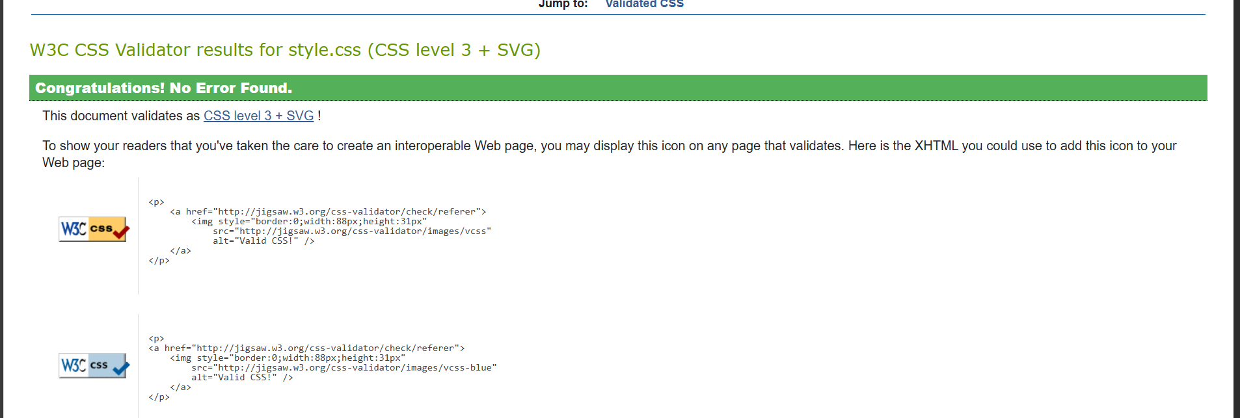

Add.php

Details.php

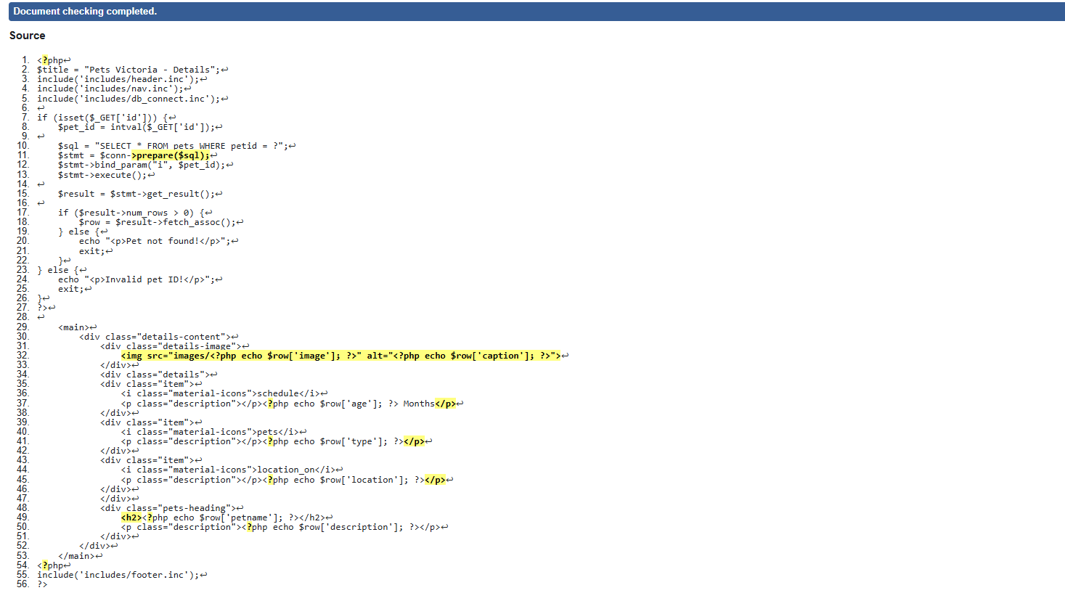

Gallery.php

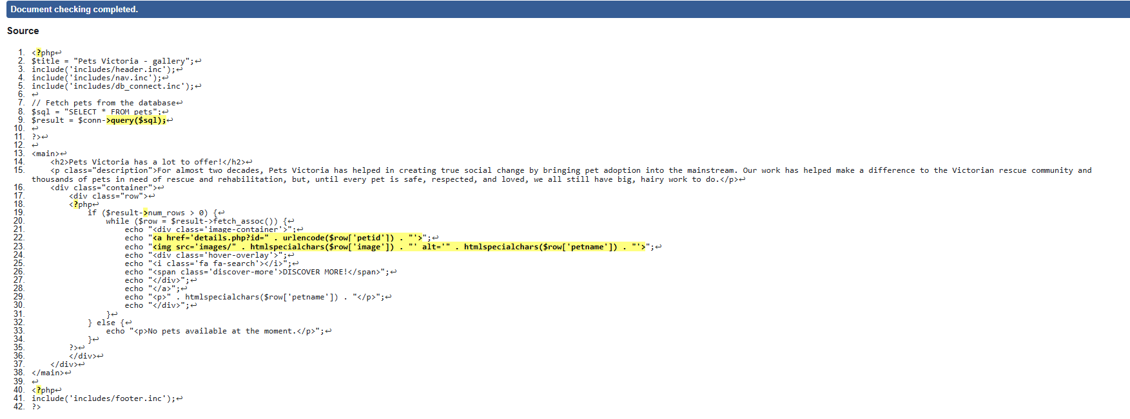

Index.php

Pets.php

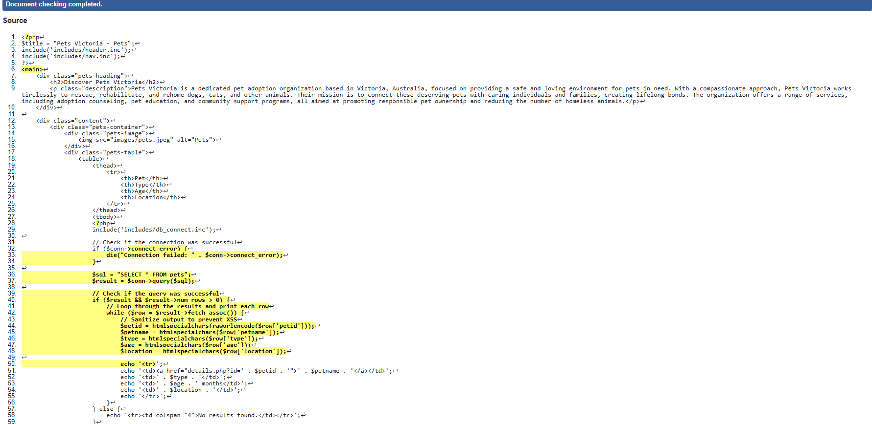

Process_add_php

