# **COSC2446 Web Programming**

## **Practical Assessment 1 (worth 15%)**

## **The due date is the 30th of August 2024 (5:30 pm) Sophie Dorland s3969368**

# - HTML and CSS Validation -

Each html page should be validated against W3C standards at <https://validator.w3.org/>. You should validate all your HTML files and the CSS file. Correct and re-test issues. Fix any errors or warnings.

- HTML Validator: (https://validator.w3.org/)  
- CSS Validator: (https://jigsaw.w3.org/css-validator/)

- Validation Screenshots -

index.html

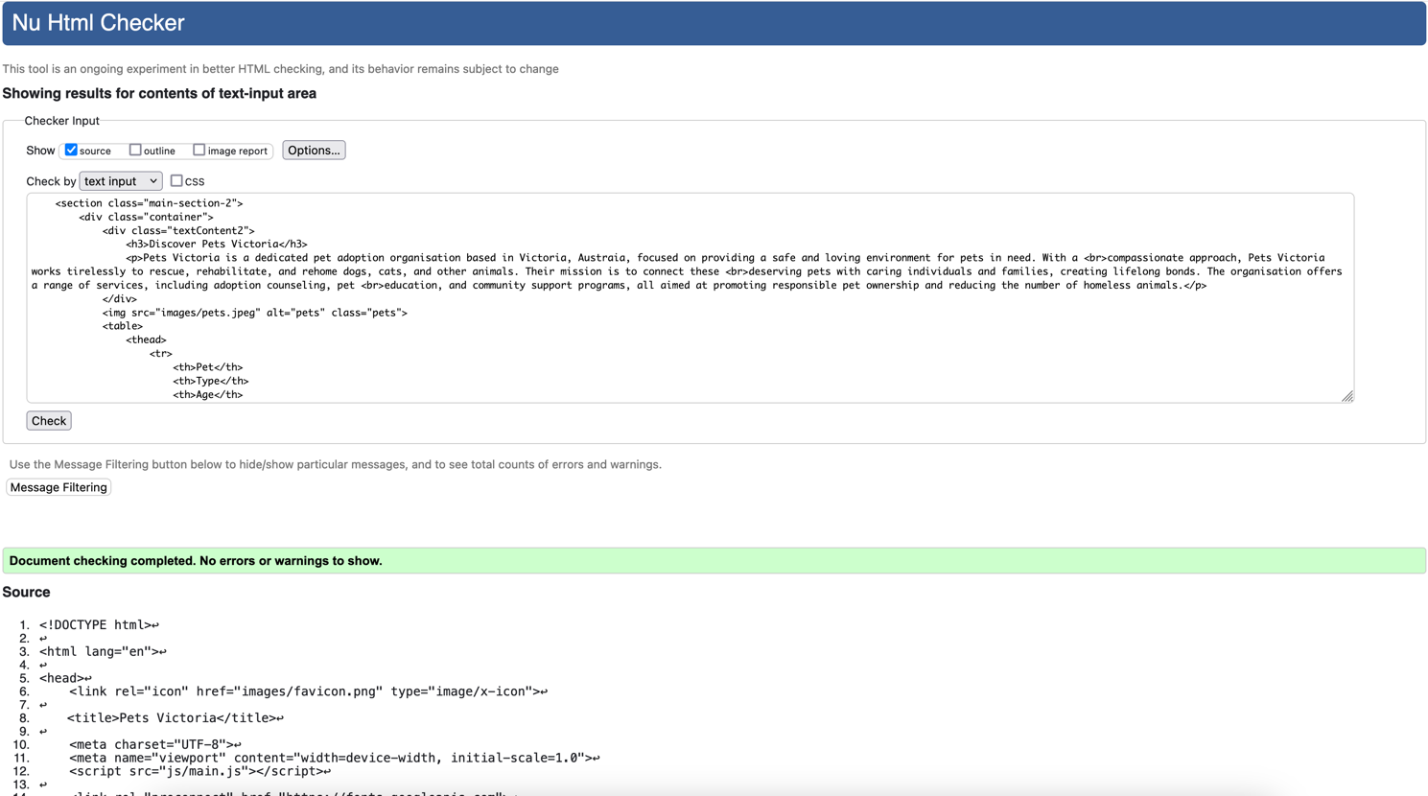pets.html  
  
  
add.html

gallery.html  
  
  
style.css