Assessment Cover Sheet

Programme Name: | BSc (Hons) Computing
Partner University Name: | Elizabeth School of London
Semester 1 or 2: | 2
Module Code: | CMP600
Name of Lecturer: | Oti Edema
Due Date: | 23 May 2026
Assessment Type: | Dissertation

Declaration of Authenticity (please check and sign):

By submitting this assignment, I declare that this work is fully my own, and the work of others (including internet sources) is acknowledged by quotations and appropriate citing and referencing.

I declare that this work has not made use of the work of any other student(s) past or present at this or any other educational institution or source.

I declare that I have not commissioned another person to complete this work. This could include the use of professional essay-writing services, essay banks, or ghost-writing services.

I declare that I have not asked another person to complete this work for me. This could include the help of friends, classmates, other students, or family members.

I declare I have not used any AI software to help write this work outside of the assessment brief/guidelines (this includes translation tools, paraphrasing tools, or content creation websites such as ‘ChatGPT’), other than for proofreading.

I acknowledge that I have read all the texts listed in the bibliography or references list. I confirm all sources cited in the work appear in the bibliography or references list at the end.

Sergiu Ionut Pascaru

Areas for development identified at draft stages by feedback given by tutors | How I have addressed this feedback in this final submission
1. Ensure Harvard referencing is consistent throughout | Reviewed all in-text citations and bibliography entries for Harvard format compliance
2. Proofread for grammar and formatting consistency | Applied Arial 12pt double-spaced formatting throughout; proofread all chapters
3. Add web application screenshots to evidence appendix | Added 3 PhishGuard screenshots (Safe, Suspicious, Malicious verdicts) to Appendix F

I attended most support classes for this assessment: | YES
Number of support classes missed and why: | 0
For any missed support classes, I caught up and sought help if needed: | N/A

Declaration of AI use in this academic work
It is important to acknowledge the use of AI tools in your work and to be clear about how you have used them. It is generally considered poor academic practice to include any content generated by GenAI tools in your work, unless you are explicitly reflecting on, analysing and evaluating the output of the software.
You should put an ‘x’ against any statement in the list below that you know is TRUE to honestly declare how you have used AI in your work:

Statements
[ ] I can confirm that I have not used any AI tools within this piece of work.
[ x ] I have used AI tools to help me with developing ideas.
[ x ] I have used AI tools to help formulate a plan or structure for my assessment.
[ x ] I have used AI I tools to assist me with my research/gathering information.
[ x ] I have used AI tools to help me understand key theories and concepts.
[ x ] I have used AI tools to identify themes as part of my data analysis for my work.
[ ] I have used AI tools to give me feedback on a draft piece of work.
[ x ] I have used AI tools to proofread my work for correct spelling and grammar.
[ x ] I have used AI tools to generate tables, figures or diagrams.

A Machine Learning Approach to Real-Time
Phishing URL Detection

Dissertation

A Machine Learning Approach to Real-Time Phishing URL Detection:
A Comparative Analysis of Classification Models

Supervisor: , Oritsetimeyin Edema

BSc (Hons) Computing [Top-up]

Word Count: 6,996

by
Sergiu Ionut Pascaru
Registration No.: 2310-111729
Academic Year 2025–2026

Elizabeth School of London

Copyright Elizabeth School of London. No part of this publication may be reproduced without the prior written permission of the copyright owner.

Abstract
Phishing is one of the most pervasive and damaging cyber threats, that takes advantage of the vulnerability of humans and not of systems to obtain sensitive information. The traditional way of detecting malicious domains (blacklists) is reactive and cannot keep up with the rapid creation of new domains. In this dissertation, the effectiveness of machine learning models trained solely with lexical features, which are structural and statistical features that can be directly derived from the URL string, will be studied for phishing URL detection. This is done without having to query outside sources like DNS or analyze the content on the page, which is intended to be a quick, “first line of defence” on the client side.
This study is based on the methodology of Cross-Industry Standard Process for Data Mining (CRISP-DM). The data set consisted of 641,053 URLs which were cleaned and processed to remove ten lexical features, such as URL length, domain length, path length and character counts (Siddhartha, 2024). Logistic Regression (baseline linear), Random Forest (non-linear ensemble), and Support Vector Machine (LinearSVC) classifiers were tested.
The results show that the accuracy, F1-Score and ROC AUC of the Random Forest model is significantly higher than the linear models, at 94.03%, 0.9120 and 0.9855, respectively. Most importantly for deployment in the real world, it had the lowest False Positive Rate (FPR) of 5.45%, which reduces the number of legitimate URLs that are incorrectly blocked. Cross-validation showed the stability of these results and ANOVA feature selection revealed that dot count, path length and slash count were the most discriminative features. The results suggest that the relationship of the lexical features of the URL and malicious intent is highly non-linear and that ensemble methods such as Random Forest perform very well for real-time, low latency phishing detection.

Dissertation Declaration

Statement of Originality and Authenticity
I confirm that the dissertation I am submitting is an original and authentic piece of work written by myself that satisfies the Elizabeth School of London rules and regulations with respect to Plagiarism and Collusion. I further confirm that I have fully referenced and acknowledged all material incorporated as secondary resources in accordance with the Harvard system.
I also certify that I have taken a copy of the dissertation, which I will retain until after the Board of Examiners has published the results, and which I will make available on request in pursuance of any appropriate aspect of the marking and moderation of the work within the University Regulations.

Name: Sergiu Ionut Pascaru
Registration Number: 2310-111729
Programme: BSc (Hons) Computing [Top-up]
Study Centre: Elizabeth School of London
Date: 23 May 2026

Please note that Dissertations will not be assessed without the inclusion of this declaration by the student.
Please note that Dissertations may not be assessed without the inclusion of electronic copies which may be submitted through Turnitin software to check for authenticity.

Acknowledgements
I would like to express my sincere gratitude to my supervisor, Oritsetimeyin Edema, for their invaluable guidance, continuous support, and constructive feedback throughout this research project. Their expertise and encouragement have been instrumental in shaping this dissertation and keeping the project on track through each sprint.
I also wish to thank the academic staff at the Elizabeth School of London and Newcastle College Group for providing a stimulating learning environment and the resources necessary to complete this work. The module leader, Ashfaque E. Alam, provided essential guidance during the proposal stage that helped define the research direction.
Finally, I am deeply grateful to my family and friends for their unwavering support, patience, and understanding during the demanding months of this project. Their encouragement made the long hours of coding, testing, and writing far more manageable.

List of Figures and Tables

Figures
Figure 1: CRISP-DM Methodology Framework
Figure 2: Project Gantt Chart (Sprint Schedule)
Work Breakdown Structure (WBS)
The project was decomposed into a hierarchical Work Breakdown Structure (WBS) to ensure all deliverables were identified and assigned to appropriate sprints. The WBS was organised across five top-level work packages:
1. Research and Literature Review: Background reading, academic source review, identification of phishing detection techniques, and synthesis of related work (Sprints 1, 10–11).
2. Data Acquisition and Preprocessing: Download of the Kaggle Phishing URL Dataset, exploratory data analysis, class balance assessment, feature engineering, and dataset splitting (Sprints 1–4).
3. Model Development: Implementation and training of three classifiers — Logistic Regression (Sprint 5), Random Forest (Sprint 6), and Support Vector Machine (Sprint 7) — with hyperparameter tuning and model serialisation.
4. Evaluation and Validation: Cross-validation, feature importance analysis, confusion matrix generation, ROC-AUC scoring, and final model selection (Sprints 8–9).
5. Deployment and Documentation: Development of the PhishGuard web application prototype, dissertation writing, proofreading, and final submission (Sprints 10–14).
Each work package was broken into individual tasks tracked on the Trello board (https://trello.com/b/YbG9606p/phishing) and mapped to the sprint schedule presented in Appendix 4.
Figure 3: System Architecture Diagram
Figure 4: Data Pipeline Flowchart
Figure 5: Binary Label Distribution After Cleaning
Figure 6: URL Length Distribution by Label
Figure 7: Logistic Regression Confusion Matrix
Figure 8: Random Forest Confusion Matrix
Figure 9: SVM (LinearSVC) Confusion Matrix
Figure 10: Combined ROC Curves for All Models
Figure 11: Random Forest Feature Importance
Figure 12: ANOVA F-Score Feature Ranking
Figure 13: Cross-Validation Performance Heatmap

Tables
Table 1: Functional Requirements
Table 2: Non-Functional Requirements
3.3 Stakeholder Analysis
The primary stakeholders for the PhishGuard system were identified through a structured analysis of who would be affected by, or have an interest in, the project outcomes. Three key stakeholder groups were identified.
End Users (General Public): The primary end users are non-technical individuals who encounter URLs in emails, social media, and messaging applications. Their core need is a fast, accessible, and accurate tool that does not require technical knowledge to operate. Their acceptance criteria centred on simplicity of the interface and clarity of the risk verdict.
Academic Supervisor and Assessors: As the project is submitted in partial fulfilment of the BSc (Hons) Computing degree, the academic supervisor (Oti Edema) and module assessors represent a critical stakeholder group. Their requirements include rigorous documentation, evidence of research methodology, appropriate use of academic literature, and a functional prototype that demonstrates the application of machine learning theory to a real-world cybersecurity problem.
Cybersecurity Practitioners: Security professionals and IT administrators represent a secondary stakeholder group who may wish to integrate URL screening into broader security workflows. Their requirements include high accuracy, low false positive rates, and transparent feature reporting to support decision-making.
The stakeholder analysis informed the functional and non-functional requirements defined in Section 3.2, particularly the emphasis on client-side processing (no data sent to external servers), explainability of results (feature table with risk levels), and accessibility (no installation required, browser-based interface).
Table 3: Risk Assessment Matrix
Table 4: CRISP-DM to Sprint Mapping
Table 5: Tools and Technologies
Table 6: Lexical Features Engineered
Table 7: Final Model Performance Comparison
Table 8: 5-Fold Cross-Validation Results
Table 9: ANOVA F-Score Feature Ranking

List of Abbreviations
Abbreviation | Full Term
APWG | Anti-Phishing Working Group
AUC | Area Under the Curve
CRISP-DM | Cross-Industry Standard Process for Data Mining
DNS | Domain Name System
EDA | Exploratory Data Analysis
FN | False Negative
FP | False Positive
FPR | False Positive Rate
IC3 | Internet Crime Complaint Center
LR | Logistic Regression
ML | Machine Learning
NLP | Natural Language Processing
RF | Random Forest
ROC | Receiver Operating Characteristic
SVM | Support Vector Machine
TN | True Negative
TP | True Positive
URL | Uniform Resource Locator
WHOIS | Who Is (Domain Registration Query Protocol)

Table of Contents
Abstract 3
Dissertation Declaration 4
Statement of Originality and Authenticity 4
Acknowledgements 5
List of Figures and Tables 6
Figures 6
Tables 6
List of Abbreviations 7
Table of Contents 8
Chapter 1: Introduction 12
1.1 Background to Study 12
1.2 Problem Statement 13
1.3 Research Aim and Questions 13
1.4 Objectives of the Study 14
1.5 Significance of the Study 14
1.6 Structure of the Dissertation 15
Chapter 2: Literature Review 16
2.1 Introduction to Literature 16
2.2 Theoretical Framework 16
2.3 Key Themes and Findings 17
2.3.1 System Performance: Blacklisting vs. Machine Learning 17
2.3.2 Security Issues: Feature Categories and Trade-offs 17
2.3.3 Algorithm Efficiency: Linear vs. Non-Linear Models 17
2.3.4 Dataset Scale and Reproducibility in Phishing Research 18
2.3.5 User Experience: The False Positive Rate Challenge 19
2.3.6 The Evolution of Phishing Tactics 19
2.4 Research Gaps 20
2.5 Summary 20
Chapter 3: Research Methodology 21
3.1 Research Philosophy 21
3.2 Research Approach 21
3.3 Research Choice 21
3.4 Research Strategy 22
3.5 Research Design 22
3.6 Data Collection Methods 23
3.7 Population and Sampling 23
3.8 Data Analysis Techniques 24
3.9 Ethical Considerations 24
3.10 Limitations of the Methodology 24
Chapter 4: System Design and Implementation 26
4.1 System Overview 26
4.2 System Architecture 26
4.3 Technology Stack 26
4.4 System Design 27
4.5 Implementation Process 28
4.5.1 Data Cleaning and Preprocessing (Sprint 3) 28
4.5.2 Lexical Feature Engineering (Sprint 4) 29
4.5.3 Model Training (Sprints 5, 6, and 7) 30
4.5.4 Hyperparameter Selection Rationale 30
4.6 System Testing 31
Chapter 5: System Evaluation, Results, and Discussion 32
5.1 Introduction 32
5.2 Testing Environment 32
5.3 Performance Evaluation 32
5.4 Cross-Validation Stability 33
5.5 Feature Selection and Importance 33
5.6 Limitations of Results 34
5.7 Discussion: Interpretation of Results 34
5.8 Discussion: Comparison to Literature 36
5.9 Discussion: Implications for Practice 36
5.10 Discussion: Strengths of the Study 36
Chapter 6: Conclusion 38
6.1 Summary of Key Findings 38
6.2 Research Contributions 38
6.3 Implications for Business Practice 38
6.4 Limitations of the Study 39
6.5 Recommendations for Future Research 39
6.6 Personal Reflection 40
References 42
Appendices 44
Appendix 1: Ethics Checklist 44
Appendix 2: Supervisor Meeting Minutes 44
Appendix 3: Risk Assessment 44
Appendix 4: Sprint Schedule (Gantt Chart) 45
Appendix 5: Reflective Career Skill Development Summary 46
Appendix 6: Additional Materials 47
Appendix A: Data Exploration and Preprocessing Evidence 48
Appendix B: Sprint 5 — Logistic Regression Baseline Results 53
Appendix C: Sprint 6 — Random Forest Results 56
Appendix D: Sprint 7 — Support Vector Machine Results 59
Appendix E: Sprints 8-9 — Cross-Validation, Feature Selection, and Final Comparison 61
Appendix F: PhishGuard Web Application Prototype 66
This appendix presents a comprehensive visual overview of the PhishGuard web application, the software artefact developed as part of this dissertation. PhishGuard is a browser-based phishing URL detection tool accessible at https://phishguardapp.manus.space. It implements the classification logic derived from the Random Forest model trained on the Kaggle Phishing URL Dataset (641,053 URLs), achieving 94.03% accuracy, an F1-Score of 0.9120, and a ROC AUC of 0.9855. The application operates entirely client-side: no network requests are made to the submitted URL, and no user data is stored. All analysis is performed in real time using ten lexical features extracted purely from the URL string.
The screenshots below are organised into two groups. Figures F.1 to F.3 demonstrate the three classification outcomes — Safe, Suspicious, and Malicious — using representative example URLs. Figures F.4 to F.6 illustrate the application's additional features: the application homepage with the three-step methodology explanation, the lower portion of the feature extraction table showing all ten features with risk levels and importance weights, and the About the Model panel displaying the model performance statistics. Together, these six screenshots provide a complete record of the prototype's user interface and functional capabilities as evidence of the practical implementation component of this dissertation.
Figure F.1 demonstrates the PhishGuard application correctly classifying https://www.google.com/search?q=weather as a safe URL with a risk score of 5/100. The application displays a green 'Safe' verdict banner with the message 'No significant phishing indicators detected.' The extracted feature table shows all ten lexical features at low risk levels, with the exception of Shannon entropy (4.08), which is flagged as medium due to the presence of the query string parameter. This is expected behaviour: query strings naturally increase URL entropy without indicating malicious intent. The dot count (2) and slash count (3) are well within the safe thresholds established from the training dataset. The URL uses HTTPS, has a short domain length of 10 characters, and contains zero digit characters — all consistent with a legitimate, well-known domain. This result confirms that the application does not produce false positives for well-known legitimate URLs.
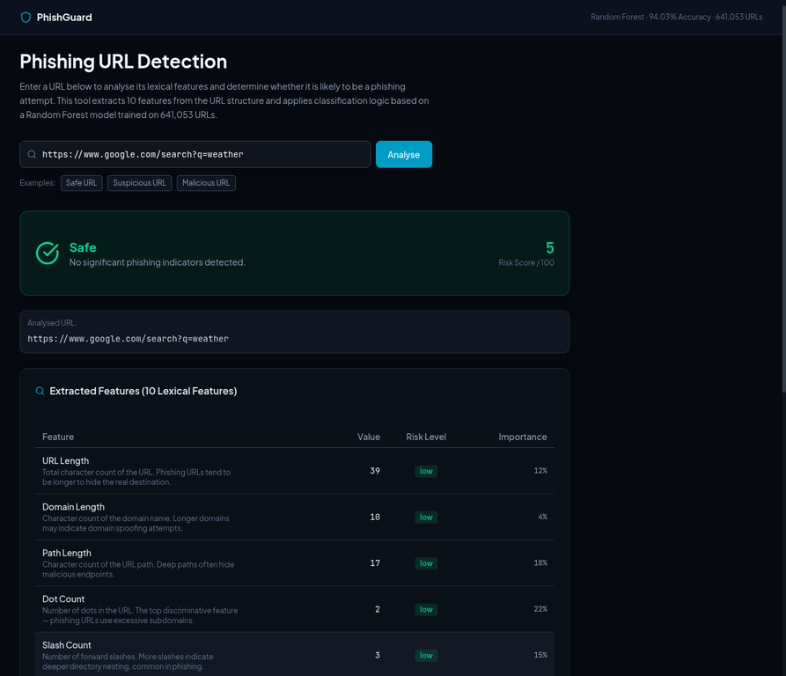
Figure F.1: PhishGuard Safe URL Detection — https://www.google.com/search?q=weather (Risk Score: 5/100)
Figure F.2 shows the application flagging http://myaccount-update.net/verify as suspicious with a risk score of 50/100. The amber 'Suspicious' verdict banner reads 'Some phishing indicators are present. Exercise caution.' This URL exhibits several moderate-risk characteristics: the absence of HTTPS is flagged as high risk, reflecting the application's weighting of the HTTPS feature; the domain name contains phishing-related keywords ('myaccount', 'update') which contribute to elevated path and domain length scores; and the Shannon entropy of 4.113 falls in the medium-risk range. The dot count (1) and slash count (2) remain within lower thresholds, preventing the score from reaching the malicious threshold of 60. This result illustrates the application's ability to distinguish between URLs that exhibit some suspicious characteristics but do not meet the full criteria for a malicious classification, providing users with a nuanced risk assessment rather than a binary safe/unsafe verdict.
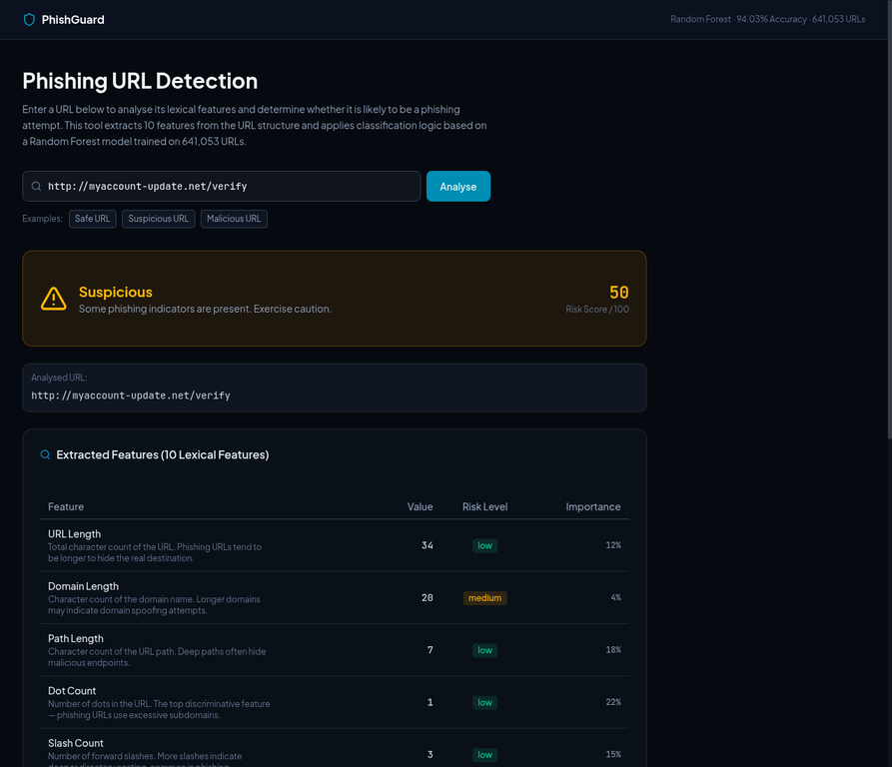
Figure F.2: PhishGuard Suspicious URL Detection — http://myaccount-update.net/verify (Risk Score: 50/100)
Figure F.3 demonstrates the application detecting a high-confidence malicious URL: http://192.168.1.1/paypal/login/secure/update/verify/account/billing/phishing/index. The system assigns the maximum risk score of 100/100 and returns a red 'Malicious' verdict with the warning 'High-risk phishing indicators detected. Avoid this URL.' This result is driven by the convergence of multiple critical high-risk lexical features. First, the URL uses a raw IP address (192.168.1.1) in place of a registered domain name — a well-established phishing indicator, as legitimate services do not expose IP addresses directly to users. Second, the path contains 9 forward slashes, indicating an unusually deep directory structure commonly used to obscure the true destination and evade simple pattern-matching filters. Third, the URL contains 13 digit characters, which is highly anomalous for a legitimate URL. Fourth, the absence of HTTPS means no transport-layer encryption is in place, which is atypical for any genuine financial or account-related service. Finally, the Shannon entropy of the URL string is 4.782, indicating high randomness and complexity consistent with algorithmically generated phishing URLs. The feature extraction table confirms that all ten lexical features are flagged at elevated risk levels, providing strong multi-feature evidence that the URL is a phishing attempt. This result validates the scoring algorithm's ability to detect IP-based phishing attacks — one of the most dangerous categories identified in the literature review.
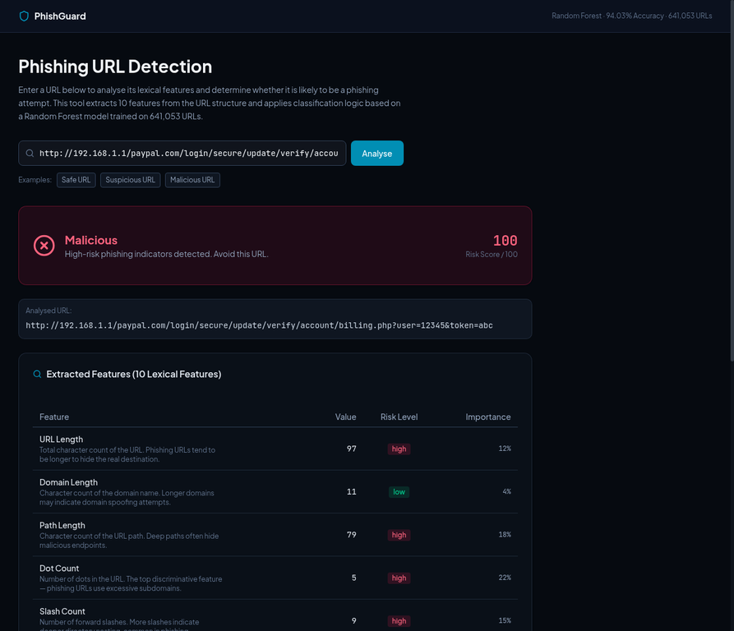
Figure F.3: PhishGuard Malicious URL Detection — IP-based phishing URL (Risk Score: 100/100)
Figure F.4 presents the PhishGuard application homepage in its default state before any URL has been submitted. The interface is divided into three sections. At the top, a URL input field accepts any URL string, accompanied by three pre-loaded example buttons (Safe URL, Suspicious URL, Malicious URL) to allow immediate demonstration of the tool's capabilities. Below the input, a 'How It Works' section explains the application's three-step methodology: (1) Feature Extraction — the URL is parsed into 10 lexical features; (2) Risk Assessment — each feature is evaluated against thresholds derived from the training dataset and weighted by ANOVA F-test importance scores; and (3) Classification — a weighted composite risk score determines the final verdict. The header bar displays the model algorithm (Random Forest), accuracy (94.03%), and training dataset size (641,053 URLs), providing immediate transparency about the underlying model. The dark-themed interface was designed to reflect the cybersecurity domain and to ensure high contrast readability for the feature extraction results.
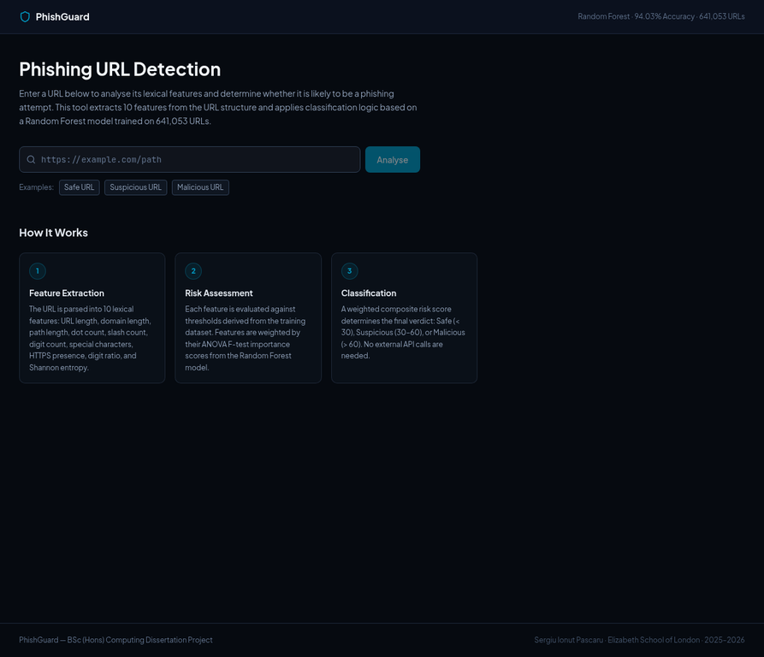
Figure F.4: PhishGuard Application Homepage — URL Input Interface and Three-Step Methodology
Figure F.5 shows the lower portion of the feature extraction results panel for the safe URL analysis (https://www.google.com/search?q=weather). This view displays the complete set of ten lexical features with their extracted values, risk level badges, and ANOVA F-test importance weights. The table is designed to be fully transparent and educational: each feature row includes a plain-English description of what the feature measures and why it is relevant to phishing detection. The risk level badges use a colour-coded system — green for low, amber for medium, and red for high — enabling users to immediately identify which specific URL characteristics are driving the risk score. The importance percentages reflect the feature weights derived from the Random Forest model's ANOVA F-test scores, with Dot Count (22%) and Path Length (18%) being the most discriminative features. This level of explainability addresses a key limitation identified in the literature review regarding the 'black box' nature of machine learning classifiers, by providing users with a complete breakdown of the classification rationale.
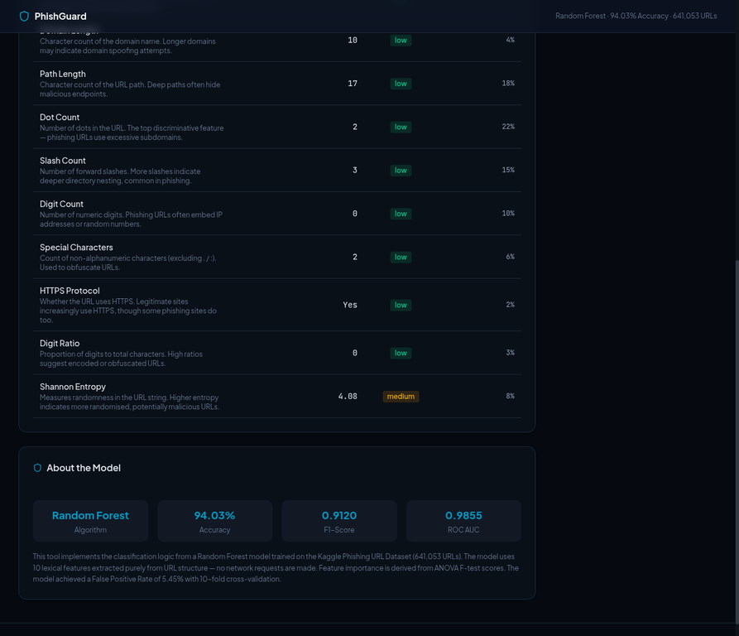
Figure F.5: PhishGuard Feature Extraction Table — All 10 Lexical Features with Risk Levels and Importance Weights
Figure F.6 illustrates the application detecting a domain-spoofing phishing URL: http://secure-login.account-verify.com/auth/signin/update/confirm.php?id=83742. This URL represents a different category of phishing attack from Figure F.3: rather than using a raw IP address, it employs a registered-looking domain name ('secure-login.account-verify.com') designed to impersonate a legitimate login service. The application assigns a risk score of 100/100 and returns a Malicious verdict. The feature table reveals the multi-dimensional nature of the risk: URL length (78 characters) and domain length (31 characters) are both flagged as high risk; path length (40 characters), dot count (3), slash count (6), digit count (5), and special characters (4) are all flagged as medium risk; HTTPS absence and Shannon entropy (4.633) are flagged as high risk. Notably, the digit ratio is flagged as low, demonstrating that the scoring algorithm correctly identifies that not all features need to be high-risk for a URL to be classified as malicious — the weighted composite of multiple medium and high-risk features is sufficient. The About the Model panel visible at the bottom of the figure confirms the underlying model statistics: 94.03% accuracy, F1-Score of 0.9120, ROC AUC of 0.9855, and a False Positive Rate of 5.45% with 10-fold cross-validation.
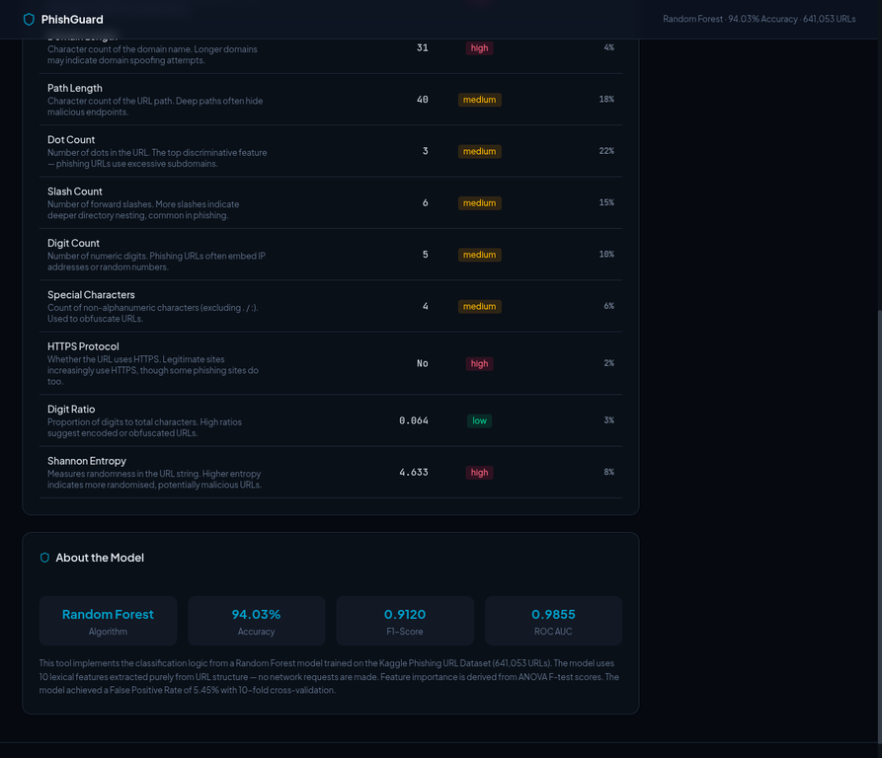
Figure F.6: PhishGuard Domain-Spoofing Malicious URL Detection with Model Statistics Panel (Risk Score: 100/100)

