# Problem 1

## Results of the program:

Test Case 0:

Original array: {62, 31, 84, 96, 19, 47}

Table for the counts: {3, 1, 4, 5, 0, 2}

Sorted array: {19, 31, 47, 62, 84, 96}

Test Case 1:

Original array: {1, 4, 1, 2, 7, 5, 2}

Table for the counts: {0, 4, 1, 2, 6, 5, 3}

Sorted array: {1, 1, 2, 2, 4, 5, 7}

Test Case 2:

Original array: {5, 2, 9, 5, 2, 3, 5}

Table for the counts: {3, 0, 6, 4, 1, 2, 5}

Sorted array: {2, 2, 3, 5, 5, 5, 9}

# Problem 2

Results of the program:

Test Case 1:

Largest Independent Set: 1, 2, 4, 6, 7

Largest Clique: 7, 8, 9

Test Case 2:

Largest Independent Set: 1, 6, 7, 9

Largest Clique: 2, 3, 5, 6

****************************************************************

Performance Experiment:

****************************************************************

Vertices: 10 Edges: 15 Time of LargestIndependentSet: 1 Time of LargestClique: 0

Vertices: 20 Edges: 68 Time of LargestIndependentSet: 5 Time of LargestClique: 1

Vertices: 30 Edges: 155 Time of LargestIndependentSet: 11 Time of LargestClique: 0

Vertices: 40 Edges: 253 Time of LargestIndependentSet: 55 Time of LargestClique: 2

Vertices: 50 Edges: 433 Time of LargestIndependentSet: 107 Time of LargestClique: 2

Vertices: 60 Edges: 634 Time of LargestIndependentSet: 289 Time of LargestClique: 2

Vertices: 70 Edges: 872 Time of LargestIndependentSet: 256 Time of LargestClique: 2

Vertices: 80 Edges: 1082 Time of LargestIndependentSet: 770 Time of LargestClique: 3

Vertices: 90 Edges: 1460 Time of LargestIndependentSet: 976 Time of LargestClique: 4

Vertices: 100 Edges: 1793 Time of LargestIndependentSet: 2136 Time of LargestClique: 4

Vertices: 110 Edges: 2179 Time of LargestIndependentSet: 4477 Time of LargestClique: 3

Vertices: 120 Edges: 2608 Time of LargestIndependentSet: 6956 Time of LargestClique: 3

Vertices: 130 Edges: 3005 Time of LargestIndependentSet: 18701 Time of LargestClique: 4

Vertices: 140 Edges: 3510 Time of LargestIndependentSet: 34376 Time of LargestClique: 5

Vertices: 150 Edges: 4097 Time of LargestIndependentSet: 50203 Time of LargestClique: 4

Vertices: 160 Edges: 4562 Time of LargestIndependentSet: 125200 Time of LargestClique: 5

Vertices: 170 Edges: 5101 Time of LargestIndependentSet: 235705 Time of LargestClique: 8

Vertices: 180 Edges: 5782 Time of LargestIndependentSet: 307830 Time of LargestClique: 5

Vertices: 190 Edges: 6490 Time of LargestIndependentSet: 408258 Time of LargestClique: 6

Vertices: 200 Edges: 7138 Time of LargestIndependentSet: 892890 Time of LargestClique: 23

The time complexity of finding the largest independent-set in a connected graph:

O(2^n)

The time complexity finding the largest clique in a connected graph:

O(n^3)

Experimentally measure plot:

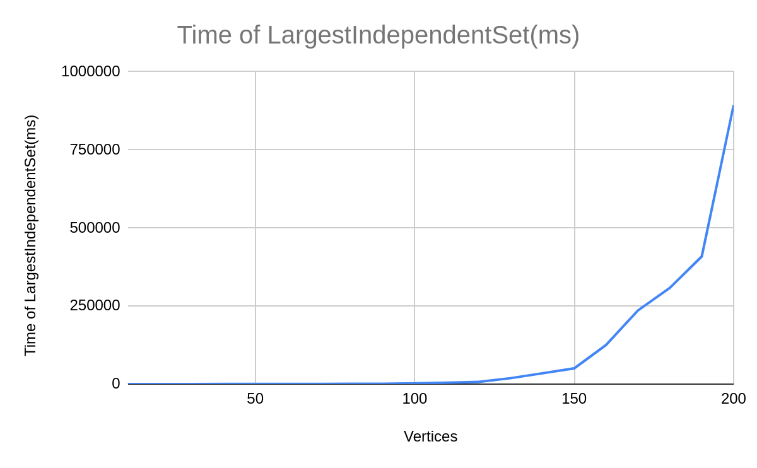

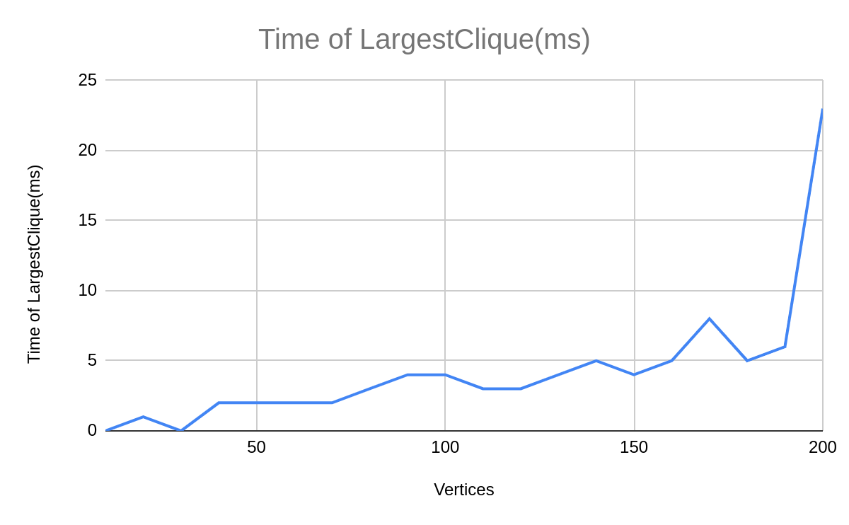

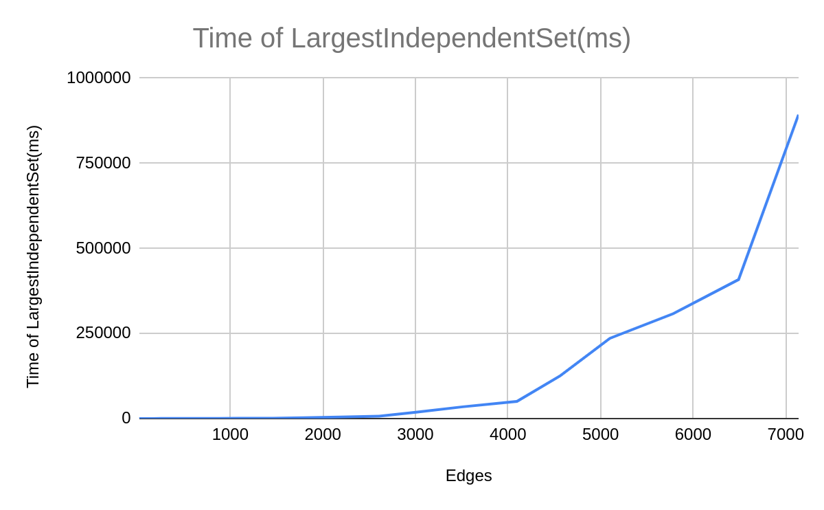

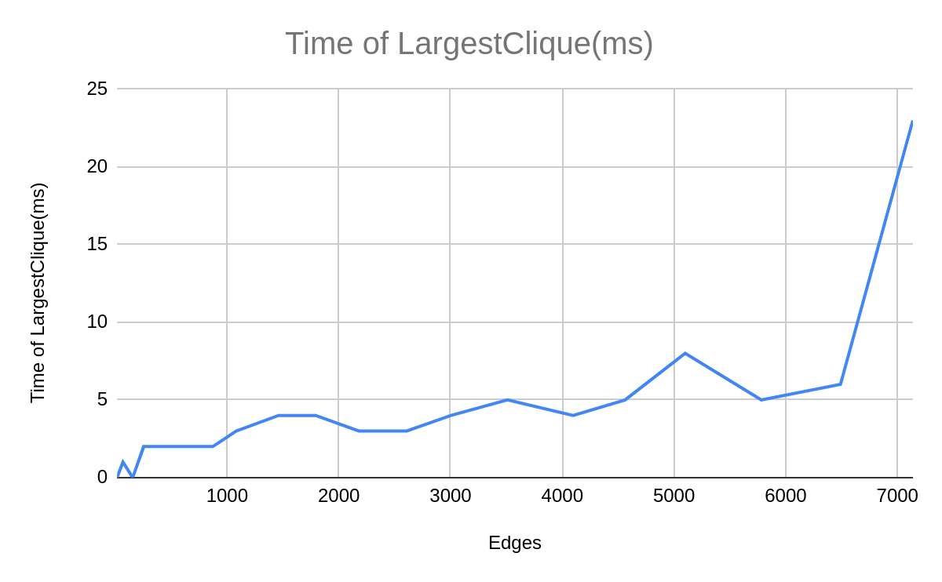

# Problem 3

Results of the program:

Testcase 1:

Greedy algorithm TSP

A -> D -> B -> E -> C -> A

50 + 40 + 30 + 55 + 100 = 275

Testcase 1:

Heuristic algorithm TSP

A -> D -> B -> E -> C -> A

50 + 40 + 30 + 55 + 100 = 275

Testcase 2:

Greedy algorithm TSP

A -> B -> C -> D -> A

10 + 35 + 30 + 20 = 95

Testcase 2:

Heuristic algorithm TSP

A -> B -> D -> C -> A

10 + 25 + 30 + 15 = 80

Time complexity of A(Greedy algorithm): $O\left(n^{2}logn\right)$

Time complexity of B(Heuristic algorithm): $O\left(n^{2}\right)$

Testcase 1:

(Weight of Tour by B)/(Weight of Tour by A) = 275 / 275 = 1

Both algorithm A and algorithm B get the same weight of tour.

Testcase 2:

(Weight of Tour by B)/(Weight of Tour by A) = 80 / 95 = 0.84

Greedy algorithm A did not get the best weight of tour. The heuristic algorithm got a better tour solution.