# Quiz 3:

## Plot for Algorithm 3.6 and Algorithm 3.7 Time Complexity:

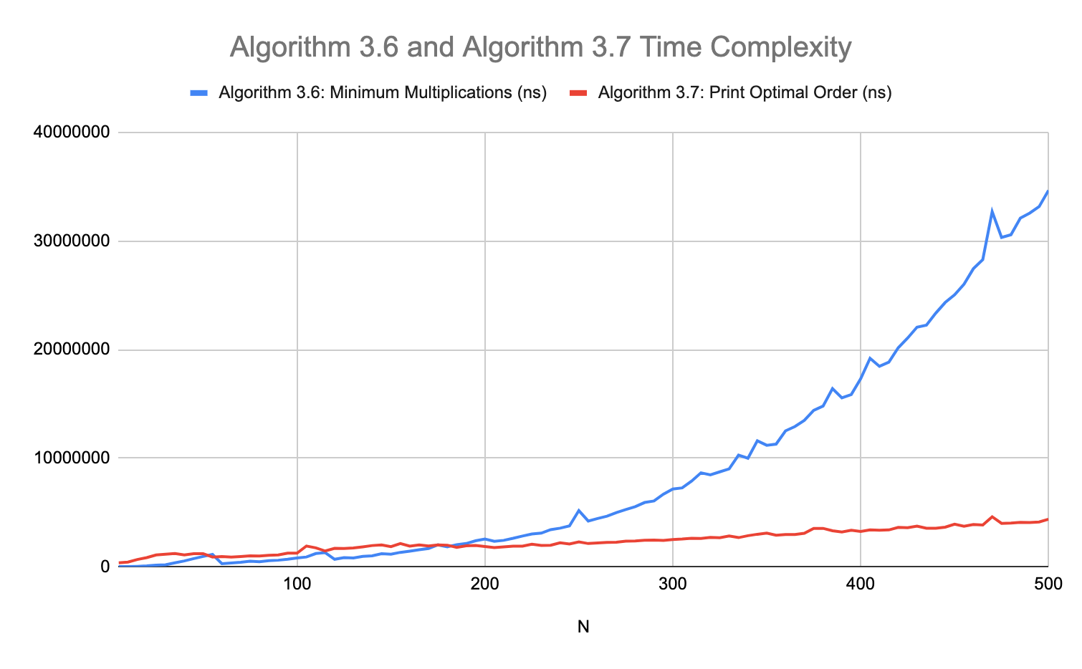

## Data for the plot (From the program output):

|  |  |  |
| --- | --- | --- |
| N | Algorithm 3.6: Minimum Multiplications (ns) | Algorithm 3.7: Print Optimal Order (ns) |
| 5 | 23182 | 361788 |
| 10 | 14407 | 438042 |
| 15 | 39117 | 674368 |
| 20 | 79375 | 844710 |
| 25 | 144627 | 1085194 |
| 30 | 185683 | 1161102 |
| 35 | 367377 | 1217298 |
| 40 | 537393 | 1099396 |
| 45 | 751702 | 1211248 |
| 50 | 952297 | 1210498 |
| 55 | 1140475 | 901928 |
| 60 | 290158 | 947034 |
| 65 | 343179 | 889133 |
| 70 | 410116 | 950489 |
| 75 | 510940 | 1016361 |
| 80 | 462425 | 987940 |
| 85 | 566567 | 1057990 |
| 90 | 605185 | 1093269 |
| 95 | 691348 | 1253559 |
| 100 | 813963 | 1252819 |
| 105 | 899854 | 1914207 |
| 110 | 1223618 | 1740839 |
| 115 | 1301454 | 1452968 |
| 120 | 689845 | 1703742 |
| 125 | 839916 | 1690623 |
| 130 | 812086 | 1741173 |
| 135 | 959821 | 1839856 |
| 140 | 1005707 | 1957751 |
| 145 | 1205340 | 2016145 |
| 150 | 1161552 | 1853885 |
| 155 | 1329163 | 2135910 |
| 160 | 1442730 | 1906049 |
| 165 | 1566646 | 2011570 |
| 170 | 1678722 | 1909205 |
| 175 | 2020194 | 2008954 |
| 180 | 1832777 | 1990647 |
| 185 | 2041703 | 1787793 |
| 190 | 2141586 | 1934199 |
| 195 | 2393085 | 1962756 |
| 200 | 2552747 | 1867135 |
| 205 | 2348076 | 1763962 |
| 210 | 2436216 | 1841503 |
| 215 | 2622767 | 1895767 |
| 220 | 2834117 | 1901920 |
| 225 | 3015871 | 2080758 |
| 230 | 3102417 | 1962827 |
| 235 | 3423946 | 1983401 |
| 240 | 3555528 | 2216709 |
| 245 | 3759499 | 2106652 |
| 250 | 5178232 | 2294560 |
| 255 | 4215977 | 2139809 |
| 260 | 4445673 | 2191543 |
| 265 | 4661944 | 2243840 |
| 270 | 4998395 | 2265818 |
| 275 | 5268677 | 2362003 |
| 280 | 5541788 | 2386075 |
| 285 | 5920560 | 2441633 |
| 290 | 6061970 | 2454001 |
| 295 | 6687219 | 2427100 |
| 300 | 7168503 | 2515613 |
| 305 | 7264158 | 2554862 |
| 310 | 7889473 | 2622412 |
| 315 | 8656011 | 2607639 |
| 320 | 8469666 | 2711354 |
| 325 | 8744231 | 2671994 |
| 330 | 9017839 | 2832301 |
| 335 | 10282416 | 2685966 |
| 340 | 9996824 | 2865395 |
| 345 | 11605511 | 2995705 |
| 350 | 11192282 | 3100593 |
| 355 | 11300120 | 2901144 |
| 360 | 12519139 | 2964880 |
| 365 | 12920888 | 2974413 |
| 370 | 13487703 | 3083434 |
| 375 | 14405457 | 3535582 |
| 380 | 14801765 | 3539226 |
| 385 | 16416327 | 3320204 |
| 390 | 15558216 | 3211730 |
| 395 | 15867034 | 3362628 |
| 400 | 17311313 | 3254313 |
| 405 | 19202800 | 3403472 |
| 410 | 18465061 | 3366486 |
| 415 | 18840828 | 3396521 |
| 420 | 20173566 | 3633783 |
| 425 | 21064669 | 3598898 |
| 430 | 22067696 | 3747966 |
| 435 | 22250763 | 3545531 |
| 440 | 23365912 | 3544666 |
| 445 | 24341641 | 3647743 |
| 450 | 25048803 | 3929967 |
| 455 | 26023301 | 3735838 |
| 460 | 27455518 | 3889951 |
| 465 | 28294261 | 3853153 |
| 470 | 32707748 | 4607808 |
| 475 | 30330687 | 4001814 |
| 480 | 30578772 | 4022823 |
| 485 | 32115164 | 4094955 |
| 490 | 32576335 | 4076106 |
| 495 | 33175109 | 4129665 |
| 500 | 34671773 | 4385796 |

## 