# Quiz 5:

The theoretically time complexity of Algorithm 3.4 Floyd’s Algorithm for Shortest Paths 2:

$O\left(n^{3}\right)$

The experimentally time complexity plot of Algorithm 3.4 Floyd’s Algorithm for Shortest Paths 2:

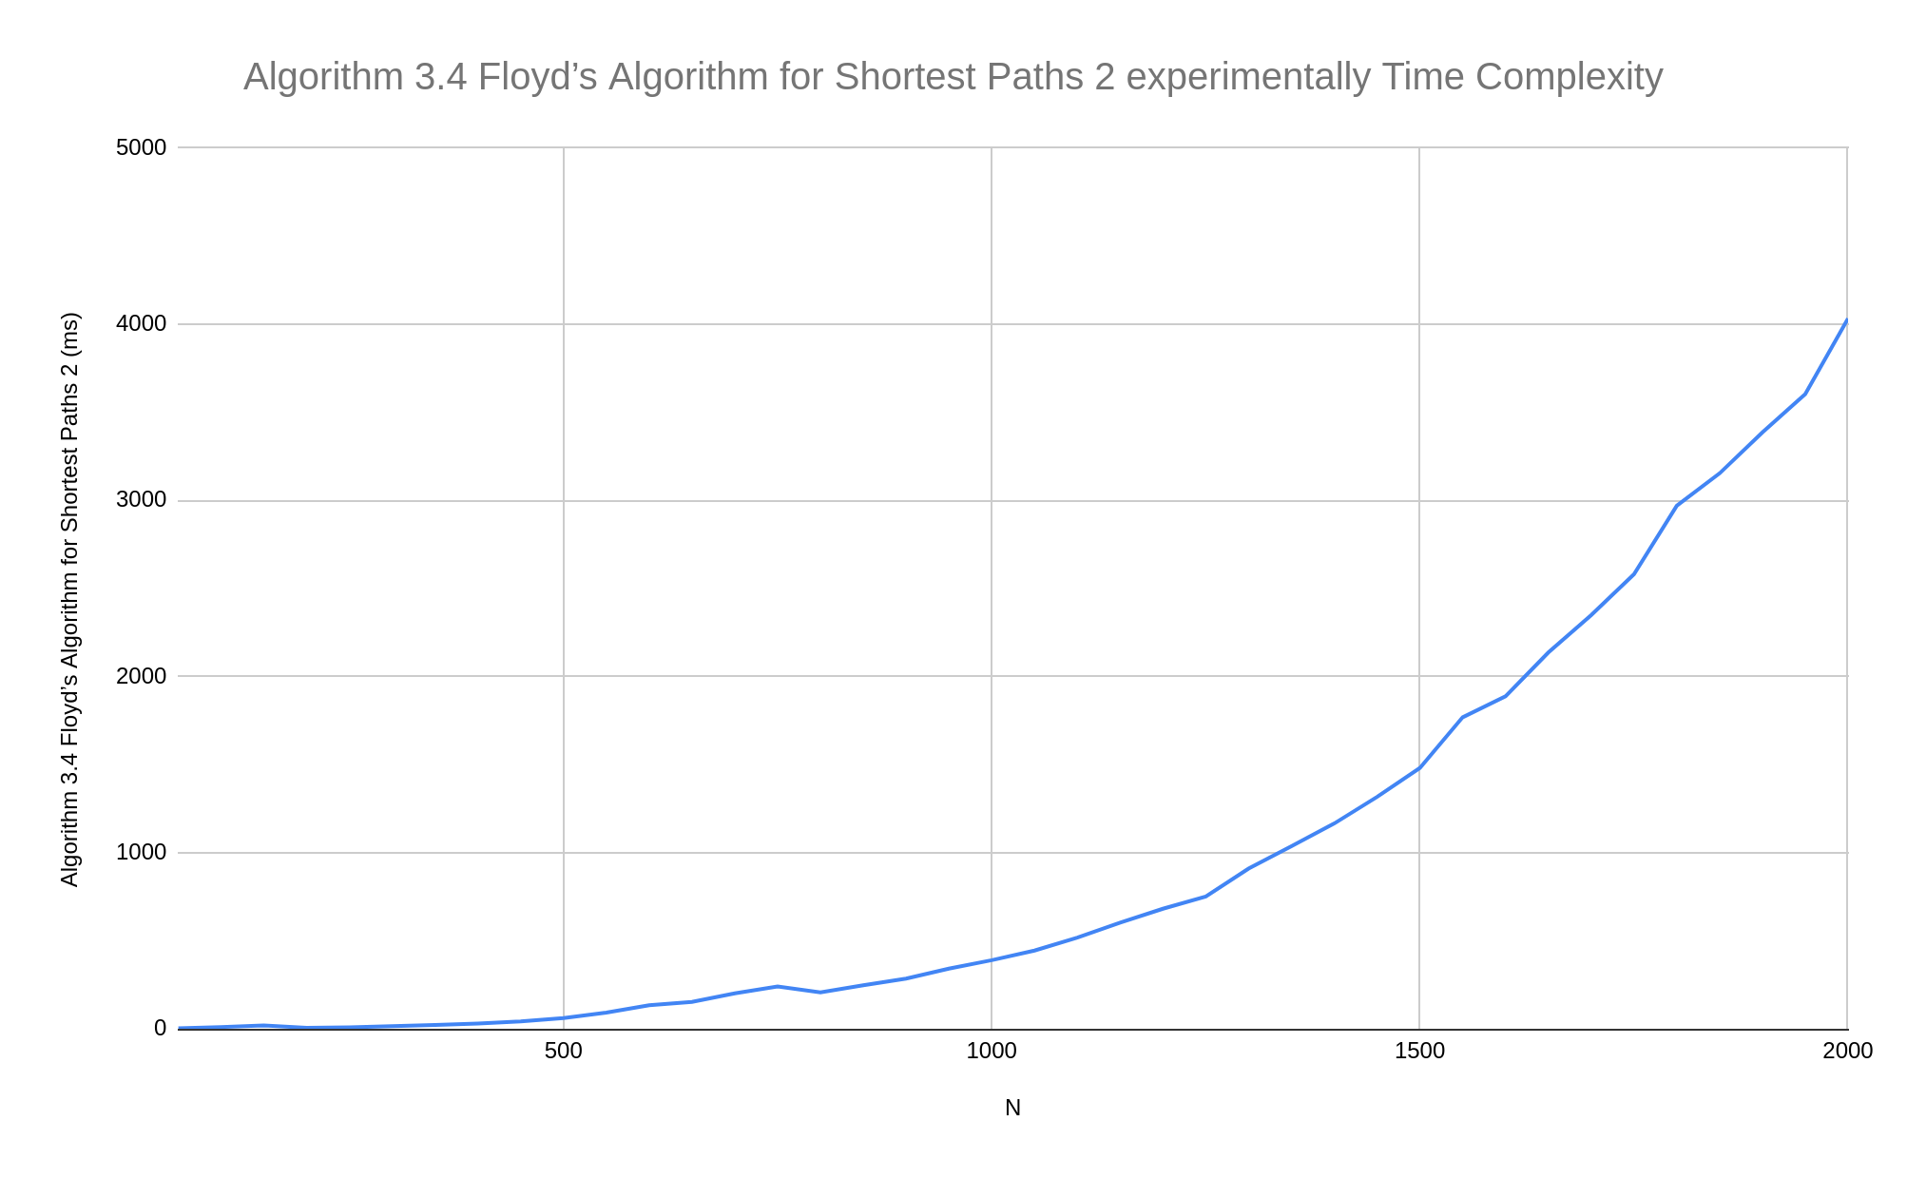

## Data for the plot (From the program output):

|  |  |
| --- | --- |
| N | Algorithm 3.4 Floyd’s Algorithm for Shortest Paths 2 (ms) |
| 50 | 3 |
| 100 | 10 |
| 150 | 19 |
| 200 | 6 |
| 250 | 8 |
| 300 | 15 |
| 350 | 22 |
| 400 | 30 |
| 450 | 42 |
| 500 | 61 |
| 550 | 92 |
| 600 | 134 |
| 650 | 152 |
| 700 | 201 |
| 750 | 240 |
| 800 | 207 |
| 850 | 247 |
| 900 | 285 |
| 950 | 341 |
| 1000 | 389 |
| 1050 | 444 |
| 1100 | 517 |
| 1150 | 602 |
| 1200 | 681 |
| 1250 | 750 |
| 1300 | 909 |
| 1350 | 1036 |
| 1400 | 1165 |
| 1450 | 1316 |
| 1500 | 1480 |
| 1550 | 1768 |
| 1600 | 1887 |
| 1650 | 2135 |
| 1700 | 2347 |
| 1750 | 2579 |
| 1800 | 2968 |
| 1850 | 3152 |
| 1900 | 3384 |
| 1950 | 3602 |
| 2000 | 4031 |