# Quiz 6:

The theoretically time complexity of Algorithm 4.3 Dijkstra’s algorithm that it computes the lengths of the shortest paths:

For computing the shortest paths for all nodes:

$O\left(n^{3}\right)$

For computing the shortest paths for a starting node:

$O\left(n^{2}\right)$

The experimentally time complexity of Algorithm 4.3 Dijkstra’s algorithm that it computes the lengths of the shortest paths:

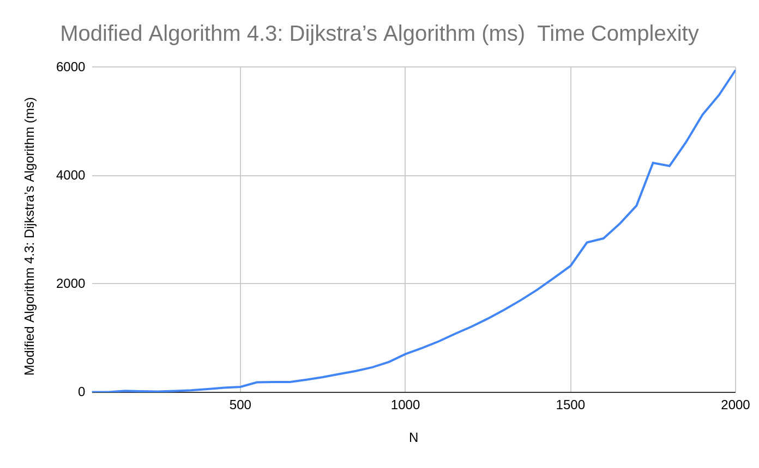

Data for the plot (From the program output):

|  |  |
| --- | --- |
| N | Modified Algorithm 4.3: Dijkstra’s Algorithm (ms) |
| 50 | 5 |
| 100 | 6 |
| 150 | 27 |
| 200 | 19 |
| 250 | 16 |
| 300 | 25 |
| 350 | 37 |
| 400 | 60 |
| 450 | 85 |
| 500 | 101 |
| 550 | 185 |
| 600 | 192 |
| 650 | 191 |
| 700 | 234 |
| 750 | 281 |
| 800 | 339 |
| 850 | 395 |
| 900 | 463 |
| 950 | 561 |
| 1000 | 707 |
| 1050 | 817 |
| 1100 | 939 |
| 1150 | 1080 |
| 1200 | 1213 |
| 1250 | 1362 |
| 1300 | 1526 |
| 1350 | 1704 |
| 1400 | 1897 |
| 1450 | 2114 |
| 1500 | 2333 |
| 1550 | 2766 |
| 1600 | 2842 |
| 1650 | 3117 |
| 1700 | 3447 |
| 1750 | 4235 |
| 1800 | 4179 |
| 1850 | 4618 |
| 1900 | 5126 |
| 1950 | 5489 |
| 2000 | 5949 |