[1]

CmpE 124 Lab 1: 74163 Analysis

Anahit Sarao, 008435583 , CmpE 124 Spring 2016, Lab Section 6

*Abstract*— Lab one’s report is a breakdown and analysis of the purpose for lab one which was to test and analyze the 74163. The circuits were built in LogicWorks to learn how the 74163 functions when the inputs are manipulated.

# INTRODUCTION

The 74163 4 bit counter is used to fully understand the functions and uses. The two variations will be fully analyzed within the LogicWorks software. As the inputs are manipulated the outputs will adjust according creating a variety of data for this experiment. The variation of the 74163 will utilize a SPDT switch that will control the clock.

# Design methodology

## Parts List

* Part 74163
* Part 7404
* SPDT Switch

## Truth Tables

N/A

## Original and Derived Equations

N/A

## Schematics

This schematic shows a complete 74163 counter circuit.

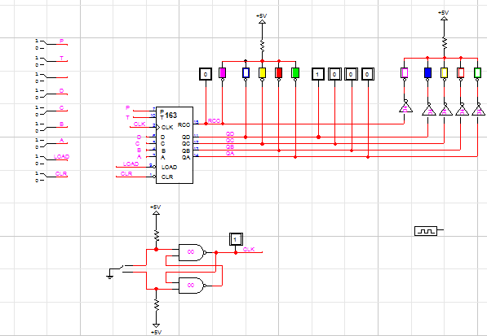

This schematic shows a 74163 with a SPDT switch control.

# testing procedures

1. Construct basic 74163 counter circuit
2. Record and observe outputs
3. Construct variation circuit
4. Record and observe outputs

# testing results

The 74163 has several inputs and outputs. The CLR and LOAD are active low inputs. While the input is 0 the output is cleared and the count is not kept, also the no value is stored. While the inputs are 1 they counter counts in binary. Other inputs such as P and T are actives highs that control the counting. The input at 1 will resume the count while 0 will disable the count. The RCO is responsible for resetting the count. The RCO becomes 1 when the count is needed to reset. Also when the count is active the A, B, C, D inputs are disables because the LOAS and CLR are deactivated.

The switch allows manual control of the counter circuit.

# Conclusion

LogicWorks helped understand the circuit and how it can be an essential to basic logic design. The quick testing of inputs for potential outputs makes this very efficient way of learning the functions and uses of the 74163.The outputs are connected to LEDS and counter probes which in hand allow a clear representation of the output provided. However conducting this experiment with real parts will not result in the same results as not all parts perform at ideal performance.

# appendices and references

Özemek, Haluk. (2014, Aug 14). 124_Labs [Online]. Available: https://sjsu.instructure.com/courses/1142847/files

1. Anahit Sarao, indianvip60@gmail.com