[1]

CmpE 124 Lab 3: Theorem Verification

Anahit Sarao, 008435583, CmpE 124 Fall 2005, Lab Section 2

*Abstract*— This lab was to understand and prove Boolean algebra theorems through the usage of logical circuits. By looking at an expression a logical circuit representation was constructed to show if the left side of the expression would be equal to the right side of the expression. This would prove that each Boolean theorem is valid and shows how it can be applied to logical circuits.

# INTRODUCTION

To verify the provided Boolean theorems many different gates were utilized, however only the sixth expression was constructed on the breadboard while the other expressions were constructed in logic simulation software. By comparing the waveforms of the right and left side of each expression the theorems are shown to be true as both waveforms are identical. By proving these theorems through logical circuits a new instance was revealed, as the clock continued to count the gates were provided inputs of either 1 or 0. However there was delay as the gates switched from a stable input to a stable output this is known as propagation delay

# Design methodology

## Parts List

* 1 x Oscilloscope
* 1 x 74LS00
* 1 x 74LS04
* 1 x 74LS02
* Simulation Software Logical Gates Library

## Truth Tables

|  |  |  |
| --- | --- | --- |
| Truth/Voltage Table for 74LS00 NAND Gate | | |
| A | B | Y |
| 0/L-- | 0/L-- | 1/H++ |
| 0/L-- | 1/H++ | 1/H++ |
| 1/H++ | 0/L-- | 1/H++ |
| 1/H++ | 1/H++ | 0/L-- |

Truth/Voltage Table for 74LS04 Hex Inverter

|  |  |  |
| --- | --- | --- |
| A | Y | |
| 0/L-- | 1/H++ | |
| 1/H++ | 0/L-- | |
| Truth/Voltage Table for 74LS02 NOR Gate | | | |
| A | B | Y | |
| 0/L-- | 0/L-- | 1/H++ | |
| 0/L-- | 1/H++ | 0/L-- | |
| 1/H++ | 0/L-- | 0/L-- | |
| 1/H++ | 1/H++ | 0/L-- | |

## Karnaugh Maps

N/A

## Original and Derived Equations

1. Original Equations
   1. 74LS00 NAND Gate
 $Y=\overline{AB}$

  2. 74LS04 Hex Inverter
 $Y=\overline{A}$

  3. 74LS02 Nor Gate
$Y=\overline{A+B}$

2. Derived Equations for Schematics g1=g2

## Schematics

Schematics are labeled for each corresponding equation according to section D subsection 2 from this report.

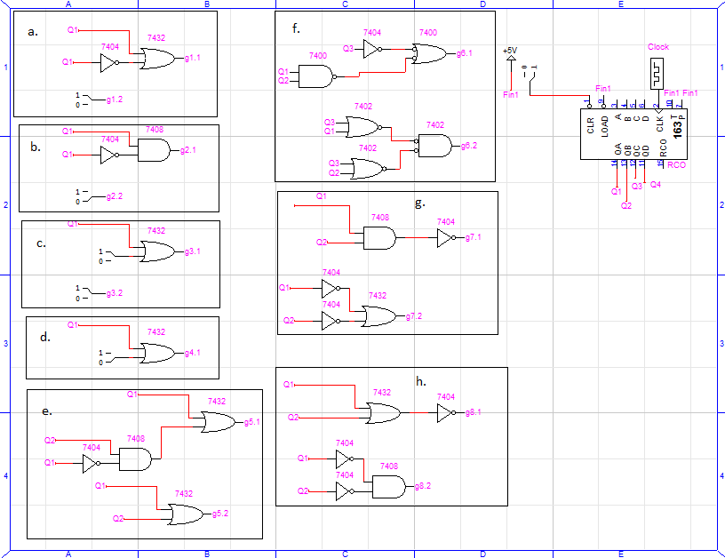

Figure 1: Schematics for Boolean Theorems

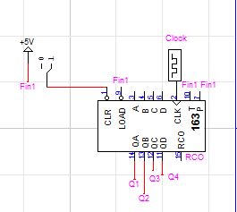For inputs into any logical gate a 74LS163 Simulated Counter Function was used.

Figure 2: Simulation 4 Bit Counter

# testing procedures

The testing procedure should be broken down into steps:

1. Set up circuit equivalent circuit for expressions a-e and g-h in Simulation Software
2. Create a input signal using a 4 Bit Counter
3. Create simulation waveforms to see consistency of expressions
4. Create equivalent circuit for expression f
5. Use oscilloscope to show both sides of expression
6. Compare results from oscilloscope and simulation also compare each Boolean expression

Figure 3: Logic Works Simulation Waveform Output

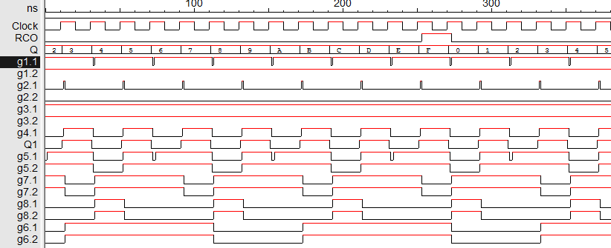

Labeling proceeds on this figure as: gA.B. Where A is changing in terms of expression. And B is changing between 1 and 2, where 1 is the left side and 2 is the right side of each expression.

# testing results

The results for this lab are clear as theorems are already proven to be true hence they are called theorems. The point was to efficiently replicate the validity of each theorem through the usage of logical circuitry. Expression f was the only physically constructed expression. The oscilloscope showed the waveforms matched however a propagation delay was shown. However the delay did not show within the Simulation Waveform.

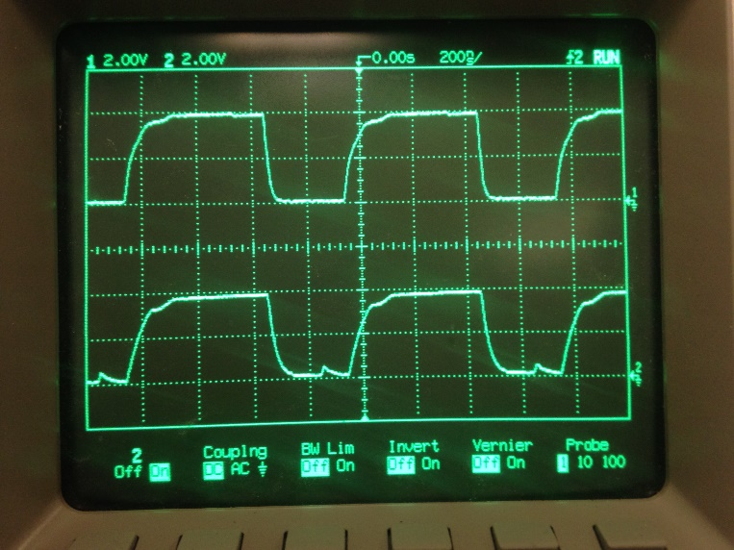Figure 4: Oscilloscope Results for Expression f

# Conclusion

This lab focused on Boolean algebra theorems and how to prove them using logic circuits such as NAND and NOR gates. From the results it can be concluded that the theorems are true as the left side equals the right side. Due to the constant switching of input and output the logic gates face a delay known as propagation delay. This delay occurs when the either the input or output of a gate is not in sync with one another. This causes a false value to occur for a short time so allow both the input and output to be in sync. This lab was focused mainly on simulation software however the purpose and understanding was the key, as propagation delay is a major concept when working with logical components.

# appendices and references

N/A

1. Anahit Sarao, indianvip60@gmail.com