***Introduction***

***Design Methodology***

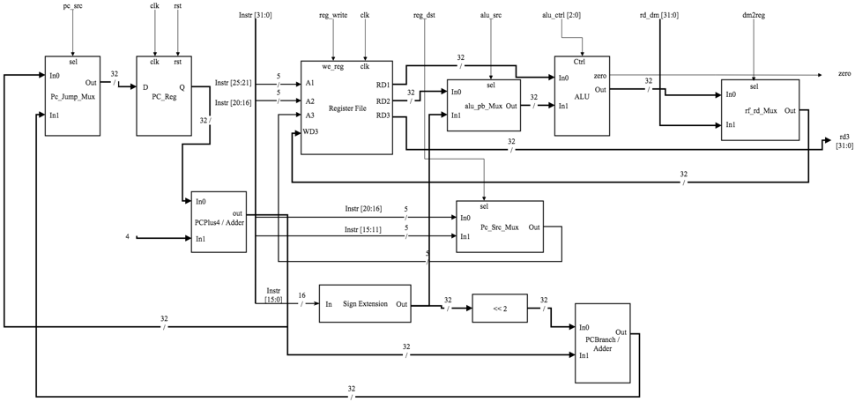

Figure 1. Data Path Diagram

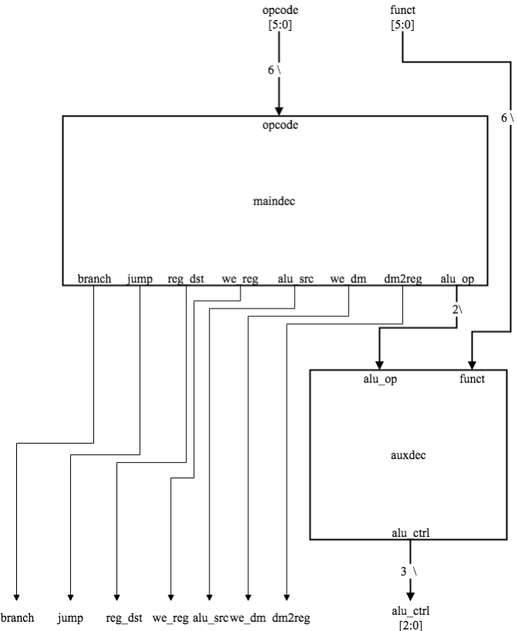

Figure 2. Control Unit Diagram

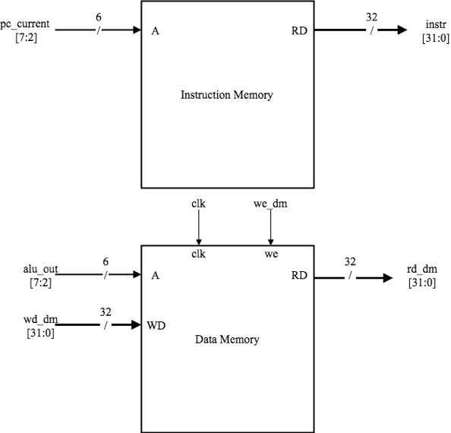

Figure 3. Instruction Memory and Data Memory Diagram

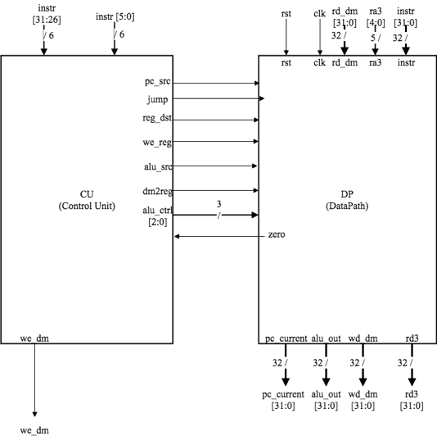

Figure 4. Control Unit and Data Path Diagram

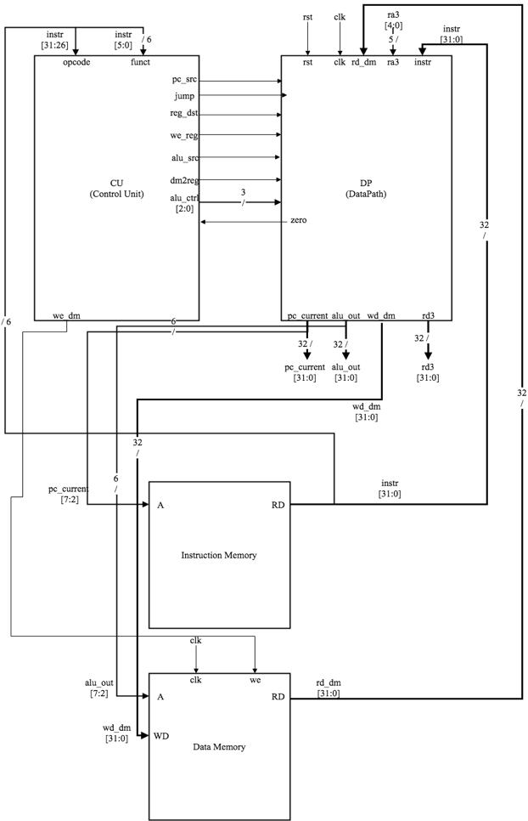

Figure 5. Complete Processor Diagram

***Simulation Test Plan***

***FPGA Test Plan***

***Conclusion***

***Appendix***

***Source Code***