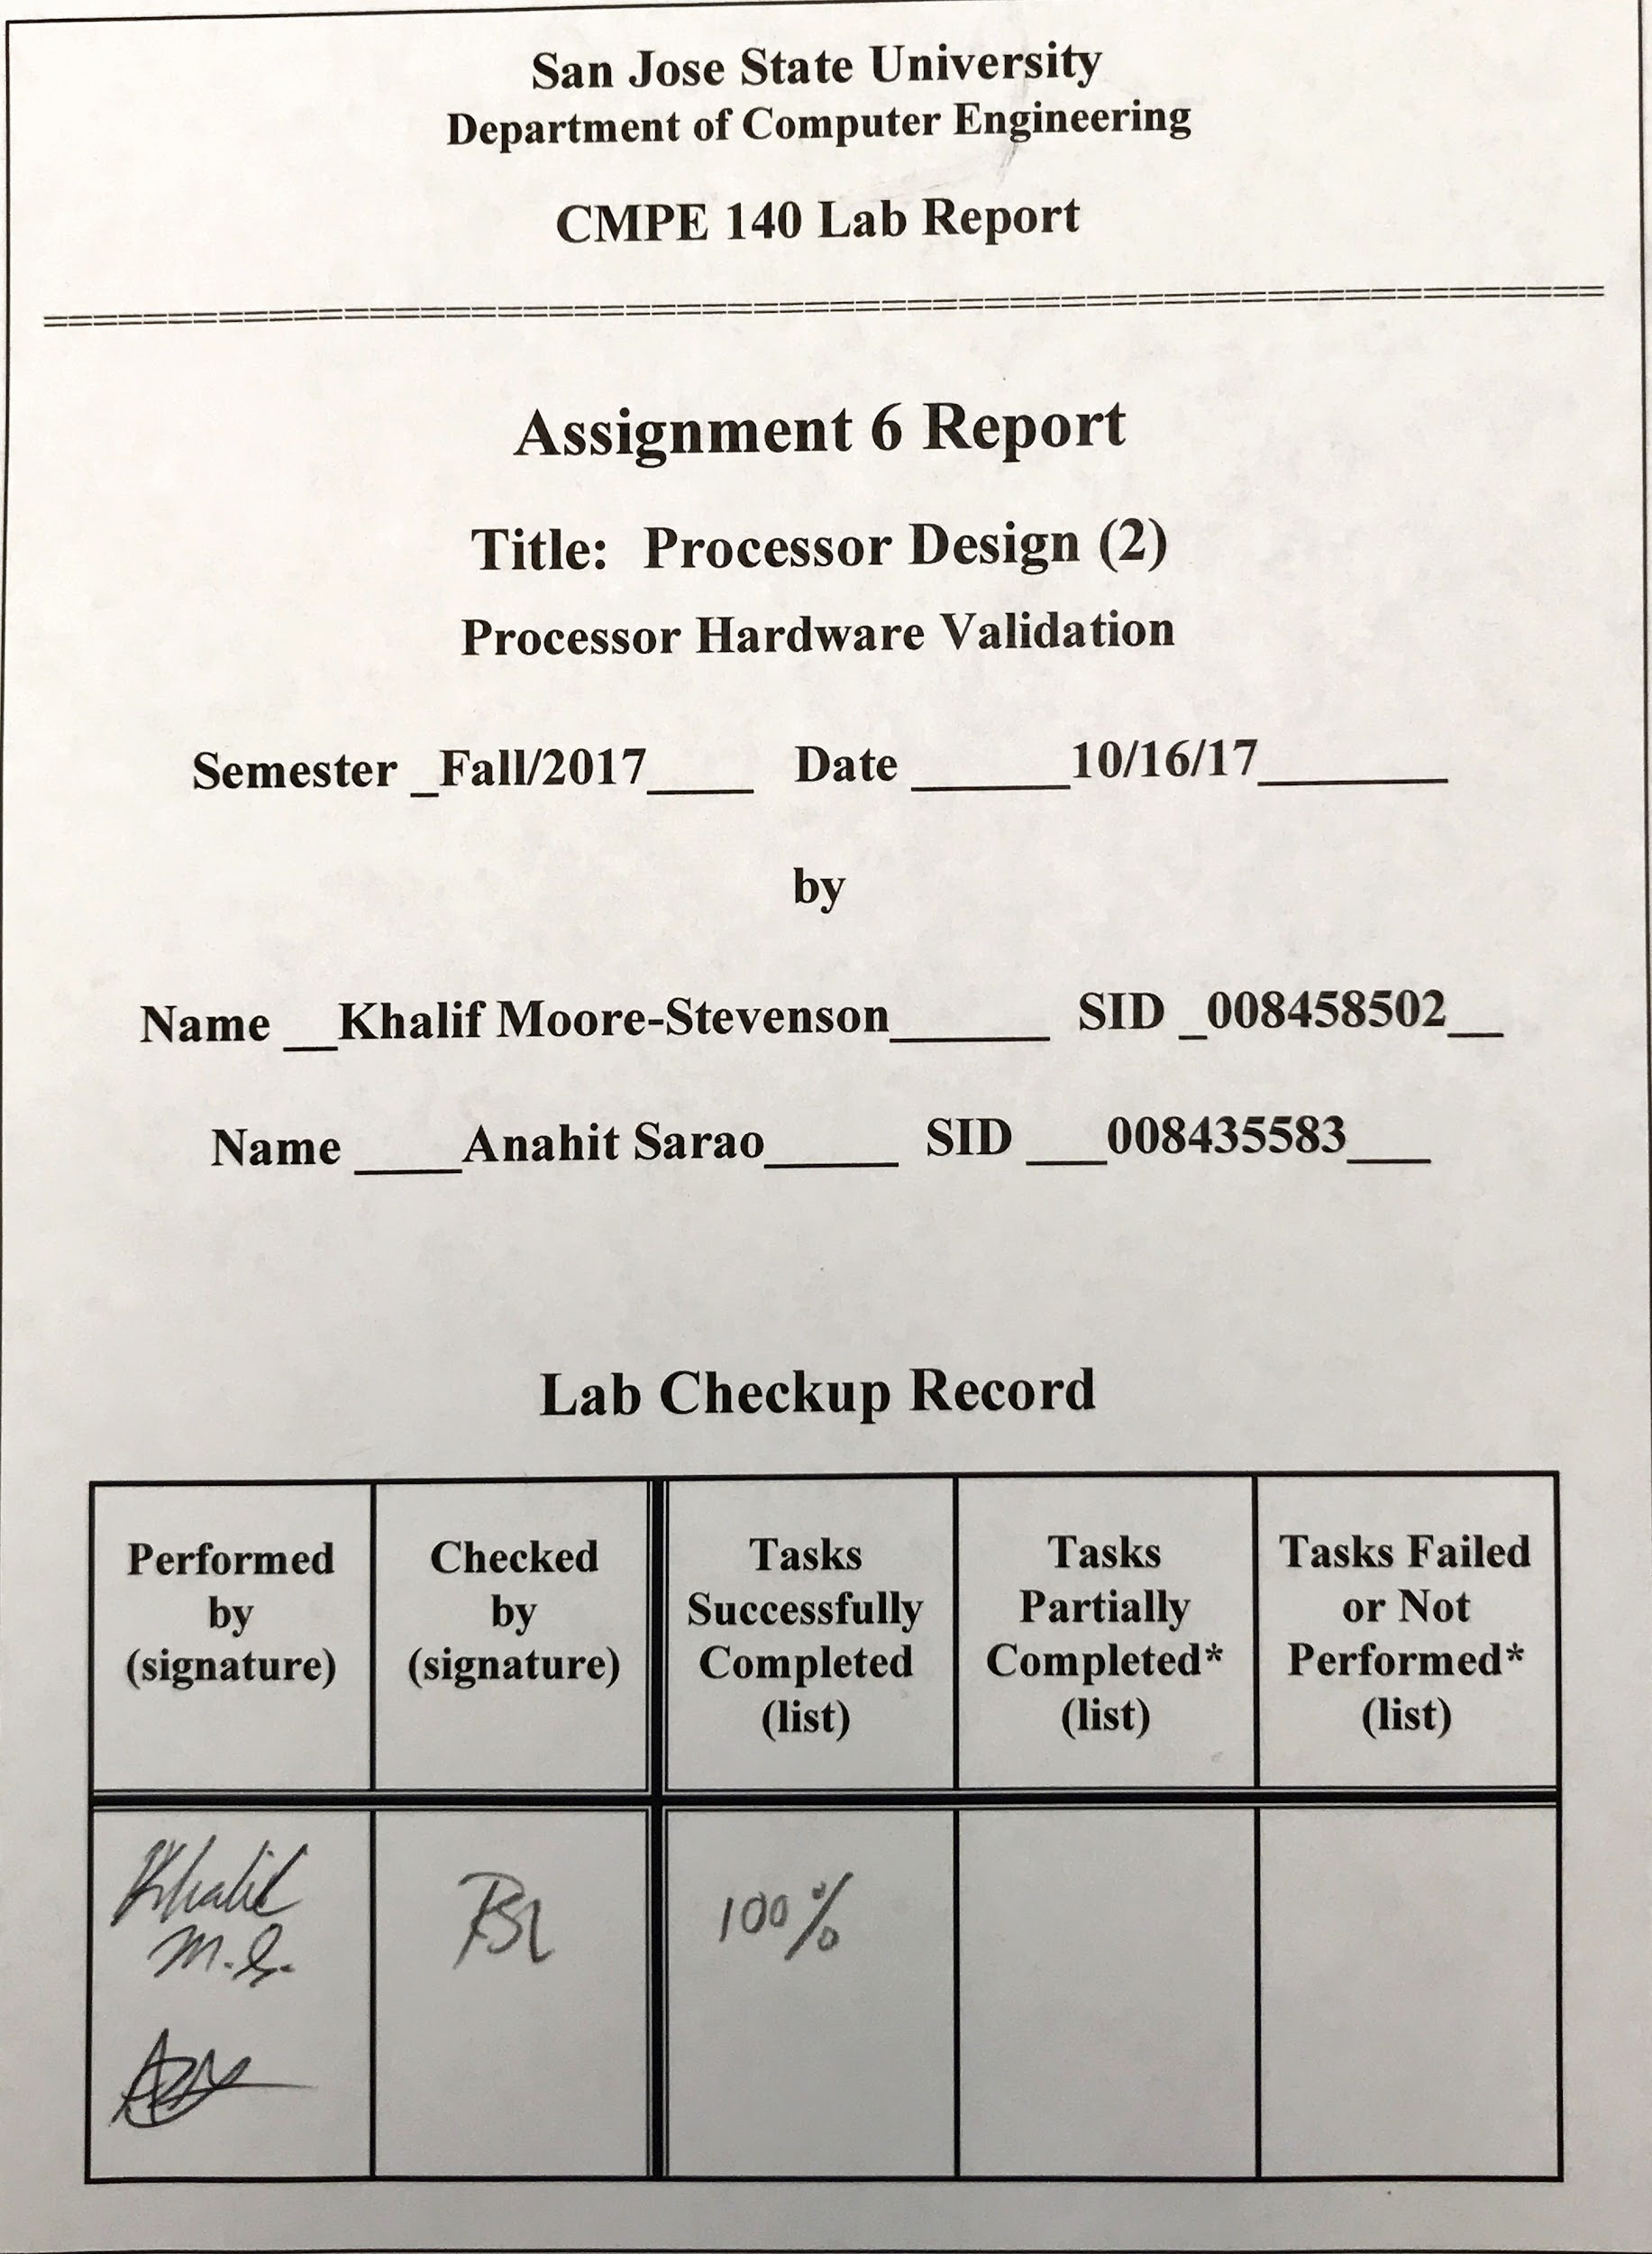***Design Methodology***

This is lab is an extension of lab 5, this lab requires full hardware validation testing for a single-process cpu . The files added to this project were the xdc constraints file and two extra source files. Provided below is a block diagram showing the testing environment in full. The learning outcome for this lab was to validate the MIPS processor design using the FPGA board. This allows the cpu to undergo software and hardware validation.

Tasks which were completed in lab:

* Create a diagram to show the validation environment setup.
* Fully verify the functionality using the FPGA.
* Compare the FPGA validation results with test log obtained from Lab 2.

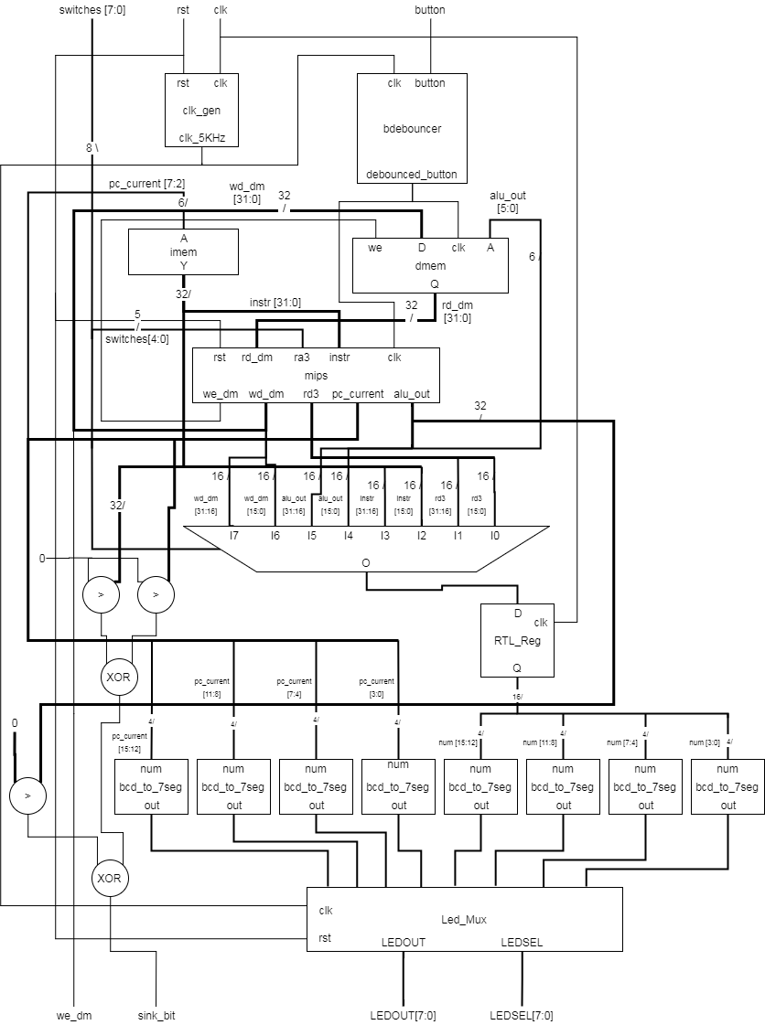

Figure 1. Validation Environment Setup.

Table 1. Test Results Log

| Adr | Expected Machine Code | Actual Machine Code | PC | Registers | | | | | Memory Content | |
| --- | --- | --- | --- | --- | --- | --- | --- | --- | --- | --- |
| $v0 | $v1 | $a0 | $a1 | $a3 | [80] | [84] |
| 00 | 20020005 | 20020005 | 0 | 5 | 0 | 0 | 0 | 0 | 0 | 0 |
| 04 | 2003000c | 2003000c | 4 | 5 | c | 0 | 0 | 0 | 0 | 0 |
| 08 | 2067fff7 | 2067ffff | 8 | 5 | c | 0 | 0 | 3 | 0 | 0 |
| 0c | 00e22025 | 00e22025 | c | 5 | c | 7 | 0 | 3 | 0 | 0 |
| 10 | 00642824 | 00642824 | 10 | 5 | c | 7 | 4 | 3 | 0 | 0 |
| 14 | 00a42820 | 00a42820 | 14 | 5 | c | 7 | b | 3 | 0 | 0 |
| 18 | 10a7000a | 10e5000a | 18 | 5 | c | 7 | b | 3 | 0 | 0 |
| 1c | 0064202a | 0064202a | 1c | 5 | c | 0 | b | 3 | 0 | 0 |
| 20 | 10800001 | 10040001 | 20 | 5 | c | 0 | b | 3 | 0 | 0 |
| 24 | 20050000 | 20050000 |  |  |  |  |  |  |  |  |
| 28 | 00e2202a | 00e2202a | 28 | 5 | c | 1 | b | 3 | 0 | 0 |
| 2c | 00853820 | 00853820 | 2c | 5 | c | 1 | b | c | 0 | 0 |
| 30 | 00e23822 | 00e23822 | 30 | 5 | c | 1 | b | 7 | 0 | 0 |
| 34 | Ac670044 | Ac670044 | 34 | 5 | c | 1 | b | 7 | 7 | 0 |
| 38 | 8c020050 | 8c020050 | 38 | 7 | c | 1 | b | 7 | 7 | 0 |
| 3c | 08000011 | 08000011 | 3c | 7 | c | 1 | b | 7 | 7 | 0 |
| 40 | 20020001 | 20020001 |  |  |  |  |  |  |  |  |
| 44 | Ac020054 | Ac020054 | 44 | 7 | c | 1 | b | 7 | 7 | 7 |
| 48 | 08000000 | 08000000 | 48 | 7 | c | 1 | b | 7 | 7 | 7 |

***Screenshot***

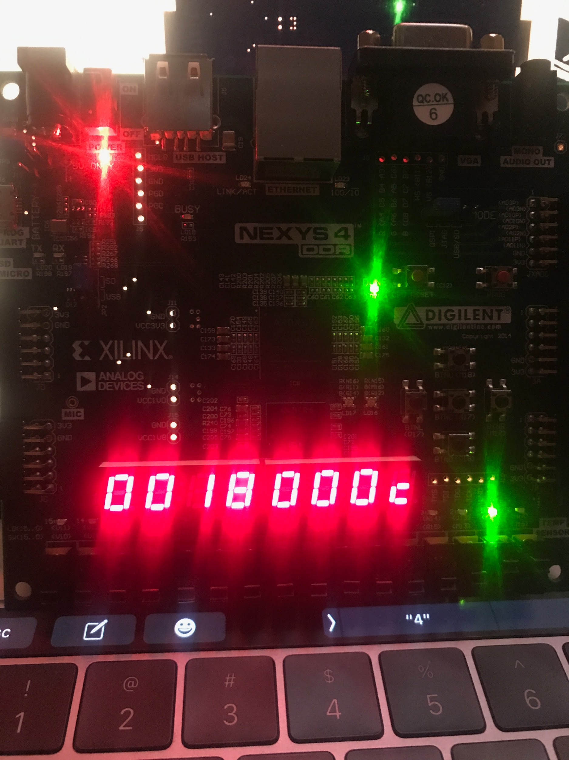

Figure 2. 7-Segment Display Showing Machine Code & Address

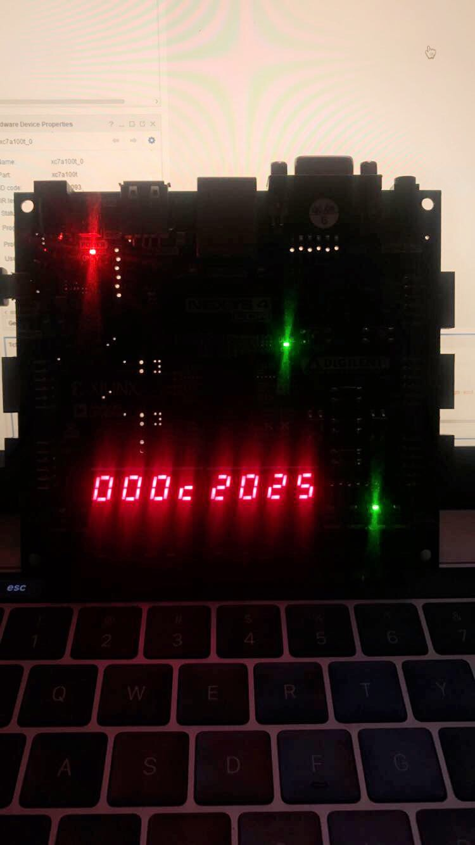

Figure 3. 7-Segment Display Showing Contents of Registers & Address

***Source Code:***

**mips_top.v**

module mips_top

(input clk, rst, output we_dm, [31:0] pc_current, instr, alu_out, wd_dm, rd_dm);

wire [31:0] DONT_USE;

mips mips (clk, rst, 0, instr, rd_dm, we_dm, pc_current, alu_out, wd_dm, DONT_USE);

imem imem (pc_current[7:2], instr);

dmem dmem (clk, we_dm, alu_out[7:2], wd_dm, rd_dm);

endmodule

**mips.v**

module mips

(input clk, rst, [4:0] ra3, [31:0] instr, rd_dm, output we_dm, [31:0] pc_current, alu_out, wd_dm, rd3);

wire pc_src, jump, reg_dst, we_reg, alu_src, dm2reg;

wire [2:0] alu_ctrl;

datapath dp (clk, rst, pc_src, jump, reg_dst, we_reg, alu_src, dm2reg, alu_ctrl, ra3, instr, rd_dm, zero, pc_current, alu_out, wd_dm, rd3);

controlunit cu (zero, instr[31:26], instr[5:0], pc_src, jump, reg_dst, we_reg, alu_src, we_dm, dm2reg, alu_ctrl);

endmodule

**Mem_parts.v**

module imem

(input [5:0] a, output [31:0] y);

reg [31:0] rom [0:63];

initial begin

$readmemh ("memfile.dat", rom);

end

assign y = rom[a];

endmodule

module dmem

(input clk, we, [5:0] a, [31:0] d, output [31:0] q);

reg [31:0] ram [0:63];

integer n;

initial begin

for (n = 0; n < 64; n = n + 1) ram[n] = 32'hFFFFFFFF;

end

always @ (posedge clk)

begin

if (we) ram[a] <= d;

end

assign q = ram[a];

endmodule

**datapath.v**

module datapath

(input clk, rst, pc_src, jump, reg_dst, we_reg, alu_src, dm2reg, [2:0] alu_ctrl, [4:0] ra3, [31:0] instr, rd_dm, output zero, [31:0] pc_current, alu_out, wd_dm, rd3);

wire [4:0] rf_wa;

wire [31:0] pc_plus4, pc_pre, pc_next, sext_imm, ba, bta, jta, alu_pa, alu_pb, wd_rf;

assign ba = {sext_imm[29:0], 2'b00};

assign jta = {pc_plus4[31:28], instr[25:0], 2'b00};

// --- PC Logic --- //

dreg pc_reg (clk, rst, pc_next, pc_current);

adder pc_plus_4 (pc_current, 4, pc_plus4);

adder pc_plus_br (pc_plus4, ba, bta);

mux2 #(32) pc_src_mux (pc_src, pc_plus4, bta, pc_pre);

mux2 #(32) pc_jmp_mux (jump, pc_pre, jta, pc_next);

// --- RF Logic --- //

mux2 #(5) rf_wa_mux (reg_dst, instr[20:16], instr[15:11], rf_wa);

regfile rf (clk, we_reg, instr[25:21], instr[20:16], ra3, rf_wa, wd_rf, alu_pa, wd_dm, rd3);

signext se (instr[15:0], sext_imm);

// --- ALU Logic --- //

mux2 #(32) alu_pb_mux (alu_src, wd_dm, sext_imm, alu_pb);

alu alu (alu_ctrl, alu_pa, alu_pb, zero, alu_out);

// --- MEM Logic --- //

mux2 #(32) rf_wd_mux (dm2reg, alu_out, rd_dm, wd_rf);

endmodule

**dp_parts.v**

module mux2 #(parameter wide = 8)

(input sel, [wide-1:0] a, b, output [wide-1:0] y);

assign y = (sel) ? b : a;

endmodule

module adder

(input [31:0] a, b, output [31:0] y);

assign y = a + b;

endmodule

module signext

(input [15:0] a, output [31:0] y);

assign y = {{16{a[15]}}, a};

endmodule

module alu

(input [2:0] op, [31:0] a, b, output zero, reg [31:0] y);

assign zero = (y == 0);

always @ (op, a, b)

begin

case (op)

3'b000: y = a & b;

3'b001: y = a | b;

3'b010: y = a + b;

3'b110: y = a - b;

3'b111: y = (a < b) ? 1 : 0;

endcase

end

endmodule

module dreg

(input clk, rst, [31:0] d, output reg [31:0] q);

always @ (posedge clk, posedge rst)

begin

if (rst) q <= 0;

else q <= d;

end

endmodule

module regfile

(input clk, we, [4:0] ra1, ra2, ra3, wa, [31:0] wd, output [31:0] rd1, rd2, rd3);

reg [31:0] rf [0:31];

integer n;

initial begin

for (n = 0; n < 32; n = n + 1) rf[n] = 32'h0;

end

always @ (posedge clk)

begin

if (we) rf[wa] <= wd;

end

assign rd1 = (ra1 == 0) ? 0 : rf[ra1];

assign rd2 = (ra2 == 0) ? 0 : rf[ra2];

assign rd3 = (ra3 == 0) ? 0 : rf[ra3];

endmodule

**controlunit.v**

module controlunit

(input zero, [5:0] opcode, funct, output pc_src, jump, reg_dst, we_reg, alu_src, we_dm, dm2reg, [2:0] alu_ctrl);

wire [1:0] alu_op;

assign pc_src = branch & zero;

maindec md (opcode, branch, jump, reg_dst, we_reg, alu_src, we_dm, dm2reg, alu_op);

auxdec ad (alu_op, funct, alu_ctrl);

endmodule

**cu_parts.v**

module maindec

(input [5:0] opcode, output branch, jump, reg_dst, we_reg, alu_src, we_dm, dm2reg, [1:0] alu_op);

reg [8:0] ctrl;

assign {branch, jump, reg_dst, we_reg, alu_src, we_dm, dm2reg, alu_op} = ctrl;

always @ (opcode)

begin

case (opcode)

6'b00_0000: ctrl = 9'b0_0_1_1_0_0_0_10; // R-type

6'b00_1000: ctrl = 9'b0_0_0_1_1_0_0_00; // ADDI

6'b00_0100: ctrl = 9'b1_0_0_0_0_0_0_01; // BEQ

6'b00_0010: ctrl = 9'b0_1_0_0_0_0_0_00; // J

6'b10_1011: ctrl = 9'b0_0_0_0_1_1_0_00; // SW

6'b10_0011: ctrl = 9'b0_0_0_1_1_0_1_00; // LW

default: ctrl = 9'bx_x_x_x_x_x_x_xx;

endcase

end

endmodule

module auxdec

(input [1:0] alu_op, [5:0] funct, output [2:0] alu_ctrl);

reg [2:0] ctrl;

assign {alu_ctrl} = ctrl;

always @ (alu_op, funct)

begin

case (alu_op)

2'b00: ctrl = 3'b010; // add

2'b01: ctrl = 3'b110; // sub

default: case (funct)

6'b10_0100: ctrl = 3'b000; // AND

6'b10_0101: ctrl = 3'b001; // OR

6'b10_0000: ctrl = 3'b010; // ADD

6'b10_0010: ctrl = 3'b110; // SUB

6'b10_1010: ctrl = 3'b111; // SLT

default: ctrl = 3'bxxx;

endcase

endcase

end

endmodule

**tb_mips_top.v**

module tb_mips_top;

reg clk, rst;

wire we_dm;

wire [31:0] pc_current, instr, alu_out, wd_dm, rd_dm;

mips_top DUT (clk, rst, we_dm, pc_current, instr, alu_out, wd_dm, rd_dm);

task tick; begin #5 clk = 1; #5 clk = 0; end endtask

task rest; begin #5 rst = 1; #5 rst = 0; end endtask

initial begin

rest;

while(pc_current != 32'h48) tick;

$finish;

end

Endmodule

**memfile.dat**

20020005

2003000C

2067FFF7

00E22025

00642824

00A42820

10E5000A

0064202A

10040001

20050000

00E2202A

00853820

00E23822

AC670044

8C020050

08000011

20020001

AC020054

08000000

**Mips.xdc**

set_property -dict { PACKAGE_PIN E3 IOSTANDARD LVCMOS33 } [get_ports { clk }];

create_clock -add -name sys_clk_pin -period 10.00 -waveform {0 5} [get_ports {clk}];

set_property -dict { PACKAGE_PIN N17 IOSTANDARD LVCMOS33 } [get_ports { button }];

set_property -dict { PACKAGE_PIN P17 IOSTANDARD LVCMOS33 } [get_ports { rst }];

set_property -dict { PACKAGE_PIN J15 IOSTANDARD LVCMOS33 } [get_ports { switches[0] }];

set_property -dict { PACKAGE_PIN L16 IOSTANDARD LVCMOS33 } [get_ports { switches[1] }];

set_property -dict { PACKAGE_PIN M13 IOSTANDARD LVCMOS33 } [get_ports { switches[2] }];

set_property -dict { PACKAGE_PIN R15 IOSTANDARD LVCMOS33 } [get_ports { switches[3] }];

set_property -dict { PACKAGE_PIN R17 IOSTANDARD LVCMOS33 } [get_ports { switches[4] }];

set_property -dict { PACKAGE_PIN T18 IOSTANDARD LVCMOS33 } [get_ports { switches[5] }];

set_property -dict { PACKAGE_PIN U18 IOSTANDARD LVCMOS33 } [get_ports { switches[6] }];

set_property -dict { PACKAGE_PIN R13 IOSTANDARD LVCMOS33 } [get_ports { switches[7] }];

set_property -dict { PACKAGE_PIN H17 IOSTANDARD LVCMOS33 } [get_ports { we_dm }];

set_property -dict { PACKAGE_PIN K15 IOSTANDARD LVCMOS33 } [get_ports { sink_bit }];

set_property -dict { PACKAGE_PIN K13 IOSTANDARD LVCMOS33 } [get_ports { LEDOUT[0] }];

set_property -dict { PACKAGE_PIN K16 IOSTANDARD LVCMOS33 } [get_ports { LEDOUT[1] }];

set_property -dict { PACKAGE_PIN P15 IOSTANDARD LVCMOS33 } [get_ports { LEDOUT[2] }];

set_property -dict { PACKAGE_PIN L18 IOSTANDARD LVCMOS33 } [get_ports { LEDOUT[3] }];

set_property -dict { PACKAGE_PIN R10 IOSTANDARD LVCMOS33 } [get_ports { LEDOUT[4] }];

set_property -dict { PACKAGE_PIN T11 IOSTANDARD LVCMOS33 } [get_ports { LEDOUT[5] }];

set_property -dict { PACKAGE_PIN T10 IOSTANDARD LVCMOS33 } [get_ports { LEDOUT[6] }];

set_property -dict { PACKAGE_PIN H15 IOSTANDARD LVCMOS33 } [get_ports { LEDOUT[7] }];

set_property -dict { PACKAGE_PIN J17 IOSTANDARD LVCMOS33 } [get_ports { LEDSEL[0] }];

set_property -dict { PACKAGE_PIN J18 IOSTANDARD LVCMOS33 } [get_ports { LEDSEL[1] }];

set_property -dict { PACKAGE_PIN T9 IOSTANDARD LVCMOS33 } [get_ports { LEDSEL[2] }];

set_property -dict { PACKAGE_PIN J14 IOSTANDARD LVCMOS33 } [get_ports { LEDSEL[3] }];

set_property -dict { PACKAGE_PIN P14 IOSTANDARD LVCMOS33 } [get_ports { LEDSEL[4] }];

set_property -dict { PACKAGE_PIN T14 IOSTANDARD LVCMOS33 } [get_ports { LEDSEL[5] }];

set_property -dict { PACKAGE_PIN K2 IOSTANDARD LVCMOS33 } [get_ports { LEDSEL[6] }];

set_property -dict { PACKAGE_PIN U13 IOSTANDARD LVCMOS33 } [get_ports { LEDSEL[7] }];

**Mips_fpga.v**

module mips_fpga

(input clk, rst, button, [7:0] switches, output we_dm, sink_bit, [7:0] LEDSEL, LEDOUT);

reg [15:0] reg_hex;

wire clk_sec, clk_5KHz, clk_pb;

wire [7:0] digit0, digit1, digit2, digit3, digit4, digit5, digit6, digit7;

wire [31:0] pc_current, instr, alu_out, wd_dm, rd_dm, dispData;

clk_gen clk_gen (clk, rst, clk_sec, clk_5KHz);

bdebouncer bd (clk_5KHz, button, clk_pb);

mips mips (clk_pb, rst, switches[4:0], instr, rd_dm, we_dm, pc_current, alu_out, wd_dm, dispData);

/*

switchs[4:0] are used as the 3rd read address (ra3) of the RF,

dispData is the register contents from the RF's 3rd read port (rd3).

*/

imem imem (pc_current[7:2], instr);

dmem dmem (clk_pb, we_dm, alu_out[7:2], wd_dm, rd_dm);

bcd_to_7seg bcd7 (pc_current[15:12], digit7);

bcd_to_7seg bcd6 (pc_current[11:8], digit6);

bcd_to_7seg bcd5 (pc_current[7:4], digit5);

bcd_to_7seg bcd4 (pc_current[3:0], digit4);

bcd_to_7seg bcd3 (reg_hex[15:12], digit3);

bcd_to_7seg bcd2 (reg_hex[11:8], digit2);

bcd_to_7seg bcd1 (reg_hex[7:4], digit1);

bcd_to_7seg bcd0 (reg_hex[3:0], digit0);

led_mux led_mux (clk_5KHz, rst, digit7, digit6, digit5, digit4, digit3, digit2, digit1, digit0, LEDSEL, LEDOUT);

/*

switches[7:5] = 000 : Display lower half word of register selected by switches[4:0]

switches[7:5] = 001 : Display higher half word of register selected by switches[4:0]

switches[7:5] = 010 : Display lower half word of 'instr'

switches[7:5] = 011 : Display higher half word of 'instr'

switches[7:5] = 100 : Display lower half word of 'alu_out'

switches[7:5] = 101 : Display higher half word of 'alu_out'

switches[7:5] = 110 : Display lower half word of 'wd_dm'

switches[7:5] = 111 : Display higher half word of 'wd_dm'

*/

always @ (posedge clk)

begin

case ({switches[7], switches[6], switches[5]})

3'b000: reg_hex = dispData[15:0];

3'b001: reg_hex = dispData[31:16];

3'b010: reg_hex = instr[15:0];

3'b011: reg_hex = instr[31:16];

3'b100: reg_hex = alu_out[15:0];

3'b101: reg_hex = alu_out[31:16];

3'b110: reg_hex = wd_dm[15:0];

3'b111: reg_hex = wd_dm[31:16];

endcase

end

assign sink_bit = (pc_current > 0) ^ (instr > 0) ^ (alu_out > 0);

endmodule

**Utility.v**

module clk_gen

(input clk100MHz, rst, output reg clk_sec, clk_5KHz);

integer count1, count2;

always @ (posedge clk100MHz)

begin

if (rst)

begin

count1 = 0; clk_sec = 0;

count2 = 0; clk_5KHz = 0;

end

else

begin

if (count1 == 50000000)

begin

clk_sec = ~clk_sec;

count1 = 0;

end

if (count2 == 10000)

begin

clk_5KHz = ~clk_5KHz;

count2 = 0;

end

count1 = count1 + 1;

count2 = count2 + 1;

end

end

endmodule

/* 7-segment values */

`define D0 8'b10001000 /* 0 */

`define D1 8'b11101101 /* 1 */

`define D2 8'b10100010 /* 2 */

`define D3 8'b10100100 /* 3 */

`define D4 8'b11000101 /* 4 */

`define D5 8'b10010100 /* 5 */

`define D6 8'b10010000 /* 6 */

`define D7 8'b10101101 /* 7 */

`define D8 8'b10000000 /* 8 */

`define D9 8'b10000100 /* 9 */

`define DA 8'b10100000 /* A */

`define DB 8'b11010000 /* B */

`define DC 8'b11110010 /* C */

`define DD 8'b11100000 /* D */

`define DE 8'b10010010 /* E */

`define DF 8'b10010011 /* F */

`define DX 8'b01111111 /* All segments off except decimal point */

module bcd_to_7seg

(input [3:0] num, output reg [7:0] out);

always @ (num)

begin

case (num)

4'h0: begin out=`D0; end

4'h1: begin out=`D1; end

4'h2: begin out=`D2; end

4'h3: begin out=`D3; end

4'h4: begin out=`D4; end

4'h5: begin out=`D5; end

4'h6: begin out=`D6; end

4'h7: begin out=`D7; end

4'h8: begin out=`D8; end

4'h9: begin out=`D9; end

4'hA: begin out=`DA; end

4'hB: begin out=`DB; end

4'hC: begin out=`DC; end

4'hD: begin out=`DD; end

4'hE: begin out=`DE; end

4'hF: begin out=`DF; end

default: begin out=`DX; end

endcase

end

endmodule

module led_mux

(input clk, rst, [7:0] LED0, LED1, LED2, LED3, LED4, LED5, LED6, LED7, output [7:0] LEDSEL, LEDOUT);

reg [2:0] index;

reg [15:0] led_ctrl;

assign {LEDSEL, LEDOUT} = led_ctrl;

always@(posedge clk)

begin

index <= (rst) ? 3'd0 : (index + 3'd1);

end

always @(index, LED0, LED1, LED2, LED3, LED4, LED5, LED6, LED7)

begin

case(index)

3'd0: led_ctrl <= {8'b11111110, LED7};

3'd1: led_ctrl <= {8'b11111101, LED6};

3'd2: led_ctrl <= {8'b11111011, LED5};

3'd3: led_ctrl <= {8'b11110111, LED4};

3'd4: led_ctrl <= {8'b11101111, LED3};

3'd5: led_ctrl <= {8'b11011111, LED2};

3'd6: led_ctrl <= {8'b10111111, LED1};

3'd7: led_ctrl <= {8'b01111111, LED0};

default: led_ctrl <= {8'b11111111, 8'hFF};

endcase

end

endmodule

module bdebouncer #(parameter depth = 16)

(input clk, button, output reg debounced_button);

localparam history_max = (2**depth)-1;

reg [depth-1:0] history;

always @ (posedge clk)

begin

history <= {button, history[depth-1:1]};

debounced_button <= (history == history_max) ? 1'b1 : 1'b0;

end

endmodule