EE 97 Fall 2014

Lab#1: Characteristic of a Practical DC Source

Anahit Sarao

Partner: Yong Gui Huang

Station 3

Submitted: September 04, 2014

**Preface**

All experiments were successfully conducted in Engineering Building room 249, on August twenty-eight, 2014.

**Experiment 1 and 2**

The first two experiments used four randomly selected resistors form the given EE97 Lab Parts kit Packed By: Electronic School Supply, INC. With the four resistors selected the nominal resistance, Tolerance, measured resistance, deviation of resistance and if each resister is within the tolerance rating was measured and recorded.

The four resistors selected listed in standard resistor color band notation:

1. orange, orange, blue, gold
2. yellow, purple, red, gold
3. green, brown ,red, gold
4. red, black, red, gold

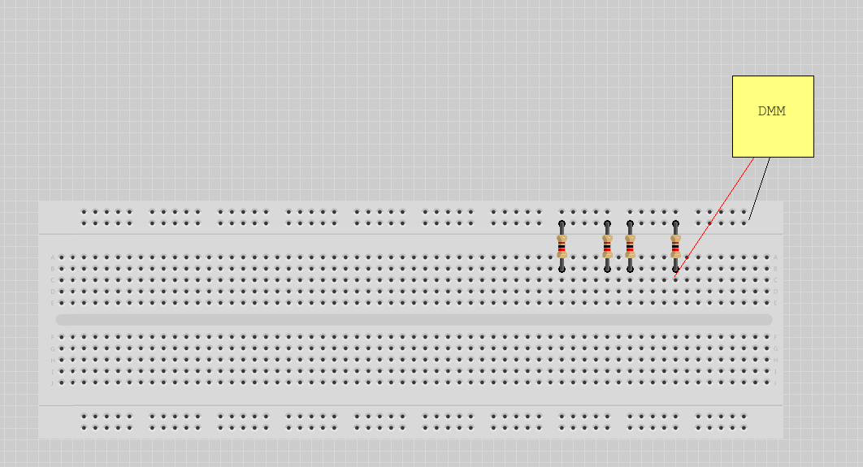Using the standard resistor color band table the nominal resistance and tolerance were recorded. The power rating is given on the parts kit reference page to be one-fourth watts. Continuing with the same 4 resistors listed above the measured resistance was measure using a Digital Millimeter (DMM) Agilent 34405A. The measurement was taken in Ohms using the ohmmeter feature on the DMM.

Figure 1: Using the DMM to measure resistance

Table 1: Data for four chosen resistors

|  |  |  |  |  |  |
| --- | --- | --- | --- | --- | --- |
| Color | Nominal Resistance [Ω] | Tolerance | Measured Resistance [Ω] | Deviation | Tolerance Rating Check |
| orange  orange  blue  gold | 33 Ω | 5% | 33.5 Ω | .15% | Yes |
| yellow  purple  red  gold | 4.7k Ω | 5% | 4.61k Ω | -1.9% | Yes |
| green  Brown  Red  gold | 5.1k Ω | 5% | 5.00k Ω | -1.9% | Yes |
| red  black  red  gold | 2k Ω | 5% | 1.96k Ω | -2.0% | Yes |

These experiments helped understand how resistors function and how to understand and use resistor in practical application. The usage of a DMM and breadboard enhanced the learning experience and was a good visualization on how simple circuits are set up and tested. Based on the data most resistors are within the tolerance level notated by the third color band, this shows how reliable and useful resistors are in circuitry.

**Experiment 3**

Four circuits were modeled out the objective was to find the errors. Four new resistors are used to create a new circuit on a breadboard. Before building the circuit the equivalent resistance is calculated and compared to the measured resistance.

Four New resistors:

R1=1kΩ

R2=2.2kΩ

R3=4.7kΩ

R4=1.5kΩ

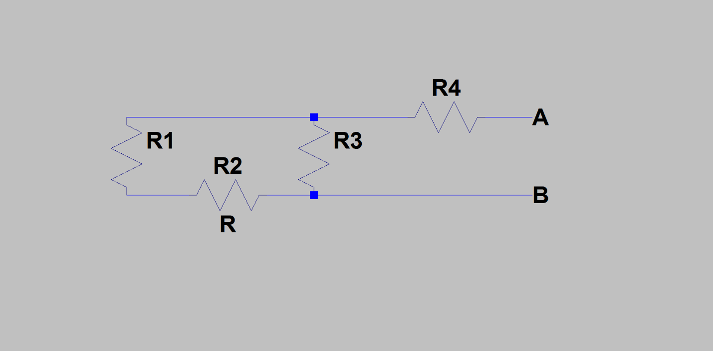Figure 2: Four-resistor circuit

Calculated Resistance: 3.34kΩ

Nominal Resistance: 3.40kΩ

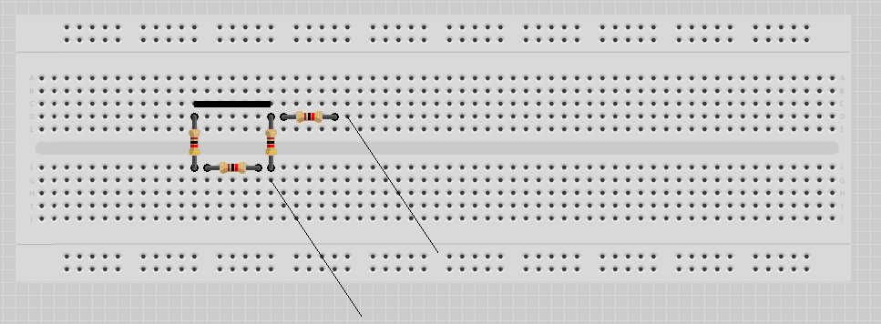Firgure 3: Circuit #3 from Lab

Each circle shows a mistake in Circuit #3

In conclusion resistor can be connected in series and parallel which enhances the versatility of resistors and there use in circuitry. Comparing the calculated resistance to the measured resistance the difference of .07kΩ is expected as most resistors are not ideal and have some variation.

**Experiment 4**

Using an AA direct current battery the load current is calculated through a variety of resistors. The purpose is to find the current range in which the battery can be considered ideal. Ohms law V=IR is used mainly to calculate the current with this set up the Open Circuit Thevenin Voltage or Norton Short Circuit current can be found.

Table 2: Data and Calculations for Experiment 4

|  |  |  |
| --- | --- | --- |
| Resistance [Ω] | Voltage [V] | Current [A] |
| VOC(R=∞) | 1.57V |  |
| 100kΩ | 1.578V | .000015A |
| 10kΩ | 1.578V | .00015A |
| 5.1kΩ | 1.577V | .00030A |
| 1KΩ | 1.575V | .0012A |
| 470Ω | 1.566V | .0033A |
| 100Ω | 1.561V | .15A |
| 47Ω | 1.546V | .032A |
| 22Ω | 1.50V | .068A |
| 10Ω | 1.48V | .14A |
| 4.7Ω | 1.36V | .28A |
| 2.4Ω | 1.23V | .51A |

Figure 4: Circuit used to get data for table 2 where R is the change of resistors

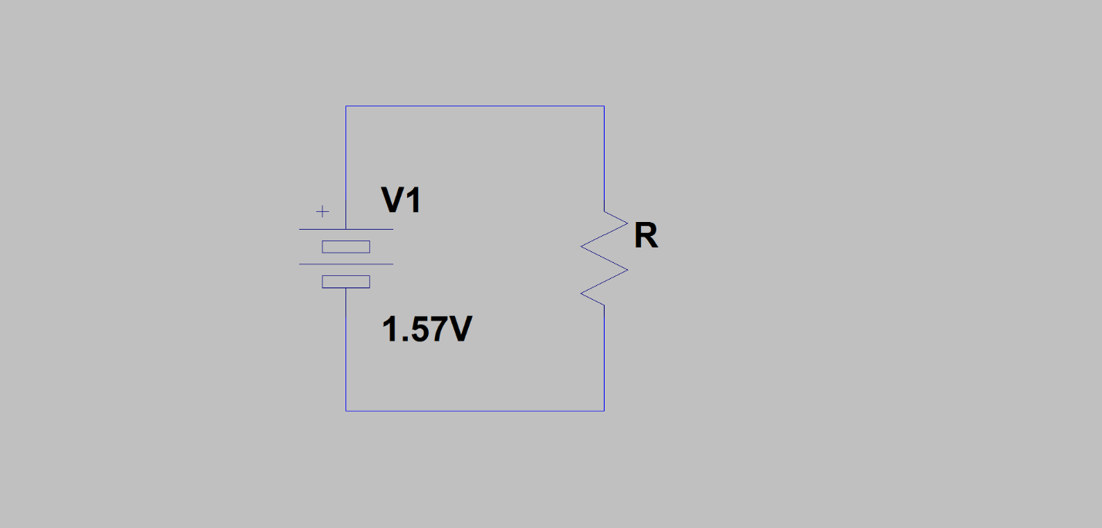

A graph Voltage vs Current is attach with the lab report to show how the load current is effected by changing the resistor value. A leaniar curve fit was used to obtain a best fit line. The battery can be considered ideal between .14A to .000015A. This is calculated by using the VOC as a base voltage then taking a 5% differnce. This gives 1.45V, so any voltage form 1.57 to 1.45 is considered ideal for this pertaining battery. The results and grpah show how current and voltage are linearly related. Also the usage of ohms law can lead to a detailed anylysis of any circuit.

**Conclusion**

Direct current is very usefull in modern day technology it utilizes many different conponents to create a direct supply of voltage and current. Resistors are the fundamental building blocks of circuits they allow the control of current and voltage from the source to the output. Resistors are passsive elements that dissipate cnverted electrical energy through heat. Lab one allowed resistors to be connected in seriers and parrallel in addition to many different calculations to find currents and voltages. Conducting lab one lead to the understanding that most resistors are not fully ideal but instead have terlerance variations. This can also be said be for batteries but since a bettery is an active element and will lose voltage over time a 5% variation can be considered ideal. In short, the four experiments proved the linearity of ohms law V=IR.