EE 97 Fall 2014

Lab#2: Graph Current vs. Voltage of a Two-Terminal Component

Anahit Sarao

Partner:Yong Gui Huang

Station 3

Submitted: September 18, 2014

**Preface**

All experiments were successfully conducted in Engineering Building room 249, on September eleventh, 2014.

**Experiment 1**

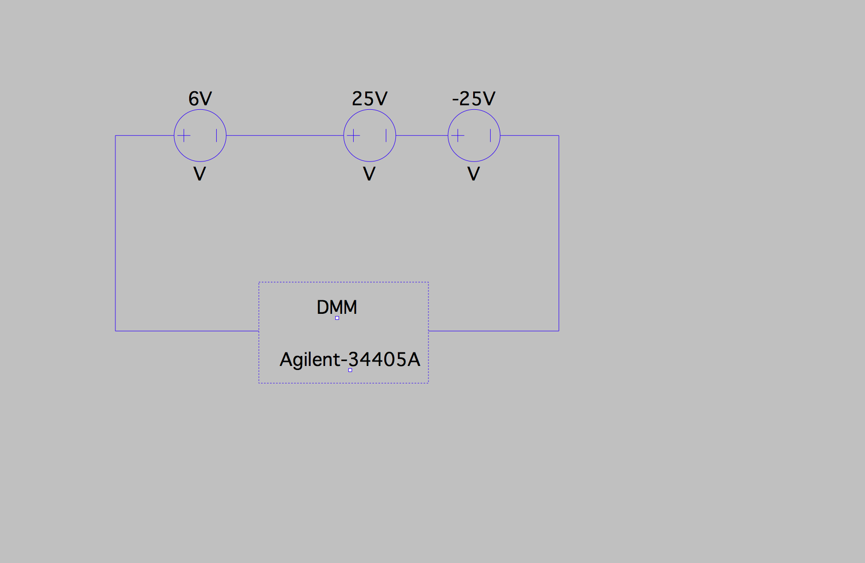Experiment one familiarized the use of the DC power supply (HP E3631A). The power supply has three terminals that provide a variety of voltages. The objective was to successfully read 30V, 55V, and two sets of simultaneous voltages.

Figure 1: Experiment 1 circuit diagram

The set up shown in figure 1 is able to measure voltages of the range -25V to 56V. By connecting the 25V voltage source in series with the 6V voltage source a voltage of 30V is achievable. By adding the third 25V in series with the other two voltage sources, 55V can be achieved. Using the same set up as before +6, -6 and -2V can be simultaneously seen on the DMM. In addition voltages +12, +5 and -5V can be measured with the same set up.

**Experiment 2**

Purpose of this experiment is to understand the change in voltage and current between two resistors. The power supply is set at 2V with a current limit at 0.1A. The two resistors observed are 10Ω and 47Ω.

Table 1: Data for two resistors

|  |  |  |  |  |
| --- | --- | --- | --- | --- |
| Load Resistance [Ω] | Voltage/[V] | Current I/ [A] | CC/CV | V/I [Ω] |
| Open Circuit | 2V | .001A | CV | 2000 Ω |
| 10 Ω | .953V | .097A | CC | 9.82 Ω |
| 47 Ω | 2V | .045A | CV | 44.44 Ω |

**Experiment 3**

Testing the power rating of a resistor yields many different attributes as to how much current can flow and how much power can the resistor dissipate. By calculating the power dissipating of a resistor and then conducting an experiment that applies voltage two different types of resistors the calculated and measured values can be compared.

Power Dissipation of a 10Ω resistor with 5V:

$P=\frac{V^{2}}{R}$ = $\frac{5^{2}}{10}$ = 2.5 W

Applying 1.58V to a 1/4W 10 Ω resistor mildly increases the resistors temperature.

Applying 5V to a 1/4W 10 Ω resistor increases the resistors temperature to point it starts to smoke and turn black. The current reading was .51A and voltage reading was 5V.

Applying 5V to a 5W 10 Ω resistor increases the resistors temperature gets hot very quickly. The current reading was .408A and voltage reading was 5V. A 5W was supplied and used instead of a 10W as stated in the lab manual.

**Experiment 4**

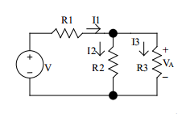By constructing questions 3 and 4 from Pre Lab 2, the voltages and current across all resistors was measure and compared to the calculated values. An indirect method was used to measure the resistance and voltage then by using Ohm’s law the current was calculated.

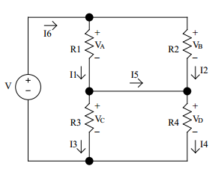

Figure 2: Pre Lab question 3

V=10V

R1=1KΩ

R2=2KΩ

R3=5.1KΩ Figure 3: Pre Lab question 4

V=12V

R1=2KΩ

R2=2.7KΩ

R3=1KΩ

R4=5.1KΩ

Table 2: Data for Figure 3

|  |  |  |  |  |
| --- | --- | --- | --- | --- |
| **Label** | **Resistance[KΩ]** | **Voltage V/[V]** | **Measured Current I/[A]** | **Calculated Current I/[A]** |
| R1 | 0.95 | 4.16 | 4.38E-03 | 4.10E-03 |
| R2 | 1.9 | 2.34 | 1.23E-03 | 2.94E-03 |
| R3 | 5 | 2.34 | 4.68E-04 | 1.15E-03 |

Table 3: Data for Figure 3

|  |  |  |  |  |
| --- | --- | --- | --- | --- |
| **Label** | **Resistance[KΩ]** | **Voltage V/[V]** | **Measured Current I/[A]** | **Calculated Current I/[A]** |
| R1 | 1.9 | 6.9 | 3.63E-03 | 3.52E-03 |
| R2 | 2.63 | 6.9 | 2.62E-03 | 2.61E-03 |
| R3 | 0.95 | 5.09 | 5.36E-03 | 5.53E-03 |
| R4 | 5 | 5.09 | 1.02E-03 | 2.62E-03 |

Figure 2 and 3 shows circuits used to calculate currents across resistors using circuit analysis methods, then these schematics were constructed upon a breadboard where the values were measured and compared to the calculated. From table 2 and 3 it can be seen that the calculated and measured are not the same.

**Experiment 5**

A 14V CL incandescent lamp (part number: 756 Lamp) was used in experiment five to find the resistance and power of the light bulb from a voltage range of 0V to 12V.

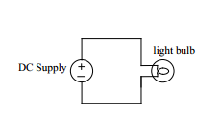

Figure 4: Experiment 5 Circuit Schematic

Table 4: Data for light blub

|  |  |  |  |
| --- | --- | --- | --- |
| Voltage V/[V] | Current I/[A] | Resistance (V/I)/[Ω] | Power (V*I)/[W] |
| 0 | 0.001 | 0 | 0 |
| 0.2 | 0.022 | 9.09 | 0.00 |
| 0.6 | 0.032 | 18.75 | 0.02 |
| 0.8 | 0.042 | 19.05 | 0.03 |
| 1 | 0.046 | 21.74 | 0.05 |
| 2 | 0.066 | 30.30 | 0.13 |
| 3 | 0.083 | 36.14 | 0.25 |
| 4 | 0.098 | 40.82 | 0.39 |
| 5 | 0.112 | 44.64 | 0.56 |
| 6 | 0.124 | 48.39 | 0.74 |
| 7 | 0.136 | 51.47 | 0.95 |
| 8 | 0.147 | 54.42 | 1.18 |
| 9 | 0.157 | 57.32 | 1.41 |
| 10 | 0.168 | 59.52 | 1.68 |
| 11 | 0.177 | 62.15 | 1.95 |
| 12 | 0.187 | 64.17 | 2.24 |

Graph 1: Resistance vs Voltage

Graph 2: Current vs Voltage

**Experiment 6**

Provided with a Red Diffused LED (part number: LEDRDT1-3/4) and a Green Diffused LED (part number: LEDGDT1-3/4), for experiment six voltage was passed through each LED in diode’s forward direction and diode’s reverse direction. While evaluating the amount of light emitted from the LED also the currents and voltages were recorded as the voltage was swept from 0V to 10V. Also a 470Ω resistor was used as a current-limiting resistor to prevent damage to the LED.

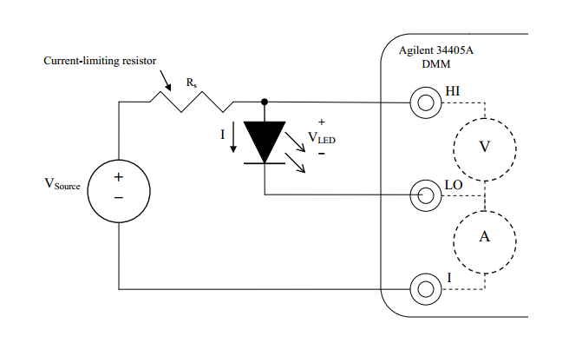

Figure 5: Experiment 6 Schematic

Table 5: Green and Red LED Data

|  |  |  |  |  |
| --- | --- | --- | --- | --- |
| RED LED |  |  |  |  |
| Power Supply HPE3631A | | DMM Agilent 34405A | |  |
| Source Voltage V/[V] | Source Current I/[A] | Diode Voltage V/[V] | Diode Current I/[mA] | LED Brightness |
| 0 | 0 | 0.004 | 0 | No Light |
| 0.5 | 0 | 0.49 | 0 | No Light |
| 1 | 0 | 0.99 | 0.001 | No Light |
| 1.5 | 0 | 1.48 | -0.0131 | No Light |
| 2 | 0 | 1.65 | -0.717 | No Light |
| 2.5 | 0.001 | 1.69 | -1.66 | Barley Visible |
| 3 | 0.002 | 1.72 | -2.65 | Barley Visible |
| 4 | 0.004 | 1.77 | -4.65 | Barley Visible |
| 5 | 0.006 | 1.8 | -6.68 | More Noticeable |
| 6 | 0.008 | 1.83 | -8.72 | Very Bright |
| 7 | 0.01 | 1.85 | -10.78 | Very Bright |
| 8 | 0.12 | 1.8 | -13.09 | Very Bright |
| 9 | 0.014 | 1.9 | -15.09 | Very Bright |
| 10 | 0.16 | 1.92 | -15.09 | Very Bright |
|  |  |  |  |  |
| Green LED |  |  |  |  |
| Power Supply HPE3631A | | DMM Agilent 34405A | |  |
| Source Voltage V/[V] | Source Current I/[A] | Diode Voltage V/[V] | Diode Current I/[mA] | LED Brightness |
| 0 | 0 | -0.003 | 0 | No Light |
| 0.5 | 0 | 0.49 | 0 | No Light |
| 1 | 0 | 0.99 | -0.001 | No Light |
| 1.5 | 0 | 1.49 | -0.002 | No Light |
| 2 | 0 | 1.82 | -0.036 | No Light |
| 2.5 | 0 | 1.88 | -1.28 | Barley Visible |
| 3 | 0.001 | 1.91 | -2.26 | Barley Visible |
| 4 | 0.003 | 1.95 | -4.26 | Barley Visible |
| 5 | 0.005 | 1.99 | -6.28 | Bright |
| 6 | 0.007 | 2.02 | -8.31 | Bright |
| 7 | 0.009 | 2.05 | -10.36 | Very Bright |
| 8 | 0.012 | 2.08 | -12.64 | Very Bright |
| 9 | 0.014 | 2.1 | -14.74 | Very Bright |
| 10 | 0.016 | 2.13 | -16.83 | Very Bright |
|  |  |  |  |  |
| Reverse RED LED |  |  |  |  |
| Power Supply HPE3631A | | DMM Agilent 34405A | |  |
| Source Voltage V/[V] | Source Current I/[A] | Diode Voltage V/[V] | Diode Current I/[mA] | LED Brightness |
| 0 | 0 | -0.003 | 0 | No Light |
| 0.5 | 0 | 0.49 | 0 | No Light |
| 1 | 0 | 0.99 | 0 | No Light |
| 1.5 | 0 | 1.49 | -0.001 | No Light |
| 2 | 0 | 1.99 | -0.002 | No Light |
| 2.5 | 0 | 2.49 | -0.003 | No Light |
| 3 | 0 | 2.99 | -0.003 | No Light |
| 4 | 0 | 3.99 | -0.004 | No Light |
| 5 | 0 | 4.99 | -0.005 | No Light |
| 6 | 0 | 5.99 | -0.006 | No Light |
| 7 | 0 | 6.99 | -0.007 | No Light |
| 8 | 0 | 7.99 | -0.008 | No Light |
| 9 | 0 | 8.99 | -0.009 | No Light |
| 10 | 0 | 9.99 | -0.01 | No Light |
|  |  |  |  |  |
| Reverse Green LED |  |  |  |  |
| Power Supply HPE3631A | | DMM Agilent 34405A | |  |
| Source Voltage V/[V] | Source Current I/[A] | Diode Voltage V/[V] | Diode Current I/[mA] | LED Brightness |
| 0 | 0 | -0.003 | 0 | No Light |
| 0.5 | 0 | 0.49 | 0 | No Light |
| 1 | 0 | 0.99 | 0 | No Light |
| 1.5 | 0 | 1.49 | -0.001 | No Light |
| 2 | 0 | 1.99 | -0.002 | No Light |
| 2.5 | 0 | 2.49 | -0.003 | No Light |
| 3 | 0 | 2.99 | -0.003 | No Light |
| 4 | 0 | 3.99 | -0.004 | No Light |
| 5 | 0 | 4.99 | -0.005 | No Light |
| 6 | 0 | 5.99 | -0.006 | No Light |
| 7 | 0 | 6.99 | -0.007 | No Light |
| 8 | 0 | 7.99 | -0.008 | No Light |
| 9 | 0 | 8.99 | -0.009 | No Light |
| 10 | 0 | 9.99 | -0.01 | No Light |

Graph 3: Red LED Graph

Graph 4: Green LED Graph

**Experiment 7**

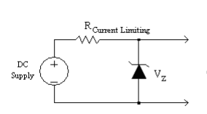

Figure 6: Experiment 7 Schematic

Table 6: Zener LED Data

REVERSE BIAS

|  |  |  |  |
| --- | --- | --- | --- |
| Power Supply HPE3631A |  | DMM Agilent 34405A |  |
| Source Voltage V/[V] | Source Current I/[A] | Diode Voltage V/[V] | Diode Current I/[mA] |
| 0 | 0 | -0.003 | 0 |
| 0.5 | 0 | 0.49 | 0 |
| 1 | 0 | 0.99 | -0.001 |
| 1.5 | 0 | 1.49 | -0.001 |
| 2 | 0 | 1.99 | -0.002 |
| 2.5 | 0 | 2.49 | -0.002 |
| 3 | 0 | 2.99 | -0.003 |
| 4 | 0 | 3.99 | -0.004 |
| 5 | 0 | 4.99 | -0.0018 |
| 6 | 0 | 5.95 | -0.83 |
| 7 | 0.001 | 6.06 | -1.95 |
| 8 | 0.003 | 6.07 | -4.022 |
| 9 | 0.005 | 6.08 | -6.09 |
| 10 | 0.007 | 6.09 | -8.16 |
|  |  |  |  |
| FORWARD BIAS |  |  |  |
| Power Supply HPE3631A |  | DMM Agilent 34405A |  |
| Source Voltage V/[V] | Source Current I/[A] | Diode Voltage V/[V] | Diode Current I/[mA] |
| 0 | 0 | 0 | 0 |
| 0.5 | 0 | 0.49 | 0.56 |
| 1 | 0 | 0.72 | 1.5 |
| 1.5 | 0.001 | 0.75 | 2.55 |
| 2 | 0.002 | 0.77 | 3.58 |
| 2.5 | 0.003 | 0.78 | 4.61 |
| 3 | 0.004 | 0.792 | 6.68 |
| 4 | 0.006 | 0.804 | 8.7 |
| 5 | 0.008 | 0.813 | 11.06 |
| 6 | 0.01 | 0.82 | 11.06 |
| 7 | 0.012 | 0.82 | 13.2 |
| 8 | 0.014 | 0.83 | 15.34 |
| 9 | 0.016 | 0.837 | 17.5 |
| 10 | 0.019 | 0.839 | 19.66 |

Note: Figures 2, 3,4,5,6 were taken from EE 97 Lab Manual by P. Hsu