EE 97 Fall 2014

Lab#5 Rectifier and Voltage Regulator

Anahit Sarao

Partner:Yong Gui Huang

Station 3

Submitted: October 23, 2014

**Preface**

All experiments were successfully conducted in Engineering Building room 249, on October ninth, 2014.

**Experiment 1**

The objective of this experiment was to understand the functionality of a half-wave rectifier. The usage of a transformer along with a 470µF filtering capacitor, 1kΩ load resistor and a diode (part number: IN4003) the circuit shown in figure one was constructed. Using the DMM (Agilent 34405A) and the oscilloscope (Tektronix DPO314) measurements were acquired. The purpose of the half-wave rectifier is to change an AC signal to a DC signal.

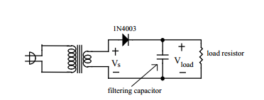

Figure 1: Circuit Schematic for experiment 1

To calculate the winding ratio of the transformer the input was 120AC the output was measured with the DMM. The equation used to calculate the winding ratio:

$Winding Ratio=\frac{Voutput}{Vinput}$ = $\frac{10.17V}{120V}$ = .084

The transformer Model NO: M/N-40 and type: SB41-206A is an AC to AC power supply class II transformer.

Input: AC120V 60Hz 6W

Output: AC9v 450mA

Using the DMM the capacitance was measured to 448μF this being the actual capacitance.

Table 1: Data for Half Wave Rectifier

|  |  |  |
| --- | --- | --- |
| Half-Wave Rectifier | | |
| Load Resistor: 1kΩ | | |
|  |  |  |
| Vavg with Scope V/[V] |  | 13 |
| Vavg with DMM V/[V] |  | 13.04 |
| Vpp(ripple) with Scope V/[V] |  | 0.41 |
| Vpp(ripple) with DMM V/[V] |  | 0.485 |
| Vpp(ripple) computed V/[V] |  | 0.48 |
| %Δ-Between Vpp Scope & Vpp DMM |  | 15.46 |
| Frequency [Hz] |  | 62.5 |
| Load Resistor: 2kΩ | | |
|  |  |  |
| Vavg with Scope V/[V] |  | 14.5 |
| Vavg with DMM V/[V] |  | 14.1 |
| Vpp(ripple) with Scope V/[V] |  | 0.5 |
| Vpp(ripple) with DMM V/[V] |  | 0.525 |
| Vpp(ripple) computed V/[V] |  | 0.539 |
| %Δ-Between Vpp Scopp & Vpp DMM |  | 4.76 |
| Frequency |  | 100Hz |
|  |  |  |
| Load Resistor: 1MΩ/OC | | |
|  |  |  |
| Vavg with Scope V/[V] |  | 14 |
| Vavg with DMM V/[V] |  | 13.88 |
| Vpp(ripple) with Scope V/[V] |  | 0.00005 |
| Vpp(ripple) with DMM V/[V] |  | 0.000052 |
| Vpp(ripple) computed V/[V] |  | 0.000051 |
| %Δ-Between Vpp Scope & Vpp DMM |  | 3.85 |
| Frequency [Hz] |  | N/A |
|  |  |  |
| Load Resistor: 1kΩ/No Capacitor | | |
|  |  |  |
| Vavg with Scope V/[V] |  | 0V |
| Vavg with DMM V/[V] |  | 0V |
| Vpp(ripple) with Scope V/[V] |  | N/A |
| Vpp(ripple) with DMM V/[V] |  | N/A |
| Vpp(ripple) computed V/[V] |  | N/A |
| %Δ-Between Vpp Scope & Vpp DMM |  | N/A |
| Frequency [Hz] |  | N/A |

Calculations for Table 1:

Half Wave Rectifier with a 1kΩ load resistor.

Vripple= = = .4836V

$Frequency=\frac{1}{P}= \frac{1}{16*{10}^{-3}}=62.5Hz$

%Δ-Between Vpp Scope & Vpp DMM = $\frac{\left( .48-.41 \right)}{161.2.48}*100=15.49\%$

Half Wave Rectifier with a 2kΩ load resistor.

Vripple= = = .539V

$Frequency=\frac{1}{P}= \frac{1}{10*{10}^{-3}}=100Hz$

%Δ-Between Vpp Scope & Vpp DMM = $\frac{\left( .539-.525 \right)}{.539}*100=4.79\%$

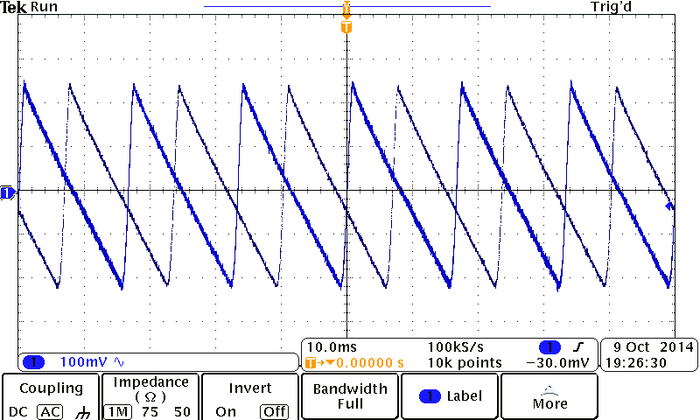

Figure 2: Half Wave Rectifier-2kΩ RL-AC Coupling

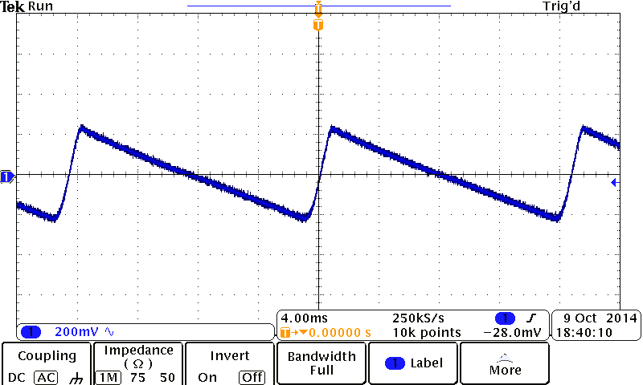

Figure 3: Half Wave Rectifier-1kΩ RL-AC Coupling

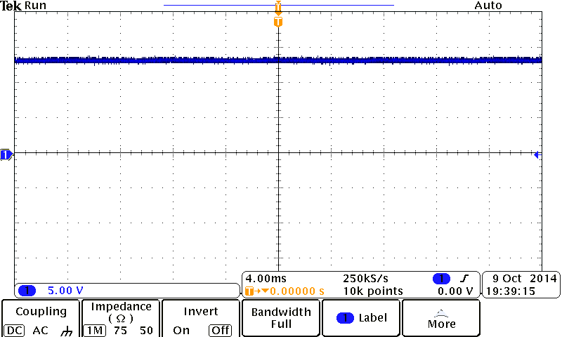Figure 4: Half Wave Rectifier-1MΩ/OC-DC Coupling

Conclusion

A half-wave rectifier only take in the positive cycle of an AC circuit but a filtering capacitor is used to fill in the empty cycle to complete a DC signal. This experiment was to compare the DMM and oscilloscope readings, for the 1kΩ load resistor with capacitor the readings between the Vavg and Vpp from the DMM and scope are in agreement. This is also true for the 1kΩ load resistor. The small percent error between the Vpp being 15.49% (1kΩ load resistor) and even a smaller percent error between the Vavg at 2.7% (2kΩ load resistor), it can be concluded that both devices are within an ideal uncertainty range. A conclusion can be drawn from the data that the ripple increases as the load resistor increases. The successfulness in this experiment also indicated that the circuit worked as it was supposed to, in other words the ripple effect was reduced also reducing the delay time as the filtering capacitor was added to the circuit.

**Experiment 2**

This experiment used a full-wave rectifier instead of a half-wave rectifier. The usage of a transformer along with a 470µF filtering capacitor, 1kΩ load resistor and 4 diodes (part number: IN4003) the circuit shown in figure five. The diodes were connected in a bridge to allow both cycles of an AC signal to be transferred into DC. Using the DMM (Agilent 34405A) and the oscilloscope (Tektronix DPO314) data for Vavg, Vpp, Vp were taken.

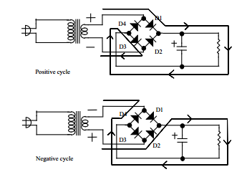

Figure 5: Full Wave Rectifier Schematic

The transformer Model NO: M/N-40 and type: SB41-206A is an AC to AC power supply class II transformer.

Input: AC120V 60Hz 6W

Output: AC9v 450mA

Using the DMM the capacitance was measured to 448μF this being the actual capacitance.

Table 2: Data for Full Wave Rectifier

|  |  |  |
| --- | --- | --- |
| Full-Wave Rectifier | | |
| Actual Capacitance=448µF | | |
|  | | |
| Load Resistor: 1kΩ | | |
|  | | |
| Vavg with Scope V/[V] |  | 12 |
| Vavg with DMM V/[V] |  | 12.44 |
| Vpp(ripple) with Scope V/[V] |  | 0.2 |
| Vpp(ripple) with DMM V/[V] |  | 0.165 |
| Vpp(ripple) computed V/[V] |  | 0.223 |
| %Δ-Between Vpp Scope & Vpp DMM |  | 21.21 |
| Frequency [Hz] |  | 125Hz |
|  |  |  |
| Load Resistor: 1kΩ/No Capacitor | | |
|  | | |
| Vavg with Scope V/[V] |  | 12.3 |
| Vavg with DMM V/[V] |  | 13.04 |
| Vp with Scope V/[V] |  | 5 |
| Vp with DMM V/[V] |  | 4.36 |
| Vp computed V/[V] |  | 4.36 |
| %Δ-Between Vp Scope & Vp DMM |  | 14.68 |
| Frequency [Hz] |  | 125Hz |

Calculations for Table 1:

Full Wave Rectifier with a 1kΩ load resistor.

Vripple= = = .223V

$Frequency=\frac{1}{P}= \frac{1}{8*{10}^{-3}}=125Hz$

%Δ-Between Vpp Scope & Vpp DMM = $\frac{\left( 0.2-0.165 \right)}{0.2}*100=21.21\%$

Full Wave Rectifier with a 2kΩ load resistor/No Capacitor.

$$V_{avg}=Vp*2*\sqrt{2}=4.36*2*\sqrt{2}=12.3 V$$

$Frequency=\frac{1}{P}= \frac{1}{8*{10}^{-3}}=125Hz$

%Δ-Between Vp Scope & Vp DMM = $\frac{\left( 5-4.36 \right)}{5}*100=14.68$%

%Δ-Between Vavg Scope & Vavg DMM = $\frac{\left( 13.04-12.3 \right)}{13.04}*100=5.67\%$

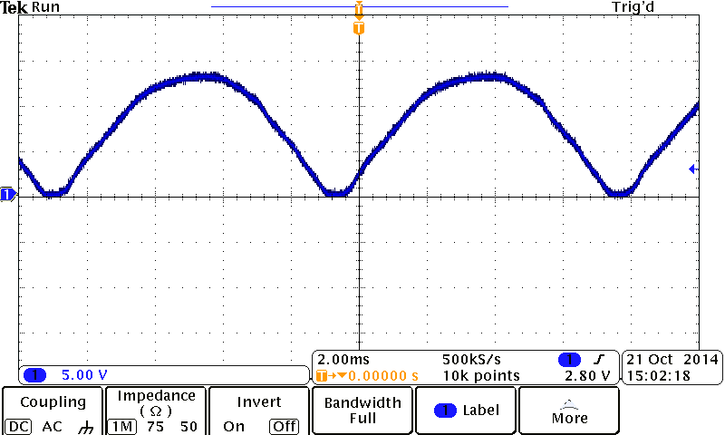

Figure 5: Full Wave Rectifier-1kΩ RL/No Capacitor-DC Coupling

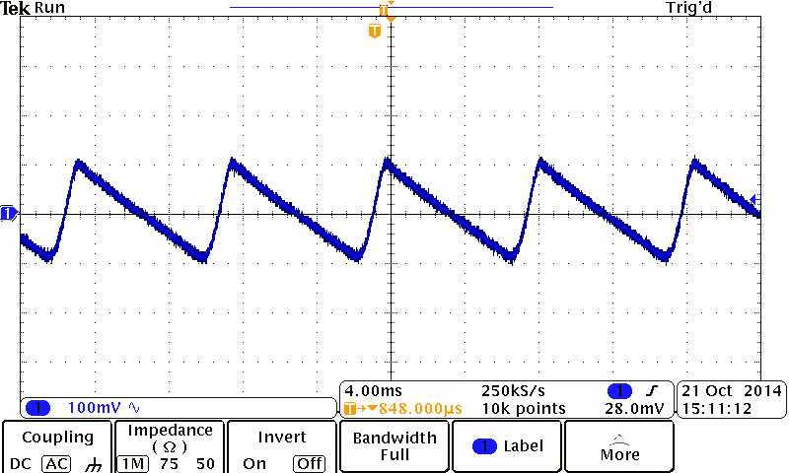

Figure 5: Full Wave Rectifier-1kΩ RL-AC Coupling

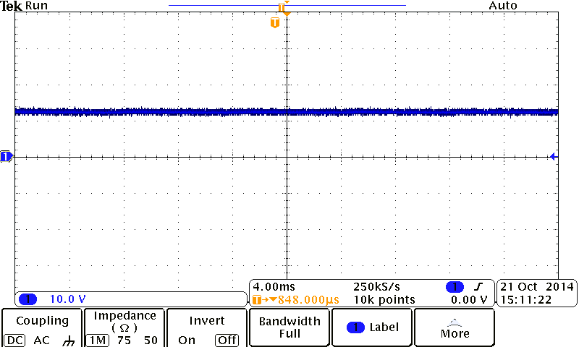

Figure 5: Full Wave Rectifier-1kΩ R -DC Coupling

Conclusion

**Experiment 3**

By using the data and results from the previous experiments, experiment three was designed to understand the basics of voltage regulation within Integrated Circuits. In this experiment the specifications for the (Part Number :) 7805T voltage regulator was thoroughly read and analyzed to be able to find out the voltage at the input and output of the regulator when connected to a full wave rectifier.

The max input voltage is 35V and the max output voltage is 5.2V with a current output of 1A. Typically it will output 5v as long as the line regulation is 3mV which means the input voltage needs to be between 7V to 25V. By connecting a full wave rectifier the ripple can be assumed as the same from experiment two 0.223V. The 7805T has a ripple rejection of 78dB which will cause some shift in ideal usage, also the 2% accuracy can cause some variation.

The 7805T ripple at the output is the difference between the input and output voltages. In this case 5.2V and 4.8V, in other words the maximum ripple can be 0.4V.