EE 97 Fall 2014

Lab#6: Frequency Response

Anahit Sarao

Partner:Yong Gui Huang

Station 3

Submitted: November 05, 2014

**Preface**

All experiments were successfully conducted in Engineering Building room 249, on October twenty-third and thirtieth, 2014 using the DMM (Agilent 34405A), Oscilloscope (Tecktronix DPO3012), and Function Generator (Agilent 33210A).

**Experiment 1**

The purpose of experiment one was to compare the manufacture power rating to the calculated power rating with the DMM and oscilloscope. Figure one schematic was used to pin point the power cutoff of the amplifier. By finding the clipping point also known as the saturation level the power of the amplifier can be calculated.

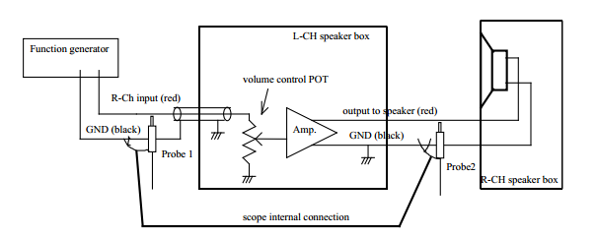

Figure 1: Experiment One Schematic

Table 1: Data for Experiment One

|  |  |
| --- | --- |
| Vin V/[V] | .1V |
| Vout V/[V] | 1V |
| Voltage Gain V/[V] | 10V |
| Max Power W/[W] | 8W |
| Calculated Power W/[W] | 1.17W |

Calculation

$$Voltage Gain=\frac{Vout}{Vin}=\frac{1}{.1}=10V$$

$$Power= \frac{{Vrms}^{2}}{Z}= \frac{{2.16}^{2}}{4}=1.17W$$

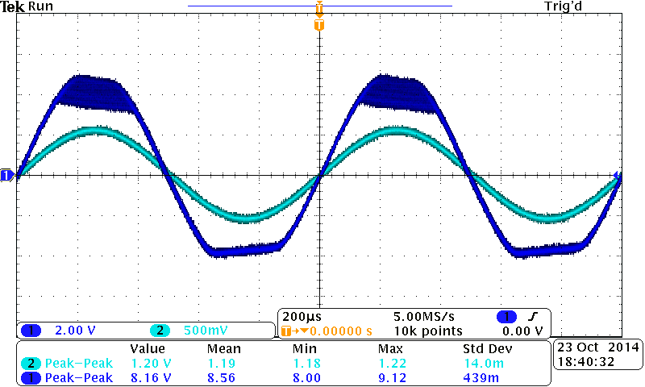 Figure 2: Amplifier Clipping at Saturation Level

By looking at the figure two and the data for experiment one the maximum power is not 8W as stated by the manufacture. In conclusion the claim is not agreeable as the amplifier provided a 1.17W maximum power which is roughly 13% of the stated maximum power rating. This difference can be for many reasons such as excessive use at frequencies that are not within the amplifiers range. Also the tests were conducted with different equipment under different environment settings.

**Experiment 2**

To accurately see how the amplifier effects different frequencies, observations of the gain with respect to frequency and phase shit can better the understanding of an amplifier. The gain error in respect to frequency is known as the magnitude response this is when the amplifier output is not at the required amplified level. A delay or phase error with respect to frequency is called a phase response this is when the output of the amplifier is either leading or lagging the input signal.

Figure 2: Delay Error & Gain Error

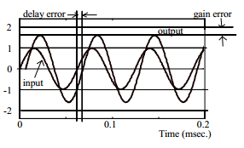

Using the same setup as in experiment one this experiment varies the frequencies instead of the amplitude of the function generator signal.

Table 2: Data for Experiment 2

|  |  |  |  |  |
| --- | --- | --- | --- | --- |
| **Frequency [Hz]** | **V**in [mV] | **V**out [mV] | **Gain (V**out/Vin)/[mV] | **Phase Shift [⁰]** |
| 20 | 100 | 750 | 7.50 | 40 |
| 40 | 100 | 880 | 8.80 | 32 |
| 60 | 100 | 960 | 9.60 | 31 |
| 80 | 100 | 1100 | 11.00 | 20 |
| 100 | 100 | 1150 | 11.50 | 7 |
| 150 | 100 | 1134 | 11.34 | 5 |
| 200 | 100 | 1100 | 11.00 | 0 |
| 250 | 100 | 1100 | 11.00 | 0 |
| 300 | 100 | 1100 | 11.00 | 0 |
| 350 | 100 | 1100 | 11.00 | 0 |
| 400 | 100 | 1100 | 11.00 | 0 |
| 500 | 100 | 1100 | 11.00 | 0 |
| 600 | 100 | 1100 | 11.00 | 0 |
| 700 | 100 | 1100 | 11.00 | 0 |
| 800 | 100 | 1100 | 11.00 | 0 |
| 900 | 100 | 1100 | 11.00 | 0 |
| 1000 | 100 | 1100 | 11.00 | 0 |
| 1500 | 100 | 1100 | 11.00 | 0 |
| 2000 | 100 | 1100 | 11.00 | 0 |
| 2500 | 100 | 1100 | 11.00 | 0 |
| 3000 | 100 | 1100 | 11.00 | -6 |
| 5000 | 100 | 1100 | 11.00 | -10 |
| 10000 | 100 | 1100 | 11.00 | -14 |
| 20000 | 100 | 1100 | 11.00 | -26 |
| 30000 | 100 | 1000 | 10.00 | -35 |
| 35000 | 100 | 950 | 9.50 | -40 |
| 40000 | 100 | 950 | 9.50 | -41 |
| 45000 | 100 | 800 | 8.00 | -46 |
| 46000 | 100 | 720 | 7.20 | -52 |
| 48000 | 100 | 650 | 6.50 | -53 |
| 50000 | 100 | 480 | 4.80 | -66 |
| 100000 | 100 | 310 | 3.10 | -70 |
| 120000 | 100 | 360 | 3.60 | -71 |
| 140000 | 100 | 350 | 3.50 | -82 |
| 160000 | 100 | 340 | 3.40 | -86 |
| 180000 | 100 | 330 | 3.30 | -89 |
| 200000 | 100 | 270 | 2.70 | -90 |
| 220000 | 100 | 240 | 2.40 | -98 |
| 240000 | 100 | 190 | 1.90 | -100 |
| 260000 | 100 | 175 | 1.75 | -102 |
| 280000 | 100 | 160 | 1.60 | -104 |
| 300000 | 100 | 150 | 1.50 | -110 |

$$Bandwitdh= 70.7\%*\left(Gain at 1KHz\right)= .707*11=7.7$$

The data from table two was used to find the bandwidth of the amplifier this means that the gain is within 70.7% of the ideal gain at 1Khz. The bandwidth range for the amplifier used is between 20Hz to 46KHz.

It can be concluded that the frequencies from 20Hz to 46KHz is where the amplifier has the least amount of gain error and delay error. Even though frequencies outside of the range can be applied and analyzed, it can be considered that the out of range frequencies are not optimal for this amplifier.

**Experiment 3**

Experiment three is basically an automated redo of experiment two. By not manually adjusting the frequencies the function generator uses its sweep function to sweep the frequencies from a range of 10Hz to 1MHz. The function generator setting were set to as follows: Starting frequency = 10Hz, Stop frequency = 1MHz, Sweep time = 1 second, Sweep Mode = Log. This produces a sweeping signal that can be compared too experiment twos data findings of bandwidth.

Using the same setup as in experiment one and two this experiment the function generators sweep function.

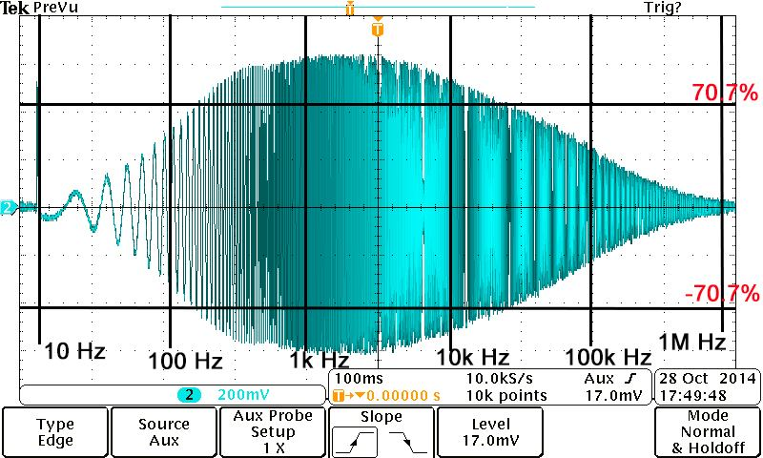

Figure 3: Bandwidth with Sweep Function Enabled

Looking at figure three the bandwidth is between 130Hz and 140Khz. This means the amplifier bandwidth is within 70.7% nominal of its 1Khz signal. Comparing the ranges of frequencies from experiment two and three there is a major change towards the higher end spectrum. This can be due to the changing of amplifiers as in the first and second experiments Station#3 was not working and were advised to move to a different station by lab instructor. During experiment three Station#3 was working and the previously used station was being used. This is the pertaining reason that experiment two and three have discrepancies.

**Conclusion**

This lab introduced a new electrical component called an amplifier. It also introduced a new function within the function generator called sweep function which can change the frequency when a given a range and time interval. This led to the observation of how an amplifier works and the purpose behind the use of an amplifier. An amplifier has to limits as all electrical elements have after this range the amplifier has a significant high amount of gain error and delay error, which leads to the output signal being clipped. This lab enhances the uses of the oscilloscope, since this lab was heavily based on calculations using the oscilloscope a way to set up the oscilloscope was found so it would show the delay error and phase shift to the user. Amplifiers are claimed to be very stable and accurate components however this lab proved that amplifiers lose stability, accuracy and precision if the input signal is not within manufacture ratings.

Note: Figure 1, 2 were taken from EE97 Lab Manual by P. Hsu