EE 97 Fall 2014

Lab#7: Time Constant,Oscillators, and Counter

Anahit Sarao

Partner:Yong Gui Huang

Station 3

Submitted: November 12, 2014

**Preface**

All experiments were successfully conducted in Engineering Building room 249, on November sixth, 2014 using the DMM (Agilent 34405A), Oscilloscope (Tecktronix DPO3012), and Function Generator (Agilent 33210A)..

**Experiment 1**

By constructing the circuit shown in figure one the time constant of the RC circuit can be found. The time constant is 65% of the total voltage change during the rising or decaying of the signal. Time constant can be found by using τ=RC where τ is the Greek letter tau represented in seconds. The circuit shows a voltage source which was replaced by the function generator.

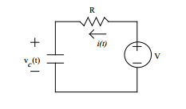

Figure 1: Experiment 1 RC Circuit Schematic

Capacitor requirements: Between .1µF and 1µF

Resistor requirements: Higher than 1kΩ

Function generator was set to output a square wave, the frequency was set to 4.707Hz by user as per lab manual the period must be twenty times the time constant.

Table 1: Data for Experiment 1

|  |  |  |
| --- | --- | --- |
|  | Actual | Measured |
| Resisitor R/[Ω] | 10kΩ | 9.899kΩ |
| Capacitor | 1µF | 1.073µF |
| Frequency f/[hz] | 4.707hz | |

|  |  |
| --- | --- |
| Calculated Time Constant τ/[s] | 0.0106 |
| Scope Time Constant τ/[s] | 0.01 |
| %∆ | 5.66 |

Calculations:

$$Calculated Time Constant= τ=RC=\left(9.899*{10}^{3}\right)*\left(1.073*{10}^{-6}\right)= .0106s$$

$$Scope Time Constant= 65\% of Charge Time= .01s$$

$$\%∆ =\left(\frac{0.0106-0.01}{0.0106}\right)*100= 5.66\%$$

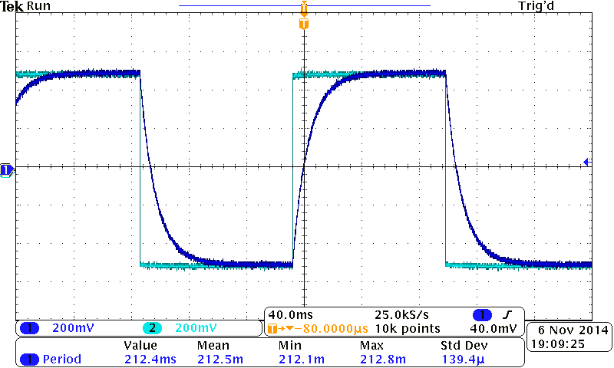

Figure 2: Dual Channel Oscilloscope Display of RC Circuit

Placing the oscilloscope probes properly was important as if placed in the wrong terminals the circuit could short. However since two inputs are shown in figure two one channel for resister voltage the other for capacitor voltage, this incurs that the oscilloscope was correctly set up. In conclusion from data table one the two different way of acquiring the time constant had very similar values, the difference between the calculated $τ$ and using the scope to find $τ$ had a percent difference of 5.66% which is indeed minimal. The reason for this variation can be from the oscilloscope as it is harder to Trig two channels at the same time, also some variation comes from the change in values of the resistor and capacitor the longer they are used. Overall the two values agree whit a minimal deviation error.

**Experiment 2**

This experiment utilizes the function of an oscillator. An oscillator generators a fixed signal, the function generator can be used as an oscillator. In combination with an oscillator an integrated circuit is used LM555 (part number: LM555N) to keep the capacitor oscillating between two voltage levels. This is helps in measuring high and low voltages during the oscillation period which is within the charging cycle of the capacitor.

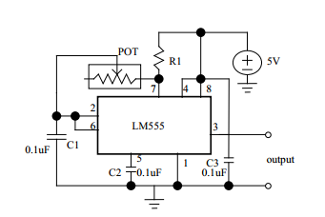

Figure 3: Experiment 3 Circuit Schematic

Table 2: Data for Experiment 2

|  |  |  |  |  |
| --- | --- | --- | --- | --- |
|  |  |  |  |  |
|  |  |  |  |  |
|  |  |  |  |  |
|  |  |  |  |  |

