EE 97 Fall 2014

Lab#10: AM Radio Receiver

Anahit Sarao

Partner:Yong Gui Huang

Station 3

Submitted: December 04, 2014

**Preface**

All experiments were successfully conducted in Engineering Building room 249, on November twenty, 2014 using the DMM (Agilent 34405A), Oscilloscope (Tecktronix DPO3012), and Function Generator (Agilent 33210A).

**Experiment 1**

The purpose of this experiment was to introduce a new circuit element the operational amplifier. Provided with an operational amplifier (part number: LM741N) an OP AMP 8pin can act any type of amplifier. Fore experiment one an inverting and non-inverting amplifier was constructed shown by figure one.

Figure 1: Schematic for Experiment 1

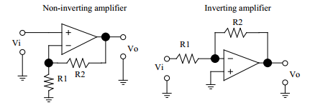

Using the schematic from figure one, first an inverting amplifier was constructed which had a gain between -2 and -20. The current limit on the power supply was set to 0.030A and R1 was 1kΩ while R2 was 10kΩ. +15V and -15V were used at the power terminals of the amplifier with respect to a common ground for all connections, while a 1kHz sinusoidal wave signal was used as the input to the amplifier.

Gain for Inverting Amplifier

$Gain=\frac{-R2}{R1}$ = -10 Gain (AV)

Table 1: Data for Inverting Amplifier

|  |  |
| --- | --- |
|  | Voltage [mV/[mV]] |
| Vin | 100 |
| V­out­ | 950 |

The oscilloscope was connected to show the input and output where channel one represents the output and channel two represents the input, as shown by figure two.

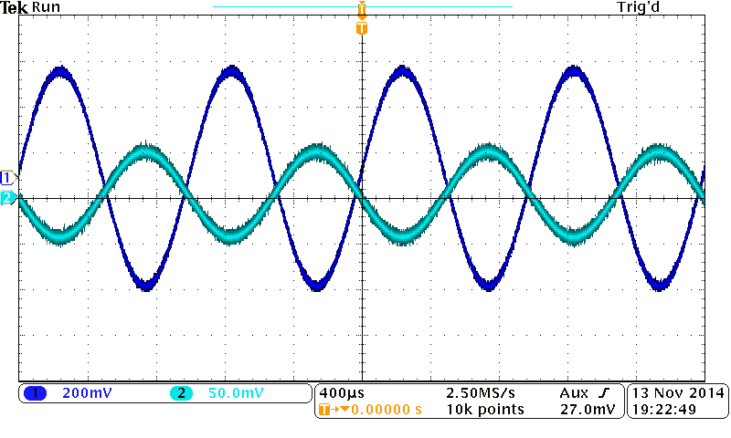

Figure 2: Inverting Amplifier Input and Output

Again looking at figure one a non-inverting amplifier was constructed with the same voltages, same current limit, same R1 and R2. The gain was to be between 2 and 20, since this is a non-inverting amplifier a positive input would mean that the output would be positive as it does not invert the polarity.

Gain for non-inverting amplifier

$Gain=\frac{R1+R2}{R1}$ = 11 Gain (AV)

Table 1: Data for Inverting Amplifier

|  |  |
| --- | --- |
|  | Voltage mV/[mV] |
| Vin | 100 |
| V­out­ | 1500 |

The oscilloscope screen shot for this amplifier shown in figure three shows the difference between the two amplifiers. The non-inverting amplifiers output has no delay like the inverting amplifier.

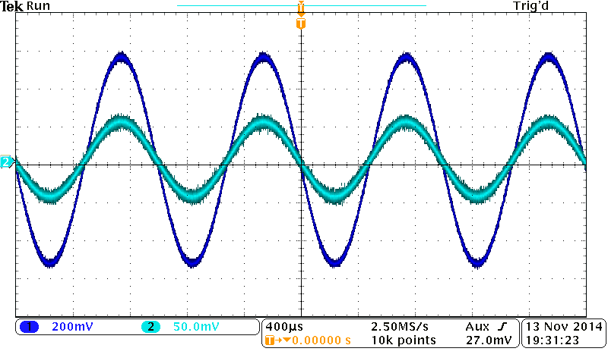Figure 3: Non-inverting amplifier Input and Output

To find the maximum output swing the non-inverting amplifier was used to find the outputs max voltage before the signal is saturated also known as clipped. This was achieved by changing the amplitude of the signal till the output signal was saturated. Figures four and five shows the maximum output voltage where figure five has a different horizontal scale showing more periods of the input and output signals. The maximum output swing voltage is 2.9V.

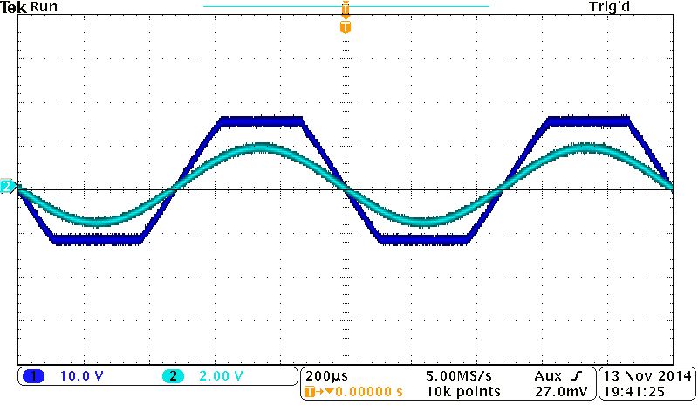

Figure 4: Maximum Output Voltage Swing of non-inverting amplifier

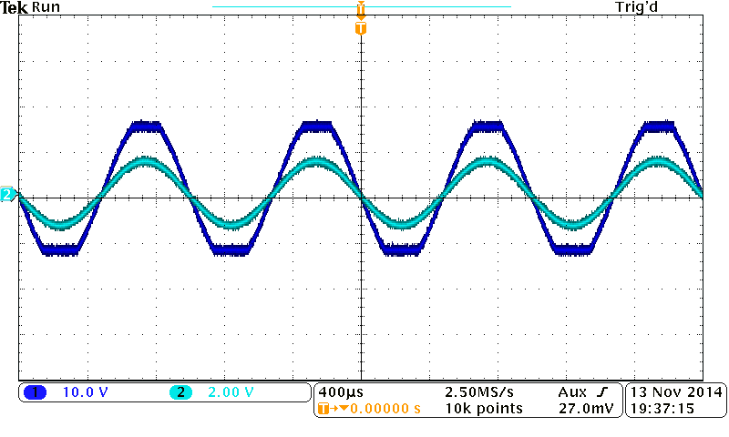

Figure 5: Identical to figure 4 with different horizontal scale

To find the amplifiers maximum output current the same non-inverting amplifier was used. During the saturation of the output signal the DMM’s AC/I feature was used to measure the current at the output pin. The maximum output current read was .00076 A.

Table 2: Future Data Collection on Amplifiers

|  |  |  |
| --- | --- | --- |
| Non-Inverting Amplifier |  |  |
|  | Voltage V/[V] | Current I/[A] |
| Max Output Voltage Swing | 2.9 | N/A |
| Max Output Current | N/A | .00076 |

Conclusion:

The 8 pin operational amplifier can be configured in many way to create different types of amplifiers. In experiment one an inverting and non-inverting amplifier was constructed and tested to see how the input signal was amplified. The inverting amplifier is very special as it can reverse the input signals polarity. This causes a delay between the input and output signal. However for both amplifiers configurations the LM 741N has no phase error as figure two and three show the input and output waves that are in phase. Further testing using a non-inverting amplifier shows it has a saturation level like all amplifiers for the LM 741N it is 2.9V at this instance the max current is .00076A. This being the maximum range the amplifier can properly work before the input signal is clipped and damage is caused to the OP amp.

**Experiment 2**

Experiment two explained the practicality of Amplitude Modulation also known as AM. This type of signal modulation allows the transmission of high frequency waves that are passed from one device to another without being physically connected. The AM itself is a low frequency sinusoidal wave which modulates the amplitude of the host signal as shown by figure six.

Figure 6: Amplitude Modulation of host signal

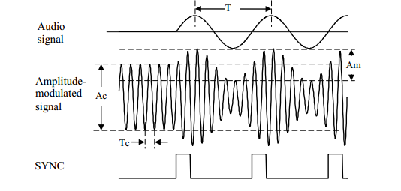

The function generator has a built in AM mode that can provide an AM signal. By configuring the setting to: Amplitude 10V, Carrier Frequency 1 MHz, Modulation Frequency 500Hz, and Modulation Index 50% the function generator provided an AM signal shown in figure 7.

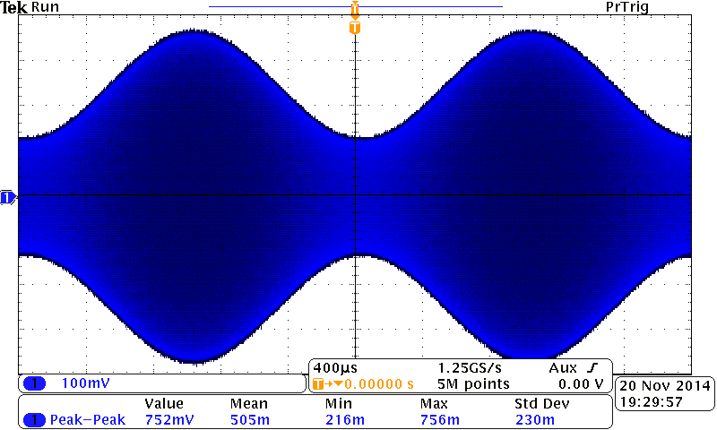Figure 7: AM Signal for Experiment 2

Conclusion:

The main purpose of this experiment was to properly set the function generator to output an AM signal. Amplitude modulation is a low frequency signal that is used to transmit carrier waves to a radio or detection circuit. The original signals amplitude is modulated to allow a fast communication between two radio type devices. Other modulations used to perform the same transmission but it with different properties is Frequency Modulation (FM) and Phase Modulation. These type of modulations are used every day to send out airwaves constantly, however it is important that the receiver side needs a constant precise method of filtering and detection to detect a particular signal.

**Experiment 3**

To capture a certain AM signal a LC resonant circuit must be used. The LC circuit filters out all other frequency’s and waves to acquire a singled out signal. The circuit contains an inductor that has a primary and secondary winding. The variable capacitor can be thought of as the tuner that can hone in on a single frequency. The same parameters were used to create a Am signal from the function generator as in experiment two except that the carrier frequency was replaced by the calculated resonant frequency.

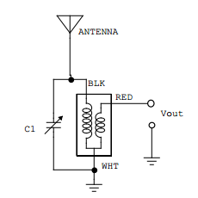 Figure 8: Experiment 3 Schematic

Table 2: Data for LC Circuit

|  |  |
| --- | --- |
| LC Circuit | |
| Capacitor C/[pF] | 100 |
| Inductor L/[µH] | 250 |

Resonant Frequency Calculation:

$$Resonant Frequency= \frac{1}{2π\sqrt{LC}}= \frac{1}{2π\sqrt{\left(250*{10}^{-6}\right)*(100*{10}^{-12})}} = 006584.2Hz$$

Table 3: Experiment 3 Frequency Variation Data

|  |  |  |
| --- | --- | --- |
|  | Frequency [KHz] | Voltage (Vpp)/[mV] |
| 1 | 904 | 216 |
| 2 | 906 | 244 |
| 3 | 908 | 280 |
| 4 | 910 | 332 |
| 5 | 912 | 452 |
| 6 | 914 | 508 |
| 7 | 916 | 640 |
| 8 | 918 | 748 |
| 9 | 920 | 716 |
| 10 | 922 | 585 |
| 11 | 924 | 464 |
| 12 | 926 | 376 |
| 13 | 928 | 316 |
| 14 | 930 | 272 |
| 15 | 932 | 240 |

Graph 1: Plot of Carrier Frequency in relation to Output Voltage

The change in voltage can be seen as the frequency is carried. From the max frequency +7 and -7 data points were taken. The max frequency was 918 KHz and max output voltage at the frequency was 748mV. Figures nine and ten show the max and min for the LC circuit at its resonant frequency.

Figure 9: LC Circuit Minimum at Resonant Frequency

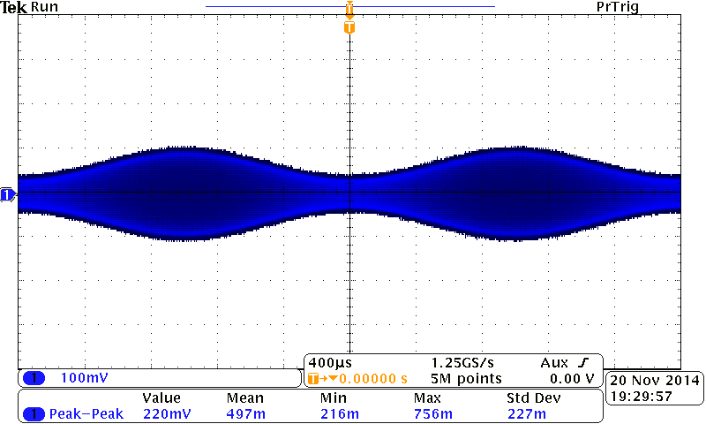

 Figure 10: LC circuit Maximum at Resonant Frequency

Conclusion:

To find a certain airwave with a precise frequency a detection circuit was constructed to be the receiving side of the signal. The LC resonant circuit allows fine tuning of resonant frequency by using a variable capacitor to change the resonant frequency in relation to the output voltage. By changing the capacitance allows the antenna to input airwaves but only one will have the correct frequency. The found airwave will allow the capacitor and inductor to resonant, for the measured values of L and C the circuit will resonant at 6584.2Hz. However the circuit does have a max resonation which is at 918 KHz the current and voltage at this frequency is also considered the max for this detection circuit. This type of circuit is a necessity as many there are many air waves present but the user only needs to acquire a single signal.

**Experiment 4**

The last experiment was a combination of all other experiments and labs that created a circuit that would detect AM signals This prototype used RC resonant circuit, half wave rectifier, non-inverting operation amplifier, and detection circuit to create a circuit that can detect and acquire real time AM signals being broadcasted. Each sub competent was utilized to successfully capture an AM signal and be able to listen to the signal. Figure nine shows the circuit schematic, the LF356 is replaced with LM741N, and audio out goes to a single channel auxiliary speaker.

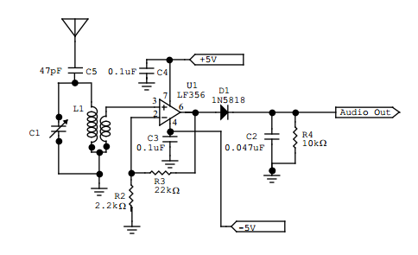Figure 11: Schematic for Experiment 4

Using the same parameters as in experiment two to set up the function generator in AM mode to find the resonant frequency of this new circuit by varying the output frequency. Figure twelve, thirteen, and fourteen show input of the amplifier, output of amplifier, and the detection circuit output where the auxiliary speaker is connect.

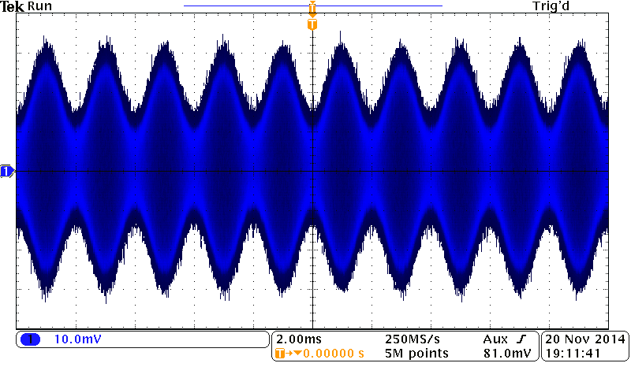

Figure 12: OP AMP Output

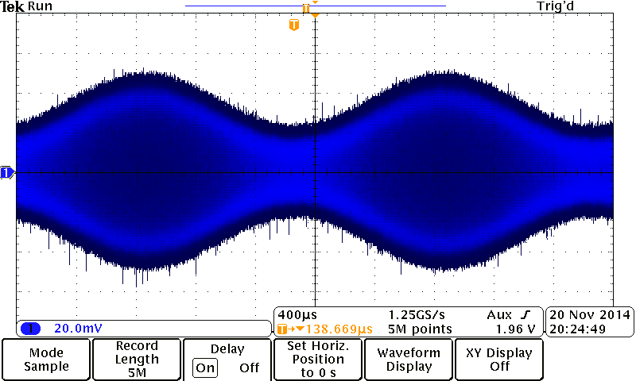

Figure 13: OP AMP Input

Figure 14: Detection Circuit Output at the Auxiliary Speaker

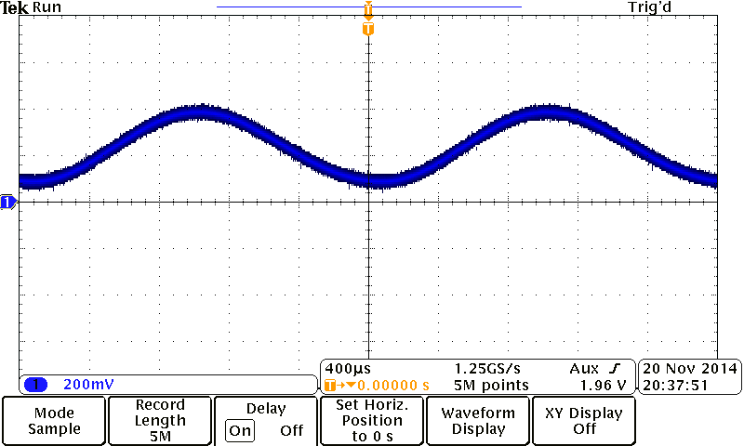

Gain for Experiment 4 OP AMP

$Gain=\frac{Vout}{Vin}= \frac{800mV}{20mV}=$ 40 Gain (AV)

The OP amp gain was higher than previous experiments so that signals that are weak can be amplified by a gain of 40 to be able to properly hear the signal. Once the circuit was constructed a new antenna was attached to the circuit this antenna was attached to the ceiling allowing a wider and more open detection for airwaves. A live radio station sending out AM signals was tuned into by adjusting the variable capacitor the signal began to output through the auxiliary speakers.

Conclusion:

Note: Figures 1, 6, 8, 11 were taken form EE97 Lab Manual by P. Hsu