[1]

CmpE 110 Lab 1: First-Order Passive Circuits

Farbod Jahan, Anahit Sarao, CmpE 110 Spring 2015, Lab Section 2

*Abstract*— The goal in this lab was to measure the rise time, fall time, and time constants of the output voltage of various first-order RC and RL circuits in order to compare them to expected values.

# INTRODUCTION

The purpose of this lab is to build various first-order RC and RL circuits according to a given time constant value. Using the oscilloscope, rise and fall times of the output voltage was measured along with time constants in order to understand how circuits differ from the ideal condition expected values.

# Design methodology

The values below were chosen to create RC and RL circuits with a time constant of 1µs for the RC circuit and 1ns for the RL circuit.

## Parts List

* 1k, 10k, 100k, 1M-Ohm Resistors
* 1.2p, 10p, 100p, 1nF Capacitors
* 1µ, 10µ, 100µ, 1mH Inductors
* Breadboard
* Tektronix AFG3021B Function Generator
* Tektronix DPO3032 Oscilloscope
* BNC to IC Hooks Cable
* Oscilloscope Probe

## Original and Derived Equations

The following was used to calculate the capacitor and inductor values needed to fit the design specification of a 1ms time constant:

$$τ=RC⇒C=\frac{τ}{R}=\frac{1µs}{R}$$

And

$$τ=\frac{R}{L}⇒L=\frac{R}{τ}=\frac{R}{1ns}$$

Where R is the resistance, C is the capacitance, and L is the inductance.

To calculate the observed time-constant, two points are used (at approximately 20% and 60% of the output voltage) and plugged into the following formula:

$$τ=\frac{t_{2}-t_{1}}{\ln\left(\frac{V_{1}}{V_{2}}\right)}$$

## Schematics

Circuit Schematics used to measure data using the oscilloscope. The other two circuits, which were not shown, simply switch the capacitor or inductor in place of the resistor.



*Figure 1. RC circuit setup* [1]*.*



*Figure 2: CR circuit setup [1].*



*Figure 3. LR circuit setup [1].*



*Figure 4. RL circuit setup [1].*

Figures two and four circuit schematics show circuits that had data, which was not measureable through the oscilloscope resulting in no data collection.

# testing procedures

The testing procedure is broken down into the listed steps:

1. Set function generators V­pp­=2.5V, Offset=1.25V.
2. Calculate C or L for the given R to attain the desired time constant.
3. Apply signal to circuit as shown in Figure 1 to 4.
4. Set probes to measure Vout­ relative to ground.
5. Place the cursors of the oscilloscope to approximately 20% and 80% of the output voltage on the rising curve. (When measuring on the secondary sinusoidal wave use the tips of the waves as data points.)
6. Repeat step 5 for the falling curve.
7. Take a screenshot.
8. Record the rise and fall times. (These are given on the screenshot.)
9. Using the cursor feature to find data points on the waveform to calculate the time-constant.
10. Repeat steps 2 through 9 for each RC/RL pair.

# testing results

The resulting waveforms from each circuit are attached in the appendices. The measurements for rise and fall times are shown in [Table 1-4]. Also the expected and calculated time constants are shown:

Table 1

|  |  |  |  |  |
| --- | --- | --- | --- | --- |
| **RC Values** | **Fall (µs)** | **Rise (µs)** | **Freq (Hz)** | **τ (µs)** |
| R=1k-Ohm  C=1nF | 3.35 | 3.51 | 10kHZ | 1.6µS |
| R=10k-Ohm  C=100pF | 5.38 | 5.75 | 10kHZ | 4.6µS |
| R=100k-Ohm  C=10pF | 37.78 | 38.85 | 1kHZ | 2.2µS |
| R=1M-Ohm  C=1pF | 207.1 | 212.6 | 700Hz | 3*10^4 |

Table 2

|  |  |  |  |
| --- | --- | --- | --- |
| **CR Values** | **Fall (µs)** | **Rise (µs)** | **τ (µs)** |
| R=1k-Ohm  C=1nF | N/A | N/A | N/A |
| R=10k-Ohm  C=100pF | N/A | N/A | N/A |
| R=100k-Ohm  C=10pF | 22.9 | N/A | N/A |
| R=1M-Ohm  C=1.0pF | N/A | N/A | N/A |

Table 3

|  |  |  |  |  |
| --- | --- | --- | --- | --- |
| **LR Values** | **Fall** | **Rise** | **Freq**  **(Hz)** | **τ** |
| R=1k-Ohm  L=1µH | 132.9nS | 138.3nS | 10kHz | 28nS |
| R=10k-Ohm  L=10µH | 116nS | 119nS | 10kHz | 37ns |
| R=100k-Ohm  L=100µH | 160nS | 170nS | 10kHz | 75ns |
| R=1M-Ohm  L=1mH | 159nS | 163nS | 10kHz | 13ns |

Table 4

|  |  |  |  |
| --- | --- | --- | --- |
| **RL Values** | **Fall (µs)** | **Rise (µs)** | **τ (µs)** |
| R=1k-Ohm  L=1µH | N/A | N/A | N/A |
| R=10k-Ohm  L=10µH | N/A | N/A | N/A |
| R=100k-Ohm  L=100µH | N/A | N/A | N/A |
| R=1M-Ohm  L=1mH | N/A | N/A | N/A |

The time constants that were measured for the RC circuit were off from the expected time constant by ≈1µs. The oscilloscope waveform shows the RC rise and fall time which was used to calculate the time constant [2]. While the LR measurements for time constant had a difference of ≈40ns. The LR square waveform provides rise and fall times which can be used to calculate time constant [3]. The measurement error can be attributed due to the additional impedance from the probes and oscilloscope itself.

Since the equipment itself acts as an additional load due to internal impedance. Data for CR and RL was unable to be measured or recorded [4] [5]. The oscilloscope, has a passive network causing an impedance load because it uses a capacitor. In other words it can be represented as a resistor and a capacitor in parallel with the measured circuit. According to the specifications of the scope, the internal capacitance has a value of 11.5pF and the internal resistance has a value of 1M-Ohm. This lead to disoriented waveforms in which the load impedance was larger than the testable circuit resulting in a non-ideal waveform [4] [5].

# Conclusion

This lab shows how external factors have to be taken into account in order to get accurate measurements during lab experiments. The waveforms that the oscilloscope displayed weren’t exact representations of the voltage drops that were actually occurring. For instance, the input voltage that was observed from the oscilloscope didn’t quite fit the expectations of what the function generator was supposed to output. This was due in part to the internal resistance and capacitance of the oscilloscope as noted in the testing results. Another issue that was encountered was difficulty in getting a readable output voltage signal when measuring the RL circuits. This issue was fixed by varying the frequency of the input signal. This proves that some circuits are not measureable but it does not render them useless.

.

# appendices and references

[1] Bindal, Ahmet, (2005, Apr, 7). CmpE 110 Lab Assignments [Online], Available: <http://www.engr.sjsu.edu/abindal/cmpe%20110.htm>

[2] RC Waveform

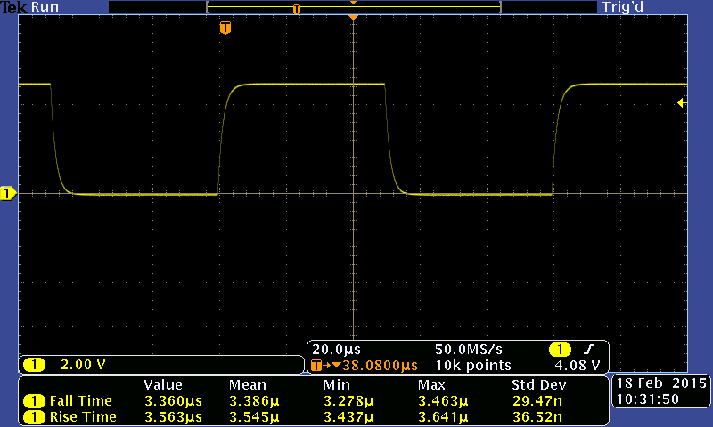

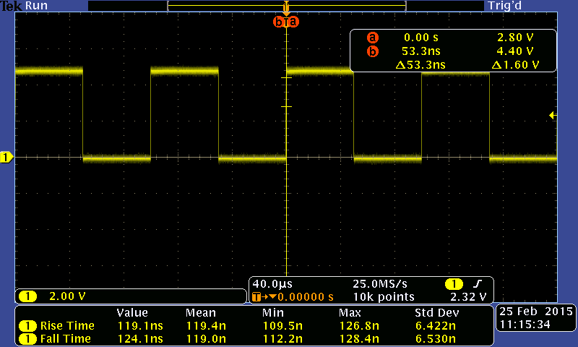 [3] LR Waveform

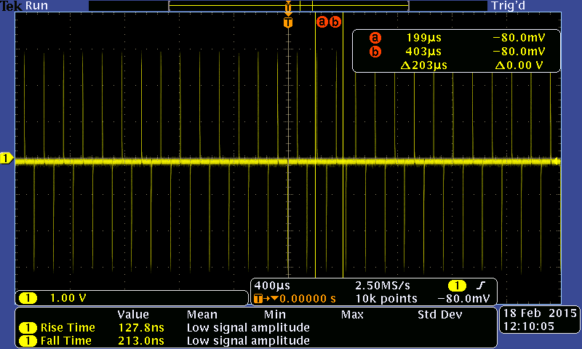[4] CR Waveform

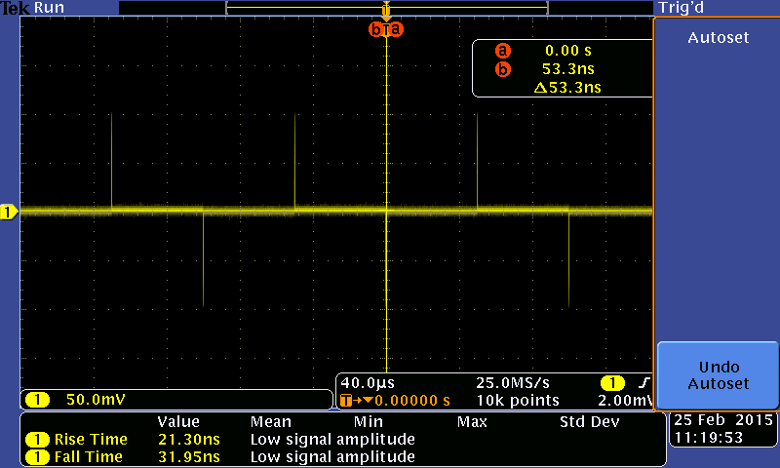[5] RL Waveform

1. Farbod Jahan, Anahit Sarao