[1]

CmpE 110 Lab 2: Second-Order Passive Circuits

Farbod Jahan, Anahit Sarao, CmpE 110 Spring 2015, Lab Section 2

*Abstract*—The goal in this lab is to measure the rise time, fall time, and time-constants of the output voltage of various second-order RLC circuits. In addition the free oscillation frequency was measured, for most cases is was very hard to measure as the oscillations shown on the oscilloscope were barely noticeable.

# INTRODUCTION

The purpose of this lab is to build various second-order RLC circuits with a given inductance and capacitance by varying resistance. Using an oscilloscope, rise and fall times of the output voltage were measured along with time constants and free oscillation frequency in order to understand how second-order passive circuits behave. Each RLC network has its characteristic equation. The equation can be solved for voltage resulting in a real and imaginary root. By measuring the oscillating frequency and alpha which is the time constant the roots can be found.

# Design methodology

The Tektronix AFG3021B function generator was setup to output a 5V square wave with a frequency low enough to observe full charge/discharge cycles of various RLC circuits. The RLC circuits were constructed with an angular frequency, ωo, of 107 rad/sec. An oscilloscope was then used to test how various resistors behaved in the RLC circuit.

## Parts List

* 100 pF Capacitor
* 1, 10, 100, 1k, 10k-ohm Resistors
* 100 μH Inductor
* Tektronix AFG3021B Function Generator
* Tektronix DPO3032 Oscilloscope
* BNC to IC Hooks Cable
* Oscilloscope Probe

## Original and Derived Equations

The following was used to calculate the inductance value, L, needed to fit the design specification of a RLC circuit with an angular frequency, ωo, of 107 rad/sec and a capacitance, C, of 100 pF:

$$ω_{0}= \frac{1}{\sqrt{LC}}⇒L= \frac{1}{C{ω_{0}}^{2}}=\frac{1}{(100pF){(\frac{{10}^{7}rad}{s})}^{2}}=100μH$$

To calculate the observed time-constant, two points are used (at approximately 20% and 80% of the output voltage) and plugged into the following formula:

$$τ=\frac{t_{2}-t_{1}}{\ln\left(\frac{V_{1}}{V_{2}}\right)}$$

To calculate the free oscillation frequency the following was used:

$$f=\frac{1}{Δt}=\frac{x}{t_{2}-t_{1}}$$

Where x is the number of cycles completed.

The two roots of each network can be found:

$$s1/s2=-α ±j \sqrt{α^{2}-{ω^{2}}_{0}}$$

## Schematics



*Figure 1. RLC circuit setup [1.]*

# testing procedures

The testing procedure are broken down into these steps:

1. Set function generator to Vp-p=2.5 V, Offset-1.25V.
2. Calculate L for the given ωo and C.
3. Apply power to circuit as in Figure 1.
4. Set probes to measure Vout relative to ground.
5. Place the cursors of the oscilloscope to approximately 20% and 80% of the output voltage on the rising curve.
6. Repeat step 5 for the falling curve.
7. Take a screenshot.
8. Record the rise and fall times. (These are given on the screenshot.)
9. Use the two cursor data points to calculate the time-constant.
10. Measure the free oscillation frequency, .
11. Repeat steps 3 through 10 for each new RLC circuit.

# testing results

The measurements and calculations from each circuit are shown in Table 1.

|  |  |  |  |  |  |  |  |
| --- | --- | --- | --- | --- | --- | --- | --- |
| R (Ohms) | L (uH) | C (pF) | Freq (kHz) | Rise Time (us) | Fall Time (us) | τ (us) | Free Osc Freq (KHz) |
| 0 | 100 | 100 | 50 | 210ns | 215ns | 1.4µs | 975610 |
| 1 | 50 | 213ns | 214ns | 1.1µs | 909091 |
| 10 | 50 | 225ns | 234ns | 2µs | 1117318 |
| 100 | 50 | 241ns | 247ns | 2.2µs | 1289665 |
| 1k | 50 | 680ns | 650ns | 3.6µs | 1.88*10^3 |
| 10k | 50 | 5.98µs | 5.8µs | N/A | 3.03*10^3 |

*Table 1. These are the final results of this experiment.*

Figure 1: Oscilloscope Output

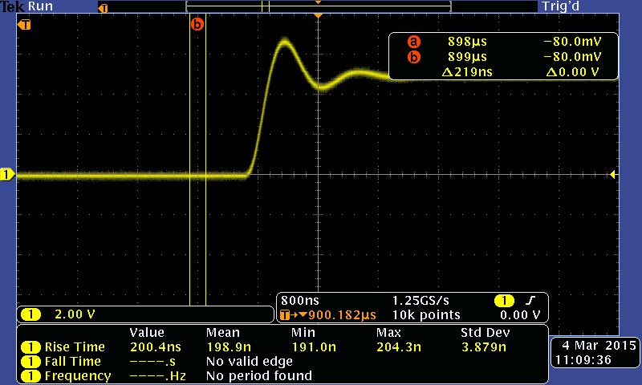

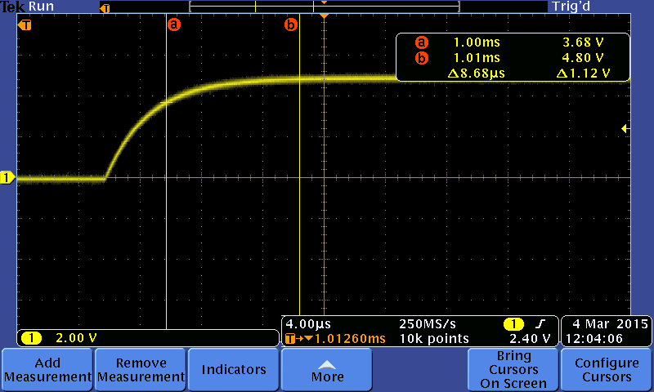Figure 2: Oscilloscope Output

The results in the lab verified that the network was constructed properly and worked as expected, from figure one and figure two the voltage output of the circuit can be seen for two different resistance values. In these cases alpha or the time constant was measurable however for the last configuration it is impossible to measure as the network has an imaginary root. In this case alpha is very hard to measure as there is no oscillation observed.

# Conclusion

This lab showed how output voltage over a capacitor behaves over time in an RLC circuit. An issue that was encountered was not being able to get ideal rise and fall times for the output voltage due to the waveform oscillating during its rise and fall cycles. This was resolved by moving the cursors to either the peaks or the troughs of the oscillating signal depending on the cycle being measured. In some cases, varying the frequency of the input signal helped to fix the readability of the output waveform. The results in this lab were hard to compare since each variation of network changes each measured variable. However it is understood that RLC networks are much more complex and intricate compared to RL and RC networks.

# appendices and references

[1] Bindal, Ahmet, (2005, Apr, 7). CmpE 110 Lab Assignments [Online], Available: <http://www.engr.sjsu.edu/abindal/cmpe%20110.htm>

1. Farbod Jahan, Anahit Sarao