[1]

CmpE 110 Lab 3: Diode Circuits

Farbod Jahan, Anahit Sarao, CmpE 110 Spring 2015, Lab Section 2

*Abstract*—The goal of this lab was to measure the electrical characteristics of various diode circuits such as full wave and half wave rectifiers.

# INTRODUCTION

The purpose of this lab was to build various diode circuits and wave rectifiers and to measure the electrical characteristics of each configuration. Using the oscilloscope the output ripple voltage is measured for the full wave rectifier to see how different diode configurations can allow AC voltage to resemble DC voltage. The various circuits also can show how one is more efficient than the other.

# Design methodology

## Parts List

* 4.7, 1, 10, kΩ and 470, 100, 560, 270, 47 Ω resistors
* 390 and 220 µF Capacitors
* 4 1N4001 rectifying diodes
* 5 V, 3.3V Zener diode
* Light-emitting diode
* Breadboard
* Tektronix AFG3021B Function Generator
* Tektronix DPO3032 Oscilloscope
* BNC to IC Hooks Cable
* Oscilloscope Probe

## Original and Derived Equations

In order create a current limiting circuit so the diode is not damaged, a resistor is calculated with the equation

${ R}_{D}= \frac{V_{cc}- V_{out}}{I_{D}}$ (1)

where RD is the resistance to limit current through the diode, Vcc is the source voltage, Vout is the voltage drop and ID is the current flowing through the diode.

## Schematics



Figure 1: Simple series diode schematic [1]



Figure 2: Half-wave rectifier schematic [1]



Figure 3: Half-wave rectifier with filtering capacitor schematic [1]



Figure 4: Full-wave rectifier with output capacitor schematic [1]

|  |  |  |  |  |
| --- | --- | --- | --- | --- |
| **Part 1 sub part B:** | | | | |
| Half Wave Rectifier | | | | |
| Resistance(Ω) | Exp. Current  (mA) | Act. Current  (mA) | Exp. Ripple (V) | Act. Ripple (V) |
| 470 | <10 | 6.5 | <100 | 90 |



Figure 5: Series Zener diode schematic [1]



Figure 6: Series LED schematic [1]

# testing procedures

The testing procedure follows:

1. Build the specified circuit according to the schematics.
2. In the case of a simple diode circuit, calculate the resistor to limit current and then measure output voltage.
3. If building a rectifier, measure the output voltage waveform using an oscilloscope. Attach a capacitor to keep output ripple voltage under 100 mV, and that the Ac current is less than 10mA.

# testing results

|  |  |  |  |  |
| --- | --- | --- | --- | --- |
| **Part 1** | | | | |
| Simple Diode Circuit | | | | |
| Resistance (Ω) | Exp. Current  (mA) | Act. Current  (mA) | Exp. Vout(V) | Act. Vout (V) |
| 470 | 10 | 8 | 0.7 | 0.7 |
| 4700 | 1 | 0.70 | 0.7 | 0.6 |
| 47 | 100 | 90 | 0.7 | 0.9 |

|  |  |  |  |  |
| --- | --- | --- | --- | --- |
| **Part 1 sub part A:** | | | | |
| Half Wave Rectifier | | | | |
| ResistanceΩ | Exp. Current  (mA) | Act. Current  (mA) | Exp. Vout(V) | Act. Vout (V) |
| 470 | 8 | 4.2 | 0.7 | 3.2 |

|  |  |  |  |
| --- | --- | --- | --- |
| Frequency  (Hz) | | Amplitude (V) | |
| 10 | | +10/-10 | |
| No Capacitor |  | With Capacitor |  |
| Resistance(Ω) | Act. Vout (V) | Capacitance (µF) | Ripple (mV) |
| 100 | 3.5 | 390 | 80 |
| 1000 | 7 | 390 | 55 |
| 10000 | 8.5 | 220 | 15 |

|  |  |  |  |  |
| --- | --- | --- | --- | --- |
| **Part 3** | | | | |
| Zener Diode | | | | |
| Exp. Vout(V) | Act. Vout (V) | Exp. Current  (mA) | Act. Current  (mA) | Resistance (Ω) |
| 10 | N/A | N/A | N/A | N/A |
| 3.3 | 2.1 | 1380 |  | 560 |
| 5 | 4.16 | 890 |  | 270 |

|  |  |  |  |  |
| --- | --- | --- | --- | --- |
| **Part 4** | | | | |
| LED | | | | |
| Resistance(Ω) | Act. Vout (V) | Exp. Vout(V) | Exp. Current(mA) | Act. Current  (mA) |
| 470 | 2.01 | 1 | 21 | 17.6 |

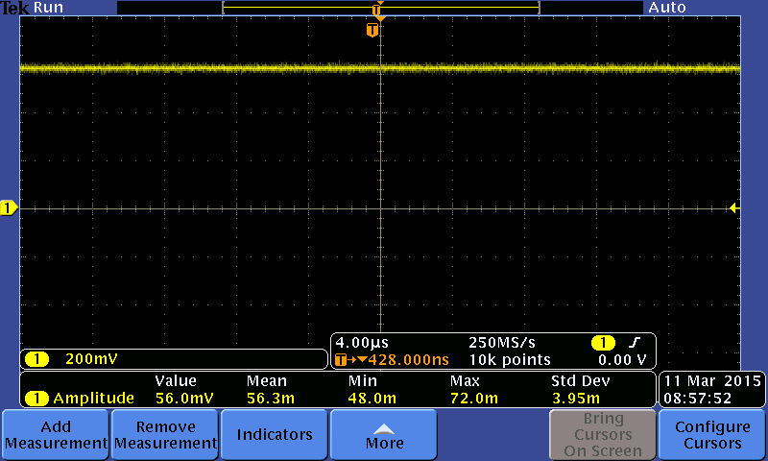

Figure 7: Part one Oscilloscope reading.

From figure seven it can be seen that the voltage drop after the resistor is around .7V, this is sufficient to drive the diodes forward bias. The oscilloscope shows the output from the point shown by figure one called Vout. Below are two figures eight and nine which show the same circuit output but with different resistance values.

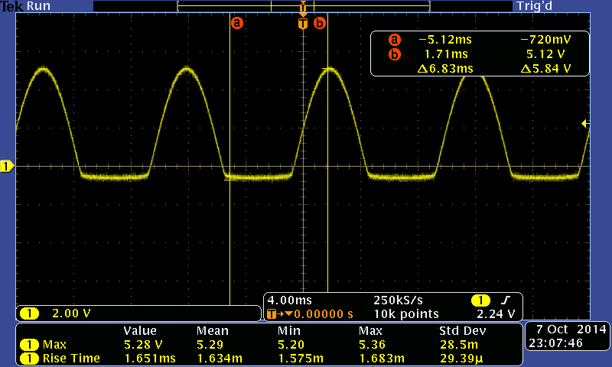

Figure 8: 4,700 Ω Series Diode Circuit

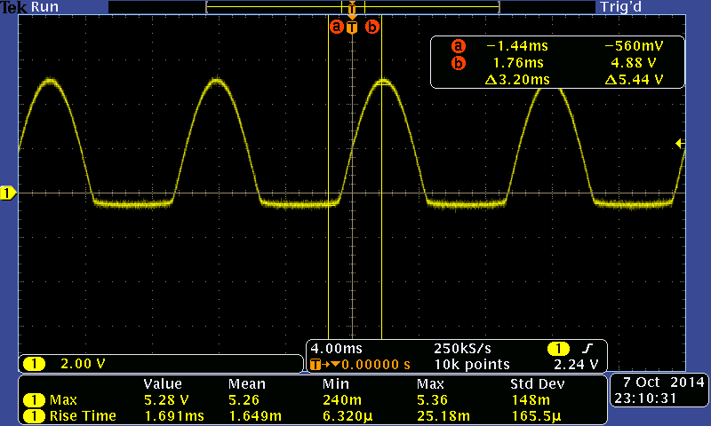

Figure 9: 47Ω Series Diode Circuit

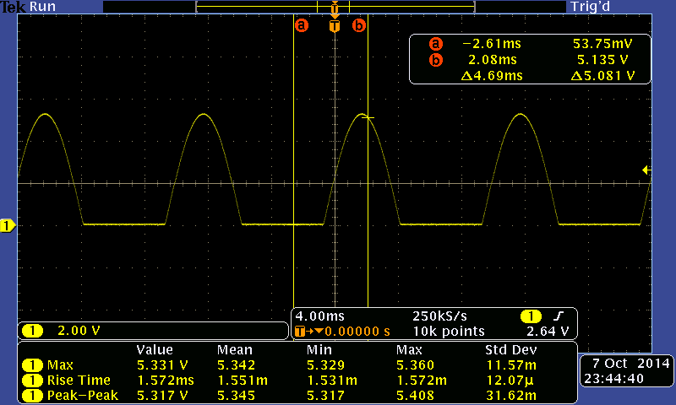Figure 10: Ideal Half wave rectifier

A half wave rectifier’s purpose is to convert an AC signal to DC, this is done using a diode in series with a current limiting resistor and a parallel capacitor. Since the half wave rectifier only transforms the positive cycle of the Alternating Current signal is can be assumed it is less efficient as there is a delay during the negative cycle. Also in a half wave rectifier a larger capacitor is needed to hold the voltage.

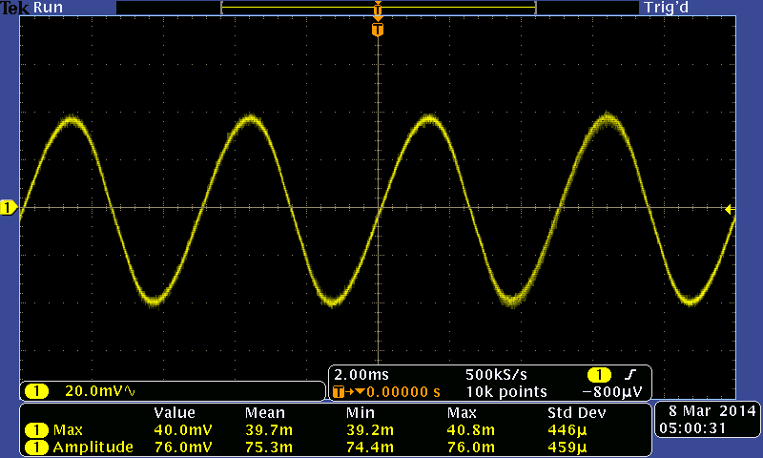

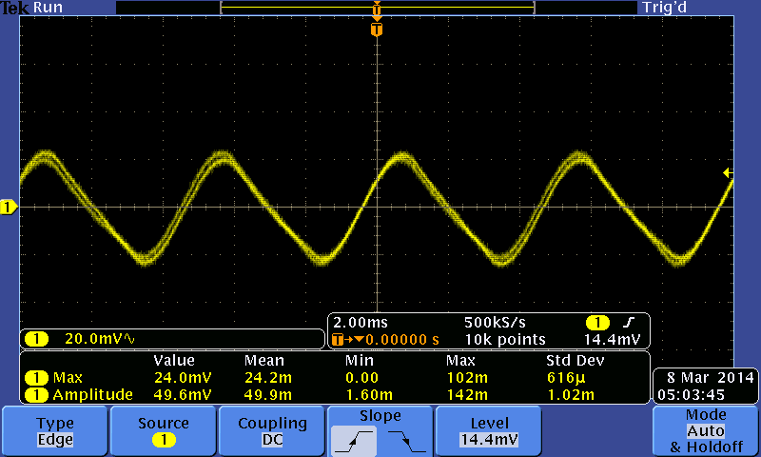



Figure 11: Full Wave Rectifier with 100Ω resistor (Top)

Figure 12: Full Wave Rectifier with 1kΩ resistor (Bottom)

The full wave rectifier is a more efficient way to convert an AC signal to DC. Since both cycles of the AC input signal are converted a lower capacitor value can be used. Figures eleven and twelve show how the wave form changes as the resistance and capacitor change. This type of rectifiers circuit has a ripple voltage which is the time is take for the next cycle to pass through he circuit. Looking at figure four it can be seen that the four diodes only work in pairs resulting in less delay and more efficiency.

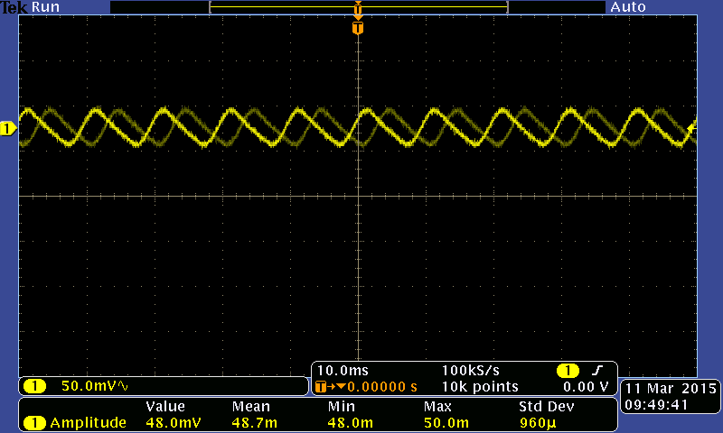

Figure 13: Ripple Voltage Full Wave rectifier



After building a half-wave rectifier, the output voltage waveform showed that only the peaks of the AC input signal are outputted. In the case of the full-wave rectifier, all the peaks and troughs of the AC signal were outputted as peaks. By adding a capacitor to these rectifier circuits, the decay in voltage was reduced. As capacitors were changed, the decay in output voltage changed, eventually imitating a DC voltage signal.

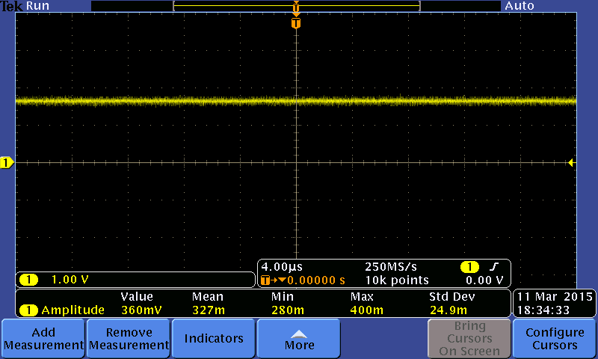

Figure 14: Zener Diode output



Figure 14: LED Output

3.3V and 5V Zener diodes were constructed in series with a resistor with a Vcc of 10V. Finding the resistor value such that the current did not exceed the rated power level of the Zener diode was found by using equation (1). From table Part 3 it can be seen that zener diode works in revere bias and only when saturated which is near it power rating.

Last the LED bulbs act as diodes, the goal was to determine the resistor value. The current could not exceed the 20mA and $v_{out}$ could not go over 1V, these were the set maximum for the LED. From figure fourteen and data table Part 4 it shows the LED performing its function by emitting light.

# Conclusion

This lab demonstrated the electrical characteristics of a diode and showed how an AC voltage can be changed to replicate a DC voltage through the use of a rectifier circuit. Many other application can be performed with diodes, this being the reason a diode is present in almost all modern day circuitry.

# appendix

N/A

# references

[1] Bindal, A. (2014). Diodes And Diode Circuits. In *Electronics for*

*Embedded Systems* (3rd ed., pp. 15-25). Maple Press.

1. Farbod Jahan, Anahit Sarao