EE 97 Fall 2014

Lab#4: Function Generator and Oscilloscope

Anahit Sarao

Partner:Yong Gui Huang

Station 3

Submitted: October 9, 2014

**Preface**

All experiments were successfully conducted in Engineering Building room 249, on October

Eight, 2014.

**Experiment 1**

Main objective of this experiment was to learn and understand the purpose and function of the function generator (HP33120A) and Oscilloscope (Tektronix DPO3012).

Part A required the usage of both devices, the function generator was to output 1V at 1 kHz of a sinusoidal waveform. The oscilloscope was defaulted by pressing the default button. Once the signal from the function generator was connected to channel one of the oscilloscope settings were changed to acquire a stable waveform.

Vertical Group setting were set to:

Coupling=DC, Impedance = 1MΩ, Invert=off, Bandwidth=full, More=(…Offset=0V, Position=0div, Probe Setup=10X ).

The scale was set to 200mV/div and 200µs/div.

Horizontal Group setting were set to:

Mode = Sample, Record Length=10k, Delay=On,

Waveform Display= (Dots Only=Off, Persist Time=Auto …), and XY Display=Off

Trigger Group setting were set to:

Menu=number 1, Mode=Option=Auto

At this point a steady waveform was produced as shown in figure one.

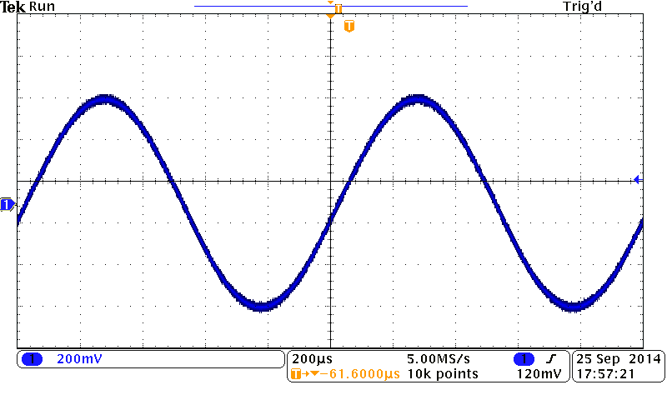

Figure 1: Channel 1 Oscilloscope Sinusoidal Waveform

By adding a 100Ω Resistor in parallel with the oscilloscope and function generator the volts per division were measured. The peak to peak voltage was measured at .6V but the function generator still outputted 1V, this change is due to external noise and added resistance causing variation and instability within the signal resulting in a voltage drop.

For part b more setting were changes within the trigger control. This included taking the trig level out of range and being able to see the last stable image of the waveform, this happens when Trig? shows up on the top left of the screen. Also the trig was adjusted by using the trig position knob to show how waveforms have different sensitivity and varies ranges.

For part c the vertical control setting were adjusted. Firstly the function generator was set to 10V and this was confirmed as the scope was set to 2V/div to view a steady waveform. By adding a DC offset of 1V. The waveform moved upward by 1V/div. Next the coupling settings was changed from DC to AC, when shifting from DC to AC the waveform took its original position without the offset. This is because the AC coupling passes the signal through a capacitor that does not allow DC signal nor the DC offset to pass.

Part d mainly focused on the horizontal control settings. The function generator was set to 1 kHz and was verified through the waveform on the oscilloscope. The oscilloscopes sweep rate was changed to 1µs/div and 40ms/div. These two sweep rates created a very unstable waveform showing that these two setting were improper for a 1 kHz input signal.

In conclusion this experiment taught the basic usages of an oscilloscope. By measuring different types of waveform, changing the trigger, horizontal and vertical settings to show how each group can affect the waveform. Many other functions were also learned such as saving an image to a USB, changing the coupling settings and how to efficiently use the multi-purpose knobs. Becoming more efficient and learning the functions of the lab equipment will make future experiments have more purpose and detail.

**Experiment 2**

This experiment was designed to test the knowledge of both lab members. One member was to set random frequencies and amplitude and make adjustments to the scope so that there is no waveform shown on the oscilloscope’s display.

I randomized both devices, while my partner adjusted the oscilloscopes scope and trigger so that a waveform was shown on the display. The roles were switched to make sure each member understood how to use the oscilloscope effectively.

To fully understand the usage and function of the oscilloscope both lab members tested each other. To be able to manipulate and adjust multiple settings efficiently the knowledge learned in experiment one was used to find a randomly assigned input signal.

**Experiment 3**

The function generator was set to 1V at 1 kHz to produce a stable triangular wavewith a zero offset. This signal was connected to channel one of the oscilloscope, while channel two was connected to the square-wave testing port of the oscilloscope. The objective was to change the trigger and scope so that both signals are stabilized.

Figure 2: Within Trig Range Dual Signal Input to Oscilloscope

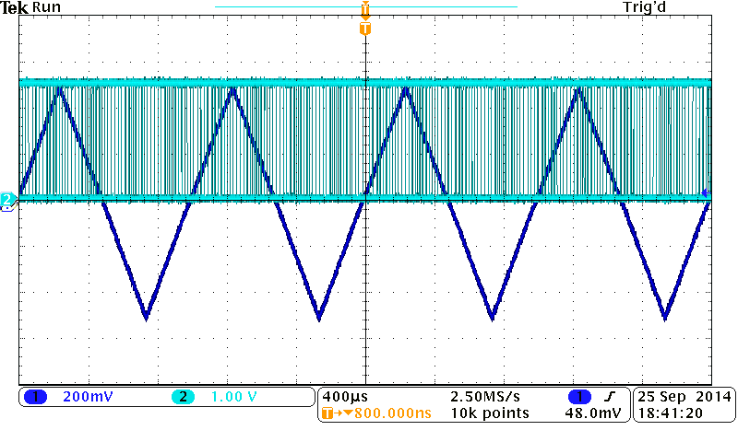

Figure 3: Out of Trig Range Dual Signal Input to Oscilloscope

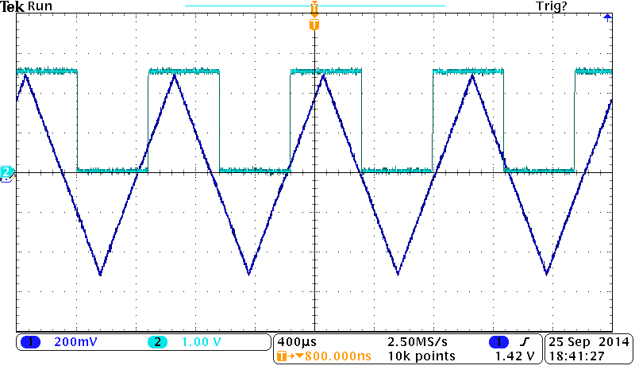

Looking at figure two it can be seen that while one signal is stable the other signal becomes unstable. This is because the two signals have different trig ranges and different scope settings.

While in the trig range the square wave is not stable but the triangular wave is stable. Looking at figure three the trig is out of range resulting in both signals being stable, in the top left of the picture Trig? can be seen meaning trig level is out of range and the last stable waveform image is shown. End result is that two different signals will not stabilize because the signals will have different scopes and different trig ranges.

**Experiment 4**

Setting the function generator to 5V at a 20Hz square wave with a null offset. This signal was connected to channel one of the oscilloscope. The input coupling options was set to DC then set the AC the change in the waveform was to be recorded and analyzed.

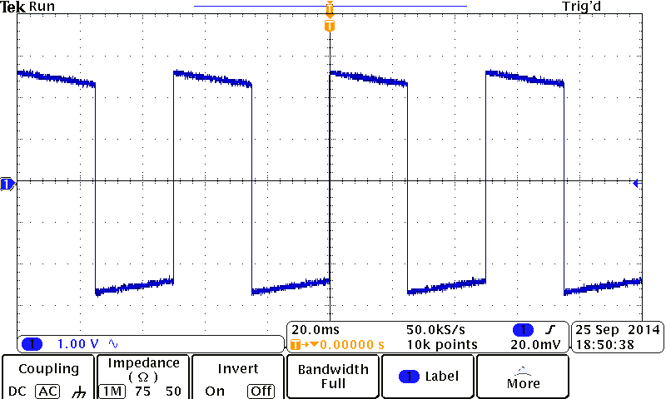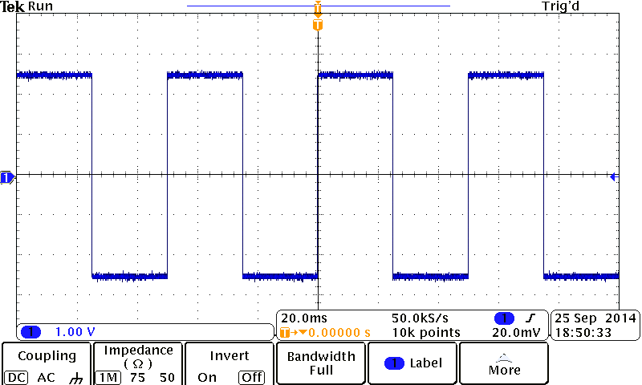Figure 4: DC Coupling Waveform Figure 5: AC Coupling Waveform

The distortion can be seen by looking at figure four then figure five. The only change made was that the coupling setting was changed from DC to AC. This causes a very noticeable distortion and change in the waveform. This is because when the coupling is to AC the signal passes through a capacitor and is not a direct feed. While in DC coupling mode the signal is direct and shows the AC and DC signal also the DC offset. If set to AC coupling the DC signal is removed and there is no offset as the signal is passed through a AC only capacitor the waveform changes and distorts. In conclusion if only interested in the AC signal use AC coupling but if interested in the DC signal which includes the DC offset use DC coupling.

**Experiment 5**

This experiment introduces the root mean square of voltage and how it compares to normal voltage. Also the measurements made by the oscilloscope will be compared to measurements made by the DMM (Agilent 34405A). This will assist in calculating the bandwidth of the oscilloscope and DMM.

The DMM is connected in parallel with the function generator and the oscilloscope. The function generator is set at a starting 50 Hz sinusoid wave that will be varied till 500 kHz, the peak to peak voltage was set at 800mV. The data collected is not in modular steps as bigger steps are taken when change in Vrms is small and smaller steps taken when change in Vrms is big.

Table 1: Measured Data for Experiment 5

|  |  |  |
| --- | --- | --- |
|  | **Output Voltage** | |
| Frequency | Oscilloscope | DMM |
| [Hz] | Vpp/[mV] | Vrms/[V] |
| 50 | 0.800 | 0.281 |
| 100 | 0.800 | 0.281 |
| 200 | 0.800 | 0.281 |
| 500 | 0.800 | 0.281 |
| 1000 | 0.800 | 0.281 |
| 7000 | 0.800 | 0.281 |
| 10000 | 0.800 | 0.280 |
| 125000 | 0.800 | 0.279 |
| 150000 | 0.800 | 0.278 |
| 165000 | 0.800 | 0.277 |
| 200000 | 0.800 | 0.273 |
| 250000 | 0.800 | 0.262 |
| 260000 | 0.800 | 0.260 |
| 270000 | 0.800 | 0.256 |
| 275000 | 0.800 | 0.254 |
| 300000 | 0.800 | 0.245 |
| 310000 | 0.800 | 0.240 |
| 320000 | 0.800 | 0.236 |
| 330000 | 0.800 | 0.231 |
| 340000 | 0.800 | 0.226 |
| 350000 | 0.800 | 0.221 |
| 400000 | 0.800 | 0.195 |
| 410000 | 0.800 | 0.189 |
| 420000 | 0.800 | 0.184 |
| 430000 | 0.800 | 0.179 |
| 440000 | 0.800 | 0.173 |
| 450000 | 0.800 | 0.168 |
| 460000 | 0.800 | 0.163 |
| 470000 | 0.800 | 0.158 |
| 480000 | 0.800 | 0.153 |
| 490000 | 0.800 | 0.148 |
| 500000 | 0.800 | 0.144 |

The data from table one is used to find the bandwidth of the oscilloscope and DMM. The bandwidth is the range of measurement for these devices that will show the measured value 70.7% of the actual value.

$Bandwidth=\frac{70.7}{100}* .281$ = .1986V

.1986V is the 70.7% of the actual value, which is the Vrms at 50Hz.

By looking at the table under Vrms .1986V falls just before 400000Hz.

A good deduction of the data shows the Bandwidth to be ≈ 380000 Hz.

From the data collected we can conclude that the DMM has a bandwidth. The bandwidth for the DMM is 380000 Hz. The bandwidth range is when the measured values are within 70.7% of the actual value. However for the oscilloscope the bandwidth cannot be attained because it has a much wider range that goes to megahertz, while in this experiment we only went till kilohertz. From the user manual of the oscilloscope the bandwidth is 100 MHz, this was not attained from the data collected.

**Experiment 6**

Constructing the circuit shown in figure six the oscilloscope was used to measure the voltages between points A and B and B and C. In this experiment both oscilloscope channels were used allowing usage of the built in Math function. Also the function generator was not use but the 6V DC power supply was used to provide voltage.

Figure 6: Circuit Schematic for Experiment 6

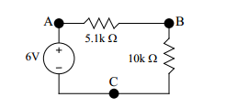

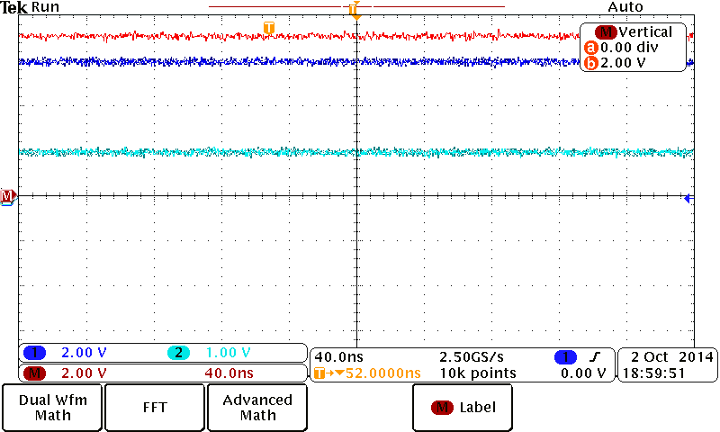Figure 7: Dual Channel Oscilloscope Input

Once the two channels were connected at the appropriate points, where channel one measured the voltage across points A and B and channel two measured the voltage across points B and C. To find the voltage across the 5.1kΩ resistor Kirchhoff’s Voltage Law must be used meaning that channel one must be subtracted by channel two. After activating and setting up the math function of the oscilloscope a third voltage line appears showing the internally calculated voltage across the 5.1kΩ resistor. The top line in figure seven shows the subtracted voltages of channel one which is in the middle and channel two which is the last line. However there is a mistake as all the voltages lines were not set to the same volts per division leading to a misleading recording. This does not hinder the results but makes the visualization of the different voltages harder to see in figure seven.

Figure 8: Dual Channel Oscilloscope Input

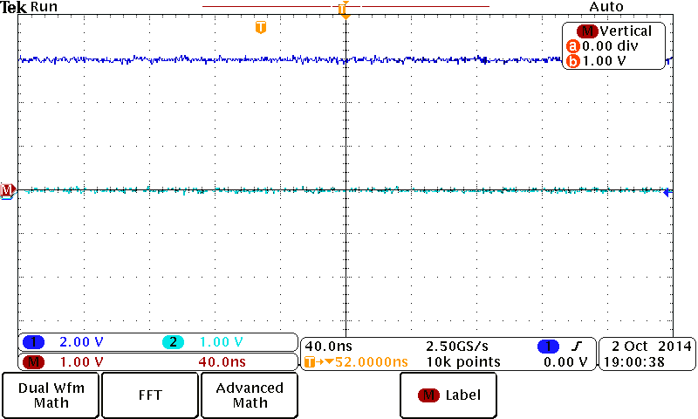

Trying to measure the voltage at the 5.1kΩ resistor directly by moving channel one to points A and B. While channel two is left as the same position before. In figure eight it can be seen that channel one is showing 6V but channel two is showing 0V. These values incorrect as the 10kΩ resistor has been removed from the circuit. The 0V across the 10kΩ resistor is due to having two grounded pins at both terminals causing it be a common ground for the circuit, this is why there is no voltage reading across the 10kΩ resistor.

In summary the experiment focused on using the oscilloscope to measure the voltage across multiple resistors. Measuring the voltage across the whole circuit and measuring a single voltage across a resistor can find the voltage across the second resistor by using KVL. Using built in math functions on the oscilloscope many different math operations can be performed in this scenario the subtraction function was used. Lastly an observation was made when all terminals of a component are connected to ground, this results in a reading of 0V.

**Conclusion**

This lab was designed to introduce and learn two new lab instruments. While learning how to use the new equipment efficiently it was also important that the purpose of these devices was understood. The function generator can provide many different types of waveforms; it generates waveforms in hertz while the voltage setting controls the amplitude of the waveform. A DC offset can be applied to the signal, there are also many more functions and properties that can alter the waveform. The oscilloscope reads signals and displays the waveforms captures onto the screen. The oscilloscope is very versatile and has many features to enhance measurements and observations. The main idea is to understand that the oscilloscope is a measurement device and it by changing the times per division or volts per division does not alter the signal rather changes the way it is presented to the user. By being able to use the new equipment efficiently it will help make experiment observations and measurements more understandable and significantly more in depth

Note: Figure 6 was taken form EE97 Lab Manual by P. Hsu