**Autonomous Response Drone**

| A Project Report  Presented to  The Faculty of the Computer Engineering Department |
| --- |
| San Jose State University  In Partial Fulfillment  Of the Requirements for the Degree  Bachelor of Science in Computer Engineering |

| Copyright © 2017 |
| --- |
|  |
| ALL RIGHTS RESERVED |

| **APPROVED FOR THE COLLEGE OF ENGINEERING** |
| --- |
|  |
| Kaikai Liu, Project Advisor |
|  |
| Professor Rod Fatoohi, Instructor |
|  |
| Dr. Xiao Su, Computer Engineering Department Chair |

**Acknowledgements**

*Advisor*

Kaikai Liu

[Kaikai.liu@sjsu.edu](mailto:Kaikai.liu@sjsu.edu)

*Authors*

Ali Baqar

[alinbaqar@gmail.com](mailto:alinbaqar@gmail.com)

Anahit Sarao

[anahitsarao@gmail.com](mailto:anahitsarao@gmail.com)

[Github](https://github.com/s3nu)

Maxwell Cheshier

maxcheshier@gmail.com

Brian Josefowicz

[brian.josefowicz@sjsu.edu](mailto:brian.josefowicz@sjsu.edu)

**ABSTRACT**

**Autonomous Response Drone**

By Ali Baqar, Maxwell Cheshier, Brian Josefowicz, and Anahit Sarao

College campuses have always dealt with criminal offenses and are always attempting to make these campuses safer for students. Most of the crimes that take place are burglaries, sex offenses, and theft. The police’s only response to this situation is to send out officers to the scene of the crime in hopes of catching the assailant in the act. With police forces struggling to catch the assailants, this can lead to a general feeling of unsafety. A school which lacks safety could possibly see fewer students enrolling out of fear of the campus. Additionally, the only deterrents the police have for this type of behavior is the use of security cameras which can be ineffective for the job required of them. Many of the assailants are able to escape and remain uncaught while relying solely on the victim’s description of the assailant in hopes of finding them. The use of a device which can respond to the situation in time faster than the response speed of police on the ground as well as aid the individual being attacked would serve as both an aid to the police and a deterrent against the attacker.

The current problem faced by police forces in attending to the aid of individuals is their slow response speed. If they are lucky, there will already be a unit on campus, however, if not, a unit will have to be deployed from their station which would reduce response time and their effectiveness. This slow response time often results in the escape of the attacker where they can’t possibly identify him or her. The use of cameras can help to solve them but it’s possible that these cameras either aren’t sensitive enough, lack a proper field of view, or simply aren’t in that location. Additionally, the cameras can’t aid the victim while they are being attacked which does not help in hindering the assailant. When cameras aren’t present, there is no way to identify the attacker besides witness descriptions. These descriptions can be faulty or lacking in detail and ultimately don’t often result in apprehending the attacker.

The drone will act as a first responder to a potential crime happening on campus. The drone will be able to reach the destination of where an attack is taking place faster than the police can respond. When the button is pressed to signal the police to an emergency, the drone will be signalled to attend to the location specified. When the drone responds, it will capture images of the location where it was sent in the form of video or still images, in order to aid in capturing photographic evidence of the attacker. This will allow the drone to both deter attacks and aid in identifying and apprehending the aggressor through image capturing. The use of an autonomous drone will allow the police to mobilize without the need of a “pilot” as well as allowing the drone to fly according to its program avoiding possible human error. The drones are also cheaper and more expendable than police lives resulting in a safer and more economical form of police aid. This drone will serve as an invaluable police aid and also a criminal activity deterrent.

**Table of Contents**

**Chapter 1 Project Overview**

* 1. Project Goals and Objectives
  2. Problem and Motivation
  3. Project Application and Impact
  4. Project Results and Deliverables

**Chapter 2 Background and Related Work**

* 1. Background and Technologies
  2. State-of-the-art

**Chapter 3 Project Requirements**

3.1 Domain and Business Requirements

3.2 System (or Component) Functional Requirements

3.3 Non-function Requirements

3.4 Context and Interface Requirements

3.5 Technology and Resource Requirements

**Chapter 4 System Design**

4.1 Architecture Design

4.2 Interface and Component Design

4.3 Structure and Logic Design

4.4 Design Constraints, Problems, Trade-offs, and Solutions

**Chapter 5 System Implementation**

5.1 Implementation Overview

5.2 Implementation of Developed Solutions

5.3 Implementation Problems, Challenges, and Lessons Learned

**Chapter 1. Introduction**

* 1. **Project Goals and Objectives**

The autonomous drone had several goals in mind. The ultimate goal was to provide a safer college campus by deterring criminal activity as well as aiding in apprehending the criminals that commit these offences. To achieve this, the drone will operate autonomously when it receives a signal to fly to a location. Once the destination for the drone to attend to is chosen, the drone begins its flight takeoff procedures. After preflight checks of battery level and peripheral status are confirmed, the drone takes flight to the specified location. From that point, the drone records images of the attacker whether in still frames or video. This process will also occur simultaneously with strobed lights flashing which better deter an attacker. When the police have arrived, the drone the drone received a signal indicating for its return to base. The drone returned to base where it goes into a standby mode awaiting the next distress signal.

This drone has aimed to aid in the prevention of criminal activity on college campuses. Many of the activities that take place on college campuses can be prevented or prevented from escalating with the use of a fast response device aimed at alerting nearby individuals and alarming the attacker. With the increase in drone popularity and the advances in the field of automation, this project was a foreseeable step forward in the advances of security and automation.

* 1. **Problem and Motivation**

San Jose State University is at the heart of downtown San Jose which is notorious for homelessness and criminal activity. Often this sort of activity can drift onto San Jose State’s campus and lead to crime that impacts students. While San Jose campus police have attempted to become more transparent and active with the criminal activity happening through SJSU alerts, this often leads to a greater feeling of unsafety and lack of police power. To deal with this, some changes must be made in how the police go about apprehending criminals and preventing any sort of criminal activity.

To properly act as a deterrent and aid for police, the drone caused the assailant to feel a sense of panic resulting in them fleeing the scene and additionally assisted the police in identifying the suspect. The drone caused this sense of alarm and panic through the use of lights and sounds that have the capability to alert bystanders and additionally assist the police in quickly acquiring the location of where the distress signal was sounded. The drone came to the aid of the victim and scared away the attacker and also provided crucial evidence to the police.

* 1. **Project Application and Impact**

The results of this project will develop a safer college campus where these drones are implemented. This will have a societal impact in creating a more enticing college experience where individuals don’t fear for their safety. With individuals not worrying about their safety, they will be able to focus properly on their academics resulting in more successful students and graduates. The use of these drones will also impact industry resulting in drones being utilized in more aspects of society. Drones may see use throughout cities in the delivering of goods or even see expanded use of their current application in police forces in urban areas. Currently, drones are seeing use by police forces in urban areas, however, these forces are manned which detracts from man power that could be used more effectively [1].

The use of these drones may also have adverse effects on society. The use of drones may call into question the possible infringement on people’s fourth amendment rights. People may feel that they did not actively consent to the use of these drones for their surveillance purposes. This may result in possible legislation being passed either in favor or opposition to the use of drones and will have many implications on the future of drones.

* 1. **Project Results and Deliverables**

The drone has met several of our desired results and has failed to meet some that we had set out earlier in the project. The drone is able to provide video/photo capturing utilities through the use of a raspberry pi and attached camera. Additionally, the drone has the ability to take an input of a desired location and autonomously arrive at that specified location. When travelling to its destination, it utilizes sensors to detect objects and avoid those throughout flight. The drone controller has been integrated with the larger Xiro frame and can carry the payload of the added ESCs, lipo battery, and raspberry pi as well as other peripheral devices. This design is a minimum viable product and it is foreseeable that features can be improved upon to make this a large scale, usable device with real world applications.

There were some troubling problems that resulted in our changing of the MVP. We initially wanted to allow a user to send the “distress signal” from their phone and the drone would attend to that location even if the user was moving. This proved to be too hard in reality and strayed too much from the actual product. Implementing a phone application for different OSs is not something that can be done simultaneously with building the drone. Our next logical step was to introduce a beacon which could be placed throughout campus which would mimic the “distress signal” we had desired earlier but found that this would be unwieldy. The beacons could be destroyed and would be too much of a liability. It would also involve us making a beacon capable of communicating its location with the drone consistently. Despite some pitfalls in the initial design compared to the finished product, the deliverable itself still represents a project that has the possibility to create change in a real life scenario.

**Chapter 2. Background and Related Work**

* 1. **Background and Technologies**

Drones have been used by the military for decades and up until quite recently they haven’t been readily accessible to the public. Within the past decade we have seen a lot of innovation in the drone industry. We are beginning to see the various applications of drones not only for military use but for things such as agriculture, exploration of areas, and to help the community in ways that don’t endanger others’ lives; a search and rescue team could send an autonomous drone into a fire versus them risking their life to do the same job.

Drones are either controlled by a remote controller or some type of pre-programmed response which is why they are commonly used by military or hobbyist.

With all the drones having surveillance capabilities we have to have some way to control it and that’s where the software portion comes in. We have a mounted camera on the drone that records what is going on in the surroundings and that is being controlled by some type of software. This obviously comes into the category of surveillance which is why for certain drones it is required to register them with the FAA(Federal Aviation Agency) and in some cases you have to obtain certain certifications from them to operate the drones.

Drones and the software that has been uploaded to the hardware can serve different purposes. DroneDeploy is a popular software that allows people to process maps, interpret data and 3D modeling. With the amount of sensors that are available we can use the drone for many different purposes and have it gather and analyze different types of data.

The coding can get really complicated when dealing with the drone and the camera interacting together. There are currently multiple autopilot softwares that take care of that and allow us to make our own edits to it. The one that we are currently utilizing is the Crazyflie 2.0 and it provides several libraries with different functionalities. The code is mostly written in Python.

Almost all autonomous drones in the market right now implement some sort of flight controller software that fully utilizes the sensors onboard to allow the drone to be controlled autonomously. The most common flight controller that is open-source is Ardupilot, it provides multiple different functionalities for a variety of different uses. The autopilot software currently requires some embedded hardware that is compatible with what needs to be done and the most commonly used one with Ardupilot is the Pixhawk. The pixhawk has a 32-bit ARM cortex M4 core with FPU which is running at 168 Mhz/256 KB RAM with 2MB Flash ROM. It come with a variety of sensors that allow the drone to autonomously fly with respect to its environment. It has a MPU6000 accelerometer and gyroscope along with a ST Micro 14-bit compass/accelerometer which they call a magnetometer. The altitude is measured and monitored with a MEAS barometer.

The software that is used to control the drone is equally important and requires a lot of work if done from scratch. There are a lot of open-source flight controller software’s that are available the most common one being the mission planner with the Ardupilot. The features that it allows are the main reason it is widely implemented; it allows users to download mission log files and analyze them. You can interface with the PC flight simulator to create a full hardware loop, which basically is what allows the drone to fly autonomously. You can use any of the common communication methods to connect the mission planner to the autopilot software i.e. Bluetooth, radio, USB cables and IP connections. A basic layout of the mission planner is given in figure 1.

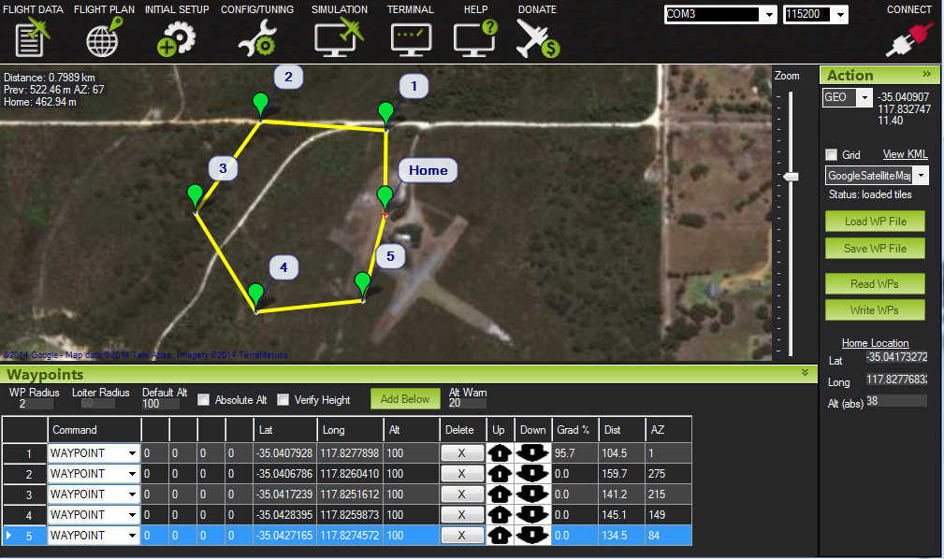

*Figure 1. Mission Controller layout.*

Currently drones are used for many different purposes, there is a huge hobbyist market along with a fastly growing developer market. One of the main advantages of using autonomous drones are that you can program a specific function for it to complete and you won’t have to manually control it. This complicates things a bit as well. For manual control of a basic quadcopter as shown in Figure 1, you only need three basic controls, roll, yaw, and pitch. However, when entering the world of autonomous drones you need to know the position of your drone with respect to its environment; moreso the UAV needs to know where it is in 3D in order to make sure it can proceed.

The current method of autonomous control for the CrazyFlie 2.0 is using a “Flow Board” which is basically just an optical flow sensor and a ToF(Time of flight) sensor. The Flow deck consists of a VL53L0x ToF sensor and a PMW3901 optical flow sensor. The ToF sensor gets the distance to the ground with high precision and the optical flow sensor tracks the movement of the drone with relation to ground. The other part of getting the CrazyFlie 2.0 to fly autonomously is through the use of the location positioning nodes and location positioning deck that is available through bitcraze. The way it is currently works is the loco positioning deck communicates with the nodes and figures out the distance from the nodes and uses that to figure out its position. This works in a room but doesn’t work for the application that we were intending it to use.

**2.2 Literature Search**

The technology of drones has been around for decades, however, they are just beginning to see mainstream appeal. They have also been utilized by the military for years but were not very popular with the public. Since their gain in popularity, more studies have been conducted on and with drones and these findings can now be found in several scholarly journals. In a recent article from 2016 titled “Reactive Controls of Autonomous Drones” by Bregu et al., it describes the use of autopilot software and its implementation with the drone of hardware. This article is just one of the many articles which have been written on the subject of autonomous flight as well as drone flight. Some of these articles have been referenced throughout this paper and can be seen in the reference section of the workbook.

The drone that we have decided to implement the autonomous software with is the Crazyflie 2.0. This drone is the successor of the Crazyflie 1.0 created by Bitcraze. Because it is open source and very new, there are little journal articles dedicated to this particular drone, however, there is a plethora of articles and forum posts dedicated to this drone that can be found online and are referenced below in the works cited. Lastly, the autopilot software to be utilized, PX4, is an open source software which has large amounts of documentation, and is referenced in the works cited section of this document.

**2.3 State-of-the-art**

The drone market is flooded with drones specific to the the individual needs of the person purchasing the drone. The drone is growing at an exponential rate, according to an article on recode global sales grew about 60 percent in the last year, with the hobbyist market almost doubling. Drones are becoming more compatible and some can even be controlled through the Android platform [14]. The leading company in the hobbyist community is definitely DJI which make drones with excellent video and photo functionalities. The current drone they offer which is considered the best in the field is the DJI Mavic Pro which can go up to 65 mph and has 27 minutes of fly time. It has a range of about 7 km and has a 3-axis gimbal attached to the camera. Currently we are looking into editing and making changes to their drones if possible. In terms of having a stable drone that we can use to perform the functionality we need, it would be better to try and “hack” their software and make the necessary modifications.

There is also a growing market for drone racing, it’s to the point where people are talking about drone racing being an actual sport. Most drones outside of racing racing drone are using LiPo(Lithium Polymer) batteries for the following reasons: low profile and rechargeable, sizeable charge density, and with high C ratings can deliver lots of current without too much degradation. A pretty good racing drone that we examined was the KingKong 210GT. The components used on this drone were something that we considered, however we later decided not to pursue this drone due to the controller software being incompatible with our expertise. The 210GT runs the F3 flight controller, which is a suitable product; however, we wanted something that would be more open source and developer friendly where we could make some modifications.

# **Chapter 3 Project Requirements**

**3.1 Domain and Business Requirements**

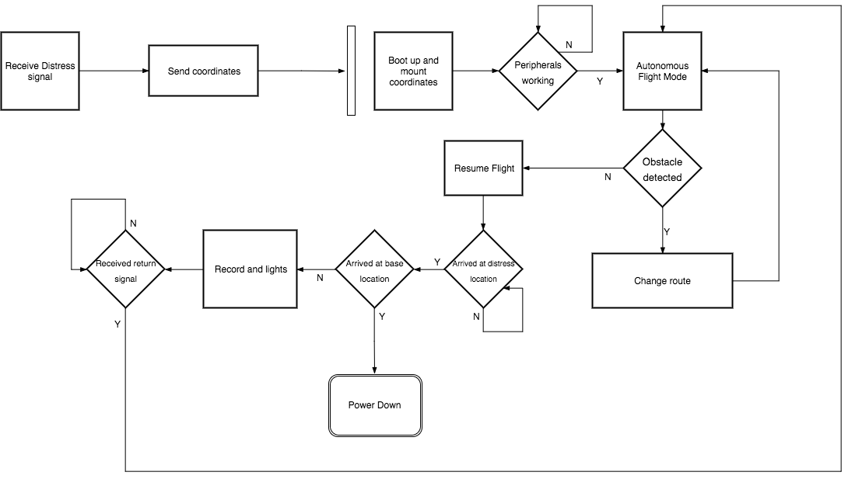

**Figure 2.** UML2 Activity diagram demonstrating state transition

As shown in the UML2 activity diagram, the drone begins with the base receiving an input from the “distress signal” and then transfers the desired GPS location to the drone causing the boot up procedure. The drone check that the peripherals are working and then proceed to flight. Once the drone is in flight, it goes towards the destination and continuously checks for an object. If there is an object in the way, the drone changes it route and resumes its original protocol for flying towards the location but still checks for objects in the way. It runs a check to see if it has arrived at the distress location and once it has arrived, it checks the flag for having arrived. This flag will be used later for checking if the drone has arrived at the base station location. Once it’s at the location, it begins to record and illuminate the location of the distress signal. After it receives the return signal, it begins its protocol

**3.2 System Functional Requirements**

Within the system there are several functional requirements that are required to successfully build the MVP. The functional requirements are the requirements deemed necessary to complete a fully operating system. There are requirements that are considered non-functional requirements which are requirements that describe the numerical performance of the system.

***Functional Requirements***

* The system shall be able to turn on from the base station
* The system shall fly to the desired location of the user
* The system shall utilize the GPS module
* The system shall avoid objects during flight
* The system shall begin recording when it reaches the desired location
* The system shall fly back to the base when the return signal is sent
* The system shall go into a wait state for the next signal

**3.3 Non-functional Requirements**

* The system shall take no longer than 30 seconds to boot and take flight
* The system shall maintain a flight time of at least 15 minutes
* The system shall carry the payload of the Raspberry Pi and other peripherals
* The system shall go to the correct destination 90% of the time
* The system shall be capable to operate at a range of at least ½ a mile
* The system shall take at least 5 minutes of video

**3.4** **Context and Interface Requirements**

The development was comprised of two sections: hardware and software. The hardware was comprised of several different modules which came together to form one larger system. The CrazyFlie 2.0 controller was mounted on the Xiro drone frame which had 4 new ESCs for generating greater power. The ESCs were powered by a new Lipo battery and the Raspberry Pi module as well as GPS module were mounted upon the drone.

Regarding the software, the development came from various locations of open sourced code. The CrazyFlie drone is an open source drone, so many solutions are available. The software would be flashed on the Crazyflie over radio signal. The Raspberry Pi also had to have code mounted on it to implement camera recording or photography applications.

The testing for the modules could sometimes be conducted separately. For instance, the testing and verification of the Raspberry Pi module could be completed outside the context of the system. For the GPS, it had to be tested on the system in order to generate the readings needed for debugging. The frame could be tested first by adding the new ESCs and battery and testing the drone manually for testing the payload and power generated. The Crazyflie software could be tested by mounting it on the Crazyflie first and the putting it on the Xiro drone frame.

The deployment of this system took shape in the form of the fully functioning autonomous response drone system. It is a full drone system which incorporates each module into one functioning unit. It has the ability to take an input signal and travel to that location and avoid objects on the way. Additionally it has the ability to record video and maintain stable flight. Lastly, it can return to the base where it can be charged again and waits for the next signal to be issued.

**3.5** **Technology and Resource Requirements**

| Part | Description |
| --- | --- |
| XIRO Xplorer Aerial UAV Drone Quadcopter | Drone Chassis and motor assembly. |
| RacerStar 4-in-1 20A Brushless ESC 2-4S for Quadcopter Racing Drone | Electronic Speed Control. |
| SD-card deck | N/A |
| Buzzer deck | N/A |
| BigQuad deck | Expansion board for CrazyFlie. |
| CrazyFlie 2.0 | Small open source drone. |
| 6-cell AA battery holder | Battery power for smaller components. |
| Molex Connectors | N/A |
| Molex Contacts | N/A |
| LiPO Battery | Battery to power bigger motors. |
| 4 x IR Sensor | IR sensors for various uses. |
| 4 x 3 pin headers for expansion board | N/A |
| uBLOX MAX-M8C Pico Breakout with Chip Antenna | GPS module for custom firmware. |
| 1 x telemetry module | Addon |
| 1 x radio antenna dongle | Addon |
| 4 x 3 pin molex connectors (3.16mm or .1inch pitch) 2.65mm or .1 inch pin width | N/A |
| 6 x Energizer AA batteries (ENERGIZER NH15-2300) | Batteries for battery holder. |
| 1 x 4 pack AA battery cell holder | Battery power for smaller components. |
| 4 x Break-away 0.1" 2x20-pin Strip Dual Male Header (PRODUCT ID: 2822) | N/A |
| 4 x GPIO Header for Raspberry Pi A+/B+/Pi 2/Pi 3 - 2x20 Female Header (PRODUCT ID: 2222) | N/A |

The software stack is split into two main parts, one handles the drone and other external peripherals. The drone consists of a bootloader which is flashed onto the drone for extended onboard functionalities. While the firmware allows external boards and custom designs to be produced. Uploading the crazyflie custom qground control firmware and bootloader these open source software libraries were used. The libraries are mainly low level C code with a simple wrapper of python. Since we are integrating custom hardware the firmware and bootloader are built for a specific set of hardware.

<https://github.com/PX4/Firmware>

<https://dev.px4.io/en/flight_controller/crazyflie2.html>

<https://github.com/PX4/Bootloader>

The second part of the code deals with the RPI running on linux based debian systems. The goal is to be able to store video and audio data on microsd card code and be able to upload it to a server. This will include battery managment, elevation, audio, video, led control, and all internals.

**Chapter 4. System Design**

**4.1 Architecture Design**

ARD is designed around the concepts of stability, simple assembly, and modular simple maintenance. The chassis is a *XIRO drone* frame which features a quad motor configuration with blade style propellers, and a retractable quad leg landing gear system. The chassis is able to house the several primary components: Crazyflie 2.0 chassis and microcontroller, BigQuad expansion deck, electronic speed controller (ESC), and the situational record unit (SRU). The overall chassis is made of formed plastic, and houses several built in components: 4 DC brushless motors, LED’s, and system wiring for easy integration.

The core of ARD is the SCB, which is a Crazyflie 2.0 micro controller built around the STM32F405xx processor, which outputs PWM signals to the ESC for motor control. This board also contains several components required for aerial embedded systems: pressure transducer for altitude sensing, 3-axis accelerometer for tilt angle sensing, 3-axis gyro for rate sensing, and a 3-axis digital compass which helps the drone find its heading with respect to true north. It also uses the nRF51822 radio and power management MCU which is a Cortex-M0 architecture. This board performs a dual purpose as it is used for power management as well.

The ESC is a 4-channel DC-AC controller. It takes in 4 separate PWM signals from the SCB (one for each motor), and distributes the signals to their addressed motor. It utilizes a 12V DC power from a 5200mAh Li-Po battery that is rated at 20C. The ESC can handle a distribution of up to 20A across for each AC Brushless motor.

The motors are each rated for 100W, and take in 3-phase AC. They are axial-flux motors which means their outer housing rotates as the electromotive force is applied to it. This means the motors are efficient as compared to DC brushless.

All electronics with the exception of the high powered components (motors and servos), will be powered by a filtered and regulated 240 mAh LiPo battery. This will allow the engineers to power any onboard device via their respective power port (e.g. USB port, through-hole header, screw terminal fastener, etc). The board offers simplicity in terms of power management and application to ensure long lasting life.

For the user interface, there will simply be a handheld device such as a mobile phone with an application where the user can just send a request to the main station, and that will in turn activate the drone. It maintains a constant broadcast for the drone to map its way to the user in distress. Once the range has been minimized, the drone will then know the location of the user, as be able to capture the on scene information.

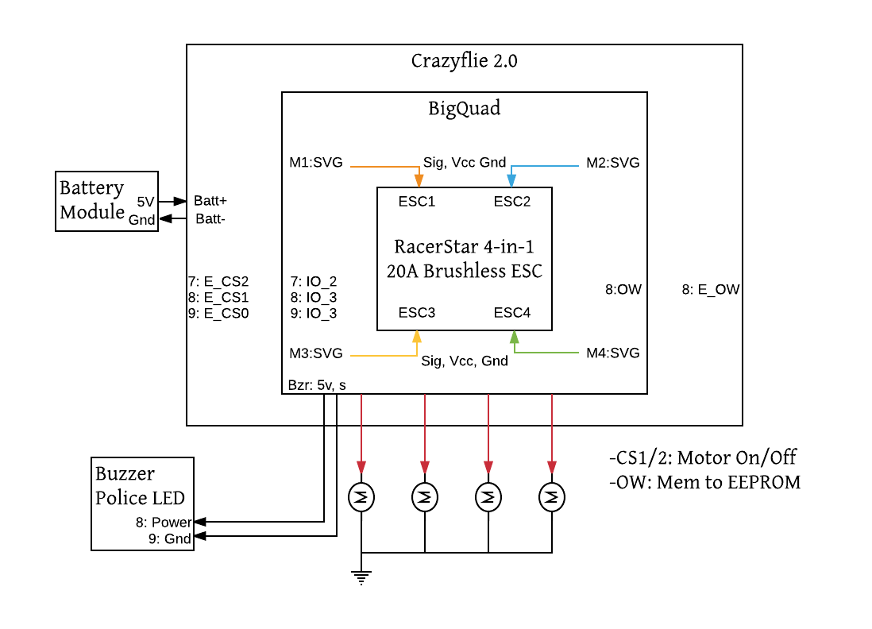

Figure: ARD Central Stack

**4.2** **Interface and Component Design**

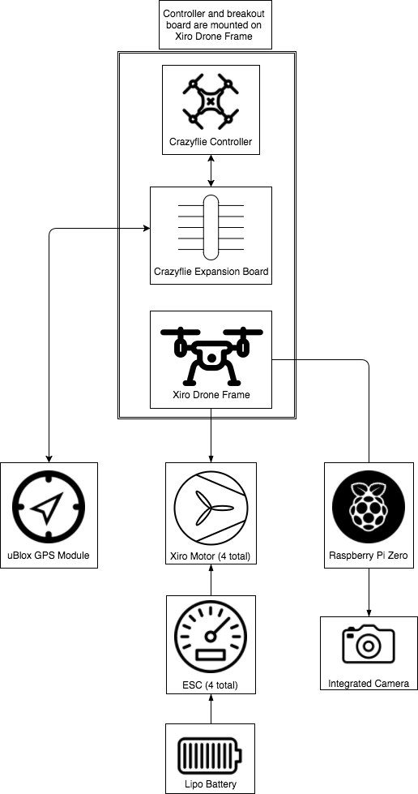

Figure: Overall system block diagram

**4.3** **Structure and Logic Design**

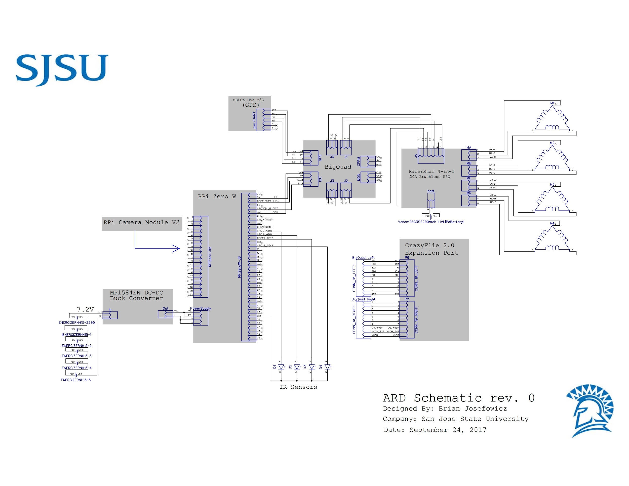

Figure. Diptrace pinout of full system

**4.4 Design Constraints, Problems, Trade-offs, and Solutions**

Throughout the process of planning and development, engineers must foresee the possible setbacks in order to mitigate risk, and have a chance to design around the issues that can arise from unforeseen failures. Certain parameters play a key role in creating the proper design plan going forward, and here are the factors that were considered during the planning and design process.

* 1. **4.4.1 Design Constraints and Challenges**

The primary design constraint is of course time. We need to be sure that our design fits our capability to deliver a working product on time including testing, regression, and possible changes that may occur. Similarly, we are limited on financial contribution which means we need to not only build a reliable product, but a cost effective one too. Individual mistakes turn into sunk costs, so it is a goal to minimize the reality of these risks.

A large constraint is ensuring proper integration between hardware and software. In our design, we will be modifying the drone to take on a larger chassis. With these modifications, unforeseen circumstances may arise. The drone may not be able to generate enough power with the new chassis or the drone’s balance may be thrown off. These types of challenges have to deal with and overcome either with additional hardware modifications or modifications to the software. In order to have a successful autonomous drone, the drone’s hardware must be able to work effectively with the software. The drone must properly relay information from the sensors, and the code we implement must adjust accordingly.

While there are some hardware changes being performed on the drone, those challenges are miniscule compared to the challenge of programming for autonomous flight. The drone will largely act like a state-machine, following various states to achieve takeoff, flight, and landing, however, these steps themselves are very intricate. In order to execute autonomous flight, the drone must be able to recognize the location of a signal and properly reach that destination. This includes using its own sensors to avoid obstacles, and that can be implemented with sensors that mimic vision for the drone, or exteroceptive sensors [6]. Using IR or laser sensors, the drone will be able to accurately tell the distance from an object and following its programming, be able to avoid it and continue. The drone will also have to ensure that its in proper working order to be able to make the flight. Damage to certain sensors or a low battery would hinder the success of the drone flying to its destination. The drone will make use of proprioceptive sensors which monitor the drone’s internal status [6]. This will ensure safe flight and prevent damage to the drone or to any objects or people.

**4.4.2 Design Solutions and Trade-offs**

To compensate for the low load capacity of the CrazyFlie, an additional chassis and ESC were purchased. These additional components will allow for us to carry a heavier payload and provide more stable flight. With this additional chassis comes extra weight. The tradeoff of being able to generate more power is that the drone will consume more power from the battery. With this in mind, a shorter flight time and more consistent charges will be required, or the purchase of a larger battery may be necessitated.

The use of external, third-party sensors is a solution we came to in order to provide a more accurate and controllable object detection system. Compared to other drones which are equipped with cameras, the sensors will work more effectively and do not necessitate creating an object detection algorithm based on a 2D image. The drawback of using third-party sensors compared to the proprietary components is that they may be harder to manage. While it may not be simple plug and play like the cameras that come standard on some drones, the CrazyFlie’s expansion connectors and implementation of the big quad deck will allow for simple integration of various third-party sensors and components

**Chapter 5. System Implementation**

**5.1 Implementation Overview**

The fundamental principle behind designing the ARD was to make everything modular, compatible, and simple to manufacture. The drone core allows us to adapt a lightweight platform into any larger scale assembly while maintaining the open source capabilities. With the addition of Raspberry Pi Zero W boards, added functional capabilities are made possible. Some of which include, live video recording, object detection, and user interfacing for cellular communication. To meet the needs of the drone we needed to focus on limiting the dependencies, and maintaining freedom in terms of drone software implementation.

Assembly of the drone requires the removal of the proprietary Xiro Explorer core such that the motor pin interface is fully exposed. The onboard LED’s are not required for the CrazyFlie 2.0 integration. Once the chassis is prepped for interface, the manufacturing process moves over to assembling the drone core.

**5.2 Implementation of Developed Solutions**

The drone core comes in several different pieces: CrazyFlie 2.0 drone, BigQuad expansion board, and the 4-channel ESC. By taking each component and its constituent hardware, it is intuitive to follow through with the mounting process. The interface should mate the CrazyFlie 2.0 to the top of the BigQuad board. This will allow all control signals, and data communication to flow through the core to peripherals. Then mounting the 4-channel ESC to the bottom of the BigQuad gives accessibility for the PWM signal pins to be connected between ESC inputs and BigQuad outputs. These signal pins and constituent 5V and Gnd pins provide power, gnd, and motor signal control to the ESC. This setup is what makes up the entirety of the drone core.

Peripherals to the drone core include: two Raspberry Pi Zero W boards with attached HD cameras capable of delivering 1080P video feed to the ground control station, a GPS module that provides accurate real-time GPS location of the drone, four Arduino laser sensors attached to the RPi GPIO pins providing distance to object recognition, and a low current battery power supply regulator board eBoot Mini MP1584EN DC-DC Buck Converter. The interface between Raspberry Pi Zero W boards and the drone core will be handled using the I2C communication protocol. The implementation will allow us to send messages from the RPi to the drone core registers which will store data for the PX4 autopilot software to read from. It is imperative to ensure that all firmware developed for the RPi’s have the proper addressing references for the drone to operate properly.

The laser sensor components allow us to sense the response time between laser output, and reflected signal input to the RPi. This time data will be stored into 4 separate bytes equating to a 32-bit value for interpretation by the PX4 firmware. The 32-bit value is sent over the I2C bus, and received by the PX4 control system for auto piloting the drone in an avoidance pattern pattern. We have also developed an object avoidance redundant system such that the PX4 control system fails. The concept is to stop the drone when an object is detected within 15 meters. If the object location persists, the drone should raise its elevation until the object is cleared, or another object is detected. If the drone cannot clear the object within a 10 foot elevation climb, it should then begin sending calculated GPS coordinates using a heading reference. While maintaining the original GPS location, the drone will essentially be navigated around the object until there is no longer an object impeding the line of travel towards the initial location.

To mount the core, high current battery, and low current batteries along with the surrounding peripherals, we needed to design a rapid prototyping mounting fixture. This allows us to place components on the frame without offsetting its geometric weight balance. Our hardware also reduces the overall weight of the drone allowing us more payload room for adding the additional peripherals. Although our high current battery possess half the capacity of the OEM part, we have a smaller profile package, and a 63% weight reduction. The battery also meets our ESC’s 20C rating. The low current 6 AA cell pack provides the necessary current and voltage to supply power to the RPi boards and cameras.

**5.3 Implementation Problems, Challenges, and Lesson Learned**

Implementation problems mainly revolved around proprietary hardware and software pairing with open source software. Finding the proper drone configuration was a lengthy step. Problems with weight, power, expansion options were are limiting factors to the project. Challenges were also faced during software development. The main challenges were the compilation and flashing of a custom bootloader and custom firmware upon the drone. Due to various operating systems and most of the drone software and hardware is still in beta. The BigQuad expansion board is still under beta testing, along with the PX4 firmware for the CrazyFlie.

Overcoming challenges has pushed the project forward. The biggest lesson learned is to pay attention to every detail and research part and product before assuming it can be implemented. During the project assembly and testing it is best to be in a safe environment. Smaller lessons learned earlier such as test every corner case, write scaling code, and document everything helps during the early stages. The presentation can not contain a demo as San Jose city is a no fly zone, however testing and demo will be done at a more suitable environment.

**References**

[1]A. Glaser, "Police departments are using drones to find and chase down suspects", *Recode*, 2017. [Online]. Available: https://www.recode.net/2017/4/6/15209290/police-fire-department-acquired-drone-us-flying-robot-law-enforcement.

[2]"projects:crazyflie2:hardware:specification [Bitcraze Wiki]", *Wiki.bitcraze.io*, 2015. [Online]. Available: https://wiki.bitcraze.io/projects:crazyflie2:hardware:specification.

[3]"Raspberry Pi Zero weight & power consumption | mitat.tuu.fi", *Mitat.tuu.fi*. [Online]. Available: http://mitat.tuu.fi/?p=423. [Accessed: 10- Aug- 2017].

[4]"doc:crazyflie:bootloader:index [Bitcraze Wiki]", *Wiki.bitcraze.io*, 2015. [Online]. Available: https://wiki.bitcraze.io/doc:crazyflie:bootloader:index.

[5]"Crazyflie 2.0", *Bitcraze Store*, 2017. [Online]. Available: https://store.bitcraze.io/products/crazyflie-2-0.

[6]G. Bekey, *Autonomous Robots: From Biological Inspiration to Implementation and Control*. Cambridge: MIT Press, 2005, p. 11.

[7]"projects:crazyflie2:architecture:index [Bitcraze Wiki]", *Wiki.bitcraze.io*, 2015. [Online]. Available: https://wiki.bitcraze.io/projects:crazyflie2:architecture:index.

[8]"STM32F405RG - High-performance foundation line, ARM Cortex-M4 core with DSP and FPU, 1 Mbyte Flash, 168 MHz CPU, ART Accelerator - STMicroelectronics", *St.com*, 2017. [Online]. Available: http://www.st.com/en/microcontrollers/stm32f405rg.html.

[9]"nRF51 Series SoC / Products / Home - Ultra Low Power Wireless Solutions from NORDIC SEMICONDUCTOR", *Nordicsemi.com*, 2017. [Online]. Available: https://www.nordicsemi.com/Products/nRF51-Series-SoC.

[10]"Mission Planner Home — Mission Planner documentation", *Ardupilot.org*, 2016. [Online]. Available: http://ardupilot.org/planner/index.html#home.

[11]"projects:crazyflie2:expansionboards:bigquad [Bitcraze Wiki]", *Wiki.bitcraze.io*, 2016. [Online]. Available: https://wiki.bitcraze.io/projects:crazyflie2:expansionboards:bigquad.

[12]L. Koh and S. Wich, "Dawn of Drone Ecology: Low-Cost Autonomous Aerial Vehicles for Conservation", *Tropical Conservation Science*, vol. 5, no. 2, pp. 121-132, 2012.

[13]Z. Yu, K. Nonami, J. Shin and D. Celestino, "3D Vision Based Landing Control of a Small Scale Autonomous Helicopter", *International Journal of Advanced Robotic Systems*, vol. 4, no. 1, p. 7, 2007.

[14]R. Faragher, O. Chick and D. Wagner, "Captain Buzz: An all-smartphone autonomous delta-wing drone", *Workshop on Micro Aerial Vehicle Networks, Systems, and Applications (with ACM MOBISYS)*, 2015.

**Appendices**

**Appendix A –**

[Typical example: you can include a specific standard here.]

**Appendix B – Source Code**

[Typical example: you can include a specific interface details here.]