CMPE 195B

September 10, 2017

Update for Project ARD

Group Updates:

Anahit

* Gave brian custom pcb fabrication design. Need custom mounts and circuits for powering RPIs.
* Waiting for Xiro drone to be replaced with crazyflie 2.0 expansion board.
* Storage of video and audio data on microsd card code began.
* Helped with crazyflie firmware uploading.
* Uploaded crazyflie custom qground control firmware
  + <https://github.com/PX4/Firmware>
  + <https://dev.px4.io/en/flight_controller/crazyflie2.html>
  + <https://github.com/PX4/Bootloader>
* 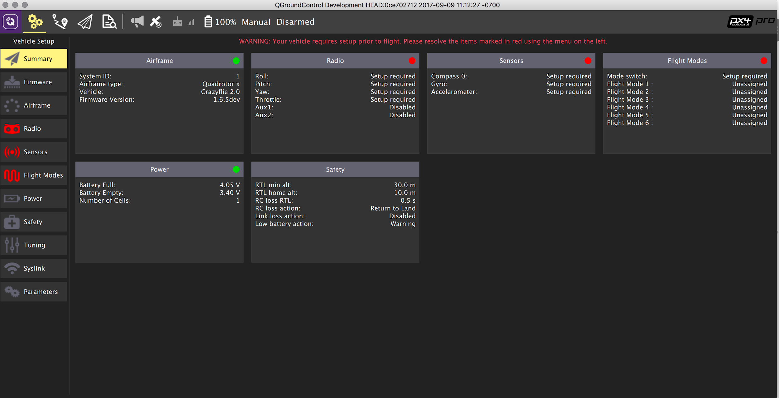
* 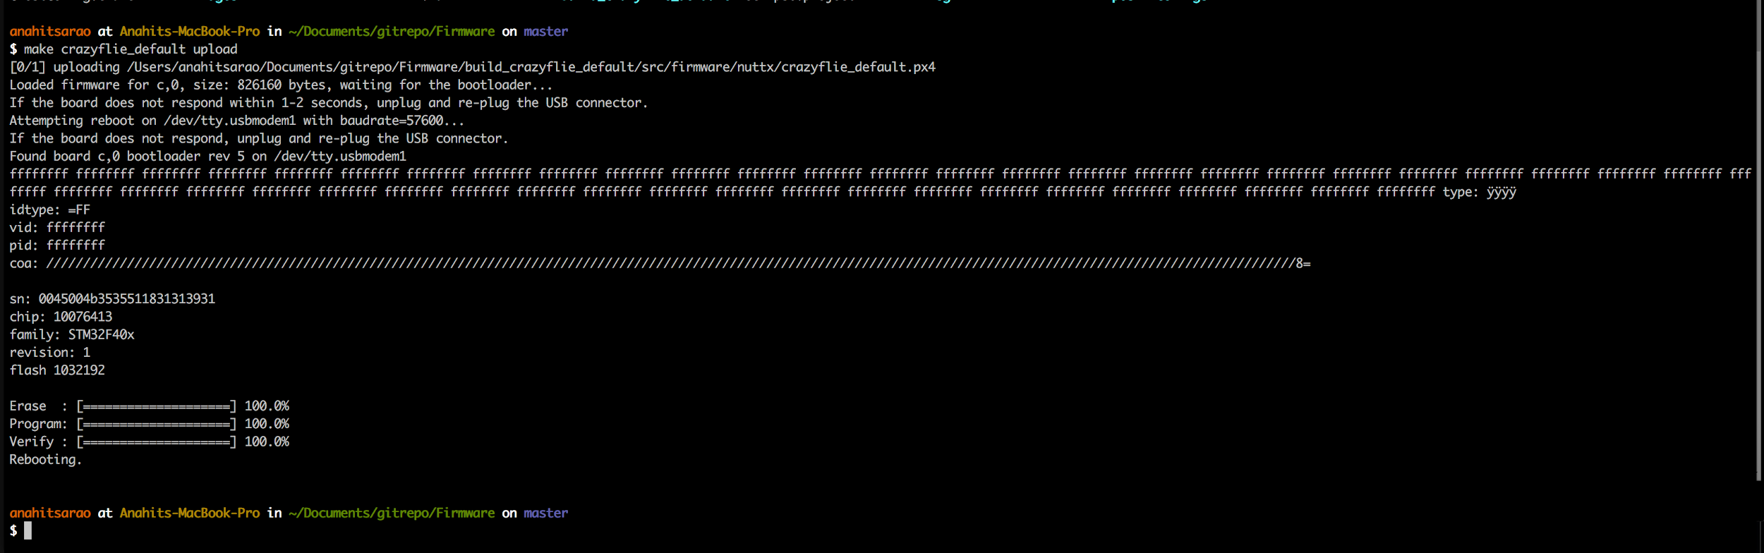

Ali

* Worked with Anahit to get the PX4 Ground control on the crazyFlie.
* Working on bootloader issue with MAC environment.

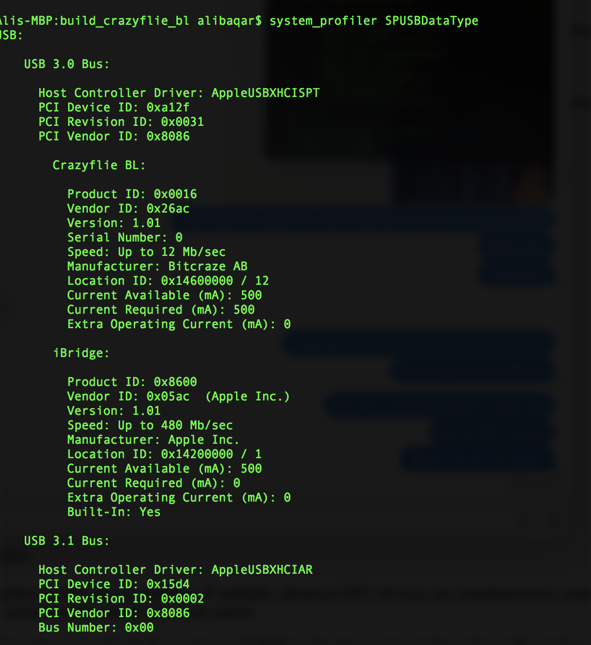

* Worked on next steps to take with the project.
  + Need more sensors for the Ground Control software to properly connect to drone.

Max

* Revised abstract to provide include our updated approach
  + New approach entails directing the drone to location and having it return to original location
* Met with Anahit and Ali to discuss current applications and software being utilized for the drone to relay in report
* Reviewed PX4 documentation and assisted with bootloader uploading

Brian

* Out of town this weekend for Guard duty, but made plans for PCB design, and drone testing this week.
  + Wed, 9/13 - Xiro disassembly
  + Wed, 9/13 - Connect Crazyflie and Xiro drones
  + Wed, 9/13 - Test Crazyflie firmware on Xiro chassis + motors
  + Wed, 9/13 - Begin research on specs and parts for PCB design (stretch goal)
  + Sun, 9/17 - Route PCB for RPi power supply / regulator