CMPE 195B

September 24, 2017

Update for Project ARD

Group Updates:

Anahit

* Assisted with latest BOM for new parts
* Helped setup the GCS and implement PX4 testing
* Helped figure out the hardware setup to support software development

Ali

* Setup the ground control station
* Connected PS3 controller to drone for testing the PX4 firmware
* Verified that PX4 firmware runs properly on CrazyFlie

Max

* Ublox MAX-M8:
  + Product page: <https://www.u-blox.com/en/product/max-m8-series#product-information>
  + Data sheet: <https://www.u-blox.com/sites/default/files/MAX-M8-FW3_DataSheet_%28UBX-15031506%29.pdf>
    - Pin assignment in section 2.1 page 15
    - 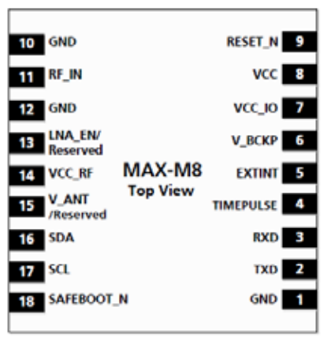
* SARA-N2 NB IoT:
  + Product page: <https://www.u-blox.com/en/product/sara-n2-series#product-information>
  + Product summary: <https://www.u-blox.com/sites/default/files/SARA-N2_ProductSummary_%28UBX-16014015%29.pdf>
    - No pinout available possibly due to not being fully developed
* Cellular module overview:
  + <https://www.u-blox.com/sites/default/files/CEL-module-selector_Overview_%28UBX-14001802%29.pdf>
    - Contains compatibility between GNSS and cellular modules (page 3)

Brian

1. Finished rev. 0 schematic for ARD - attached in E-mail
2. Spec’d out battery for motor power
   1. [Venom 2200 20C 3s](https://www.venompower.com/products/venom-20c-3s-2100mah-11-1v-lipo-battery-with-universal-plug-system)
   2. This battery has less capacity; however, it is nearly half the size, and less than half the mass of the OEM battery. It will allow us to carry the additional payloads of our peripherals, and still weigh less than OEM.
3. Spec’d [IR sensors](https://www.amazon.com/KY-008-Copper-Sensor-Module-Arduino/dp/B01CG52K1S/ref=sr_1_17?ie=UTF8&qid=1506314576&sr=8-17&keywords=laser+module)
4. Designed implementation for the RPi → CrazyFlie 2.0 communication
   1. Need to contact the developers of PX4 firmware to figure out **which memory locations within the CrazyFlie 2.0 they are reading for IR sensor values, and/or any GSM data**. This will tell us where to write the “sensor” on the CrazyFlie using I2C from the RPi. This should allow us to achieve object avoidance if the firmware supports it.
5. Spec’d [AA Energizer batteries](https://www.digikey.com/product-detail/en/mpd-memory-protection-devices/BH26AAB/BH26AAB-ND/2439329) for powering the 4 RPi boards, and peripherals
   1. Also spec’d out a cell holder that can be mounted on board.
6. Spec’d out [voltage regulator](https://www.amazon.com/eBoot-MP1584EN-Converter-Adjustable-Module/dp/B01MQGMOKI/ref=pd_sbs_23_4?_encoding=UTF8&psc=1&refRID=0SRH9Q93HZE9BMJ6HXVV) for the RPi’s
7. For the GSM module, Max has noted some of the issues with that. The UBLOX may support GSM or some kind of cellular communication, but the other units out there do not permit this in the US. As far as the connection interface between the CrazyFlie and the UBLOX, they use **UART**. Can be seen in the schematic.The BigQuad routes this channel to the CF board. Hopefully the PX4 firmware reads from that location.