Articles Api

Revision History
Date | Version | Prepared by | Comments
04.03.2022 | 1.0.0 | Yanko Mihaylov | First revision

Overview
Crud for Articles
Get/Post methods

Endpoints for Articles
- /api/getArticles
- /api/createArticle
- /api/deleteArticle
- /api/editArticle

getArticles

Get all Articles from api.
This is Get request.

The endpoint have optional parameters page_size , page_number
set This parameters to pagination dinamically

Request: /api/getArticles?page_size=10&page_number=1

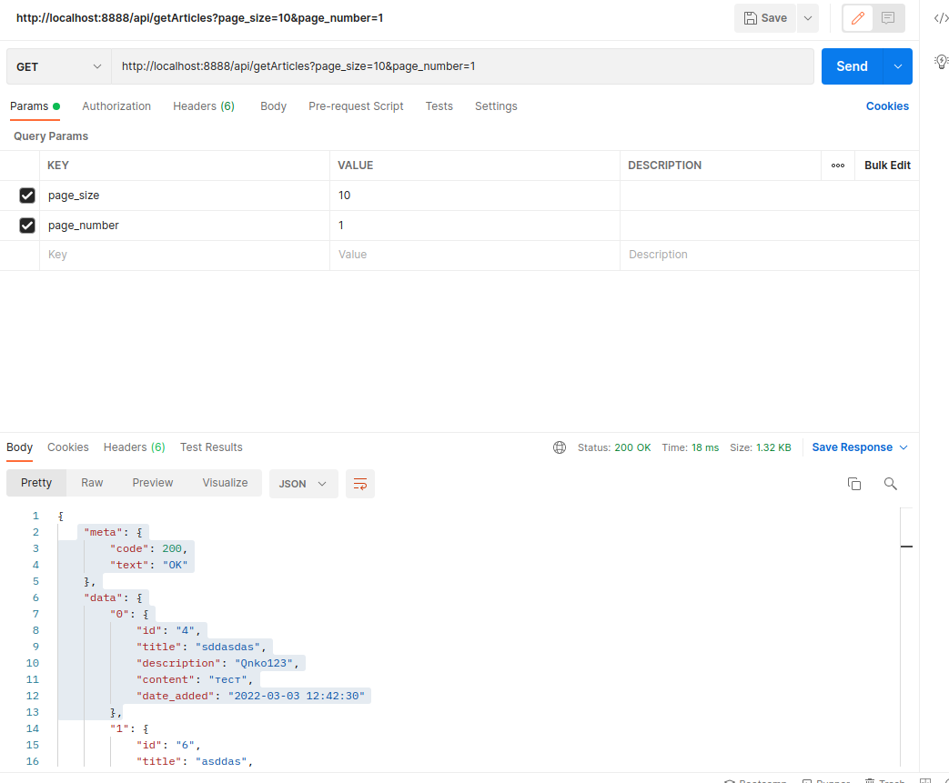

Response:
"meta": {
"code": intiger,
"text": string
},
"data": {
"text": string
}

createArticle

This is Post request.

The endpoint expects form-data title , contend ,description and optional parameter type=file if wana save data to file not to database

Request: api/createArticle
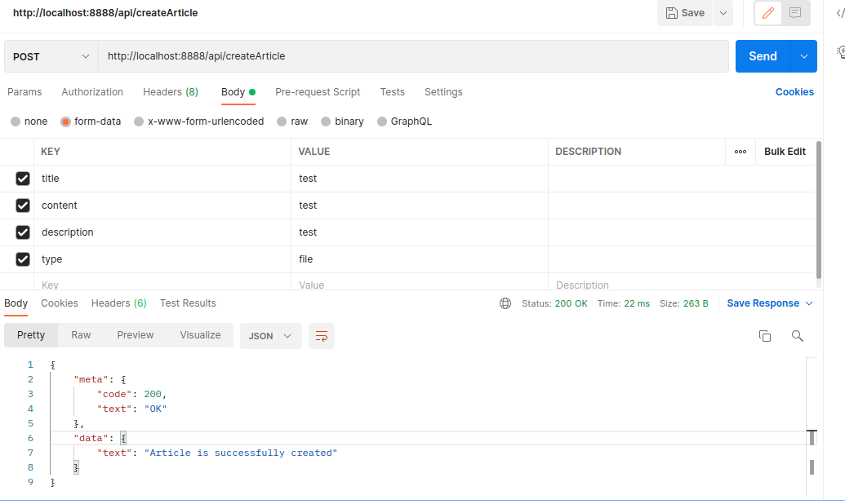

Response:
"meta": {
"code": intiger,
"text": string
},
"data": {
"text": string
}

deleteArticle

This is Get request.

The endpoint expects mandatory params id.

Request: api/deleteArticle/id
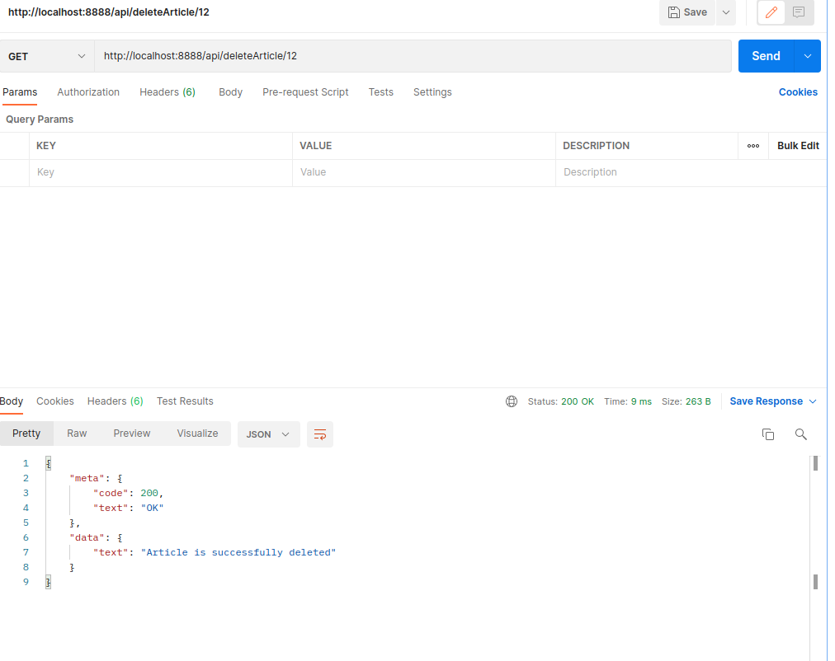

Response:
"meta": {
"code": intiger,
"text": string
},
"data": {
"text": string
}

editArticle
This is POST request.api/editArticle.

The endpoint expects mandatory params id and

Request: api/editArticle
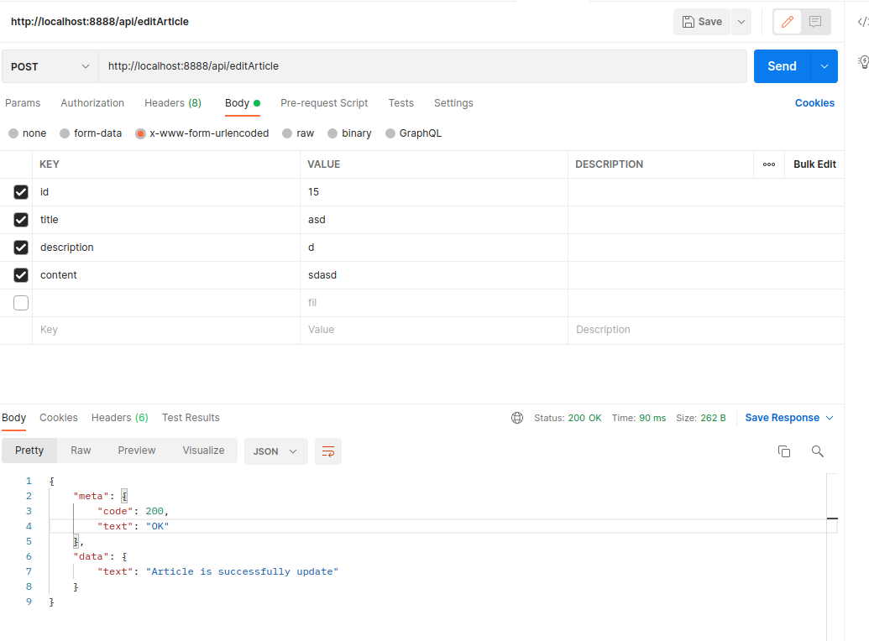
Response:
"meta": {
"code": intiger,
"text": string
},
"data": {
"text": string
}

