22 РАЗВЕРТЫВАНИЕ ПРИЛОЖЕНИЯ
Задание: выполнить развертывание ASP.NET приложения, разработанного
в рамках практики по программированию, двумя способами: С помощью MS IIS или OpenServer на выбор. (Удобнее OpenServer). С помощью сервиса Render.com (бесплатно для личного использования)

Листинг программы:
; Script generated by the Inno Setup Script Wizard.
; SEE THE DOCUMENTATION FOR DETAILS ON CREATING INNO SETUP SCRIPT FILES!
; Non-commercial use only
#define MyAppName "ShopOrders"
#define MyAppVersion "1"
#define MyAppPublisher "Petrov Roman"
#define MyAppURL "https://github.com/romapetrov-ctrl/Practice"
#define MyAppExeName "ShopOrdersWpf.exe"
#define MyAppAssocName MyAppName + " File"
#define MyAppAssocExt ".gzd"
#define MyAppAssocKey StringChange(MyAppAssocName, " ", "") + MyAppAssocExt
[Setup]
; NOTE: The value of AppId uniquely identifies this application. Do not use the same AppId value in installers for other applications.
; (To generate a new GUID, click Tools | Generate GUID inside the IDE.)
AppId={{06541B23-2AE4-4B89-853A-FB59A000AA76}
AppName={#MyAppName}
AppVersion={#MyAppVersion}
;AppVerName={#MyAppName} {#MyAppVersion}
AppPublisher={#MyAppPublisher}
AppPublisherURL={#MyAppURL}
AppSupportURL={#MyAppURL}
AppUpdatesURL={#MyAppURL}
DefaultDirName=C:\My Program
UninstallDisplayIcon={app}\{#MyAppExeName}
; "ArchitecturesAllowed=x64compatible" specifies that Setup cannot run
; on anything but x64 and Windows 11 on Arm.
ArchitecturesAllowed=x64compatible
; "ArchitecturesInstallIn64BitMode=x64compatible" requests that the
; Uncomment the following line to run in non administrative install mode (install for current user only).
;PrivilegesRequired=lowest
[Tasks]

Name: "desktopicon"; Description: "{cm:CreateDesktopIcon}"; GroupDescription: "{cm:AdditionalIcons}"; Flags: unchecked
[Files]
Source: "C:\Study\Practice Roma\ShopOrdersWpf\ShopOrdersWpf\bin\Debug\net10.0-windows\{#MyAppExeName}"; DestDir: "{app}"; Flags: ignoreversion
; NOTE: Don't use "Flags: ignoreversion" on any shared system files

[Registry]
Root: HKA; Subkey: "Software\Classes\{#MyAppAssocExt}\OpenWithProgids"; ValueType: string; ValueName: "{#MyAppAssocKey}"; ValueData: ""; Flags: uninsdeletevalue
Root: HKA; Subkey: "Software\Classes\{#MyAppAssocKey}"; ValueType: string; ValueName: ""; ValueData: "{#MyAppAssocName}"; Flags: uninsdeletekey
Root: HKA; Subkey: "Software\Classes\{#MyAppAssocKey}\DefaultIcon"; ValueType: string; ValueName: ""; ValueData: "{app}\{#MyAppExeName},0"
Root: HKA; Subkey: "Software\Classes\{#MyAppAssocKey}\shell\open\command"; ValueType: string; ValueName: ""; ValueData: """{app}\{#MyAppExeName}"" ""%1"""

Таблица 16 – Входные и выходные данные
Входные данные | Выходные данные
Готовое приложение , Inno Setup | Рабочий установщик
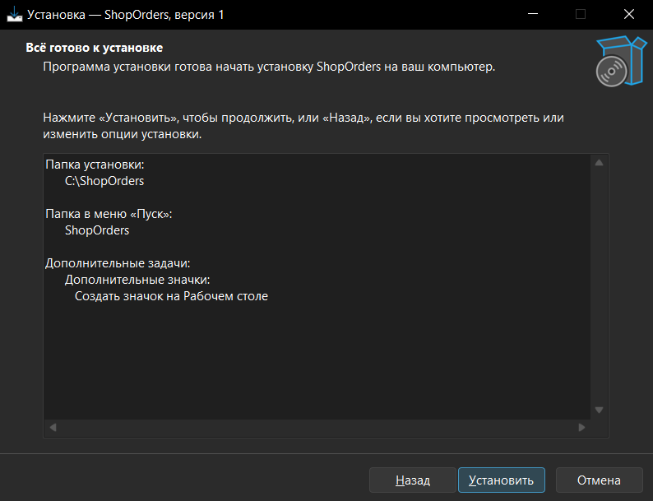
Анализ результатов:

Рисунок 16 – Результат работы программы

