**TEST**

HTML validation for Index page:

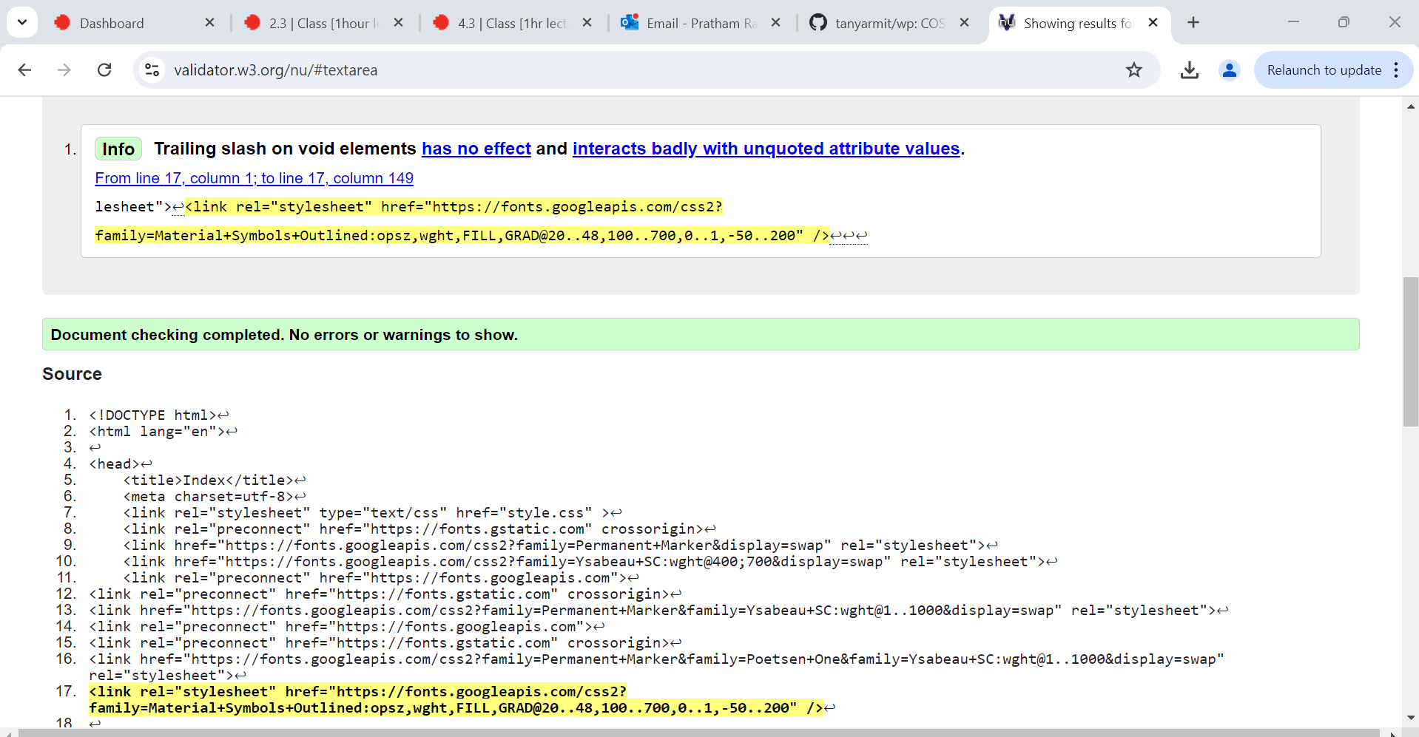

No errors or warnings to show.

HTML validation for pets.html

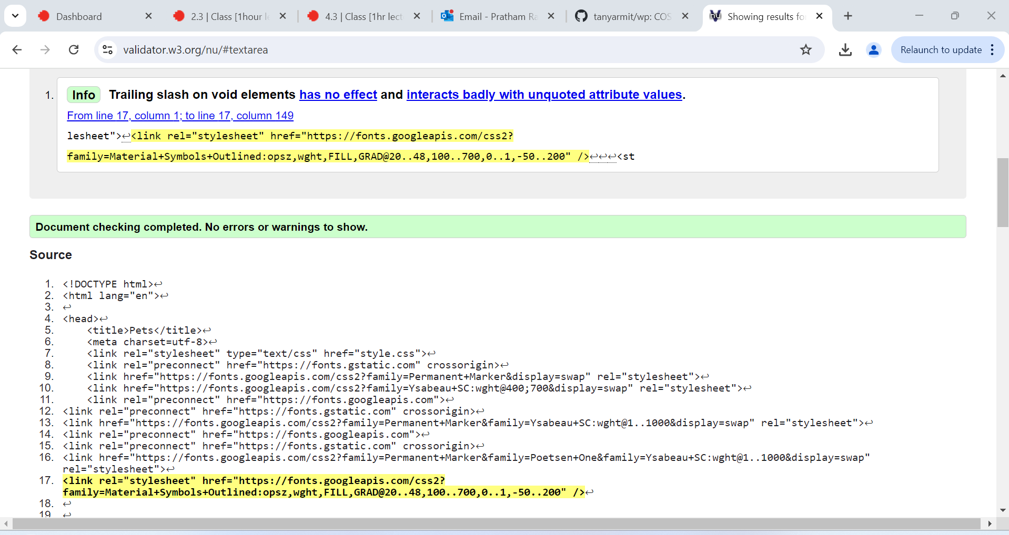

No errors or warnings to show.

HTML validation for add.html:

No errors or warnings to show.

HTML validation for gallery.html

No errors or warnings to show.