IBM × RMIT Capstone

Detailed Auditor & Manager User Flows
Responsible Content-Safety Infrastructure
Prepared by | Harneet Kaur
Role | UX Designer
Sprint | Sprint 1: Design & Bootstrap
Task | Create Detailed Auditor & Manager User Flows

1. Purpose and Requirement Basis
This task converts the earlier high-level UX direction into more detailed Auditor and Manager/Supervisor workflows. The flows are constrained by the BA's finalised Core MVP workflow and prioritised scope. The document deliberately separates confirmed Core MVP functionality from future-refinement and still-unconfirmed behaviour so that UX does not introduce business rules that have not been approved.

2. Requirement Status Legend
Status | Meaning | How it is treated in these flows
P0 — Confirmed Core MVP | Required for Sprint 2 | Shown as the main confirmed path.
P1 — Conditional | May be included if confirmed/feasible | Not required for the main flow.
P2 — Future refinement | Primarily Sprint 3 | Shown only as a clearly labelled future branch.
Pending | Client/BA/PM confirmation still required | Shown as TBD; no exact behaviour is invented.

3. Detailed Auditor User Flow
The Auditor is the primary user. The confirmed path keeps AI as assistive information and preserves the Auditor's final human decision. Where the Planner checklist asks for exposure, wellbeing or decline/escalation steps that are not confirmed as P0 requirements, they are marked as future or pending.
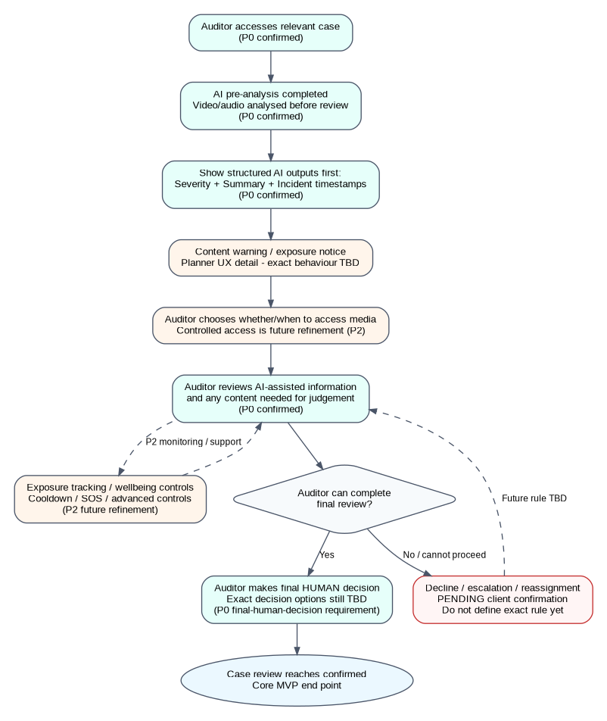

3.1 Detailed Auditor Flow Steps
Planner item | Status | Detailed treatment
Auditor case entry | P0 / partly pending | The Auditor accesses the relevant case. The exact case assignment/availability rule is still pending, so the flow does not assume how a case is assigned.
AI pre-analysis stage | P0 | The submitted approved test video/audio has already been processed by the AI analysis workflow before the Auditor reviews the structured outputs.
Content warnings | Planner UX detail / not separately confirmed as P0 | A warning/exposure notice is represented as a UX safeguard before direct media access. Exact wording, trigger and behaviour require BA/PM confirmation.
Severity / summary information | P0 | The Auditor is shown severity information, a summary and incident timestamps. These are the confirmed structured outputs.
Controlled video access | P2 / future refinement | The flow gives the Auditor control over when direct media is viewed, but advanced exposure-management controls are not part of the confirmed Core MVP.
Exposure tracking | P2 / future refinement | Exposure tracking is represented only as a future refinement concept. No metric, threshold or automatic rule is assumed.
Wellbeing controls | P2 / future refinement | Cooldown, SOS and other wellbeing controls are future refinement items and are not shown as required Core MVP behaviour.
Decline / escalation flow | Pending | The exact decline, escalation, reassignment and case-availability rules are not confirmed. The flow shows a TBD branch only and does not define the system action.
Final human decision | P0 | The Auditor makes the final human review decision. The exact decision-option labels remain pending client confirmation.

4. Detailed Manager / Supervisor User Flow
Manager/Supervisor functionality is a secondary/future-refinement area rather than part of the confirmed Sprint 2 Core MVP. The following flow is therefore a conceptual Sprint 3 direction that covers the Planner checklist without presenting any unconfirmed Manager rule as mandatory.
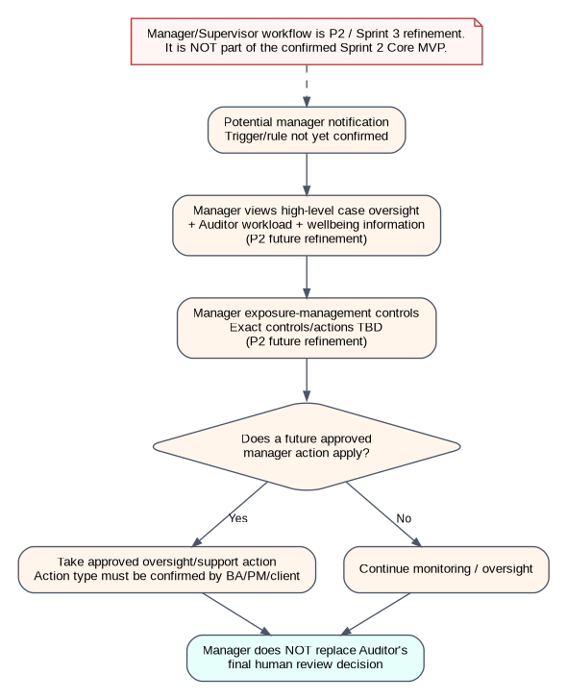

4.1 Detailed Manager Flow Steps
Planner item | Status | Detailed treatment
Manager notification | P2 / future refinement | A future Manager notification may occur if an approved exposure, wellbeing or escalation trigger is defined. The current requirements do not confirm the trigger or notification rule.
Manager case oversight | P2 / future refinement | The Manager may monitor cases, Auditor workload and Auditor wellbeing at a high level.
Manager exposure control | P2 / future refinement | Advanced exposure-management controls are future scope. The exact controls, permissions and actions are not defined in the current Core MVP requirements.
Manager action | Pending within future scope | Any support, workload or case action must be defined by later BA/PM/client decisions. This task does not invent those actions.
Relationship to final decision | P0 boundary | Manager oversight must not replace the Auditor's responsibility for the final human review decision.

5. Auditor ↔ Manager Interaction / Escalation Boundary
The Planner asks for decline/escalation and Manager interaction, but the BA requirements do not confirm the exact escalation, reassignment, notification or Manager-action rules. The interaction below is therefore intentionally shown as a conditional future branch rather than a confirmed Core MVP workflow.
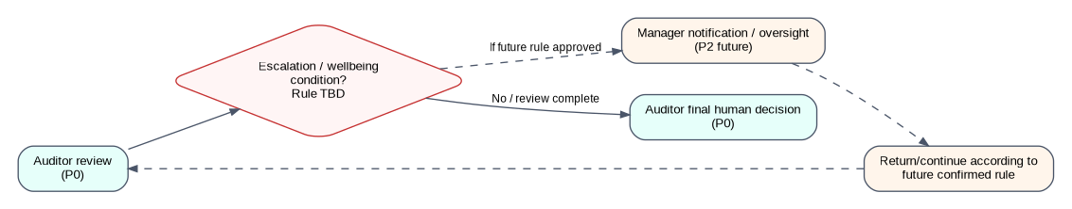

6. Confirmed Core MVP Boundary
The confirmed implementation path remains:
Public User submission → Case ID creation → AI video/audio analysis → Structured AI outputs → Auditor review → Final human decision
Confirmed structured outputs:
- Severity information
- Summary
- Incident timestamps
Important scope boundaries:
- AI is assistive; it does not make the final autonomous decision.
- Only approved synthetic/staged content is used.
- Manager oversight, cooldown, SOS and advanced exposure-management controls are not confirmed Sprint 2 Core MVP functionality.
- Decline/reassignment/escalation rules and exact final-decision options remain pending confirmation.
- Tags and transcription are conditional outputs and must not displace the P0 workflow.

