IBM × RMIT Capstone
High-Level User Flows & UX Direction
Responsible Content-Safety Infrastructure
Prepared by | Harneet Kaur
Role | UX Designer
Sprint | Sprint 1
Primary persona | Auditor / Content Reviewer
Status | Ready for BA / PM / Developer review

1. Purpose and Scope
This artifact maps the high-level interactions of the Public User, Auditor / Content Reviewer, and Manager / Supervisor with the proposed Responsible Content-Safety Infrastructure platform. It also represents the AI-assisted analysis step and records initial UX decisions intended to reduce unnecessary Auditor exposure to potentially distressing content.
The flows are intentionally high-level. They provide UX context for BA review and Developer architecture/data-flow work. Detailed screen design and prototype work will continue in Week 2.
2. Flow Legend and Scope Boundaries
Item | Meaning | Scope status
Public User | Submits approved synthetic/staged content and receives a Case ID. | Core MVP
System / AI | Creates/processes the case and analyses video/audio to produce structured outputs. | Core MVP
Auditor | Primary persona; reviews AI-assisted case information and makes the final human decision. | Core MVP
Manager / Supervisor | Oversight of cases, Auditor workload and wellbeing. | Broader scope / later refinement
Cooldown / SOS | Wellbeing concepts to consider in the Auditor experience. | Future refinement / Sprint 3

3. Combined End-to-End High-Level Flow
Core journey
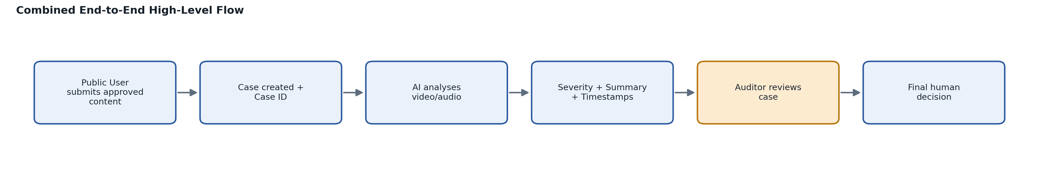
Figure 1. Combined end-to-end high-level flow — the Auditor step (highlighted) is the primary persona interaction.
UX annotation: The AI supports the review process but does not make the final decision. The Auditor remains responsible for the final human review decision.
Manager oversight sits alongside the core journey rather than between AI and the Auditor. The Manager may monitor relevant cases, Auditor workload and wellbeing as the broader solution is refined.
4. Flow 1 — Public User Submission
Public User flow
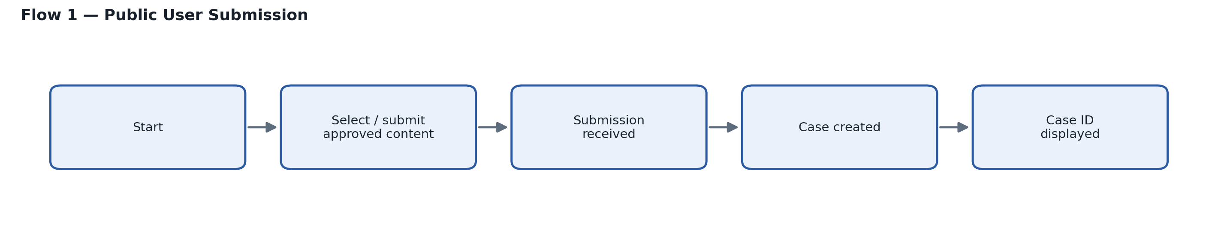
Figure 2. Public User submission flow.
UX annotation: Keep the submission journey simple and guided. Clearly confirm successful submission and make the Case ID prominent.
Key UX annotations
- Use clear guidance about approved/supported content.
- Show submission progress/status so the user knows what is happening.
- Provide a clear success state after submission.
- Display the Case ID prominently so the user can retain it.
- Do not expose internal Auditor or Manager information to the Public User.
5. Flow 2 — AI-Assisted Processing
System / AI flow
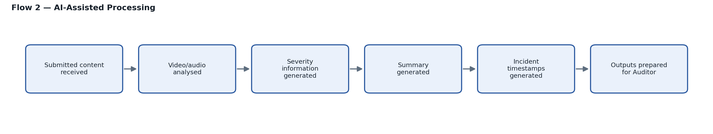
Figure 3. AI-assisted processing flow from submitted content to Auditor-ready outputs.
UX annotation: Severity information, summary and incident timestamps are treated as the confirmed Core MVP structured outputs. Tags/transcription should only be added if later confirmed.
Key UX direction
- AI outputs should be presented as decision-support information, not as an autonomous final judgement.
- The interface should make it clear that AI-generated information can support, but not replace, Auditor judgement.
- Structured outputs should help the Auditor understand the case before unnecessary direct media exposure.
6. Flow 3 — Auditor Review (Primary Flow)
Auditor review flow
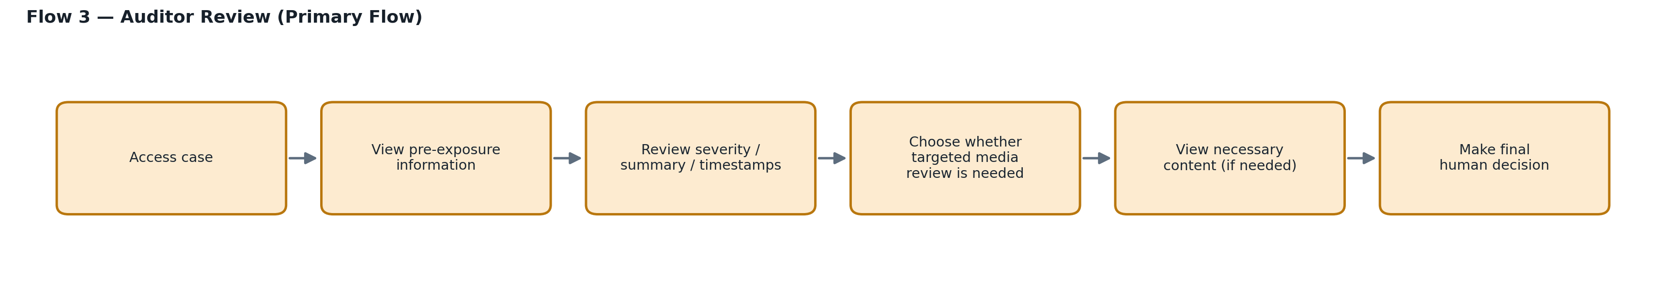
Figure 4. Auditor review flow — the platform's primary persona journey.
UX annotation: The Auditor should receive useful structured information before direct media viewing where appropriate, and should control when potentially distressing media is opened.
Pre-exposure information
Before requiring direct review of potentially distressing media, the experience should first present useful case information that can help the Auditor understand what may be relevant.
- AI-generated severity information.
- Concise AI-generated summary.
- Incident timestamps identifying relevant moments.
- A warning or content indication where appropriate, without unnecessarily exposing graphic material.
Warning and wellbeing UX direction
- Avoid unnecessary autoplay of potentially distressing media.
- Give the Auditor control over when direct media is viewed.
- Use incident timestamps to support targeted review instead of requiring full-content viewing.
- Keep AI information clearly separated from the Auditor's own final decision.
- Keep the interface focused to reduce unnecessary cognitive load and exposure.
Future wellbeing concepts
Exposure-management, cooldown and SOS/support concepts should be considered in the UX direction, but they are later refinement areas rather than confirmed Core MVP functionality.
- Cooldown concept: provide a future mechanism for recovery/breaks after sustained or difficult review work.
- SOS/support concept: provide a future route for the Auditor to request or access support where appropriate.
- Exposure-management concept: consider future ways to monitor or reduce repeated exposure.
7. Flow 4 — Manager / Supervisor Oversight
Manager oversight flow
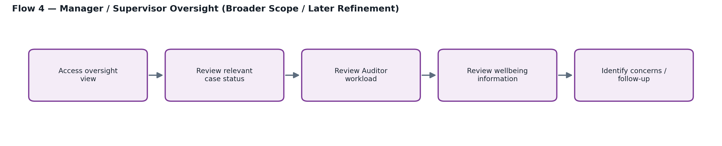
Figure 5. Manager / Supervisor oversight flow — broader scope, later refinement.
UX annotation: Manager oversight should remain high-level and should not replace or interfere with the Auditor's final review responsibility.
Scope note: Manager oversight is part of the broader proposed platform and is primarily a later refinement area, so this flow communicates UX direction rather than detailed Core MVP functionality.
8. Main Handoffs
From | Handoff | To | What is passed / made available
Public User | Submission | System / AI | Approved synthetic/staged content
System | Case creation | Public User | Case ID / submission confirmation
System / AI | AI-assisted analysis | Auditor | Case + severity information + summary + incident timestamps
Auditor | Human review outcome | Platform | Final human review decision
Platform / workflow | Oversight context | Manager | Relevant case, workload and wellbeing information as scope is refined

9. UX Decisions and Annotations for BA / Developer Review
UX decision | Reason | Status
Show Case ID clearly after submission | Confirms successful Public User submission and supports case reference. | Core MVP direction
Show severity, summary and timestamps before unnecessary media viewing | Supports case understanding and reduced direct exposure. | Core MVP UX direction
Do not autoplay potentially distressing media unnecessarily | Preserves Auditor control and supports wellbeing. | Initial UX direction
Keep final decision human-controlled | AI is assistive; Auditor retains final decision. | Core MVP requirement
Treat Manager oversight as high-level | Avoids expanding the Core MVP beyond the approved scope. | Later refinement
Treat cooldown / SOS as future concepts | They are wellbeing considerations planned for refinement rather than confirmed Core MVP features. | Sprint 3 / future

