Final Raw MVP UX QA & Wellbeing/Accessibility Review
IBM — Responsible Content-Safety Infrastructure
UX Design | Harneet Kaur

Deliverable | Final Raw MVP UX QA & Wellbeing/Accessibility Review
Dependencies | T18, T21
Evidence captured | 27/09/2026 (latest build shared by Dev1 at the time of writing)
Prepared | 04/10/2026
Status | Complete for the evidence available — items marked Not yet evidenced will be re-verified against the next build

1. Purpose and Scope
This review records the status of the latest Raw MVP build for the Public User and Auditor experiences: what is implemented, what remains incomplete and what should be refined in Sprint 3. It re-checks the Week 2 UX gaps, processing and error states, AI-result presentation, controlled media exposure, the final human decision flow, usability and accessibility, and records wellbeing gaps.

2. Evidence Basis and Severity Scale
Evidence: Build screenshots captured on 27/09/2026 (E1–E8), annotated in Section 4.
Baseline: Public User Submission UX Specification, Auditor/Manager Implementation UX Specification, the Sprint 1 prototype, and the BA requirements and open decisions (OD-01 to OD-11).
Approach: Areas for which no screenshot has been shared are recorded as Not yet evidenced, rather than passed or failed. Business parameters that are not confirmed remain marked TBC; none has been introduced in this review.
Severity scale used in the issue log:
Critical | Blocks a core Raw MVP step, or creates a risk to Auditor wellbeing or information protection.
High | A confirmed Raw MVP requirement is not met, or the build differs materially from the approved specification.
Medium | A usability, accessibility or feedback gap, or a specification/decision gap, to be resolved in Sprint 3.
Low | Minor or cosmetic.

On the evidence available, 20 items are logged: 5 High, 13 Medium, 1 Low and 1 pending verification. No issue is rated Critical. The pending item (UX-14) will be rated once the Case Review and Analysis screens are available.

3. Implementation Status and Week 2 Gap Re-check
Area | Status | Notes
Entry points and User Dashboard | Implemented | Landing page and User Dashboard load; all consoles are reachable from one page (E1, E2). See UX-12.
Public User submission form | Partially implemented | Version A provides file selection, content type, a test-case checkbox and a submit action (E3). The approved confirmation control and format guidance are not present (UX-02, UX-08). A second version exists (E6, UX-01).
Upload state | Partially implemented | Button label change only (E4, UX-04).
Case-creation processing state | Not yet evidenced | UX-05.
Success and Case ID confirmation | Not yet evidenced | A case reached the Auditor queue (E7); the user-facing screen has not been captured (UX-06).
Failure state | Partially implemented | Generic message without technical detail (E5); wording and Retry action differ from the specification (UX-07).
Auditor Dashboard | Partially implemented | Queue, reviewed and exposure counters present, with one case listed (E7). Severity is not shown (UX-13); Manager placeholder content is present (UX-15).
Case Review tab | Not yet evidenced | Tab present; content not shared (UX-14).
Analysis tab (AI summary, severity, timestamps) | Not yet evidenced | UX-14, UX-18.
Controlled media access | Not yet evidenced | UX-14.
Human final decision | Not yet evidenced | Approve, Reject and Decline controls have not been shared (UX-14).
Decline and Manager notification | Not yet implemented | UX-19.
Manager Dashboard | Not yet implemented | Page heading only (E8, UX-19).
Role-based access | Not yet evidenced | No sign-in step evidenced (UX-12).

Week 2 review findings re-checked:
Week 2 finding | Status at Week 3 | Ref
Two versions of the submission page | Open — unchanged; current version not confirmed | UX-01
Confirmation checkbox not as specified | Open — unchanged | UX-02
Upload shown without a progress bar | Open — unchanged | UX-04
No distinct case-creation processing state | Not yet evidenced | UX-05
No validation feedback observed | Not yet evidenced | UX-09
Failure wording and Retry action | Open — unchanged | UX-07
Format and size guidance; 500 MB unconfirmed | Open — TBC | UX-08
First case observed in the Auditor queue; Public User Success / Case ID screen not captured | Observed in the Week 2 review; the user-facing screen is still to be captured | UX-06
Long system Case ID instead of a short reference | Open — BA decision | UX-11
No Severity indicator in the Auditor queue | Open — unchanged | UX-13
Case Review and Analysis tabs not shared | Open — not yet evidenced | UX-14
“---Manager Overview---” divider and “Team Overview: Done” placeholder | Open — unchanged | UX-15
Manager Dashboard is a heading only; Decline and Manager notification not implemented | Open — not yet implemented | UX-19
Missing-timestamp behaviour undefined | Open — BA decision | UX-18
“Violent content exposure” label | Open — BA decision | UX-17
Interface unstyled | Open — expected, styling in progress | UX-16
Specification has no Dashboard section | Open — UX action | UX-20

No newer build evidence has been provided since the Week 2 reviews (evidence dated 27/09/2026), so each finding is carried forward unchanged. Raised for the first time in this review: UX-03 (manual content type), UX-10 (duplicate page heading) and UX-12 (entry points and access scope).

4. Annotated Evidence and Findings

4.1 Entry points and navigation
All consoles are reachable from one landing page, and no sign-in step is evidenced (UX-12). The User Dashboard offers a single link to the submission form.
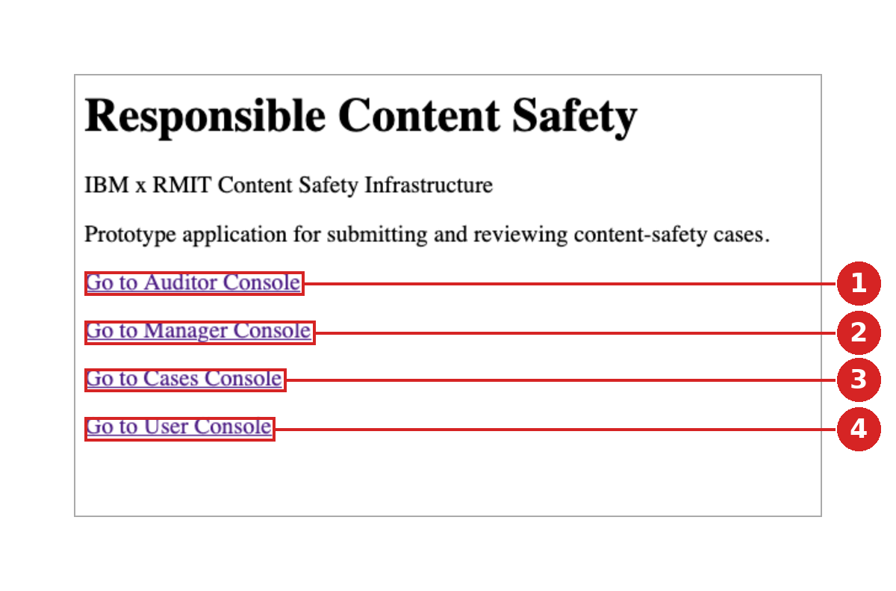 | E1 — Landing page (“Responsible Content Safety”)  1 Auditor Console link — available from the shared landing page.  2 Manager Console link — available from the shared landing page.  3 Cases Console link — purpose not evidenced.  4 User Console link — leads to the User Dashboard and submission form.  No sign-in step was evidenced between the landing page and any console (UX-12).

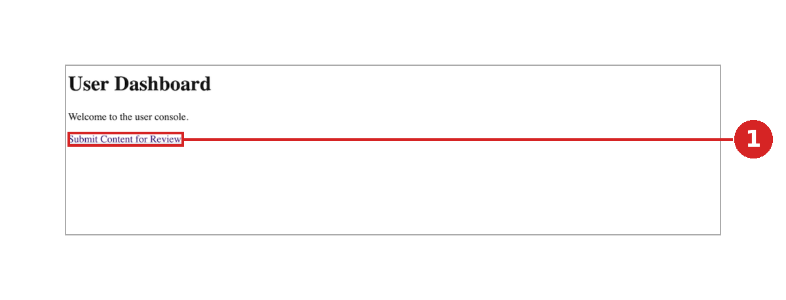 | E2 — User Dashboard  1 Single link to “Submit Content for Review”; intermediate page before the form.

4.2 Public User submission
The submission form (Version A) provides file selection, content type, a test-case checkbox and a submit action, and the generic failure message correctly withholds technical detail. The approved confirmation control, upload progress indicator, success and Case ID screen and Retry action are not yet evidenced as specified (UX-02, UX-04, UX-06, UX-07). A second version of the page, Version B, is also present (UX-01).
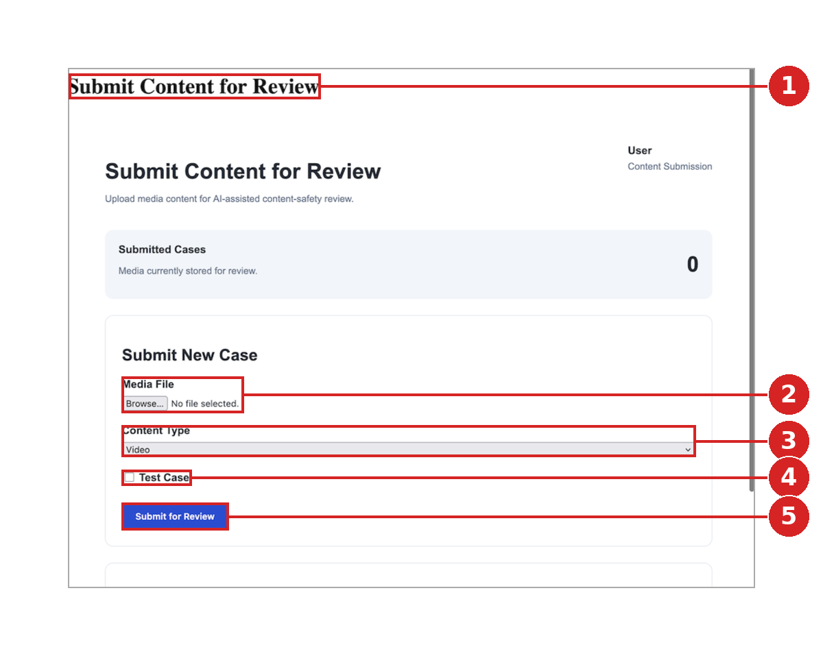 | E3 — Submission form (Version A), default state  1 Page title appears twice with different styling (UX-10).  2 Media File: no supported-format or maximum-size guidance (UX-08).  3 Content Type: manual dropdown, defaulting to Video; the approved specification calls for auto-detection (UX-03).  4 “Test Case” checkbox: label does not state the approved synthetic/staged confirmation (UX-02).  5 Submit for Review: no indication of required fields or validation feedback (UX-09).

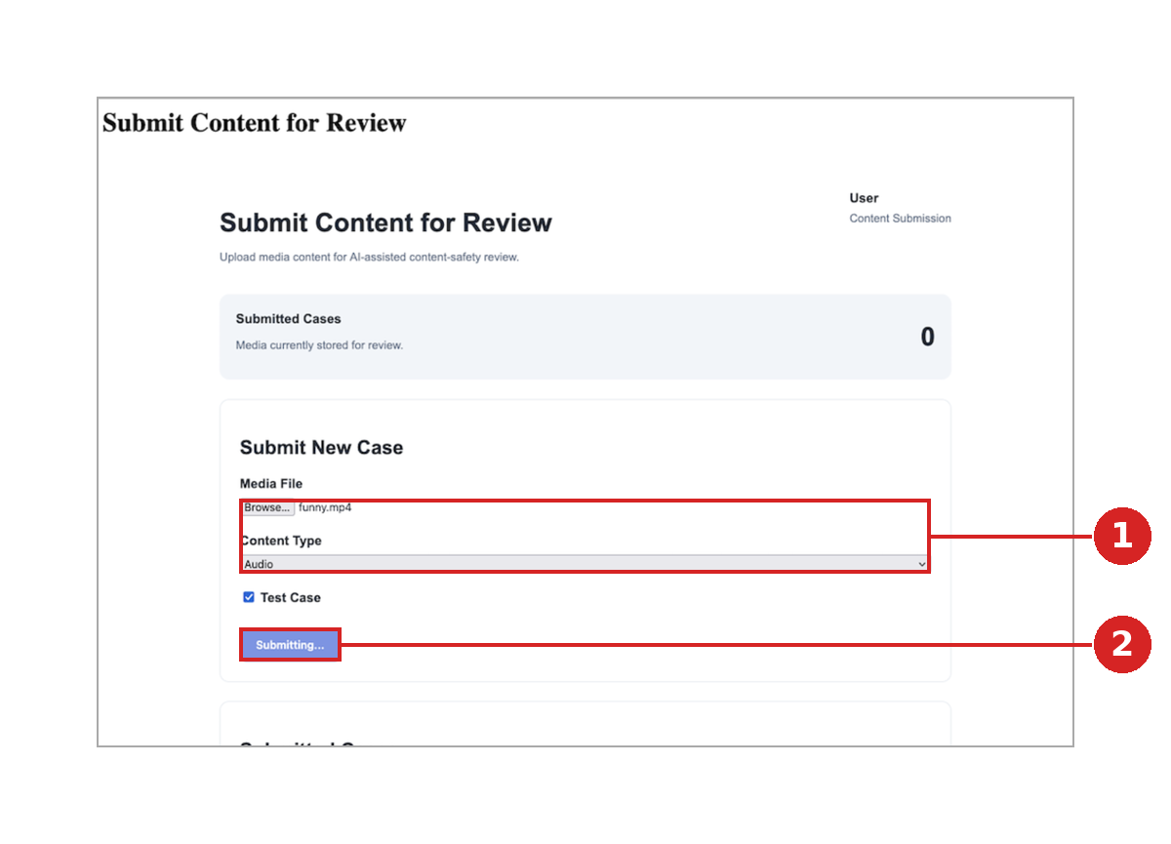 | E4 — Upload state (Version A)  1 .mp4 file with Content Type “Audio” selected (UX-03).  2 Upload shown as a button label change only (“Submitting…”); no progress bar, file name or percentage (UX-04).

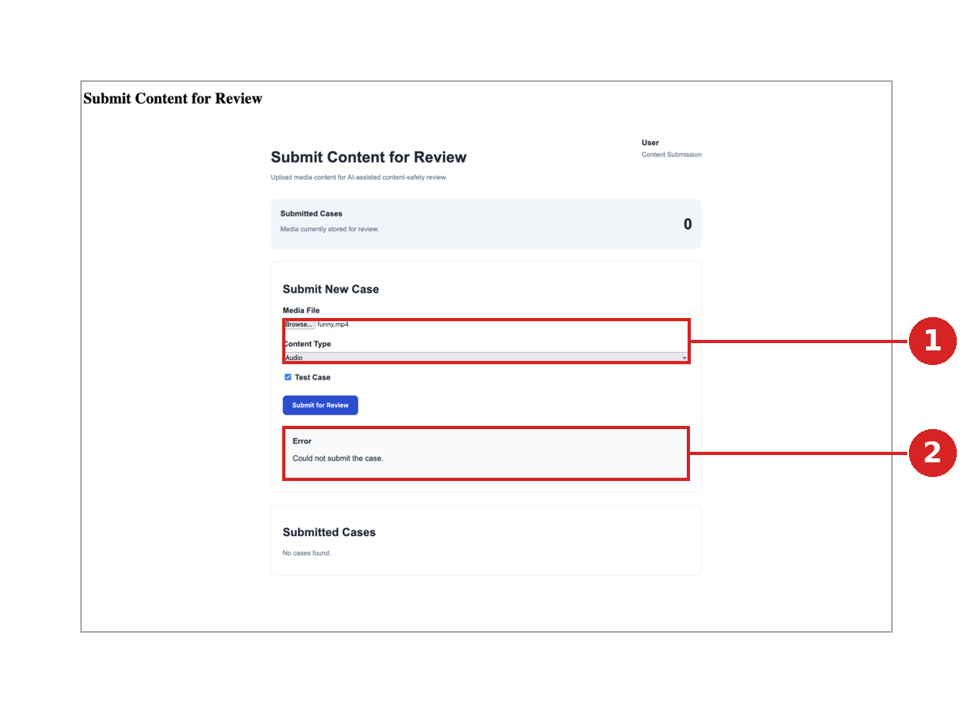 | E5 — Failure state (Version A)  1 Same .mp4 / “Audio” combination as E4 (UX-03).  2 “Could not submit the case.” is plain-language and free of technical detail, but differs from the approved wording and no Retry action is shown (UX-07).

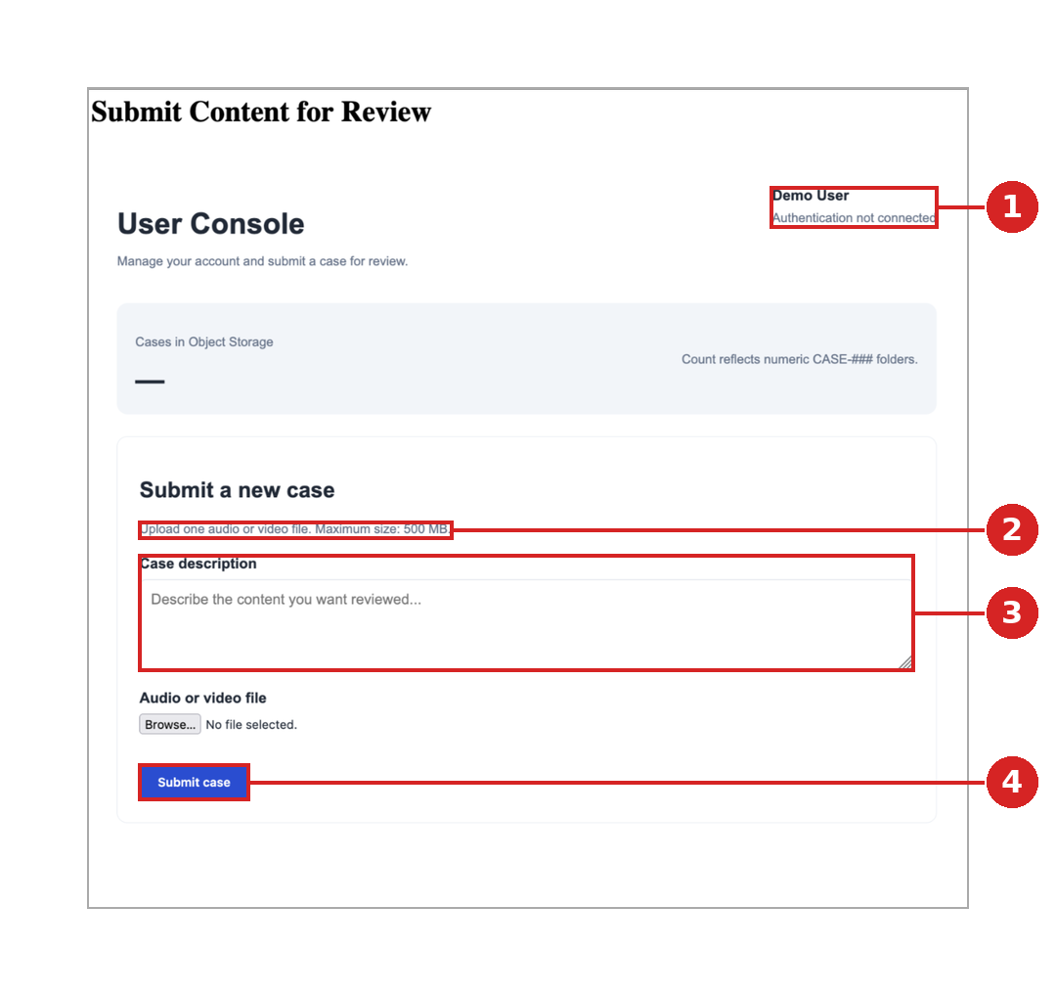 | E6 — Submission page (Version B, “User Console”)  1 “Authentication not connected” is displayed (UX-12).  2 “Maximum size: 500 MB” — limit not yet confirmed as a backend constraint (UX-08).  3 “Case description” field is not in the approved specification (UX-01).  4 Submit case: no synthetic/staged confirmation control (UX-02).

4.3 Auditor Dashboard
The dashboard lists a real case and shows queue, reviewed and exposure counters, in line with the three counters in the Sprint 1 prototype. Severity is not shown in the queue, the Case ID uses a long system format, and Manager placeholder content appears on the page (UX-11, UX-13, UX-15).
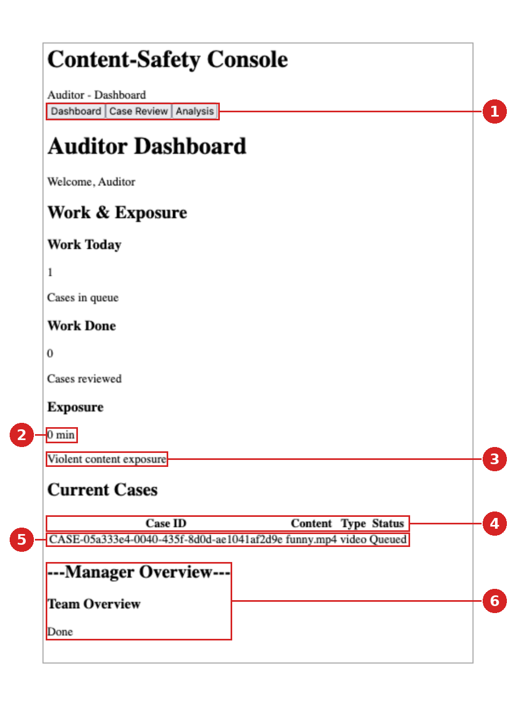 | E7 — Auditor Dashboard (first case in queue)  1 Case Review and Analysis tabs are present; their content has not been shared (UX-14).  2 Exposure is shown with its unit (min), in line with BA feedback; update behaviour not evidenced.  3 “Violent content exposure” — specific category not in the approved requirements (UX-17).  4 Queue columns are Case ID, Content, Type and Status — no Severity indicator (UX-13).  5 First case observed in the queue; the Case ID is a long system identifier (UX-11).  6 Manager Overview placeholder on the Auditor page: text-dash heading and “Done” (UX-15).

4.4 Manager Dashboard
The Manager Dashboard currently consists of a page heading only (UX-19).
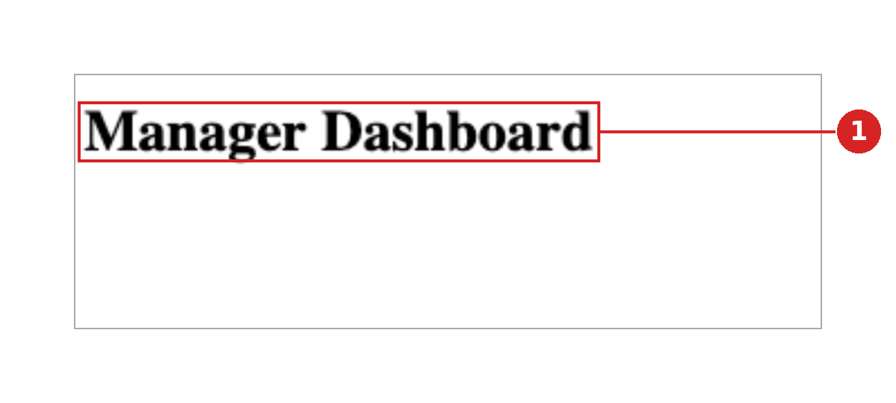 | E8 — Manager Dashboard  1 Page heading only; no content implemented (UX-19).

4.5 Specified Behaviour Awaiting Evidence
The behaviours below are defined in the approved Auditor/Manager specification. They could not be verified because the Case Review and Analysis screens have not been shared, and they form the verification list for the next build (UX-14).
Specified behaviour to verify | Status | Issue
AI-result presentation
Severity shown as a coloured pill at the top right of the AI panel, with a text label (never colour alone) | Not yet evidenced | UX-14
Summary shown directly below the panel header, read-only | Not yet evidenced | UX-14
Incident timestamps shown as clickable chips below the summary | Not yet evidenced | UX-14
Transcript shown as a placeholder labelled “(direction only)” | Not yet evidenced | UX-14
Controlled media exposure
Content warning shown before any raw media | Not yet evidenced | UX-14
Media locked by default, with no frame rendered | Not yet evidenced | UX-14
Selecting a timestamp chip reveals only that segment | Not yet evidenced | UX-14
“Segments revealed” count displayed and fed to exposure tracking | Not yet evidenced | UX-14
Human final decision
Approve and Reject grouped; Decline separated by a visible divider | Not yet evidenced | UX-14
“Draft — pending client approval” marker shown above the decision row (OD-03) | Not yet evidenced | UX-14
Decline shows an on-screen confirmation and creates an entry in the Manager view | Not yet evidenced | UX-14

5. Wellbeing Review
Wellbeing item | Implementation status | Issue | TBC parameter
Content warning before raw media is shown | Not yet evidenced — Case Preview not shared | UX-14 | —
Exposure tracking | Counter present and shown in minutes (E7); update behaviour not evidenced | UX-14 | OD-07
Controlled media and “segments revealed” count | Not yet evidenced | UX-14 | —
Decline and Manager notification | Not yet implemented | UX-19 | OD-06, OD-10
Cooldown and SOS controls | Not yet implemented — Manager view is a heading only (E8) | UX-19 | OD-07, OD-08, OD-09
Manager visibility of Auditor exposure | Not yet implemented | UX-19 | OD-07, OD-11
Wellbeing message on the Analysis screen | Not yet evidenced | UX-14 | —
Exposure category label (“Violent content exposure”) | Present; category not approved (E7) | UX-17 | —

No exposure thresholds, cooldown durations, SOS triggers, decision labels or reassignment rules have been introduced in this review; all remain TBC.

6. Accessibility and Usability Review
Check | Result | Notes
Severity conveyed by text as well as colour | Not yet verifiable | No severity is shown in the queue; the specification requires a label with colour (UX-13).
Text contrast | No concern at default styling | Black text on white. Re-check once the design styling is applied (UX-16).
Form labels | Partially met | Visible labels on Media File and Content Type; the “Test Case” label is unclear (UX-02). Programmatic association cannot be verified from screenshots.
Page structure and headings | Gaps identified | Duplicate page title (UX-10); text-dash heading on the Auditor page (UX-15).
Error feedback | Partially met | Plain-language message without technical detail; no Retry action (UX-07). Announcement to assistive technology cannot be verified.
Placeholder content | Gap identified | “Team Overview: Done” has no clear meaning to a user (UX-15).
Keyboard operation and focus | Not yet verifiable | Requires the interactive build; to be tested in Sprint 3.

These checks are based on static screenshots. Keyboard, focus and screen-reader checks will be carried out on the updated build.

7. Consolidated Issue Log
ID | Finding | Evidence | Severity | Status | Sprint 3 follow-up
Public User submission
UX-01 | Two versions of the submission page are present in the build (Version A “Submit Content for Review”; Version B “User Console” with a Case description field). It is not confirmed which is current. | E3, E6 | High | Open — Dev1 to confirm | Confirm the current version, retire the other and align it with the approved specification.
UX-02 | The approved synthetic/staged confirmation is not implemented as specified. Version A shows an unexplained “Test Case” checkbox; Version B has no equivalent control. Behaviour when unticked is not evidenced. | E3 (4), E6 (4) | High | Open | Replace with the approved required checkbox wording and prevent submission until it is confirmed.
UX-03 | Content Type is a manual dropdown. E4 and E5 show an .mp4 file with “Audio” selected. The specification calls for auto-detection shown as a read-only confirmation. | E3 (3), E4 (1), E5 (1) | Medium | Open | Detect the type from the file and display it read-only.
UX-04 | The upload state is a button label change only (“Submitting…”). The specification requires a progress bar with file name and percentage. | E4 (2) | Medium | Open | Add the progress bar with file name and percentage; keep Submit disabled during upload.
UX-05 | No distinct case-creation processing state (“Creating your case…”) was observed after upload. | — | Medium | Not yet evidenced | Add the processing message defined in the specification and provide evidence.
UX-06 | The Public User Success / Case ID confirmation screen has not been captured. A case reached the Auditor queue, so case creation has succeeded, but the user-facing confirmation is unreviewed. | E7 (5) | High | Not yet evidenced | Provide a screenshot of the success screen and confirm the Case ID is shown with the “Case created” confirmation.
UX-07 | The failure message reads “Could not submit the case.” The specification requires “We couldn’t process your submission. Please try again.” with a Retry action; no Retry control is shown. The message correctly avoids technical detail. | E5 (2) | Medium | Open | Update the message and add a Retry action.
UX-08 | Version A shows no supported-format or size guidance. Version B shows “Maximum size: 500 MB”, which has not been confirmed as a backend constraint. | E3 (2), E6 (2) | Medium | Open — to be confirmed | Show the confirmed formats and size limit once agreed.
UX-09 | No validation feedback was observed for a missing file or an unsupported format. | E3 (5) | Medium | Not yet evidenced | Add inline field-level messages and provide evidence.
UX-10 | The submission page title appears twice with different styling. | E3 (1) | Low | Open | Remove the duplicate and use a single page heading.
Cross-cutting
UX-11 | The Case ID is a long system identifier (CASE-05a333e4-0040-435f-8d0d-ae1041af2d9e), not the short, human-readable format (e.g. CS-1035) used in the approved specification and prototype. | E7 (5) | Medium | Open — BA decision | BA to confirm the format; show users a short reference and keep the long identifier internal if required.
UX-12 | The landing page offers the Auditor, Manager, Cases and User consoles together, and Version B states “Authentication not connected”. No role-based entry is evidenced. | E1, E6 (1) | Medium | Open — scope to be confirmed | BA to confirm the Raw MVP scope for role-based access; add role-specific entry points once agreed.
Auditor and Manager
UX-13 | The Auditor queue lists Case ID, Content, Type and Status but no Severity indicator. The prototype showed severity in each queue row, so that it is visible before media is opened. | E7 (4) | High | Open | Add a severity label (text and colour) to each queue row.
UX-14 | The Case Review and Analysis tabs exist but their content has not been shared. AI summary, severity, timestamps, controlled media access and the final decision actions are therefore not yet evidenced. | E7 (1) | Pending | Not yet evidenced | Provide the build or screenshots; re-run QA on these items first.
UX-15 | Manager content appears on the Auditor Dashboard: a “---Manager Overview---” text divider (not a semantic heading) and the placeholder “Team Overview: Done”. | E7 (6) | Medium | Open | Remove the placeholder or move it to the Manager view; use proper headings.
UX-16 | The interface uses browser-default styling: no visual hierarchy, colour-coded severity or interactive-state styling is evidenced, so contrast, focus and keyboard checks cannot be completed. | E7 | Medium | Expected — styling in progress | Apply the design styling, then re-test contrast, focus order and keyboard operation.
UX-17 | Under Exposure, the label “Violent content exposure” names a specific harm category that does not appear in the approved requirements or specification. | E7 (3) | Medium | Open — BA decision | Use a generic “Exposure” label unless BA approves the category.
UX-18 | The approved specification does not define what the Analysis screen shows when no incident timestamps are returned. | — | Medium | Open — BA decision | BA to decide; a proposed approach is included in the Sprint 3 handoff.
UX-19 | Decline handling and Manager notification are not implemented, and the Manager Dashboard shows a page heading only. | E8 (1) | High | Not yet implemented | Implement the minimum Manager oversight states and the Decline-to-Manager notification state; thresholds and workflow remain TBC.
UX-20 | The approved Auditor/Manager implementation specification has no Dashboard section, so queue columns and counters are not formally documented. | — | Medium | Open — UX action | UX to add a Dashboard section to the specification.

8. Recommended Sprint 3 Follow-up
1. Obtain the updated build or screenshots of the Case Review, Analysis, media viewer and decision screens, and verify the UX-14 items first.
2. Resolve the High-severity items: submission version and confirmation control (UX-01, UX-02), the success and Case ID screen (UX-06), severity in the queue (UX-13) and the Decline and Manager notification states (UX-19).
3. Obtain BA decisions on the open items: Case ID format, exposure category label, missing-timestamp behaviour, supported formats and size, and access scope.
4. Apply the design styling, then re-test accessibility (contrast, focus order, keyboard operation).
5. Add a Dashboard section to the Auditor/Manager implementation specification (UX-20).

