Auditor / Manager Implementation-Ready UX Specification
IBM - Responsible Content-Safety Infrastructure
UX Design | Harneet Kaur

Output | Auditor/Manager implementation-ready UX specification | Dependency | T4, T5

1. Case Preview — Implementation Guidance
Two-column layout: a fixed-width (280px) metadata card on the left, and a flexible-width warning panel on the right, gap 20px between them.
Element | Location | Behaviour
Case metadata (ID, type, duration, source) | Left card, stacked key/value rows | Static display; no interaction. Case ID uses monospace type throughout the product for consistency.
AI flag (severity) | Left card, bottom row | Coloured pill (teal/amber/red per severity tier). This is the case's initial severity indicator — the full severity/summary/timestamps set appears only after AI analysis, on the Analysis & Decision screen (Section 2).
Content warning panel | Right panel, full remaining width | Displayed before any raw media is revealed. Contains: icon badge, heading, one-paragraph explanation naming the severity, and two actions.
“Review AI analysis →” action | Right panel, primary button | Navigates to Analysis & Decision (Section 2). If AI processing has not yet completed for this case, this navigates to the Loading state (Section 3) instead.
“Skip to raw media” action | Right panel, secondary/text link | Also navigates to Analysis & Decision, but the Auditor's intent to bypass AI analysis is not tracked as a distinct state in this MVP — flagged as an open item; do not build separate tracking without BA confirmation.

2. Analysis & Decision — Implementation Guidance
Element | Location | Behaviour
Severity | Top-right of the AI-assisted analysis panel, as a coloured pill | Set once by the AI result for this case; not editable by the Auditor. Colour and label only — never colour alone (accessibility).
Summary | AI-assisted analysis panel, directly below the panel header | Plain-language paragraph, generated once per case. Read-only.
Incident timestamps / segments | AI-assisted analysis panel, below Summary, shown as a row of clickable mono-type chips | Each chip corresponds to one flagged moment. Clicking a chip is the only way to reveal that segment in the Media viewer (Controlled media access, below).
Transcript | AI-assisted analysis panel, bottom, labelled “(direction only)” | Shows 1–2 illustrative lines only. Full transcript integration is not yet confirmed feasible (BA §10, Q5) — do not build full-transcript scrolling against this spec; treat as a placeholder pending confirmation.
Controlled media access | Media viewer panel, right column | Default state: locked/hidden, lock icon, no video frame rendered. Clicking a timestamp chip (above) reveals only that segment — never the full clip by default. Track and display a “segments revealed” counter for this session, feeding Exposure Tracking (FR-08).
Final human decision | Decision bar, full width, bottom of screen | Three actions: Approve, Reject (content verdicts, grouped together) and Decline (separated by a visible divider — it is not a third verdict, it hands the case to the Manager's escalation queue and does not itself close the case). A visible “Draft — pending client approval” marker sits above this row, since the exact option set is not yet client-confirmed (OD-03).
Confirmed Manager notification state | Triggered by Decline; surfaced as an on-screen toast/confirmation plus a corresponding entry appearing in Manager Overview's “Escalated / Declined Case Review” area | On Decline, show immediate confirmation text: “Escalated to Manager — reassignment workflow still being defined (OD-06).” This confirms the notification fires; it does not imply the downstream reassignment logic is finalised.

3. Processing / Loading State
Not present in the Sprint 1 prototype. Required because AI processing (FR-03) is a real backend step with non-zero duration; the Auditor needs a defined screen for the interval between requesting analysis and results being ready.
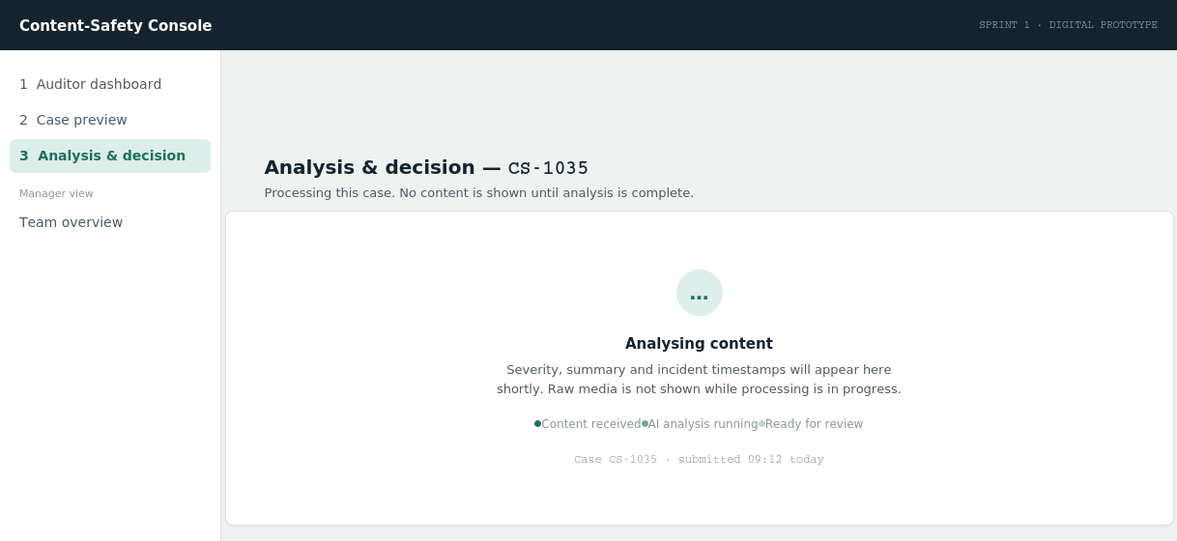
Shown in place of the Analysis & Decision content while AI processing is in progress. No media, no partial results, no decision bar.
- Trigger: Entry condition: Auditor selects “Review AI analysis” or “Skip to raw media” on Case Preview before AI processing has completed for that case.
- Content: A status badge, a short explanatory line, and a three-step progress indicator (Content received → AI analysis running → Ready for review). No raw media or partial AI output is shown at any point in this state, preserving the exposure-reduction principle even during the wait.
- Exit condition: Automatically transitions to Analysis & Decision (Section 2) once processing completes, or to the Error state (Section 4) if processing fails.

4. Error / Failed Analysis State
Not present in the Sprint 1 prototype. Required because FR-03's acceptance criteria implies a successful path only; a failure path must be defined rather than left undefined for Developers to guess at.
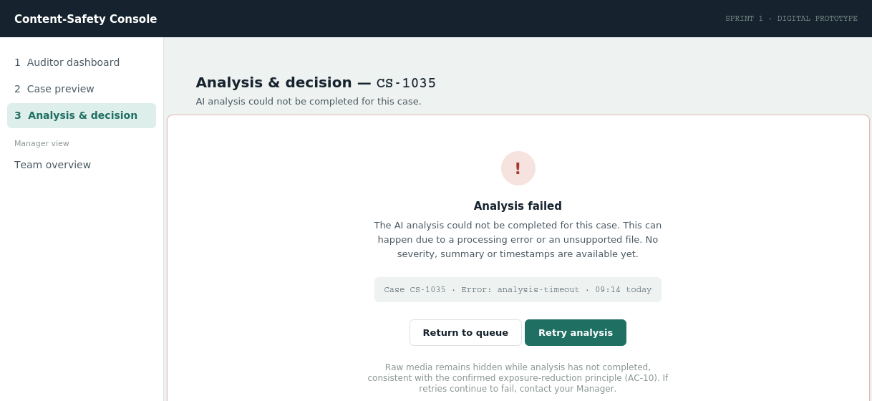
Shown when AI processing fails for a case. No auto-escalation logic is specified — see note below.
- Trigger: AI processing does not complete successfully (timeout, unsupported file, or processing error).
- Content: Error icon, plain-language explanation, a technical detail line (case ID, error code, timestamp) for support/debugging, and two actions: “Retry analysis” (primary) and “Return to queue” (outline).
- Scope note: This spec deliberately does NOT define an automatic escalation-to-Manager rule on repeated failure. The note text suggests the Auditor contact their Manager manually if retries keep failing, but no business rule automating that is confirmed anywhere in the BA documents. Do not implement auto-escalation on failure without BA sign-off.

5. Manager Overview — Minimum Oversight States Required
Per the Core MVP baseline, Manager oversight is a confirmed requirement (FR-12, FR-13) with exact permissions still open (OD-11). The minimum states required for Sprint 2 build are:
- Case oversight: Per-Auditor caseload, severity mix, and exposure minutes — already specified in the Sprint 1 prototype (Auditor workload table).
- Exposure visibility: Flagged rows for Auditors approaching a wellbeing threshold — exact threshold value open (OD-07).
- Escalated case entry point: A visible destination for cases routed via Decline (Section 2) — required so the “confirmed Manager notification” checklist item has somewhere to land, even before the full reassignment workflow (OD-06) is defined.
- Wellbeing actions: Cooldown/SOS controls shown as confirmed capabilities with thresholds marked open (OD-08, OD-09) — already specified in the Sprint 1 prototype.

