Public User Submission — Implementation-Ready UX Specification
IBM - Responsible Content-Safety Infrastructure
UX Design | Harneet Kaur

1. Submission Screen — Implementation Guidance
Standalone, unauthenticated page — does not use the internal Content-Safety Console navigation, since the Public User has no access to Auditor or Manager functionality (FR-16, role-based access). The absence of internal navigation is a deliberate choice, not an oversight: it visually reinforces the access boundary. The top bar keeps the same brand chrome as the internal console for visual consistency.
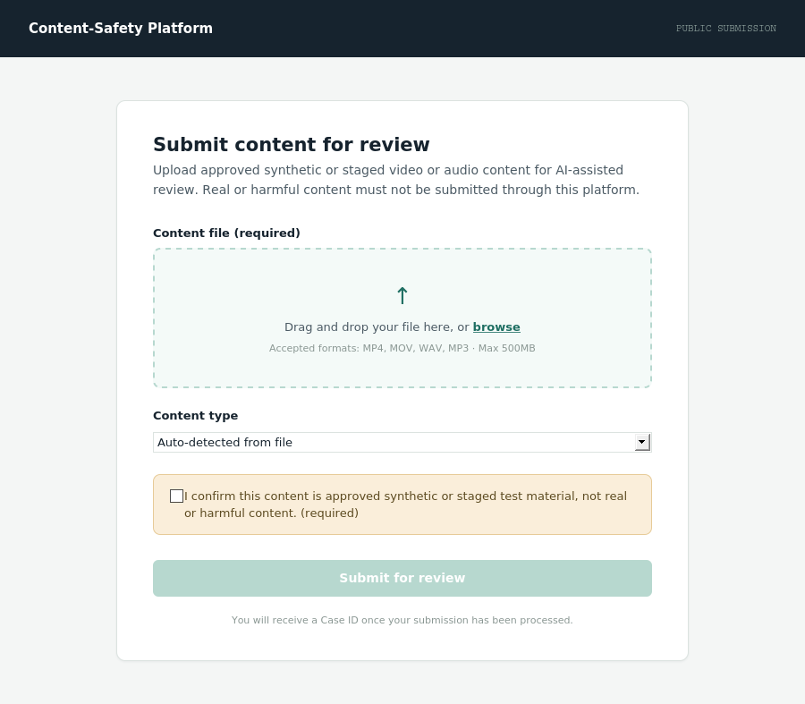
Default submission screen. Submit button stays disabled until a file is attached and the confirmation checkbox is ticked.
Element | Location | Behaviour
Submission screen | Standalone public page, brand chrome, no internal nav | Centred single-column form. No Case queue, no login required for this MVP scope.
Content file (required field) | Drop-zone, top of form | Accepts video/audio only. Required — form cannot submit without a file attached.
Content type (required field) | Below drop-zone | Auto-detected from the file where possible; shown as read-only confirmation rather than a manual choice, to reduce user error.
Approved synthetic/staged confirmation | Highlighted checkbox box, above submit | Required checkbox, distinctly styled (amber) so it cannot be missed. Directly represents the approved-content-only constraint (AC-11, FR-17). Submit stays disabled until checked.
Case ID confirmation | Success state (below), primary content | Case ID is the only identifier shown to the Public User — no severity, summary, or Auditor-facing information is ever exposed here (FR-17).

2. Upload, Processing, Success and Failure States
State | Trigger | Required feedback / message
Upload | File attached, Submit pressed | Drop-zone replaced by a progress bar with filename and percentage. Submit button disabled during upload.
Processing | Upload completes; case is being created server-side | “Creating your case…” with a status indicator. No further input possible. Duration should be brief — this is case creation (FR-02), not AI analysis, which happens later and is never shown to the Public User.
Success | Case created successfully | See screenshot below — checkmark, “Case created,” Case ID in a bordered highlight box, and a “Submit another case” action.
Failed-processing | Case creation fails server-side (not a user input error) | Generic message: “We couldn't process your submission. Please try again.” with a Retry action. No technical error code is shown to the Public User — unlike the Auditor-facing error state, this audience should not see internal diagnostic detail.
User-facing error (validation) | Submission attempted with a missing file, unsupported format, or unchecked confirmation box | Inline message at the specific field, not a full-screen state: e.g. “Please attach a video or audio file” or “Please confirm this is approved synthetic/staged content before submitting.” Submit remains disabled until resolved.
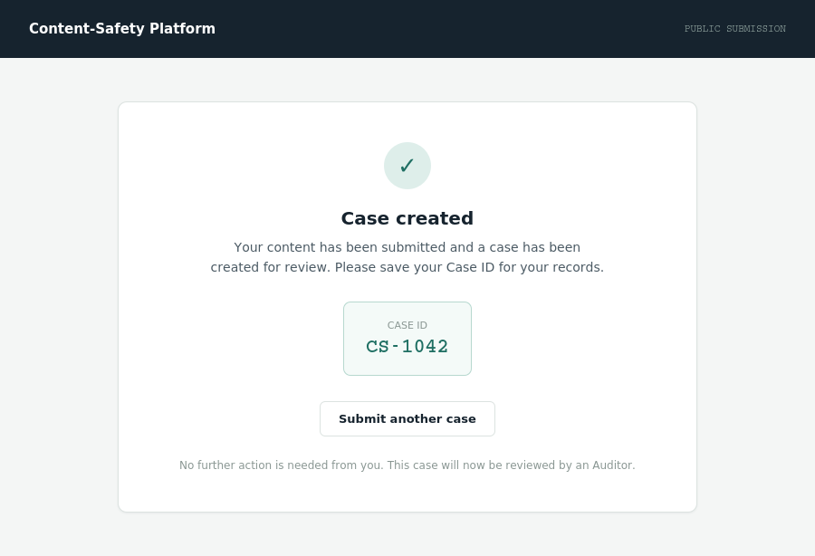
Success state — the only screen where a Case ID is shown to the Public User.
No wellbeing thresholds, exposure limits, or Auditor/Manager parameters are referenced anywhere in this document. The Public User flow has no wellbeing dimension — those requirements (FR-07–FR-15) apply to the Auditor and Manager only, and nothing here invents a connection between them.

3. Developer Handoff Notes
State summary for the Public User submission flow, in the order a Developer should build them:
State | Entry from | Exit to
Submission form | Direct page load (no login) | Upload (Submit pressed) or inline validation error (missing field/confirmation)
Upload | Submission form, Submit pressed with valid inputs | Processing (upload completes)
Processing | Upload completes | Success (case created) or Failed-processing (server error)
Success | Processing completes successfully | Submission form (“Submit another case”)
Failed-processing | Processing fails server-side | Upload (Retry) or Submission form

