Auditor Review UI — Implementation Review & Usability Findings
IBM — Responsible Content-Safety Infrastructure
UX Design | Harneet Kaur

Task | [UX REVIEW] Review Auditor Review UI & Resolve Usability Gaps
Output | Auditor UI review and wellbeing-gap log, annotated implementation evidence and Dev1/BA handoff notes | Dependencies | T6, T20
Status | In progress — case creation now reaching the Auditor queue; several items still dependent on unshared screens (see Section 2)

1. Purpose
Reviews the implemented Auditor interface against the final Week 1 UX specification (T6) and confirmed Core MVP requirements, checking structured AI-result presentation, case status, controlled media access, incident timestamps, processing/error states, and the separation between assistive AI output and the human final decision. This review identifies usability and wellbeing gaps without introducing unconfirmed exposure thresholds, decision labels or reassignment rules.

2. Implementation State at Time of Review
At the time of this review, only the Auditor Dashboard tab has been implemented and made available for inspection. The Case Review and Analysis tabs — where the majority of this checklist's items (severity, summary, timestamps, controlled media access, final decision) are specified to live — have not yet been shared for review. Several checklist items below are therefore recorded as Not Yet Verifiable rather than Passed or Failed, since no evidence exists either way.
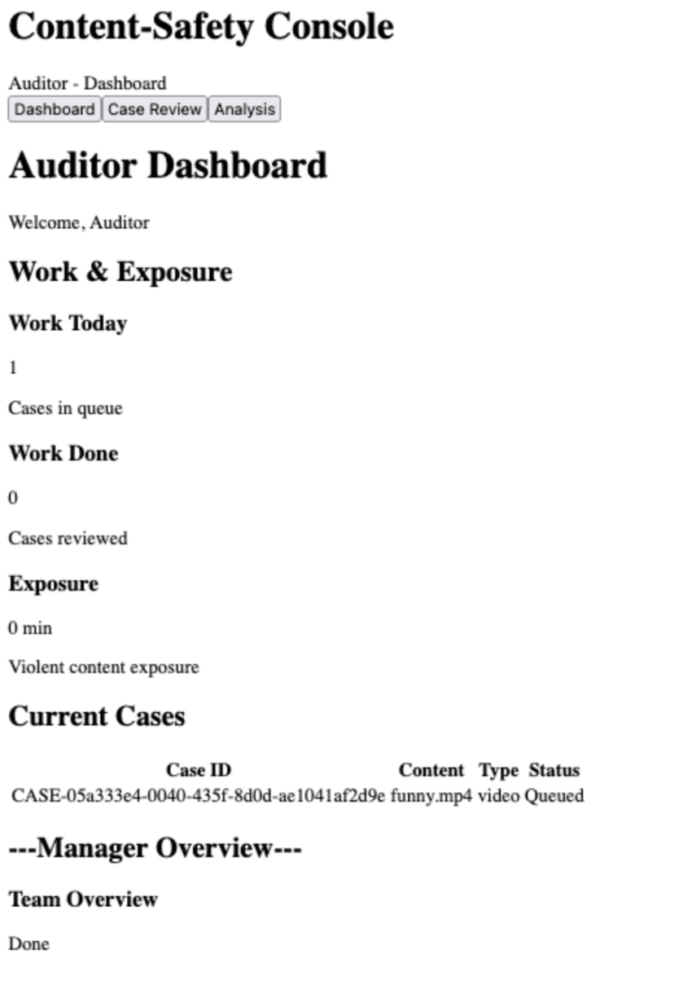
Auditor Dashboard, latest available capture — a case now appears in the Current Cases queue.

3. Checklist Findings
Checklist item | Status | Notes / Evidence
Auditor case access and preview reviewed | Partially verifiable — progress observed | The Current Cases table now displays a populated row (Case ID: CASE-05a333e4-0040-435f-8d0d-ae1041af2d9e, funny.mp4, video, Queued), confirming case creation now reaches the Auditor's queue. Opening this row into the actual Case Preview screen has not yet been captured, so that specific step remains unreviewed. Two further observations: (1) the table's columns still do not include a Severity field — this was shown in the original Sprint 1 prototype reference, but the approved specification has no dedicated Dashboard section defining required queue-table columns, so this is not yet a documented requirement to build against; (2) the Case ID shown is a long system-generated identifier, which does not match the short, human-readable format (e.g. “CS-1035”) used throughout the approved UX specification and prototype reference — recommend confirming with BA/Dev whether the Public User and Auditor should see a shorter reference ID.
Severity, summary and available timestamps checked | Not yet verifiable | These elements are specified to appear on the Analysis screen, which has not been shared for review.
AI pending/loading/error states reviewed | Not yet verifiable | No AI processing views have been implemented or shared for the Auditor flow at time of review.
Controlled media exposure behaviour reviewed | Not yet verifiable | Media viewer has not been implemented or shared for review.
Missing-timestamp fallback reviewed | Pending specification clarification | This item cannot yet be assessed against implementation, as the approved UX specification does not currently define expected behaviour for a case with no flagged timestamps. This has been raised with BA separately and should be resolved to allow this checklist item to be closed.
Human final-decision action checked | Not yet verifiable | Decision actions (Approve/Reject/Decline) have not been implemented or shared for review.
Decline and Manager notification direction checked where implemented | Not yet implemented | Neither Decline handling nor Manager notification has been implemented. The Auditor Dashboard's own “Manager Overview / Team Overview” section displays only the placeholder text “Done,” and the separate Manager Dashboard page consists of a page heading with no populated content (see Section 4). As this functionality is not yet implemented, this item is recorded as not applicable at this stage rather than failed.
Unconfirmed wellbeing values remain marked TBC | No hardcoded values observed | The Exposure counter displays “0 min” as a running count, not a fixed threshold, so no unconfirmed limit has been hardcoded. However, the label “Violent content exposure” names a specific harm category that does not appear in any confirmed BA requirement or the approved UX specification. Recommend confirming with BA whether this specific category label was an agreed decision.
Usability/accessibility gaps recorded with evidence | Findings recorded below | See Section 5.
Findings shared with BA and Developers | Pending | To be actioned once this document is finalised.

4. Manager-Side Implementation State
Included here because two checklist items above depend on it directly.
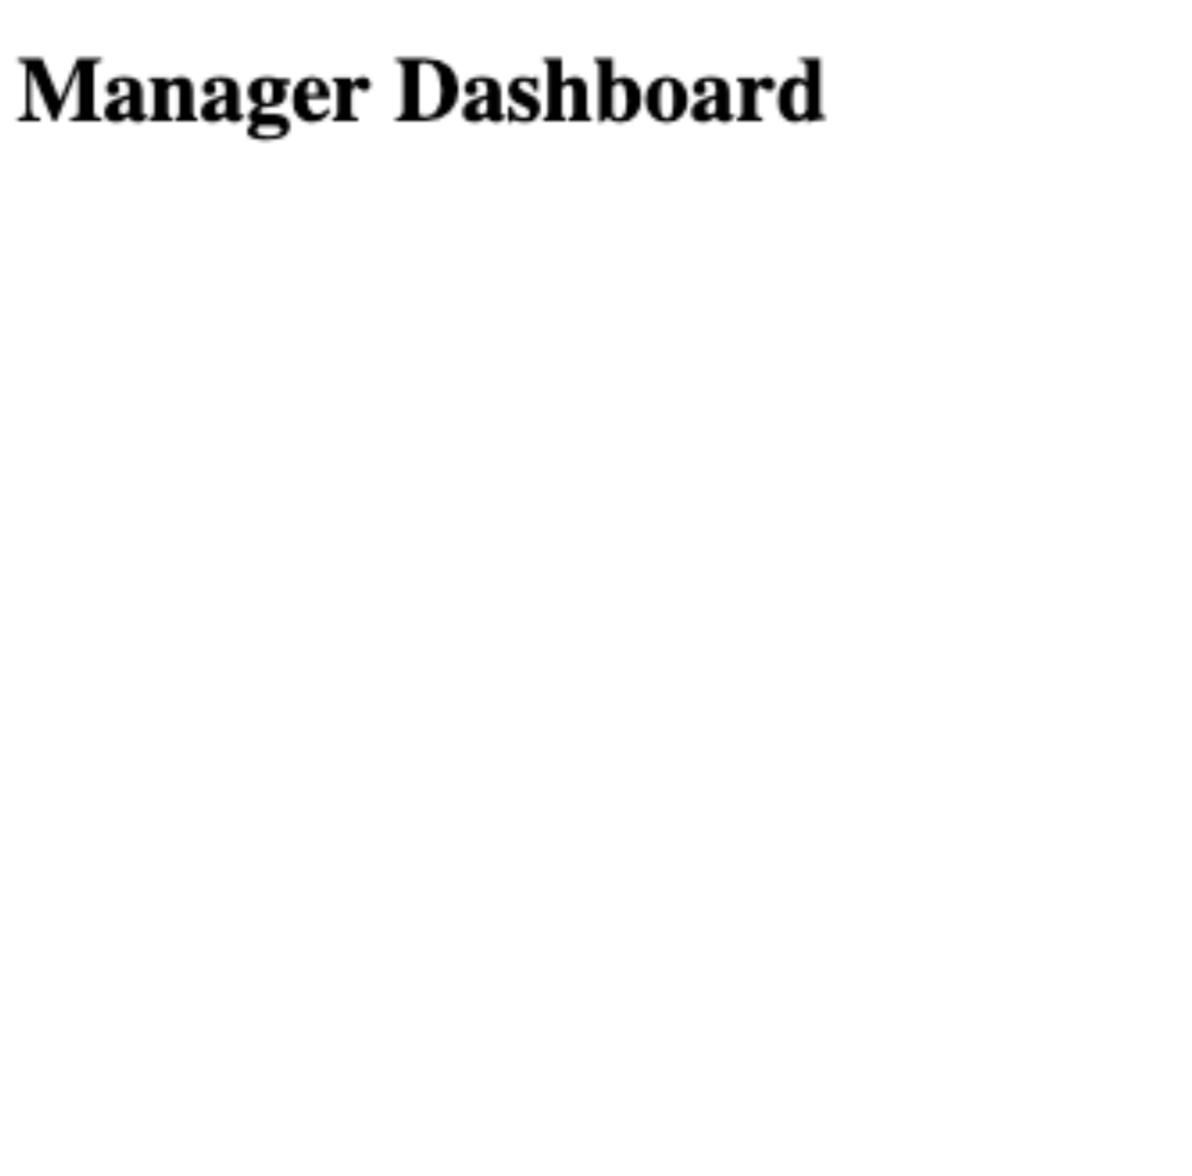
Manager Dashboard, latest available capture — confirmed unchanged: page heading only, no functional content implemented.

5. Usability & Accessibility Gaps Identified
Gap 1: The Current Cases table does not display a Severity column. Per the approved specification, severity must be visible at the point the Auditor sees the case list, not only after opening it — this is a structural gap, not a styling one.
Gap 2: The “---Manager Overview---” heading is rendered as literal dashes around plain text rather than a semantic heading element. This will read awkwardly to screen readers and does not visually distinguish itself from body text once styling is applied.
Gap 3: “Team Overview: Done” is placeholder copy with no clear meaning to an end user. If this ships unchanged, an Auditor or Manager would have no way to understand what it refers to.
Gap 4: The interface is currently unstyled (no colour, spacing, or visual hierarchy applied). No meaningful accessibility assessment of colour contrast, focus states, or visual severity indicators is possible until styling is implemented. This review should be repeated once styling is in place.

6. Notes for BA
Open item 1: The missing-timestamp fallback (Section 3) requires a decision before it can be implemented or reviewed.
Open item 2: Confirm whether “Violent content exposure” is an approved category label, or whether exposure should remain reported generically as in the current specification.
Open item 3: The Auditor/Manager Implementation-Ready UX Specification does not currently include a Dashboard section. Severity visibility in the case queue was shown in the original Sprint 1 prototype reference, but has not been formally written into the approved specification — recommend adding this section so Developers have a documented requirement to build against, rather than relying on the earlier prototype alone.
Open item 4: The Case ID now visible in the Auditor queue is a long system-generated identifier (e.g. CASE-05a333e4-0040-435f-8d0d-ae1041af2d9e), not the short human-readable format (e.g. “CS-1035”) used throughout the approved specification and prototype reference. Recommend confirming whether a shorter reference ID should be surfaced to Auditors and Public Users, with the long identifier retained internally if needed for the database.

7. Notes for Developers
Item 1: Add a Severity column/indicator to the Current Cases table.
Item 2: Replace the “---Manager Overview---” text divider with a semantic heading once this section is scoped for build.
Item 3: Case Review and Analysis tabs are required before the remainder of this checklist can be completed — please share once available.

