Public User Submission UI — Implementation Review & UX Issue Log
IBM — Responsible Content-Safety Infrastructure
UX Design | Harneet Kaur

Task | [UX REVIEW] Review Public User Submission UI & Processing States
Output | Public User UI review record, annotated screenshots, UX issue log and Dev1 handoff evidence | Dependencies | T5, T19
Status | In progress — first successful case creation observed; several items still dependent on ongoing development (see Section 2)

1. Purpose
Reviews the implemented Public User submission UI against the final Week 1 UX specification and BA acceptance criteria, checking the approved synthetic/staged content constraint, form validation, upload and case-creation states, Case ID confirmation, and error/retry behaviour. Records implementation gaps and provides actionable feedback to Dev1.

2. Submission Page — Two Versions Currently in Development
Two versions of the submission page were observed during this review, consistent with active, in-progress development. Identifying which version reflects the intended final direction will help finalise the remaining checklist items below.
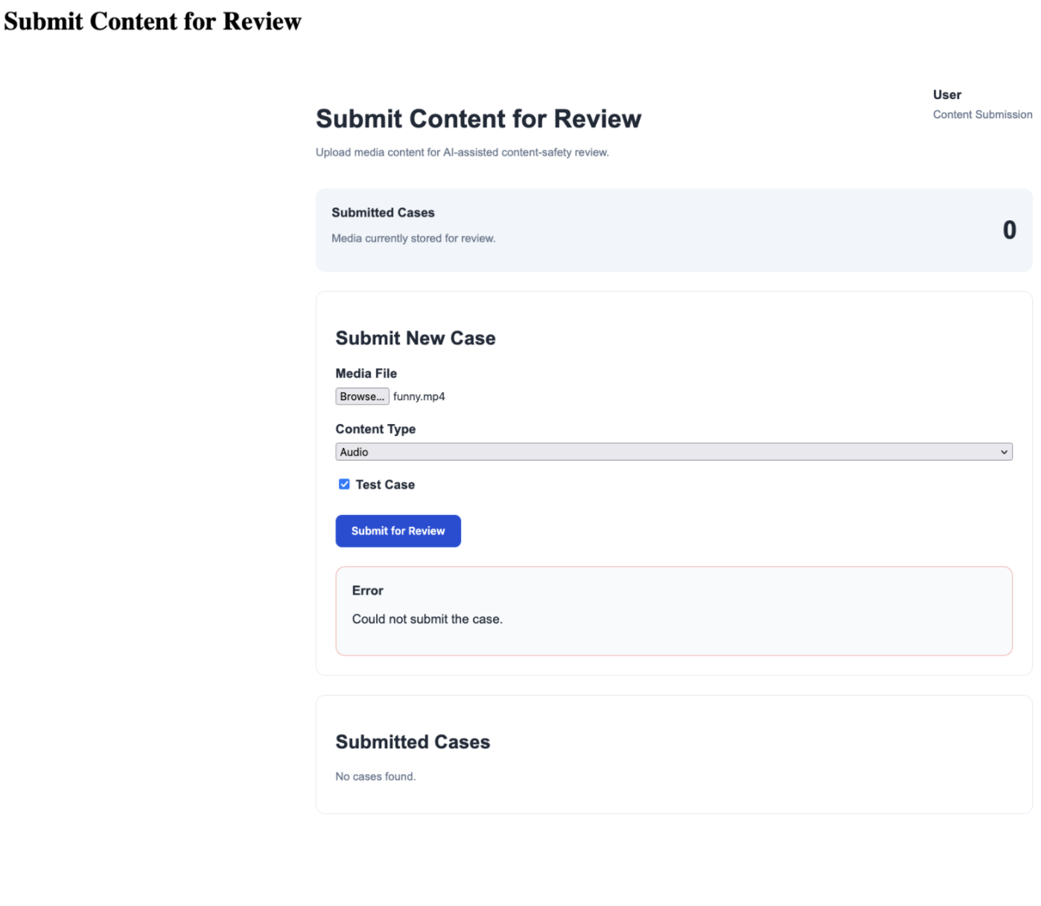
Version A — fields: Media File, Content Type (dropdown), Test Case (checkbox). Button: “Submit for Review.”
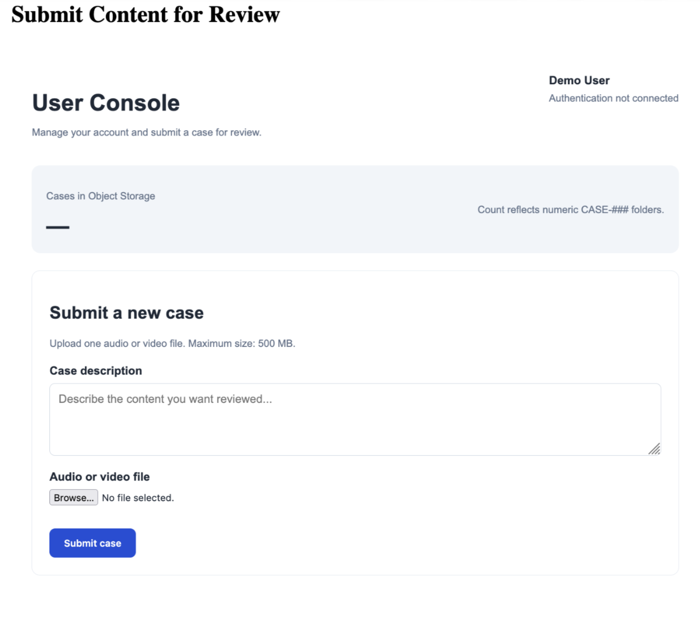
Version B — labelled “User Console,” shows “Demo User / Authentication not connected.” Fields: Case description (textarea, not in spec), Audio or video file. Button: “Submit case.” No confirmation checkbox present.
Observation 1: Neither version currently implements the confirmation checkbox with the specified wording (“I confirm this content is approved synthetic or staged test material...”). Version A's “Test Case” checkbox is the closer analogue; Version B does not yet include an equivalent control.
Observation 2: Version B includes a “Case description” free-text field not yet reflected in the approved UX specification.
Observation 3: Version B displays “Authentication not connected,” consistent with this being an earlier-stage or parallel scaffold.
Recommend confirming with Dev1 which version reflects the current build direction, to help focus finalisation efforts.

3. Site Navigation Context
Also relevant to interpreting the two versions above: the application's root landing page exposes four separate entry points, and a distinct “User Dashboard” sits between the root and the submission form.
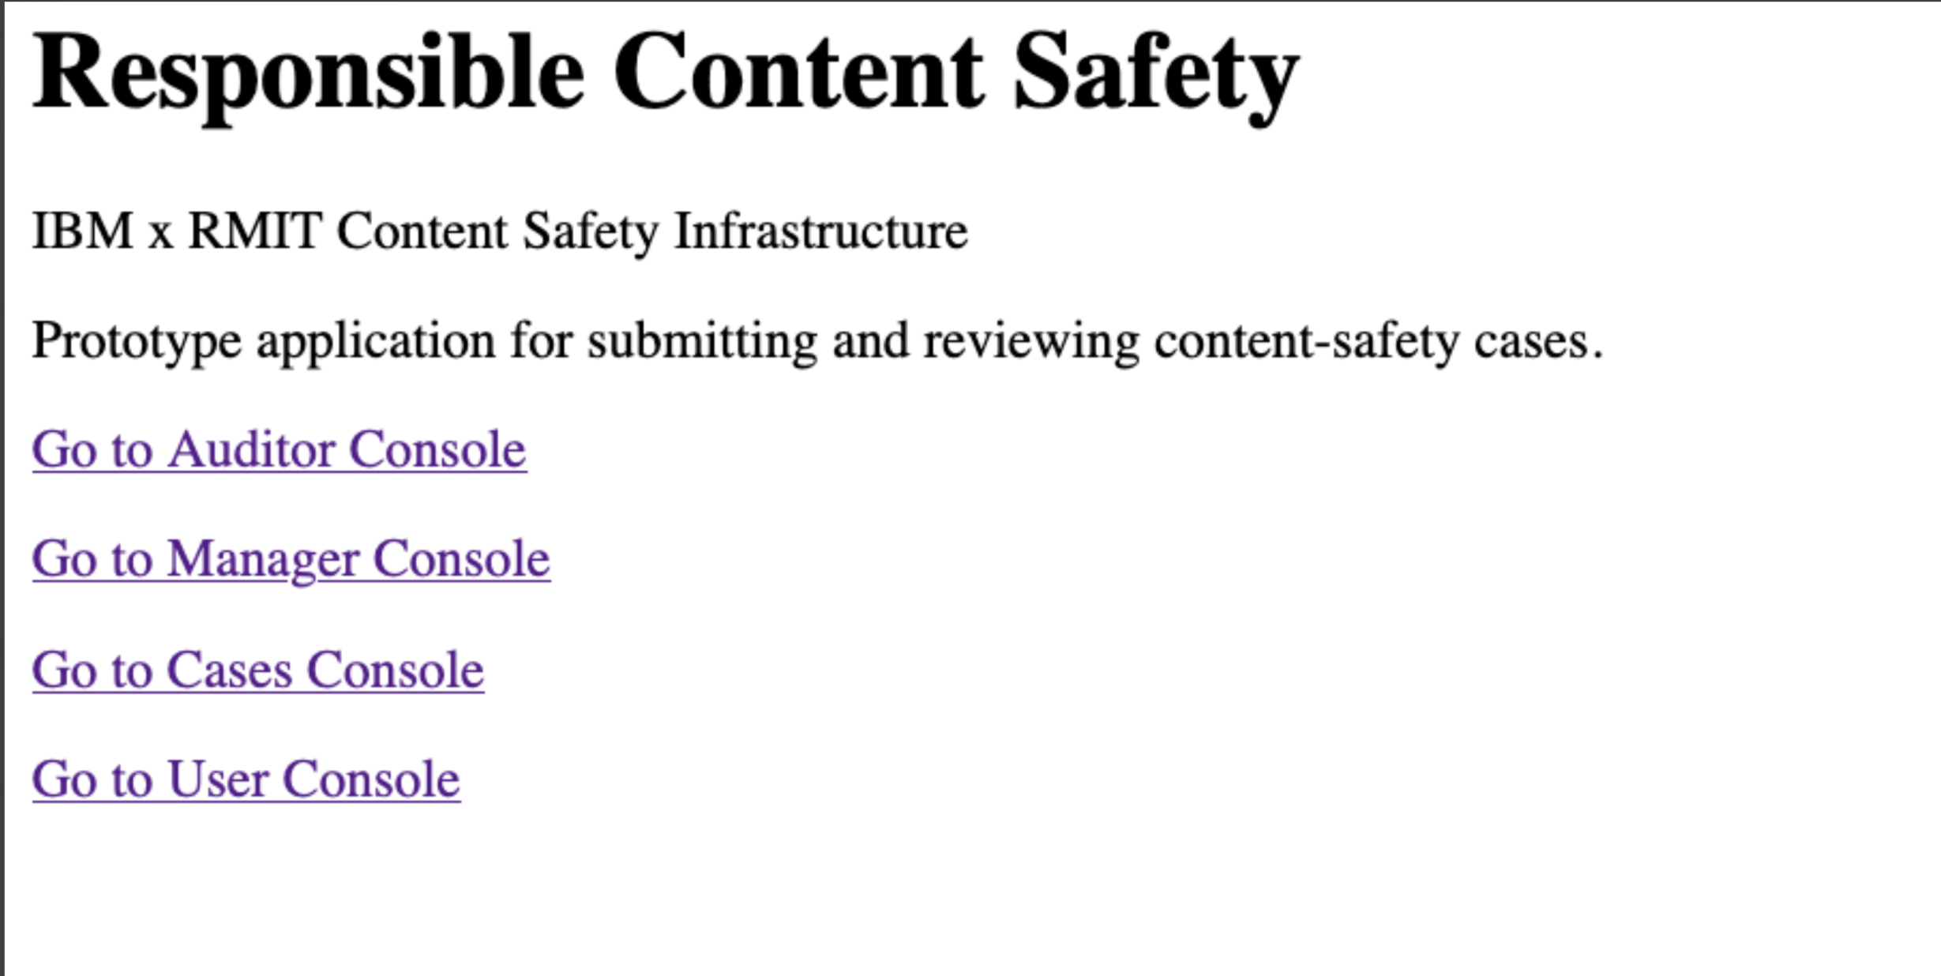
Root landing page — four console entry points, including two that plausibly both lead to submission-related pages (“Cases Console” and “User Console”).
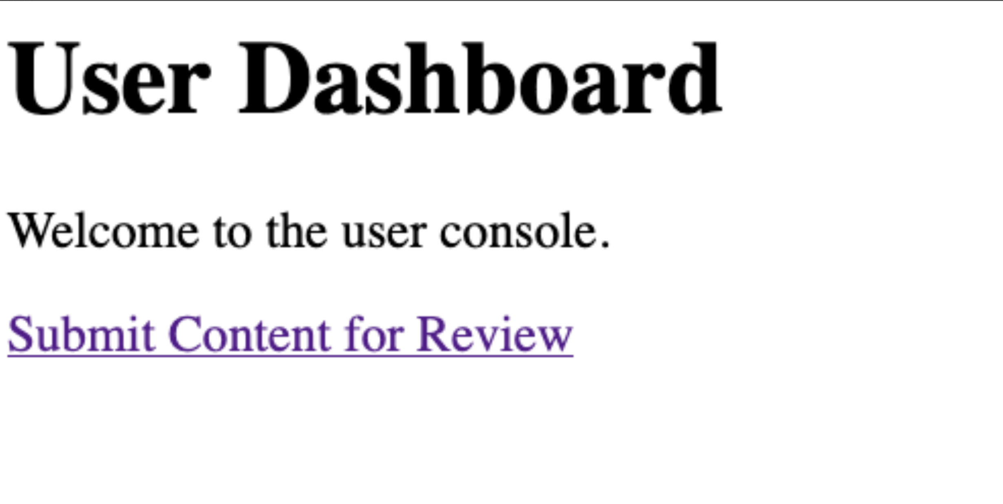
User Dashboard — an intermediate landing page reached from the root, linking onward to “Submit Content for Review.”
It is not confirmed from available evidence which entry point leads to Version A versus Version B. This should be clarified alongside the Section 2 finding.

4. Checklist Findings
Checklist item | Status | Notes / Evidence
Implemented submission UI reviewed against final UX specification | In progress — pending version confirmation | See Section 2. A single authoritative review will be completed once the intended version is confirmed.
Content upload and confirmation controls reviewed | In progress | Confirmation checkbox pending alignment with approved wording in both versions (see Section 2, Observation 1).
Supported formats/size messaging checked against confirmed backend constraints | Partially verifiable | Version B displays “Upload one audio or video file. Maximum size: 500 MB.” Version A shows no equivalent messaging in the reviewed screenshot. The 500 MB figure has not been confirmed against an agreed backend constraint — recommend checking with Dev/BA before treating it as final.
Validation and upload states reviewed | Gap identified | The specification requires the upload state to show “a progress bar with filename and percentage.” Version A currently shows only the submit button's label changing to “Submitting…”, without a progress bar, filename, or percentage indicator. No client-side validation state (e.g. missing file, wrong format) was observed in either version.
Case-creation processing state reviewed | Not verifiable | No distinct case-creation processing screen was observed, separate from the button's own submitting state. Per the approved specification, this should be a visible interim state, not only a disabled button.
Success and Case ID confirmation state reviewed | Indirectly verified — direct screen not yet captured | A case (Case ID: CASE-05a333e4-0040-435f-8d0d-ae1041af2d9e, funny.mp4) has since been observed in the Auditor's Current Cases queue, confirming the submission-to-case-creation path now succeeds at least once. However, the Public User-facing Success/Case ID confirmation screen itself has not yet been directly captured, so its content and layout cannot yet be compared against the approved specification. Separately: the Case ID observed is a long system-generated identifier, not the short human-readable format (e.g. “CS-1035”) used throughout the approved specification and prototype reference — recommend confirming with BA/Dev whether a shorter reference ID should be shown to the Public User.
Upload/storage/case-creation failure states reviewed | Partially aligned | Version A displays “Error: Could not submit the case” with no technical/diagnostic detail exposed to the Public User, which matches the specification's intent of withholding internal error detail. However, the exact required message (“We couldn't process your submission. Please try again.”) and the specified Retry action are not currently present — the built version shows different wording and no distinct Retry control.
Accessibility and clear user feedback checked | Partially verifiable | Both versions are currently unstyled; no meaningful colour-contrast or focus-state review is possible yet. At a content level, Version A's error message is appropriately plain-language. The existence of two divergent forms is itself a consistency concern for user feedback overall.
UX gaps recorded with screenshots and proposed changes | Complete | See Section 5.
Review findings handed over to Dev1 | Pending | To be actioned once this document is finalised.

5. UX Gaps & Proposed Changes
Proposed change 1: Confirm with Dev1 which submission page (Version A or B) is current, and remove or clearly label the other as deprecated/WIP so it is not mistaken for the live build.
Proposed change 2: Add the confirmation checkbox with the exact approved wording to whichever version is confirmed current.
Proposed change 3: Replace the button-label-only upload state with a progress bar showing filename and percentage, per the approved specification.
Proposed change 4: Add a visible case-creation processing state (e.g. “Creating your case…”) distinct from the upload progress indicator.
Proposed change 5: Update the failure-state message to the approved wording (“We couldn't process your submission. Please try again.”) and add a distinct Retry action, as specified.
Proposed change 6: Once the submission path succeeds end-to-end, re-review specifically to confirm the Success/Case ID screen matches the approved specification — this could not be assessed this round.
Proposed change 7: If “Case description” (Version B) is intended to remain, raise it with BA for formal addition to the specification rather than treating it as already approved.

6. Notes for Dev1
Item 1: Please confirm which of the two submission page versions shown in Section 2 is the current build.
Item 2: A case has now successfully reached the Auditor queue (Case ID: CASE-05a333e4-0040-435f-8d0d-ae1041af2d9e), confirming the submission path can complete — but this has not been reproduced consistently in the screenshots reviewed, and the Public User-facing Success/Case ID screen itself has not been captured. Please share a screenshot of that screen directly for comparison against the approved specification.
Item 3: Please confirm whether 500 MB is a backend-agreed size limit or a placeholder value.
Item 4: The upload state currently shows only a button label change (“Submitting…”); the specification calls for a progress bar with filename and percentage.
Item 5: The failure-state message and Retry action do not yet match the approved wording — see Section 4 for the exact text specified.
Item 6: The Case ID observed (a long system-generated identifier) does not match the short, human-readable format used throughout the approved specification and prototype reference — please confirm with BA whether a shorter reference ID should be generated and shown instead.

7. Notes for BA
Open item 1: Confirm whether “Case description” (a free-text field, Version B) should be added to the approved submission specification, since it does not currently appear there.
Open item 2: Confirm whether the Public User and Auditor should see a short, human-readable Case ID (as shown throughout the approved specification), or whether the long system-generated identifier now observed is intended to be user-facing.

