Manager, Authentication and Recovery UX Specification
IBM — Responsible Content-Safety Infrastructure
UX Design | Harneet Kaur — Sprint 3 Refinement and Dev1 Handoff
Task | Sprint 3 — [UX REFINEMENT] Refine Manager / Auth / Recovery States & Error Feedback
Output | Updated Manager/Auth/Recovery UX specification and implementation-ready Dev1 handoff
Dependencies | T3, T4
Builds on | Auditor/Manager Implementation UX Specification (Sections 4 and 5); Final Raw MVP UX QA (UX-01 to UX-20); Sprint 2 UX Evidence Pack and Sprint 3 Refinement Handoff
Evidence basis | Screens supplied by Dev1 on 11/10/2026: Login/Sign-in, password mismatch, email verification (pending, not yet verified, Firebase pages, success), Auditor queue and Manager Team Overview (F1–F8)
Prepared | 11/10/2026
Status | Prepared — states not yet present in the build are marked “not yet implemented”; unconfirmed rules remain TBC

1. Purpose and Scope
This document refines the Manager, authentication, recovery and error-feedback states for the Refined MVP. It reviews the screens Dev1 has built so far against the confirmed requirements and the approved specification, defines the states that are still missing, and converts the result into an implementation-ready handoff.
What is confirmed and what is not. Role-based access (FR-16) and Manager oversight (FR-12, FR-13) are confirmed requirements. The scope of authentication for the Raw MVP (TBC-09), Manager permissions (OD-11), exposure and cooldown thresholds (OD-07, OD-08, OD-09), the Decline reassignment workflow (OD-06) and Manager notification content (OD-10) are not. Where a behaviour depends on one of these, this document describes the state and its feedback but leaves the value, rule or permission explicitly TBC. No password rule, attempt limit, timeout, expiry time or permission has been introduced.
Labels used. “Implemented” means seen in a Dev1 screenshot. “Not yet implemented” means no screen has been supplied. “Specified” means defined here for Dev1 to build. “Proposed” means a UX recommendation that depends on BA/PM confirmation.

1.1 BA response applied in this version
The BA reviewed the Sprint 2 evidence and the Sprint 3 refinement direction and responded. The response is applied as follows.
BA position | How it is applied in this document
The TBC handling is endorsed: unconfirmed items stay marked TBC and no rule is invented. | Every authentication, recovery and Manager value that is not confirmed is listed in Section 11 and shown as TBC; none is set in any state, message or handoff item.
Decline leading to a Manager notification, and the wellbeing direction, are aligned with the requirements. | Manager states M5 to M8 keep Decline as a hand-over to the Manager’s escalation area and keep wellbeing actions as supportive oversight; the reassignment workflow and notification content stay TBC (OD-06, OD-10).
Access scope and wellbeing parameters stay TBC until the PM confirms them. | Role-based access is described as states only (TBC-09, OD-11); exposure, cooldown and SOS values are not shown (OD-07, OD-08, OD-09).
A Severity column in the Auditor queue is a UX recommendation, not a confirmed requirement (TBC-08); Developers are not asked to build it as a mandatory field. | Not part of this handoff. Severity remains in Case Preview and Analysis & Decision; the Manager workload table shows severity mix only where severity is available (M1).

2. Current Build Review (Dev1 screens, 11/10/2026)
Screen / state | Figure | Status | Summary
Login / Sign-in page (role tabs, new sign-in form, 2FA choice) | F1 | Implemented — gaps | Login and sign-in sit side by side. Forgot password, Remember me and a mandatory 2FA choice are present. No inline validation, failure or 2FA code-entry state is shown.
Password mismatch | F2 | Implemented — as a browser alert | A native “localhost:3000 — Passwords do not match.” alert appears. Entered email and the 2FA choice are retained.
Verification pending | F3 | Implemented | Pending badge, registered email, “I’ve Verified My Email”, resend countdown, spam hint and Return to Login.
Verification pending — email unavailable | F3 | Implemented — gap | “Email address unavailable” is shown in place of the registered email, with no guidance.
Verification not yet completed | F4 | Implemented | Clear message: “Your email is not verified yet. Click the link in your inbox, then check again.”
Verification link (Firebase-hosted page) | F5, F6 | Implemented — unbranded | Default “Verify Email Address / Complete verification” and “Your email has been verified / Continue” pages.
Verification success | F7 | Implemented — gaps | Green Verified badge and success message. “Return to Login” appears twice; the spam hint and the “Verify your email before signing in” caption remain.
Manager Team Overview | F8 | Placeholder only | Three cards with “—” values and the line “Team-level monitoring will be displayed here.”
Login failure (wrong credentials) | F9 | Implemented — as a browser alert | Dev1 supplied the screen by Teams. A native alert shows the raw text “Firebase: Error (auth/invalid-credential).”, with the host name, vendor name and an error code.
Forgot-password flow, 2FA code entry, locked account, session timeout, expired link, access denied | — | Not yet implemented | Dev1 confirmed by Teams that these are not built yet. Specified in Sections 4 and 5.

2.1 Annotated evidence
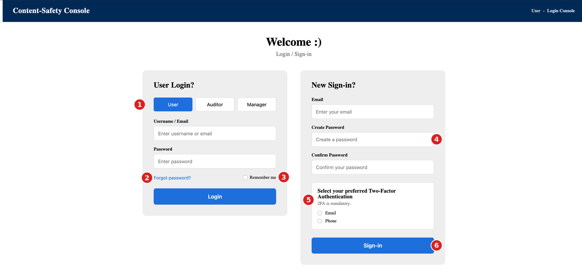
F1 — Login / Sign-in page
# | Observation | Ref
1 | Role selector (User / Auditor / Manager) on the login form. How a role is assigned is not defined. | TBC-17, FR-16
2 | “Forgot password?” link is present; the destination flow has not been supplied. | Section 5, TBC-16
3 | “Remember me” is offered. Whether it is allowed for a content-safety console is not confirmed. | TBC-15
4 | No password guidance is shown beside Create Password and no inline validation is evidenced. | UX-26, TBC-11
5 | Two-Factor Authentication is shown as mandatory with Email or Phone options. Selecting Phone does not reveal a phone-number field, and no code-entry state exists. | UX-26, UX-25, TBC-12
6 | Labels and headings render in a default serif face while buttons and inputs use a sans-serif face. | UX-29

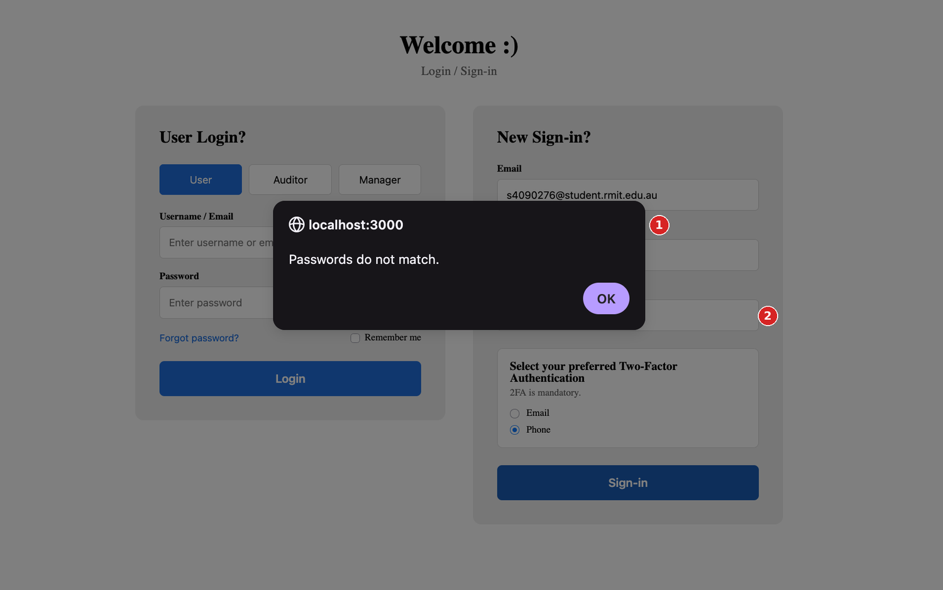
F2 — Password mismatch shown as a browser alert
# | Observation | Ref
1 | The message is a native browser alert (“localhost:3000”) that blocks the page, carries the host name and cannot be styled or placed beside the field. | UX-21
2 | The Confirm Password field gives no visual or textual indication of the error once the alert is dismissed. | UX-21

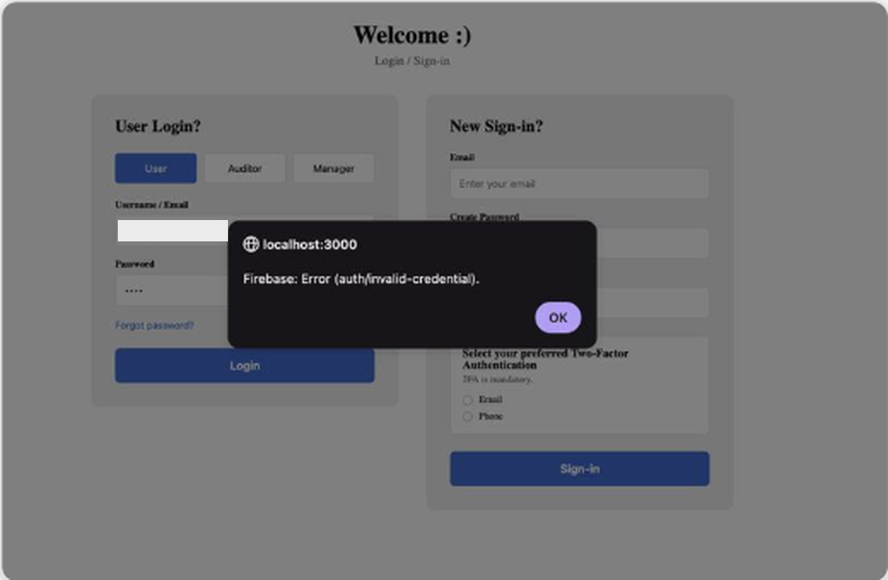
F9 — Failed login shown as a browser alert (screenshot supplied by Dev1 on Teams; low resolution, personal details removed)
# | Observation | Ref
1 | The message is a native browser alert that shows the host name, the vendor name and a technical error code (“Firebase: Error (auth/invalid-credential).”). It tells the user nothing about what to do next. | UX-21

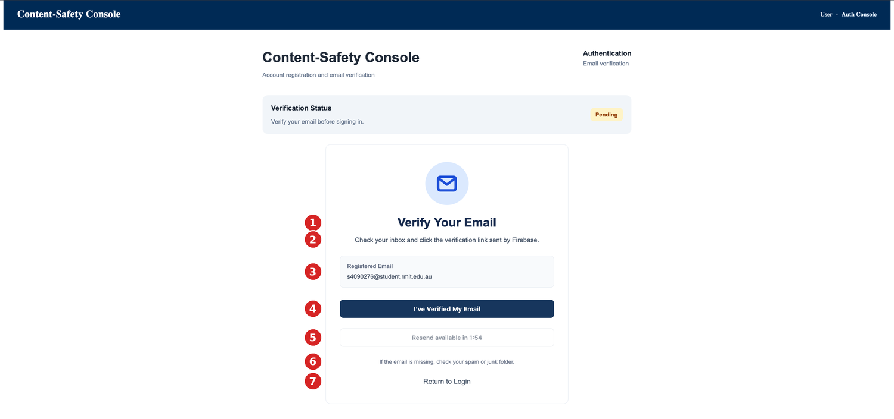
F3 — Verification pending
# | Observation | Ref
1 | Clear heading and a Pending status badge using text as well as colour. | —
2 | Instruction text names the vendor (“sent by Firebase”), which means little to a user and may be confused with the sender name. | UX-23
3 | Registered email is displayed so the user can check the address. | —
4 | “I’ve Verified My Email” is the primary action. | —
5 | Resend is disabled with a visible countdown (“Resend available in 1:54”). The cooldown value is not a confirmed rule. | TBC-13
6 | Spam/junk guidance is given. | —
7 | Return to Login is available as a text link. | —

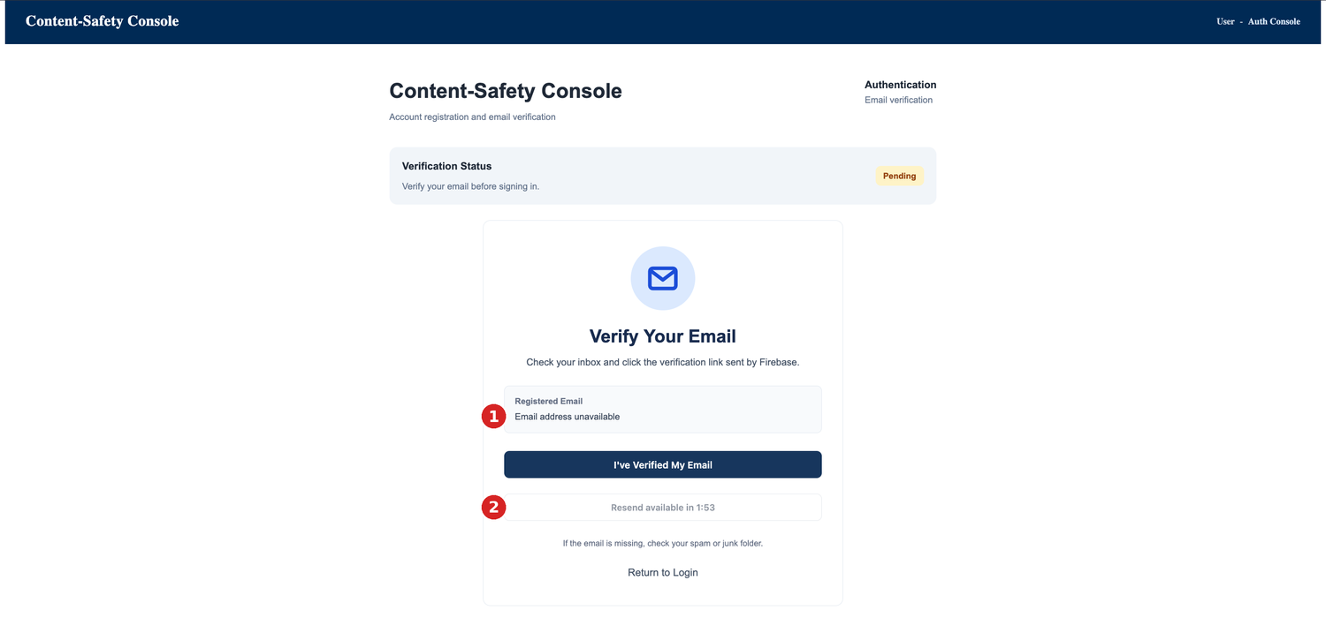
F3b — Verification pending with “Email address unavailable”
# | Observation | Ref
1 | “Email address unavailable” gives no reason and no next step. | UX-24
2 | Resend remains available only after the countdown, even though the address is unknown. | UX-24

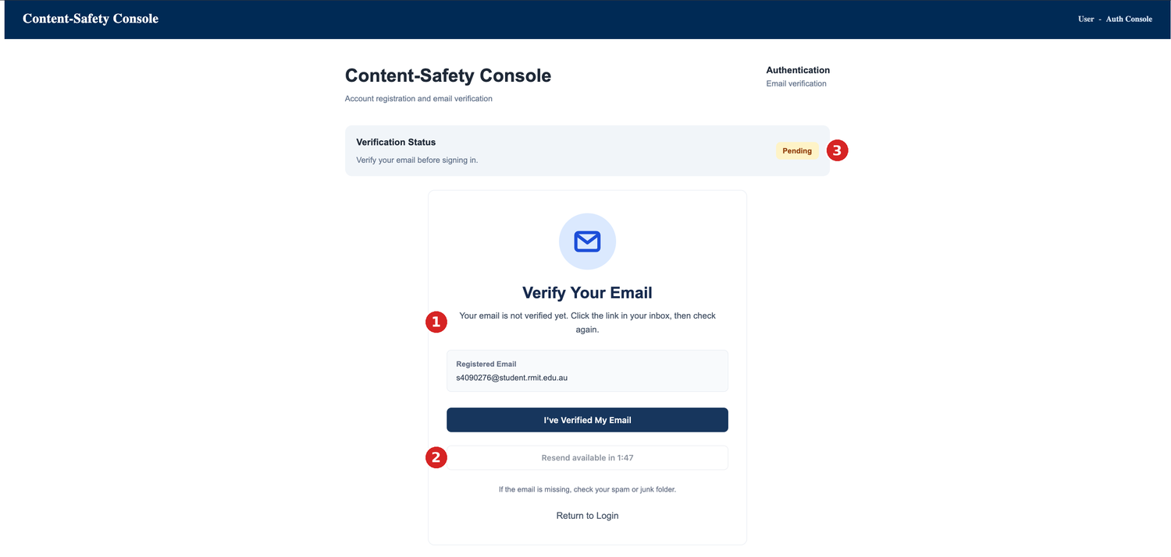
F4 — Verification not yet completed
# | Observation | Ref
1 | Plain, non-technical message that tells the user what to do next. | —
2 | Resend stays disabled while the countdown runs; the countdown is the only explanation. | TBC-13
3 | Status badge still reads Pending, consistent with the message. | —

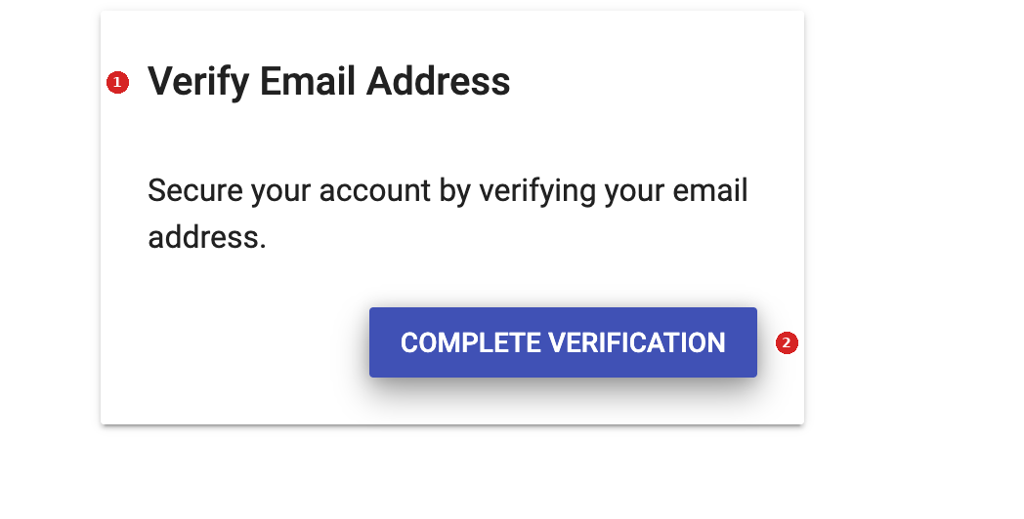
F5 — Firebase-hosted “Verify Email Address” page (opened from the email)
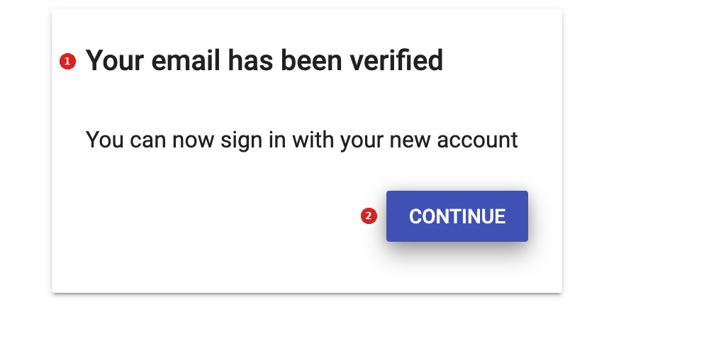
F6 — Firebase-hosted “Your email has been verified” page
# | Observation | Ref
F5-1, F6-1 | Default third-party styling; no console header, wording or product name. The user leaves the console experience at this point. | UX-23
F5-2, F6-2 | Action buttons (“Complete verification”, “Continue”) are clear, but where “Continue” leads is not evidenced. | UX-23

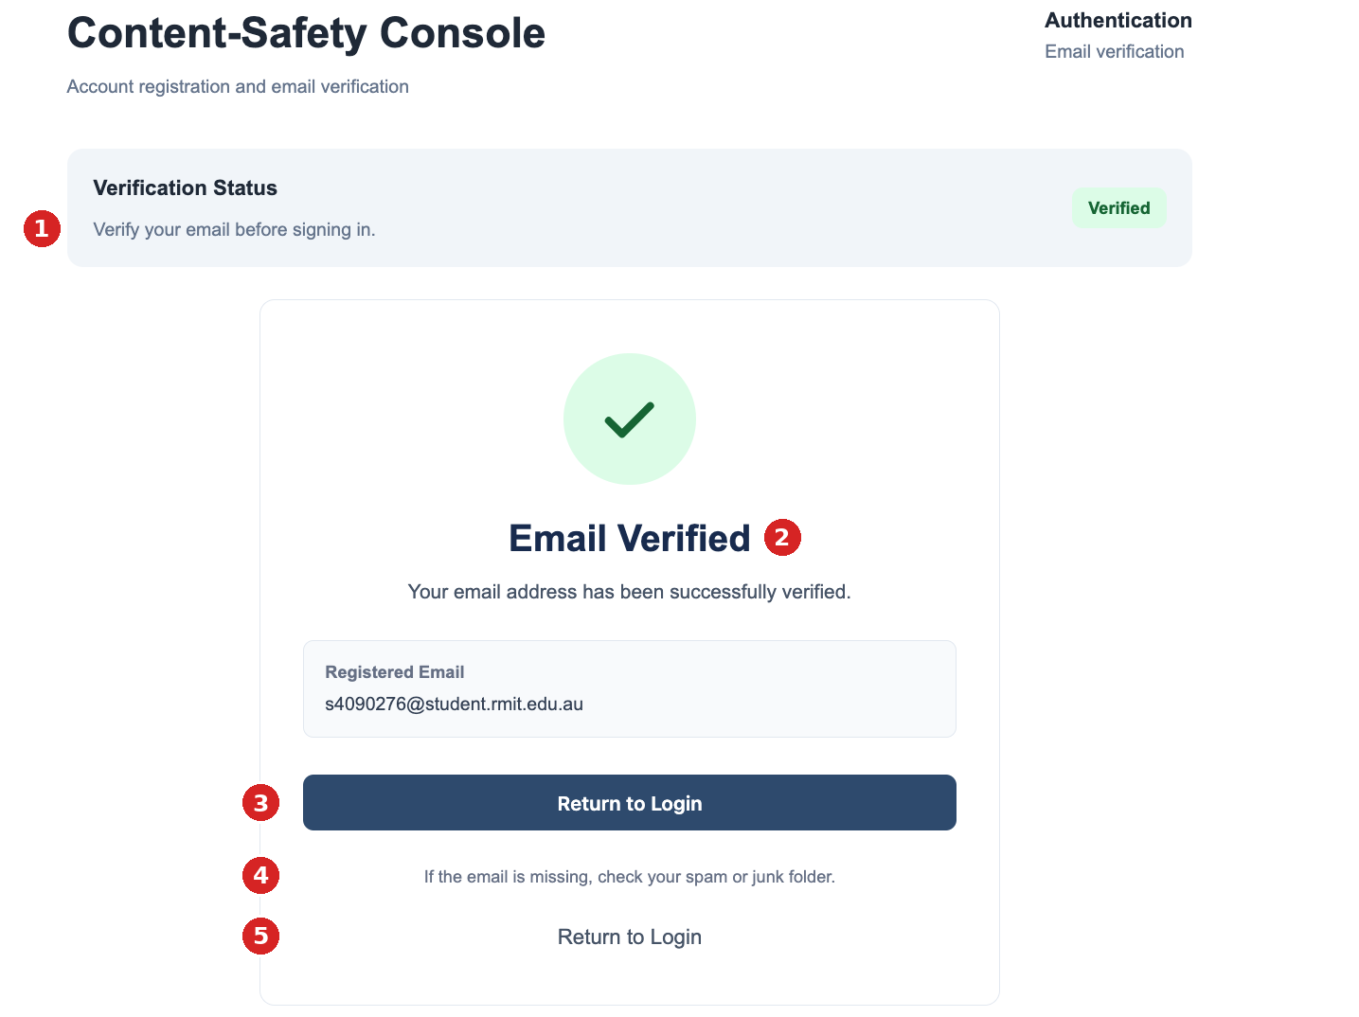
F7 — Verification success
# | Observation | Ref
1 | Status badge updates to Verified, but the caption still reads “Verify your email before signing in”. | UX-22
2 | Heading and message confirm success clearly. | —
3 | Primary “Return to Login” button. | UX-22
4 | The “check your spam or junk folder” hint is no longer relevant after success. | UX-22
5 | A second “Return to Login” link duplicates the button. | UX-22

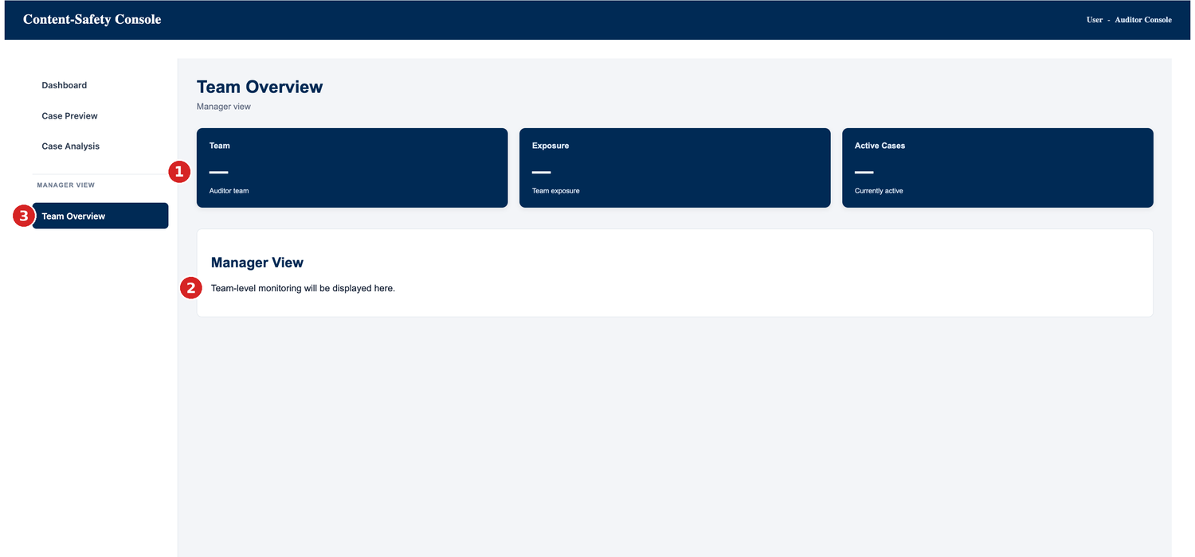
F8 — Manager Team Overview (placeholder)
# | Observation | Ref
1 | Team, Exposure and Active Cases cards show “—”. A dash cannot be told apart from loading, zero or an error. | UX-28
2 | Placeholder line “Team-level monitoring will be displayed here.” No workload table, exposure flags, escalated-case entry or wellbeing actions. | UX-28, UX-19
3 | Manager View sits in the same sidebar as the Auditor pages, and the header reads “User - Auditor Console”. Role-based visibility is not evidenced. | UX-27, TBC-09

3. Requirements Basis and TBC Boundaries
Area | Confirmed (used as a basis) | Remains TBC (not defined here)
Role-based access | FR-16: users only reach the console and pages for their role. | Scope of authentication for the Raw MVP (TBC-09); how accounts and roles are created (TBC-17).
Authentication | Authentication is part of the Refined MVP direction; the build shows email sign-up, email verification and 2FA. | Password rules (TBC-11); 2FA scope, method, code format and attempts (TBC-12); verification expiry and resend cooldown (TBC-13); lockout (TBC-14); session timeout and Remember me (TBC-15); password recovery method and expiry (TBC-16).
Manager oversight | FR-12, FR-13: Manager oversight of Auditor workload and exposure; escalated-case destination. | Manager permissions and exposure-control actions (OD-11).
Wellbeing controls | FR-08 exposure tracking; cooldown and SOS exist as capabilities (spec Section 5). | Exposure limit values (OD-07), cooldown threshold and duration (OD-08), SOS trigger and action (OD-09).
Decline | Decline hands a case to the Manager’s escalation queue and is not a verdict. | Reassignment workflow (OD-06); notification trigger and content (OD-10).
Accessibility | Accessibility expectations apply to all states; WCAG 2.1 AA is the proposed working reference. | Formal accessibility target (TBC-10).
TBC-11 to TBC-17 are proposed new references raised in this review for BA to register; TBC-01 to TBC-10 and OD-01 to OD-11 are as recorded in the Sprint 2 Evidence Pack.

4. Authentication States
All wording below is proposed copy in plain language. It avoids technical detail and vendor names, and it does not state any limit or time that is not confirmed.

4.1 State map
ID | State | Trigger | Content and behaviour | Build status
A1 | Sign-in form (new account) | User opens the Login Console. | Email, Create Password, Confirm Password, 2FA preference, Sign-in. Each field has a visible label. Password guidance appears beside Create Password once rules are confirmed (TBC-11). | Implemented
A2 | Field error — passwords do not match | Confirm Password differs from Create Password on submit or on leaving the field. | Inline message under Confirm Password; field outlined with an error icon and text (not colour alone); error summary at the top of the form; focus moves to the first field in error; email and 2FA choice are kept; only password fields are cleared. | Alert only — refine
A3 | Field error — required or invalid | A required field is empty or the email format is not valid. | Inline messages under the field (Section 4.3). Submit is not blocked from receiving focus; errors are listed in the summary. | Not yet implemented
A4 | Verification pending | Registration submitted. | As F3: Pending badge, registered email, primary “I’ve Verified My Email”, resend with countdown, spam hint, Return to Login. | Implemented
A5 | Not yet verified | User selects “I’ve Verified My Email” before verifying. | As F4. The message is announced to assistive technology and the primary action stays available. | Implemented
A6 | Verification email page | User opens the link from the email. | Currently a default hosted page (F5, F6). Wording and landing page follow Section 4.2. | Implemented — unbranded
A7 | Verification success | Verification confirmed. | Badge Verified; heading and message; one “Continue to Login” button; spam hint removed; caption updated to “Your email is verified.” | Implemented — refine
A8 | Login (existing account) | User enters email/username and password. | Login button; Remember me is shown only if confirmed (TBC-15). | Implemented
A9 | Login failure | Credentials are not accepted. | Currently a native browser alert with the raw text “Firebase: Error (auth/invalid-credential).” (F9). Refine to a generic inline message above the form (Section 4.3) that does not say which detail was wrong and shows no vendor name or error code; entered email is kept; password is cleared; focus moves to the message. Attempt limits and lockout are TBC (TBC-14). | Implemented — as alert; refine
A10 | Login with unverified email | Valid credentials but the email is not yet verified. | Proposed: take the user to the verification pending state (A4) rather than showing a login error. Pending BA confirmation of the verification rule (TBC-09). | Not yet implemented
A11 | 2FA code entry | Login or sign-in reaches the second factor. | Prompt naming the chosen method (Email or Phone), a code field, Verify and Resend actions, and a plain error for an incorrect code. Code length, expiry and attempts are TBC (TBC-12). If Phone is chosen, a phone-number field is required at sign-in. | Not yet implemented
A12 | Access denied (wrong role) | A signed-in user opens a page outside their role. | Page titled “You don’t have access to this page” with a single action to return to their own dashboard. The role-to-page mapping and Manager permissions are TBC (TBC-09, OD-11). | Not yet implemented

4.2 Verification journey (refinement)
- User-facing copy. Replace “…click the verification link sent by Firebase.” with “Check your inbox and select the verification link we sent to the address below.” The vendor name is removed (UX-23).
- Hosted verification pages (F5, F6). Use the console product name and, where Dev1 confirms it is feasible, matching styling. “Continue” should land on the Login Console. If the hosted pages cannot be changed, record that as a known limitation rather than redesigning around it.
- Success state (F7). Keep one primary button, “Continue to Login”. Remove the duplicate link and the spam hint, and change the caption beneath Verification Status to match the Verified state.
- Email unavailable (F3b). Replace the single line “Email address unavailable” with a short explanation and a next step (Section 4.3, message V4).
- Resend. Keep the disabled state with a visible countdown. Announce the state change once (when resend becomes available), not every second. The countdown length and any link expiry are TBC (TBC-13) and are not stated in the interface text.

4.3 Message and copy deck (proposed)
ID | Where | Proposed text | Notes
V1 | Confirm Password (A2) | The passwords you entered don’t match. Please enter them again. | Inline, with error icon; replaces the browser alert.
V2 | Required field (A3) | Enter your email address. / Enter a password. | One message per field; names the field.
V3 | Email format (A3) | Enter a valid email address. | No format rules beyond a valid address.
V4 | Email unavailable (F3b) | We can’t show your email address. Return to Login and sign in again to continue verification. | Proposed; exact recovery path to be confirmed with Dev1.
V5 | Login failure (A9) | We couldn’t sign you in. Check your details and try again. | Does not reveal whether the email or the password was wrong.
V6 | Not yet verified (A5) | Your email is not verified yet. Click the link in your inbox, then check again. | Already in the build; retain.
V7 | Resend sent | We’ve sent a new verification email to [email]. | Shown after a successful resend.
V8 | Link invalid or no longer valid (A6) | This verification link is no longer valid. Return to Login to request a new one. | Expiry rule is TBC (TBC-13); text names no time.
V9 | Verification success (A7) | Your email is verified. You can now sign in. | Single “Continue to Login” action.
V10 | Access denied (A12) | You don’t have access to this page. | Single “Return to your dashboard” action.
V11 | Generic system error | Something went wrong on our side. Please try again. | No error codes, host names or vendor names in user-facing text.
Lockout, session-expiry and code-entry messages are not drafted because their rules are unconfirmed (TBC-12, TBC-14, TBC-15). Dev1 should reserve a place for them and show V11 until the BA confirms the rule.

5. Recovery States
ID | State | Trigger | Content and behaviour | Build status
R1 | Verification email not received | User waits on the pending page. | Resend (disabled during countdown, then enabled), spam/junk hint, Return to Login. After a resend, V7 is shown and the countdown restarts. Cooldown value TBC (TBC-13). | Implemented
R2 | Verification link no longer valid | User opens an old or already-used link. | Message V8 and a single action to return to Login, where verification can be requested again. Expiry rule TBC (TBC-13). | Not yet implemented
R3 | Forgot password — request | User selects “Forgot password?”. | Page with one email field and a “Send reset instructions” action. After submit, the same confirmation is shown whether or not the address has an account: “If an account exists for this address, we’ve sent reset instructions.” | Not yet implemented
R4 | Forgot password — reset | User opens the reset instructions. | New password and Confirm password fields using the same inline validation as A2 and the rules in TBC-11; a clear success message and a “Continue to Login” action. The method (link or code) and expiry are TBC (TBC-16). | Not yet implemented
R5 | Reset instructions no longer valid | User opens an old or used reset link or code. | Plain message and an action to request new instructions. Expiry TBC (TBC-16). | Not yet implemented
R6 | Session ended | The session expires or the user is signed out. | Return to Login with a short message that the session ended and that nothing was lost where that is true. Timeout length and any warning before sign-out are TBC (TBC-15). Proposed for wellbeing: an Auditor mid-review is warned before being signed out. | Not yet implemented
R7 | Account locked | Repeated failed sign-ins (if a limit is confirmed). | State reserved only. The trigger, duration and unlock route are TBC (TBC-14). | Not yet implemented
R3 and R4 describe states the Login page already points to (“Forgot password?”). They are specified so Dev1 can build the screens; the delivery method, expiry and any rate limits are not decided here.

6. Error-Feedback Patterns
Pattern | Rule
Placement | Field errors appear directly beneath the field. Form-level errors appear at the top of the form. Browser alerts (window.alert) are not used for validation or errors.
Not colour alone | Every error uses text plus an icon; colour is supplementary. Status badges (Pending, Verified) keep their text labels.
Announcement | Errors and status changes are announced to assistive technology (an alert region for errors, a polite status region for progress such as “Email sent”). On submit with errors, focus moves to the first field in error.
Tone | Calm, plain and non-blaming (“We couldn’t sign you in”), with one clear next step. No technical detail, host names, vendor names or codes in user-facing text.
Data retention | Entered text (email, selected 2FA method) is kept after an error. Password fields are cleared.
Disabled controls | A disabled action states why (for example “Resend available in 1:47”). The remaining time is not announced every second.
Consistency | The same wording and layout are used for the same kind of error across the Public User, Auditor and Manager consoles.

7. Manager States
The Manager Overview is a placeholder (F8). The states below follow the approved specification (Section 5) and the Sprint 1 prototype. Every value shown as a threshold, permission or workflow outcome is marked TBC.
ID | State | Content and behaviour | TBC boundary | Build status
M1 | Overview — data available | Summary cards (Team, Exposure, Active Cases, as built) above an Auditor workload table showing each Auditor’s caseload, exposure in minutes and, where available, severity mix. | Severity mix depends on severity availability (OD-01). | Placeholder only
M2 | Overview — loading | Cards and table show a loading state with a text label (“Loading team data…”), not “—”. | — | Not yet implemented
M3 | Overview — empty | “No Auditors are assigned yet.” / “No active cases.” shown in place of values. A zero is shown as 0, never as “—”. | Assignment rules (OD-04). | Not yet implemented
M4 | Overview — failed to load | “We couldn’t load team data. Try again.” with a Retry action; the page layout stays in place. | — | Not yet implemented
M5 | Exposure flag | A row for an Auditor approaching a wellbeing threshold carries a text label and icon (for example “Exposure review”) as well as colour; wording is supportive, not disciplinary. No number is shown as a limit. | Threshold value and trigger rules (OD-07). | Not yet implemented
M6 | Escalated / Declined case review | A visible destination for cases routed by Decline, listing Case ID, the Auditor who declined it and the time, with a status column. Status labels are draft. | Reassignment workflow (OD-06); decision labels (OD-03). | Not yet implemented
M7 | Wellbeing actions | Cooldown and SOS controls are shown as confirmed capabilities with a “Parameters pending” marker; they are not wired to any value. | Cooldown threshold and duration (OD-08); SOS trigger and action (OD-09). | Not yet implemented
M8 | Manager notification | When an Auditor declines a case, an entry appears in M6 and the Manager sees it on arrival. The notification’s timing and content are not defined here. | Notification trigger and content (OD-10). | Not yet implemented
M9 | Role visibility | Manager View follows role-based access (FR-16): it is shown only to the roles the confirmed access scope allows, and other roles see the access-denied state (A12). The role-to-page mapping is kept in one configurable place so it can follow the BA’s decision. | Which roles may see the Manager View, and which Auditor data a Manager can act on (OD-11, TBC-09). | Not evidenced
Wellbeing and oversight. Oversight states are written to support Auditors, not to monitor them punitively: exposure is presented as minutes, flags invite a review, and wellbeing actions are available from the same page as caseload. No exposure limit, cooldown length or SOS rule is shown.

8. Accessibility Considerations
- Labels and structure. Every field has a visible label programmatically associated with it. The 2FA choice is a radio group with a legend. One page heading per page (the Authentication page currently shows “Content-Safety Console” both in the header and as the page title). [UX-29]
- Keyboard and focus. Logical tab order across both login forms; visible focus on tabs, links, buttons and radio options; the Role tabs are operable by keyboard and expose their selected state.
- Contrast. Check small grey text (for example the resend countdown and “Pending” badge) against the working reference, WCAG 2.1 AA (TBC-10), once styling is final. Contrast has not been measured from screenshots.
- Errors and status. Use alert and status regions as described in Section 6; do not rely on a browser alert.
- Passwords. Allow paste and password managers; offer a show/hide control on password fields (recommendation); use autocomplete attributes (email, new-password, current-password).
- Typography. Use one typeface family across headings, labels and controls. [UX-29]
- Motion and timing. Any countdown or progress indication respects reduced-motion settings; timed behaviour is not enforced without a warning (values TBC).

9. Findings Log (this review)
Continues the issue numbering of the Final Raw MVP UX QA (UX-01 to UX-20). Severity uses the same scale: High — a confirmed requirement is not met or the build differs materially from the specification; Medium — a usability, accessibility, feedback or specification gap; Low — minor or cosmetic.
ID | Finding | Evidence | Severity | Recommended action
UX-21 | Password mismatch and failed login are both shown as native browser alerts; the failed-login alert displays a raw technical message (“Firebase: Error (auth/invalid-credential).”) with the host name, vendor name and error code; no inline message or field state. | F2, F9 | Medium | Inline messages V1 and V5, error summary, focus to the field; no vendor name or error code in user-facing text.
UX-22 | Verification success shows “Return to Login” twice, keeps the spam hint, and the caption still reads “Verify your email before signing in”. | F7 | Low | One “Continue to Login” action; remove hint; update caption.
UX-23 | Verification pages hosted by Firebase are default-styled and unbranded; user copy names the vendor; the destination after “Continue” is not evidenced. | F3, F5, F6 | Medium | Remove vendor name; align wording and landing page where feasible.
UX-24 | “Email address unavailable” on the pending page gives no explanation or next step. | F3b | Medium | Use message V4 and a clear way back.
UX-25 | Forgot-password flow, 2FA code entry, expired link, access denied, session and lockout states are not built (confirmed by Dev1). | F1 | High | Build A11, A12, R2–R5 as specified; R6 and R7 reserved (TBC).
UX-26 | Sign-up form shows no password guidance or inline validation; choosing Phone for 2FA captures no phone number. | F1 | Medium | Add inline validation; show confirmed password rules (TBC-11); add phone field when Phone is chosen.
UX-27 | Manager View appears in the same sidebar as the Auditor pages and the header reads “User - Auditor Console”; role-based visibility is not evidenced. | F8 | Medium | Apply role-based visibility (FR-16) through one configurable mapping; BA to confirm which roles see the Manager View (TBC-09, OD-11).
UX-28 | Team Overview shows “—” placeholders and a holding line, with no loading, empty or error state (extends UX-19). | F8 | Medium | Build M1–M9 as specified; keep TBC values open.
UX-29 | Home and Login pages use unstyled serif labels and headings, and the page title repeats the header. Dev1 confirmed that the Home Dashboard is for developer testing only and will be disabled in the final product; the Login / Sign-in page is the landing page. | F1, F7 | Low | Apply the console typography. Treat Login / Sign-in as the entry screen; no design is needed for the Home Dashboard.
Open from last week and touched by this build: UX-12 (role-based entry now partly addressed by the Login Console and role tabs, but role-restricted access is not yet evidenced); UX-15 (Manager content is now in a separate “Manager View” navigation group, but remains in the Auditor console).

10. Dev1 Implementation Handoff
Items are grouped by priority. Acceptance criteria describe what can be observed in the build; none depends on an unconfirmed value.
ID | Build item | Acceptance criteria | Priority | Depends on
Priority 1 — address first
H1 | Inline password mismatch (A2) | No browser alert. Message V1 appears under Confirm Password with an icon; an error summary appears at the top; focus moves to the field; email and 2FA choice are kept; password fields are cleared. | P1 | UX-21
H2 | Login failure state (A9) | No browser alert, vendor name or error code. Invalid credentials show message V5 above the form without saying which detail was wrong; email is kept; focus moves to the message. | P1 | UX-21; TBC-14
H3 | Role-based navigation (M9, A12) | Navigation and pages follow a single role-to-page mapping that can be changed without redesign; a role without access sees the access-denied page (V10). The mapping itself is not decided here and is confirmed by the BA. | P1 | FR-16; UX-27; TBC-09
H4 | Manager Overview states (M1–M4) | Loading, empty (shows 0, not “—”), failed (with Retry) and data states exist; layout does not shift between states. | P1 | UX-28; OD-04
H5 | Escalated case entry point (M6, M8) | A case declined by an Auditor appears in the Manager’s escalated-case area with Case ID, declining Auditor and time. Status labels are marked draft. | P1 | UX-19; OD-06, OD-10
Priority 2 — address once Priority 1 is complete
H6 | Verification screen copy and success state (A4–A7) | Vendor name removed from copy; success screen has one “Continue to Login” button, no spam hint and an updated caption; message V4 shown when the email is unavailable. | P2 | UX-22, 23, 24
H7 | Forgot-password screens (R3–R5) | Request, confirmation, reset and invalid-link screens exist and use the shared error patterns; no expiry time or method is shown in the text. | P2 | TBC-16
H8 | 2FA entry (A11) | A code-entry state names the chosen method, offers Resend, and shows a plain error for an incorrect code; Phone requires a phone number at sign-in. | P2 | TBC-12
H9 | Manager wellbeing actions and flags (M5, M7) | Exposure flag rows use text, icon and colour; Cooldown and SOS controls show “Parameters pending”; no threshold, duration or trigger value appears. | P2 | OD-07, 08, 09
H10 | Accessibility and typography (Section 8) | Labels associated; radio group has a legend; focus visible; alert and status regions in use; one typeface family; one page heading per page. | P2 | UX-29; TBC-10
Reserve only — do not build rules until confirmed
H11 | Lockout, session timeout, Remember me, password rules, resend cooldown and link expiry | Provide a place in the design for these states and use message V11 as a fallback. Do not hard-code any limit, duration or rule. | TBC | TBC-11 to TBC-15

Dev1 confirmation (Teams, 11/10/2026). Dev1 confirmed that the list of unbuilt states above is mostly correct; that the Home Dashboard is for developer testing only and will be disabled in the final product, so the Login / Sign-in page is the landing page; and that a failed-login state exists (F9). Still to confirm with Dev1: whether the Firebase-hosted pages can be restyled or redirected, and whether Remember me and the resend countdown were placeholders or agreed behaviour.

11. TBC Register (Authentication, Recovery and Manager)
Ref | Item | Decision owner | Effect on this specification
TBC-09 | Scope of role-based access and authentication for the Raw MVP | BA | A9, A10, A12, M9 describe states only.
TBC-11 | Password rules (length, complexity) | BA / PM | No rule is shown in the interface.
TBC-12 | 2FA scope: whether mandatory, which methods, code format, expiry and attempts | BA / PM | A11 described without values.
TBC-13 | Verification link expiry and resend cooldown (build shows a countdown) | BA / Dev1 | Countdown kept as built; no value written in text.
TBC-14 | Failed sign-in limit, lockout duration and unlock route | BA / PM | R7 reserved only.
TBC-15 | Session timeout, warning before sign-out, and Remember me | BA / PM | R6 described without values; Remember me shown only if confirmed.
TBC-16 | Password recovery method (link or code) and expiry | BA / PM | R3–R5 described without method or time.
TBC-17 | How Auditor and Manager accounts are created and roles assigned | BA / PM | Role tabs noted as built; no assignment rule defined.
OD-04, 06, 07, 08, 09, 10, 11 | Assignment rules; Decline reassignment; exposure limit; cooldown; SOS; Manager notification; Manager permissions | BA / client | Manager states carry “TBC” markers and show no values.

