index.php

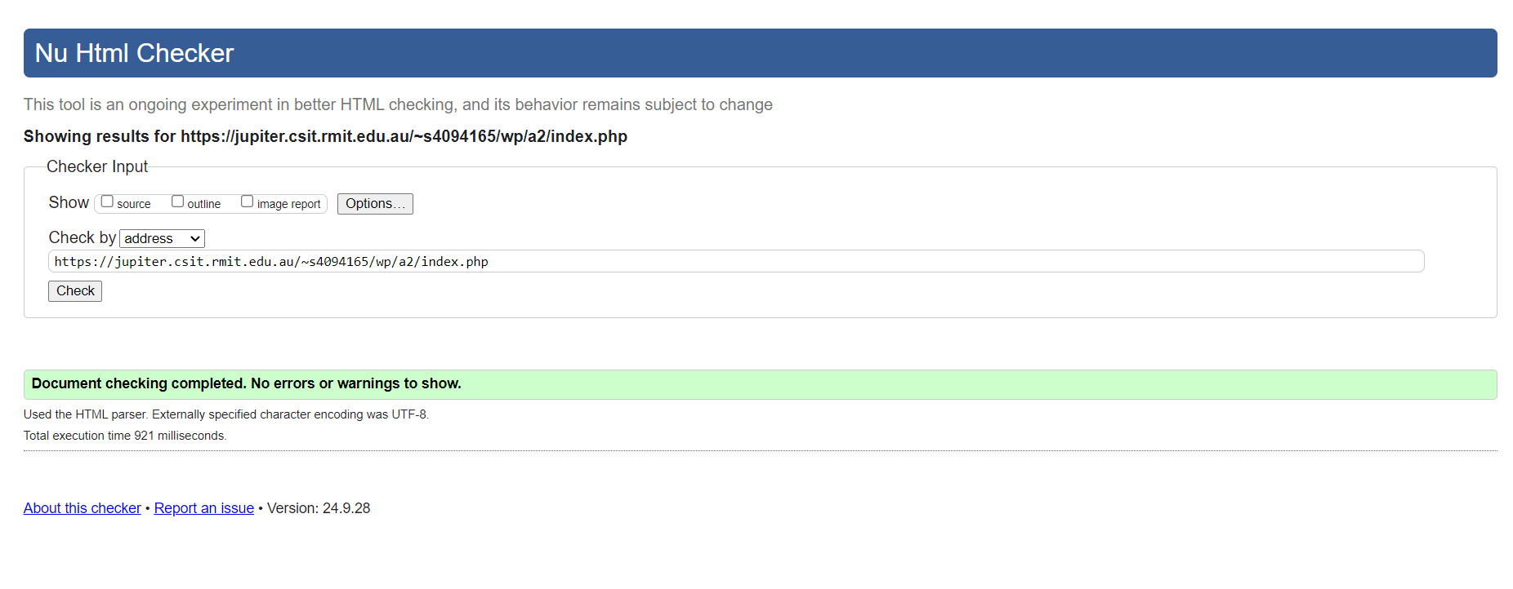

pets.php

add.php

gallery.php

details.php

upload.php

style.css

