index.html

pets.html

add.html

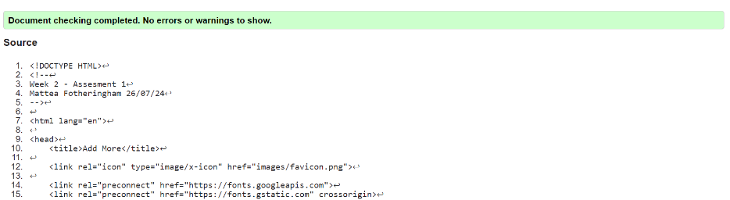

gallery.html

style.css

