300,000 Streets – School Streets
School Streets Safety Analysis

Healthy Streets Assessment

Regen Melbourne × RMIT University

1. Executive Summary
This report presents a Healthy Streets assessment of walking and cycling routes adjacent to three secondary schools in the City of Darebin, Victoria. The analysis applies the 10-indicator Healthy Streets framework developed by Lucy Saunders and adopted by Transport for London, scoring each school gate on pedestrian infrastructure, crossings, shade, rest places, noise, active travel, personal safety, amenity, traffic stress, and air quality.

The study integrates field observations with open data: OpenStreetMap spatial features, EPA Victoria air quality readings, Crime Statistics Agency Victoria suburb-level crime rates, and Victorian road crash records from data.vic.gov.au. A Ridge regression ML model is trained to predict HS indicator scores from open data, demonstrating which indicators can be automated and which require physical survey.

Key Findings
School | Overall | Severity | Lowest Indicator | Priority Action
Reservoir HS | 6.1 / 10 | Minor | HS1 — Pedestrians (4.2) | Widen + complete footpath on Plenty Rd
William Ruthven SC | 6.7 / 10 | Minor | HS3 — Shade/Shelter (3.0) | Plant street trees; install bus shelter
Preston HS | 7.2 / 10 | MAJOR | HS2 — Easy to Cross (0.4) | Install raised zebra crossing at gate

Preston High School is classified Major severity due to the absence of any formal pedestrian crossing adjacent to the school gate (HS2 = 0.4 / 10). Despite the highest overall score of 7.2, this single critical gap creates acute risk during school peak hours.

2. Healthy Streets Framework
The Healthy Streets framework (Saunders, 2015) defines 10 human-experience indicators for evaluating street quality. Each indicator is scored 0–10. An overall score ≥ 6.0 across all indicators is the target threshold for a school street. The framework is aligned with the Regen Melbourne Streets Values (regen.melbourne/gazette/regen-streets-values).

Code | Indicator | Data Source | Open-Data Proxy
HS1 | Pedestrians from all walks of life | Field observation | footpath_pct_400m
HS2 | Easy to cross | Field observation | crossing_density, signals
HS3 | Shade and shelter | OSM | tree_count, shelter_count, green_pct
HS4 | Places to stop and rest | OSM | bench_count, park_count, cafe_count
HS5 | Not too noisy | Field observation | avg_speed, arterial_pct
HS6 | People choose active travel | Field + OSM | cycle_pct, pt_stops
HS7 | People feel safe | Field + CSA Victoria | crime_rate_per_100k
HS8 | Things to see and do | OSM | amenity_count, cafe_count
HS9 | People feel relaxed | Field observation | avg_speed, road_count
HS10 | Clean air | EPA Victoria AirWatch | aqi_pm25 (PM2.5 μg/m³)

3. Schools Assessed
School | Address | Suburb | Gate Coordinates
Reservoir High School | 855 Plenty Rd | Reservoir VIC 3073 | -37.7224, 145.0294
William Ruthven Secondary College | 60 Merrilands Rd | Reservoir VIC 3073 | -37.69654, 145.00299
Preston High School | 2-16 Cooma St | Preston VIC 3072 | -37.7417, 145.0071

All three schools are located within the City of Darebin local government area.

4. Healthy Streets Indicator Scores
School | HS1 | HS2 | HS3 | HS4 | HS5 | HS6 | HS7 | HS8 | HS9 | HS10 | Overall | Severity
Reservoir HS | 4.2 | 5.7 | 5.0 | 6.0 | 5.0 | 6.0 | 8.0 | 6.8 | 5.2 | 9.0 | 6.1 | Minor
William Ruthven SC | 9.5 | 6.8 | 3.0 | 3.3 | 10.0 | 4.2 | 7.5 | 4.3 | 8.0 | 10.0 | 6.7 | Minor
Preston HS | 9.1 | 0.4 | 5.0 | 8.0 | 7.0 | 7.8 | 8.0 | 10.0 | 7.6 | 9.0 | 7.2 | Major

4.1 Radar Chart — All Schools
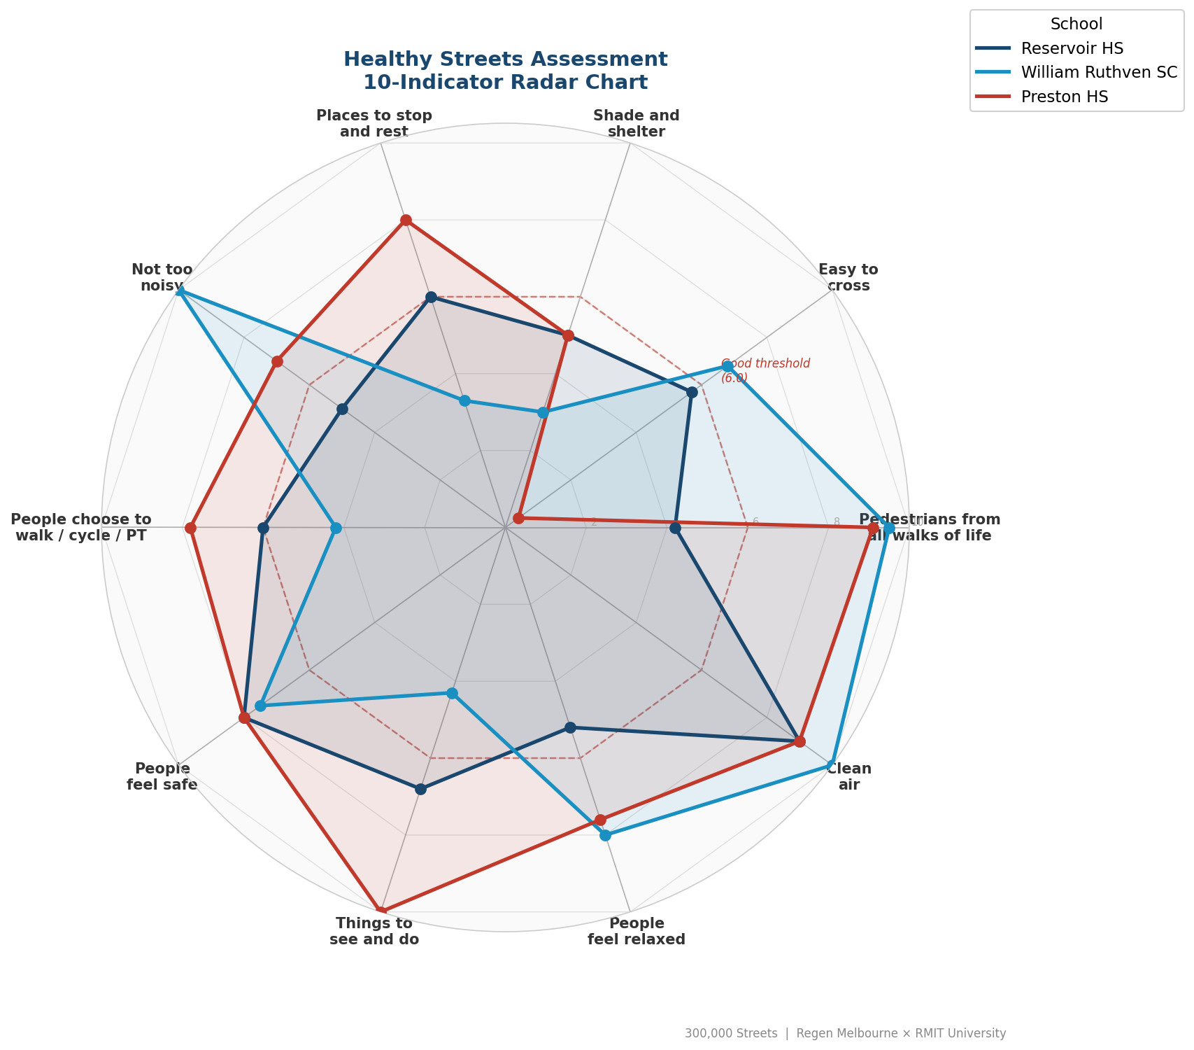
Figure 1: 10-indicator radar chart overlaying all three schools.

4.2 Per-Indicator Comparison
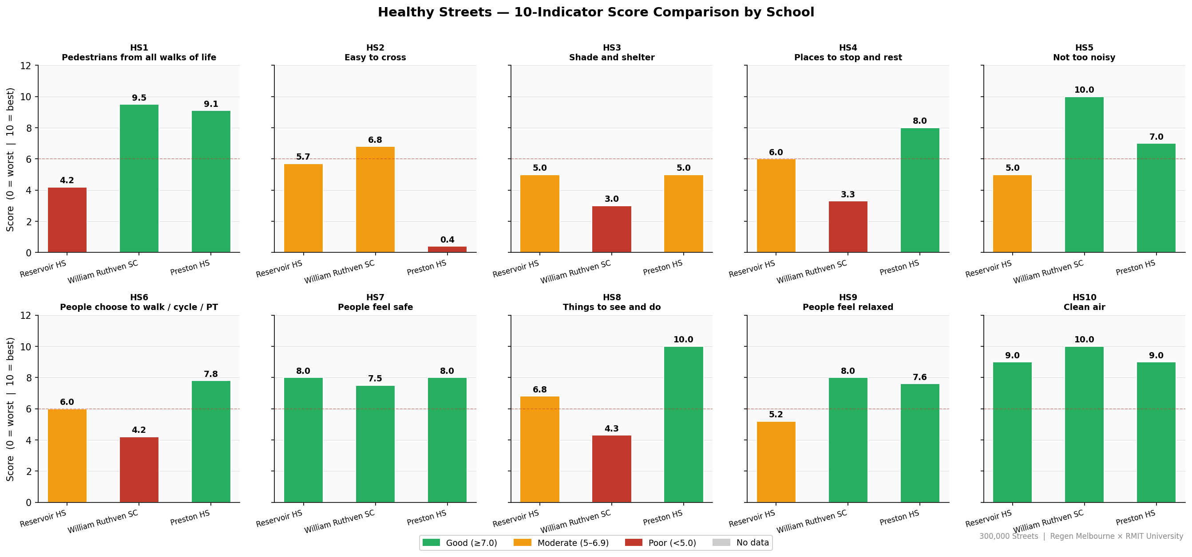
Figure 2: Bar comparison of each HS indicator across all three schools.

4.3 Per-School Breakdown
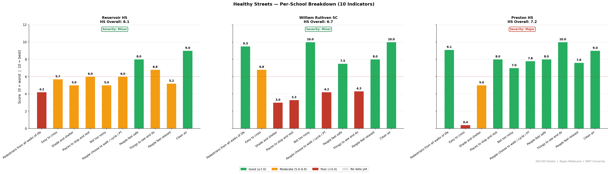
Figure 3: Individual indicator breakdown per school.

5. Recommendations
Recommendations are generated automatically by a gap-based rule engine applied to each HS indicator. Each recommendation includes a priority level, indicative cost band, timeframe, and expected score improvement (Expected_Score_Delta).

Reservoir High School
HS_Indicator | Hazard | Recommendation | Priority | Cost | Timeframe | Expected_Score_Delta
HS1 | Missing or broken footpath | Construct continuous concrete footpath minimum 1.8m wide | High | Medium — $20,000–$200,000 | Short-term — within 1 year | 3.0
HS1 | Footpath below minimum width (1.5m) | Widen footpath to minimum 1.5m — AS 1428.1 | Medium | Medium — $20,000–$200,000 | Short-term — within 1 year | 1.5
HS2 | Nearest crossing too far from school gate (>150m) | Install additional pedestrian crossing within 50m of school gate | High | Medium — $20,000–$200,000 | Short-term — within 1 year | 2.0
HS2 | No tactile ground surface indicators at crossing | Install tactile pavers on both sides of all crossings within 400m | Medium | Low — under $20,000 | Short-term — within 1 year | 1.0
HS6 | No cycling infrastructure on school frontage road | Install painted bike lane or shared path along school frontage (LTS 2–3 minimum) | Medium | Medium — $20,000–$200,000 | Medium-term — 1–3 years | 2.0
HS9 | No traffic calming on multi-lane road near school gate | Install speed humps or raised intersection table near school gate | High | Medium — $20,000–$200,000 | Short-term — within 1 year | 2.0

William Ruthven Secondary College
HS_Indicator | Hazard | Recommendation | Priority | Cost | Timeframe | Expected_Score_Delta
HS1 | Vegetation blocking footpath sightlines | Remove and regularly trim vegetation obstructing path and crossing visibility | Medium | Low — under $20,000 | Short-term — within 1 year | 0.5
HS2 | Poor crossing visibility | Remove sightline obstructions; install raised platform and advance warning signs | Medium | Medium — $20,000–$200,000 | Short-term — within 1 year | 2.0
HS3 | Low shade and shelter score (HS3 = 3.0/10) | Plant street trees at 8m spacing along school frontage; install bus shelter with seating near gate | Medium | Medium — $20,000–$200,000 | Medium-term — 1–2 years | 3.0
HS4 | Insufficient seating and rest places near school gate (HS4 = 3.3/10) | Install minimum 3 benches within 200m of school gate; add bus shelter seating | Low | Low — under $20,000 | Short-term — within 1 year | 3.0
HS6 | No cycling infrastructure on school frontage road | Install painted bike lane or shared path along school frontage (LTS 2–3 minimum) | Medium | Medium — $20,000–$200,000 | Medium-term — 1–3 years | 2.0
HS6 | Low active travel choice score (HS6 = 4.2/10) | Upgrade cycling infrastructure to separated lanes (LTS 1); improve PT stop access within 400m | Medium | High — over $200,000 | Long-term — 3–5 years | 2.5
HS9 | No school zone signage present | Install school zone signs with 40km/h speed restriction and flashing lights on all approaches | High | Low — under $20,000 | Short-term — within 1 year | 2.0

Preston High School
HS_Indicator | Hazard | Recommendation | Priority | Cost | Timeframe | Expected_Score_Delta
HS2 | No formal pedestrian crossing present | Install raised zebra crossing with tactile pavers adjacent to school gate | High | Medium — $20,000–$200,000 | Short-term — within 1 year | 4.0
HS2 | No tactile ground surface indicators at crossing | Install tactile pavers on both sides of all crossings within 400m | Medium | Low — under $20,000 | Short-term — within 1 year | 1.0
HS2 | Poor crossing visibility | Remove sightline obstructions; install raised platform and advance warning signs | Medium | Medium — $20,000–$200,000 | Short-term — within 1 year | 2.0
HS9 | No school zone signage present | Install school zone signs with 40km/h speed restriction and flashing lights on all approaches | High | Low — under $20,000 | Short-term — within 1 year | 2.0

6. Crash Data Analysis
Victorian road crash data was downloaded from data.vic.gov.au (accident, node, and person tables joined on ACCIDENT_NO). The dataset covers pedestrian and cyclist crashes over the last 5 years statewide. Each crash is assigned to its nearest school gate using vectorised haversine distance.

Severity | Count | % of total
Fatal (1) | 201 | 2.6%
Serious injury (2) | 3,150 | 40.5%
Other injury (3) | 4,422 | 56.9%
Total | 7,773 | 100%

Crash dataset: 7,773 pedestrian/cyclist crashes · Victoria · last 5 years
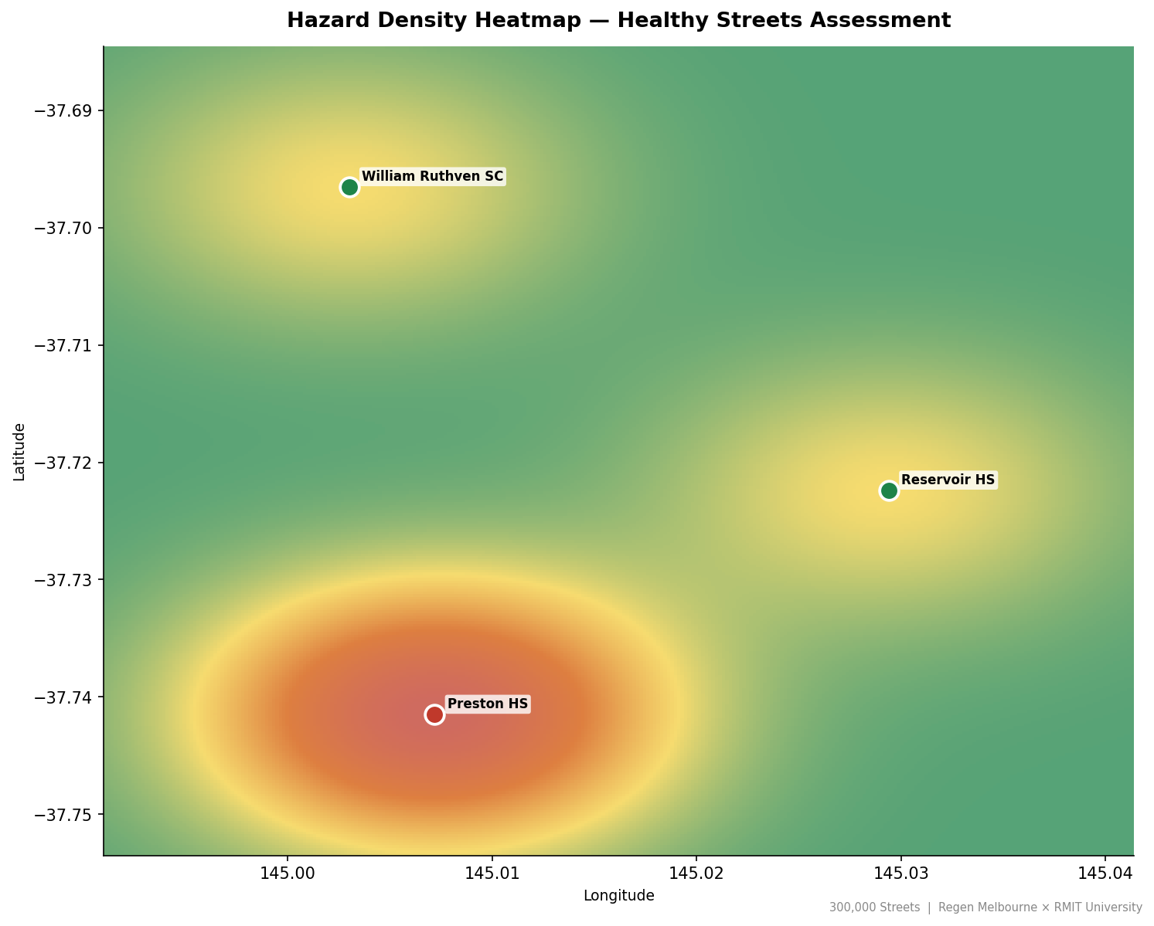
Figure 4: Crash density heatmap around school gates.

7. ML Model — Predicting HS Scores from Open Data
A Ridge regression model (multi-output) is trained to predict HS1–HS10 scores from 26 open-data features — OSM spatial data, EPA air quality, CSA crime statistics, and aggregated crash statistics. The research question is: which Healthy Streets indicators can be reliably estimated from freely available data without requiring physical field surveys?

Evaluation uses Leave-One-Out Cross-Validation (LOO-CV), the appropriate strategy for n=3 schools. Each school is predicted by a model trained on the other two.

7.1 LOO-CV Results (MAE per indicator)
Indicator | LOO-CV MAE | Can be automated?
HS7 — Feel safe | 0.54 | Yes — crime rate is a reliable proxy
HS10 — Clean air | 0.92 | Yes — AQI maps directly
HS9 — Feel relaxed | 1.72 | Largely — speed/arterial data captures most variance
HS3 — Shade/shelter | 2.17 | Partial — OSM tree data is incomplete
HS6 — Active travel | 3.08 | Partial — coverage adequate, quality not
HS1 — Pedestrians | 3.27 | Partial — footpath presence measurable, condition not
HS5 — Not too noisy | 3.68 | Partial — OSM speed data underestimates traffic volume
HS4 — Rest places | 4.19 | No — OSM bench/park data poorly maintained
HS2 — Easy to cross | 4.51 | No — crossing presence ≠ crossing quality
HS8 — Things to see and do | 4.72 | No — activity quality not captured by POI counts

Mean LOO-CV MAE across all indicators: 2.88 | n = 3 schools (results are illustrative)

7.2 Feature–Indicator Correlation
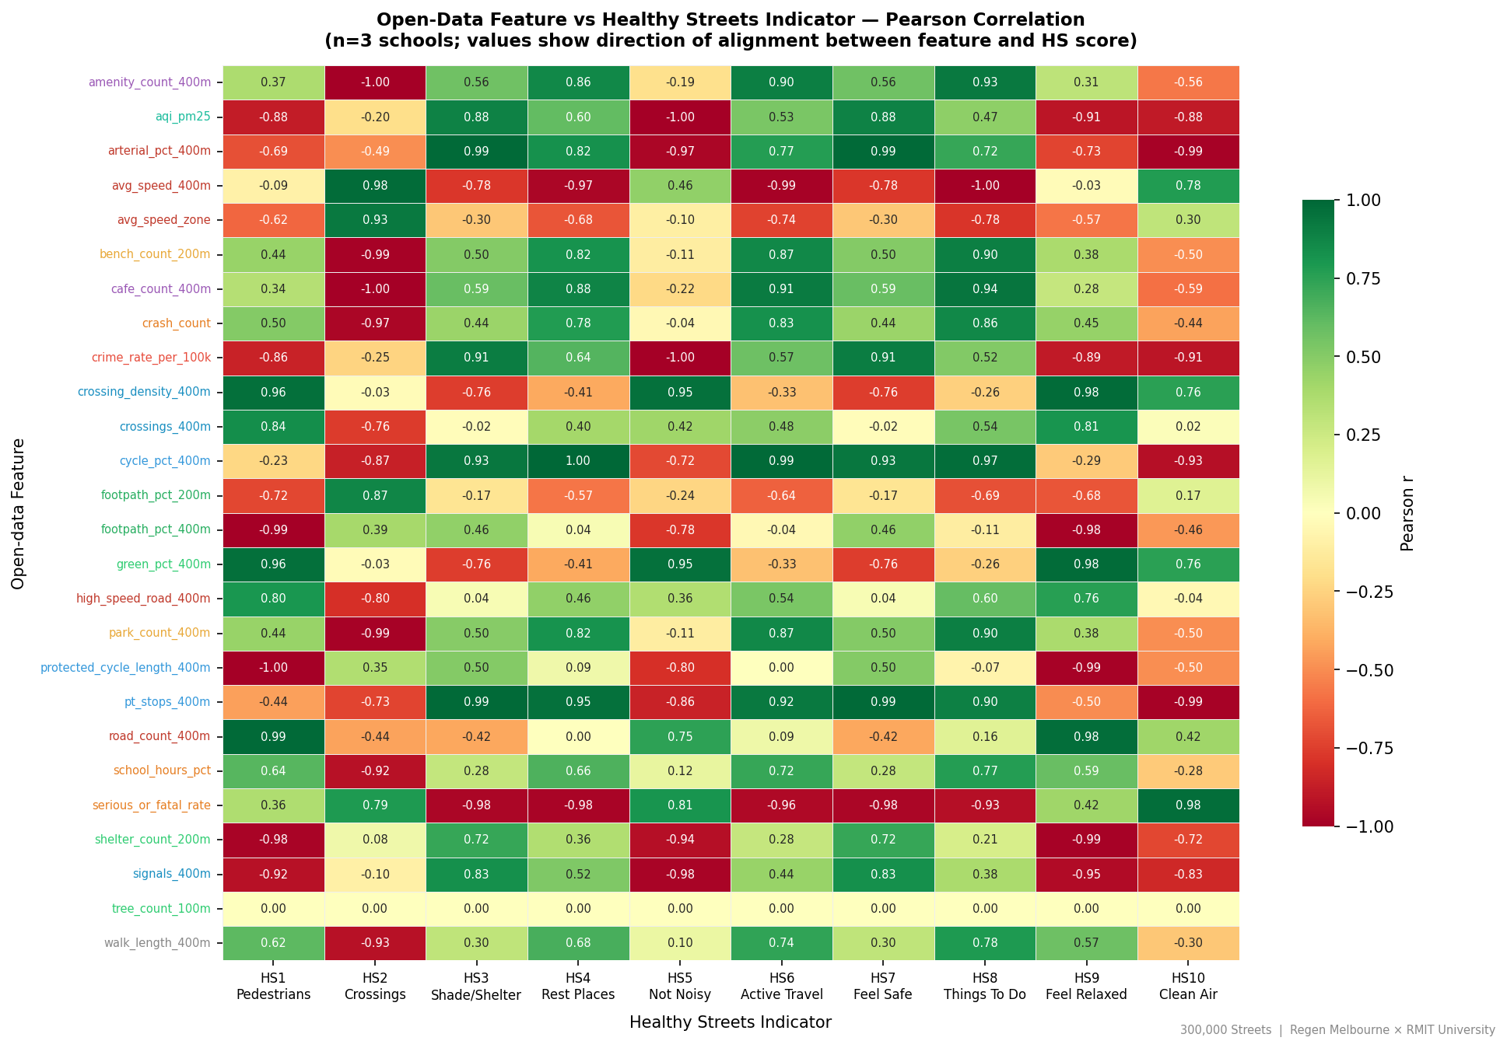
Figure 5: Pearson correlation between open-data features and HS indicator scores.

7.3 Actual vs Predicted (LOO-CV)
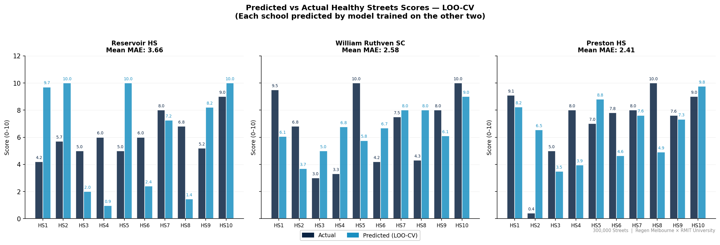
Figure 6: LOO-CV predicted vs actual HS scores per school.

7.4 Top Predictors per Indicator
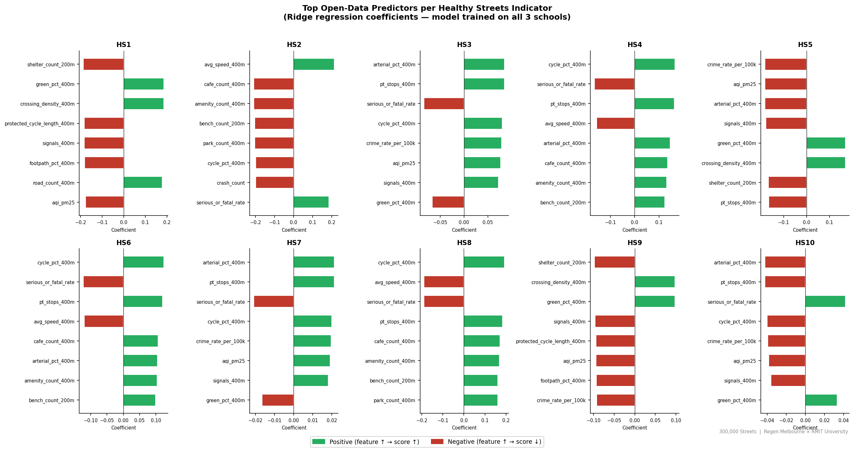
Figure 7: Ridge regression coefficients — top 8 open-data predictors per HS indicator.

8. Environmental Data — AQI and Crime Rate
School | Suburb | PM2.5 (μg/m³) | AQI Category | Crime Rate (per 100k)
Reservoir High School | Reservoir | 8.5 | Good | 820
William Ruthven Secondary College | Thornbury | 7.0 | Good | 560
Preston High School | Preston | 7.8 | Good | 710

AQI source: EPA Victoria AirWatch — Alphington station (site 10102) or 2023 suburb fallback.
Crime source: Crime Statistics Agency Victoria — offences against person per 100,000 population.
9. Demographic Context
Demographic data is sourced from the ABS Census 2021 for the suburbs surrounding each school. Lower household income, higher car dependency, and lower active transport mode share are associated with greater vulnerability to unsafe school street infrastructure.

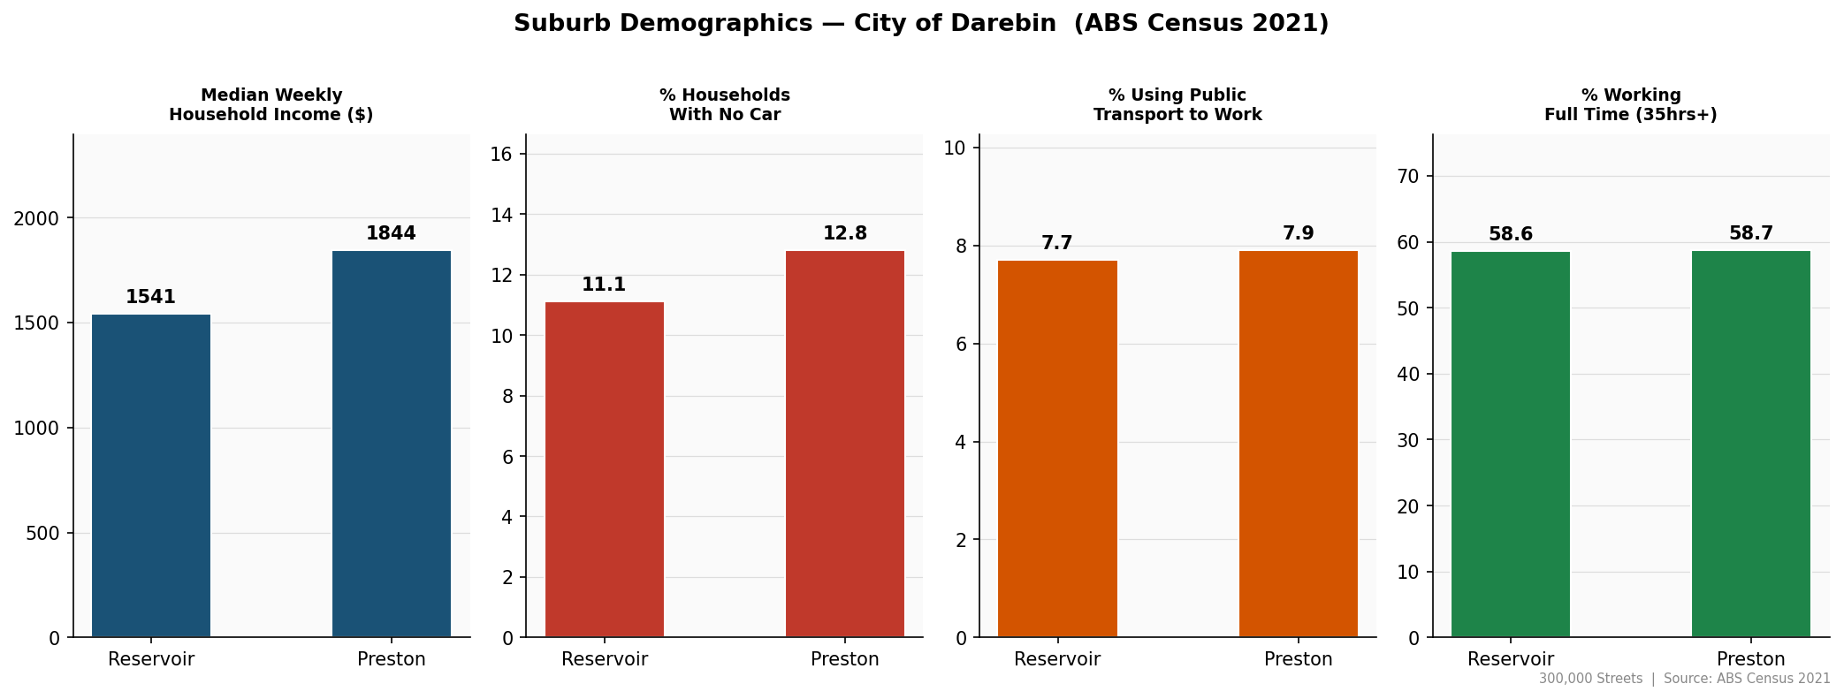
Figure 8: Demographic profile — household income, car ownership, and transport mode share.

10. Hazard Severity
Severity is classified as Major, Moderate, or Minor based on rule thresholds applied to HS1 (pedestrian infrastructure), HS2 (crossings), HS5 (noise/traffic), and HS9 (relaxed feel). A Major classification indicates a critical gap requiring urgent intervention.

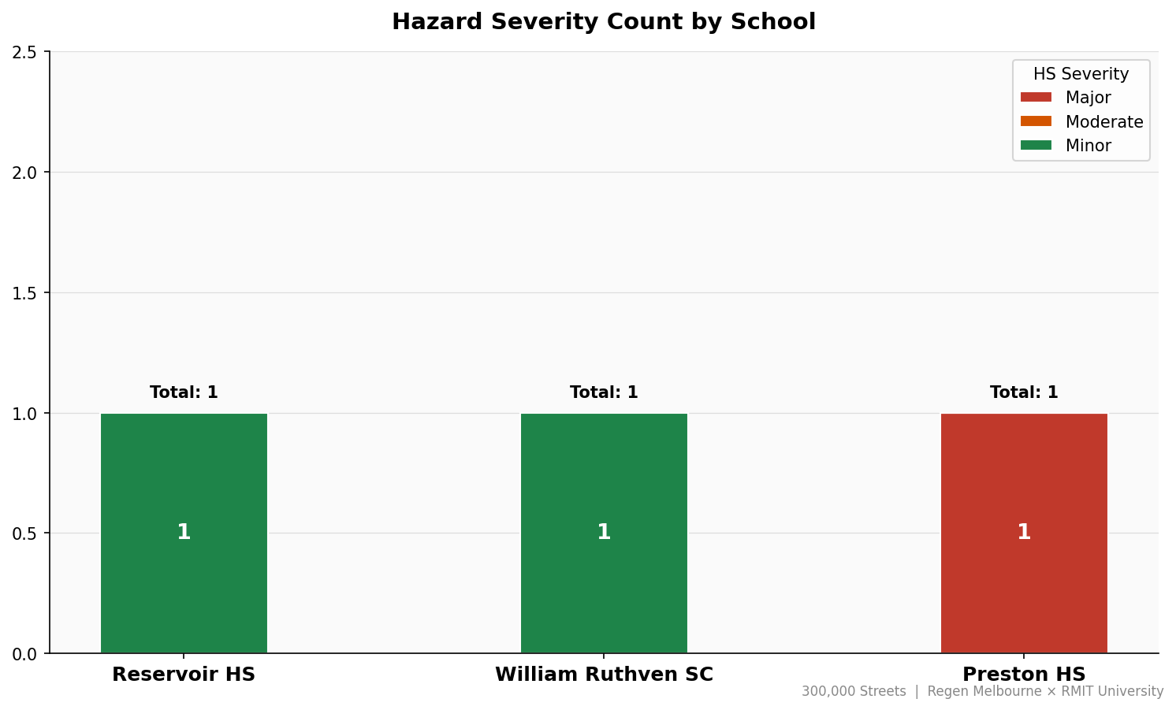
Figure 9: Hazard severity counts per school.
11. Next Steps
- Expand to more Victorian schools — the ML model improves significantly with more schools; current results are illustrative with n=3.
- Build a scenario engine — select an intervention (e.g. install crossing, plant trees) and model the resulting change in HS indicator scores and crash risk.
- Modularise poc_pipeline.py — separate scoring, charting, mapping, and recommendations into individual modules for maintainability.
- Update report and presentation outputs to reflect HS framework and ML findings.
- Deploy interactive map as a hosted web application for council planning access.

12. References
- Saunders, L. (2015). Healthy Streets for London: Prioritising walking, cycling and public transport to create a healthy city. Transport for London / Lucy Saunders Public Health Consulting.
- Regen Melbourne. Streets Values. regen.melbourne/gazette/regen-streets-values
- Mekuria, M., Furth, P., & Nixon, H. (2012). Low-stress bicycling and network connectivity. Mineta Transportation Institute, San José State University.
- VicRoads. Traffic Engineering Manual Vol. 3 Part 218 — Cycling Infrastructure Design.
- Victorian Department of Transport and Planning. Victoria Road Crash Data. data.vic.gov.au
- Victorian Department of Education and Training. School Locations Time Series. data.vic.gov.au
- EPA Victoria. AirWatch — Alphington Monitoring Station (Site 10102). epa.vic.gov.au
- Crime Statistics Agency Victoria. Recorded Offences by Suburb — Year Ending March 2024. crimestatistics.vic.gov.au
- Australian Bureau of Statistics. Census of Population and Housing 2021. abs.gov.au
- OpenStreetMap contributors. OpenStreetMap. openstreetmap.org

300,000 Streets Melbourne — Regen Melbourne × RMIT University

