HTML and CSS Validation Results

index.php - HTML Validation

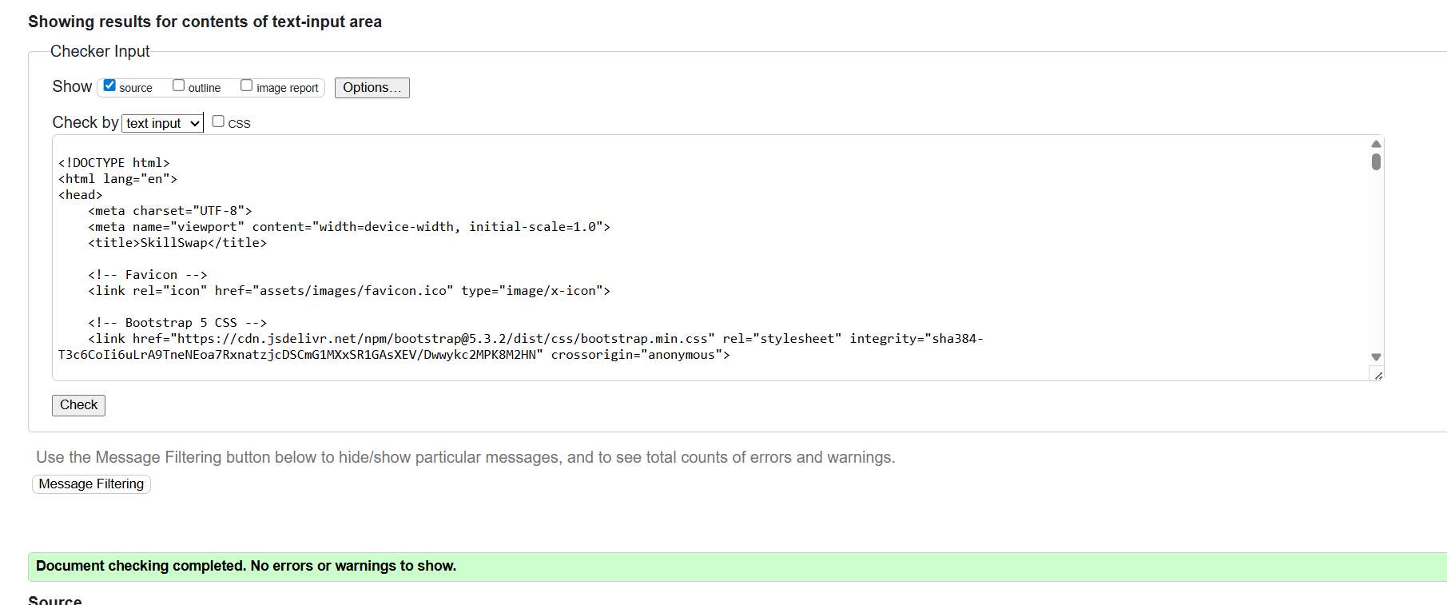

skills.php- HTML Validation

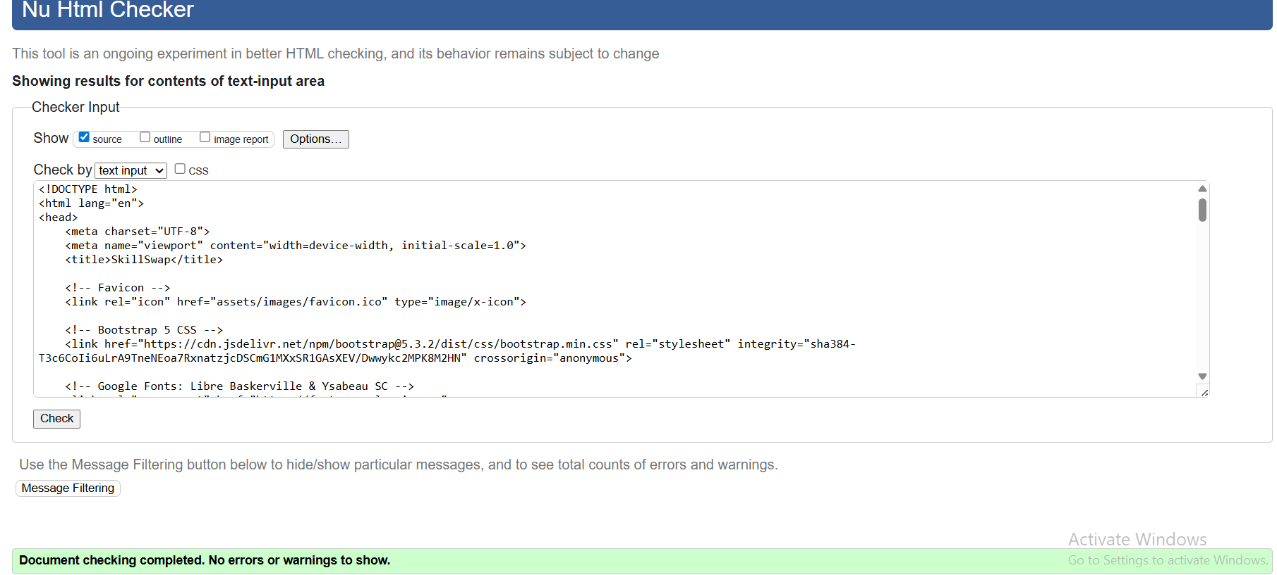

gallery.php- HTML Validation

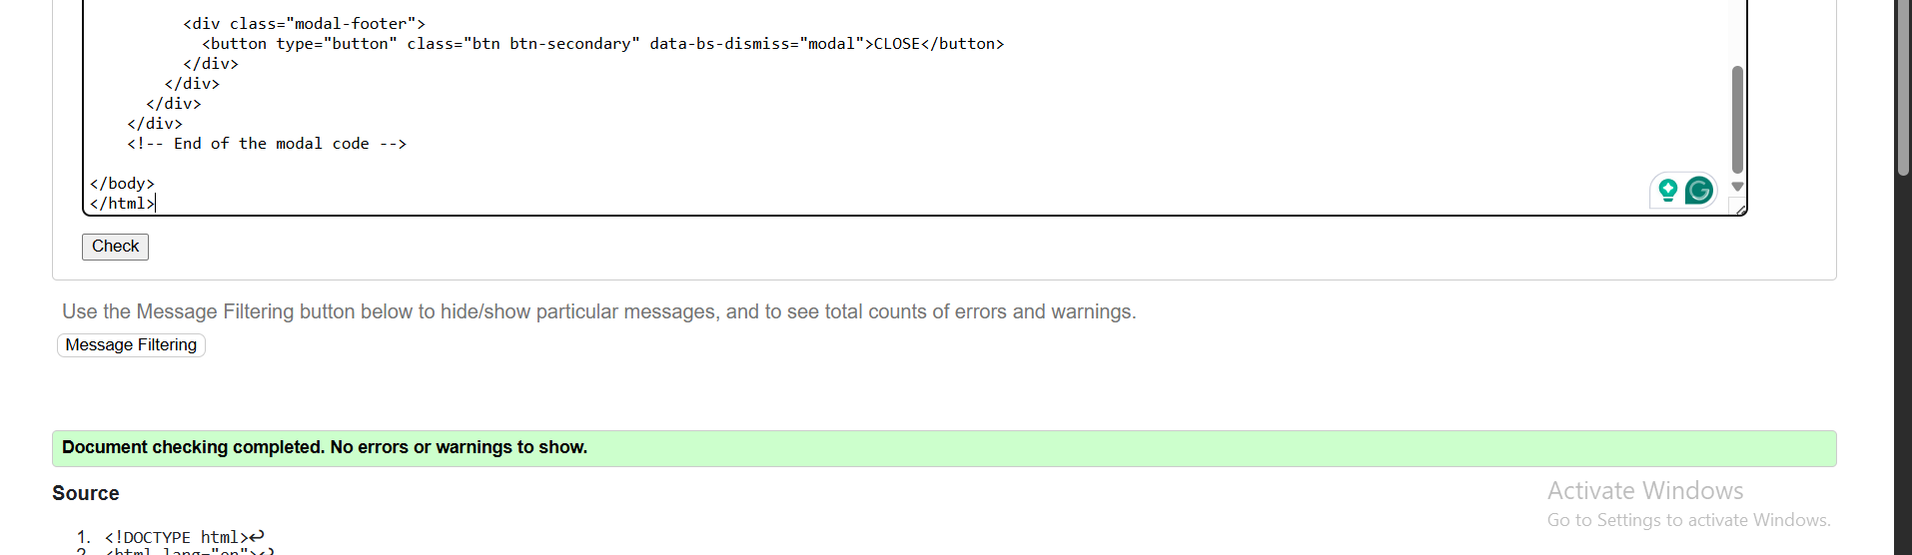

details.php- HTML Validation

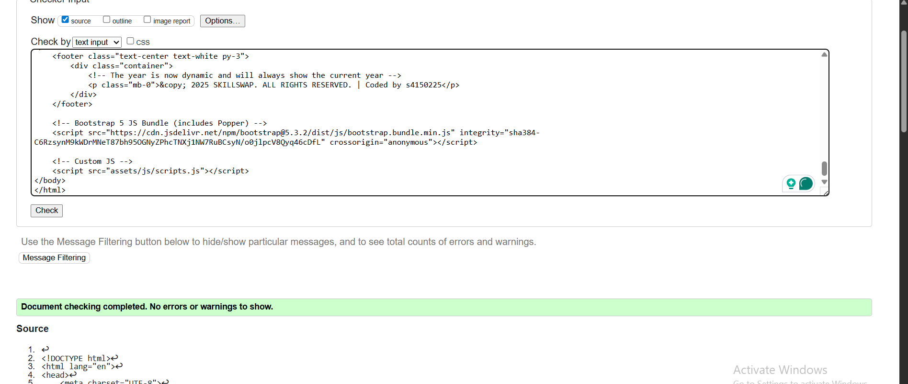

Style.css validation

