CT4023 – Assignment 2
Prototype Software
Wilkinson, Samuel
4205930

Business Case:
I have chosen to create a prototype software to interface with a loyalty system for a supermarket. When the customer signs up for the loyalty system, they input some personal details and give the supermarket permission to roughly track their shopping habits (general product types). The interface system will use the database of shopping habits, created by the loyalty system, of its customers and apply machine learning algorithms to see, and predict, trends in the demands for different product types. This allows the shop managers to appropriately place items on sale in order to boost the number of sales and the profitability of the business.

Prototype Plan:

The prototype must act as a proof of concept and hence, must have the following features.
- Read data from a CSV file.
- Process this data and clean it (Remove the numerical outliers and standardise the categorical data) in preparation to add it to the database.
- Add the data to the database within their appropriate tables.
- Load the entire dataset from the database into a single dataframe.
- Open a UI window allowing the user to select a type of graph they want to plot and analyse.
- Open a new window that allows the user to select what data they want to plot (Appropriate to the type of graph they have selected).
- Open a new window showing the plotted graph with any extra information if applicable.
- Windows containing plotted graphs must not close unless the user closes the window or the main program window so that multiple graphs may be visible at any time allowing the user to cross-reference.

Cost of Development:

This is a small-scale project that integrates with an existing software and will only be used by the supermarket’s managers, so the UI only needs to be easy to understand and the aesthetics are less important.
For this project I expect it to take 20 weeks and require the following staff for development: 3x Software Developers(£874.65/Week), 1x Database Architect(£1,301.30/Week), and 1x UI Developer(£807.80/Week).
The software developers will create the functionality of the software, the database architect will create the database and ensure the data is fully normalised and maximise efficiency, and the UI developer will only be employed near the end of the development and will create the UI for the software so that is it easy to understand and use.
For the development, I have assumed that a supermarket will have office space to accommodate 5 extra workers and space for an extra database server where they store the other servers that host the website, so the only hardware cost is the server itself. From my research, a server with SSD storage, multiple CPUs and a large amount of RAM would cost about £4,000.
So, the total development cost, if the project is completed within 20 weeks and the UI developer is employed just before the end of the development and is employed until the product is complete, would be £93,814.20.

Cost of Maintenance:

For Maintenance, the supermarket would need to employ a Database Administrator to ensure that the database is always accessible and to make any changes to accommodate updates to the amount or types of data stored. They would also keep one of the software developers that made the software to add any needed features and fix any bugs found, introduced by new features, or discovered once the software is used more. Placing these two employees on a yearly salary would cost the company £95,000 per annum.
The database server maintenance will be quite cheap as it won’t receive many write commands, only occasional ones when the software is opened, and the database receives one large write command. The majority of commands sent to the database will be requests for data which will help the server last longer before needing to be replaced meaning it is likely to last 6 years.

Profit Forecasting:

Assuming that one of the supermarket’s stores generates £800,000 profit per annum and that the new software will increase the annual profit by 15% to £920,000, the new software will make the store £10,032.12 better off in its 6th year of use. Each subsequent year, the annual profit will be £25,000 higher than if the software was never developed.
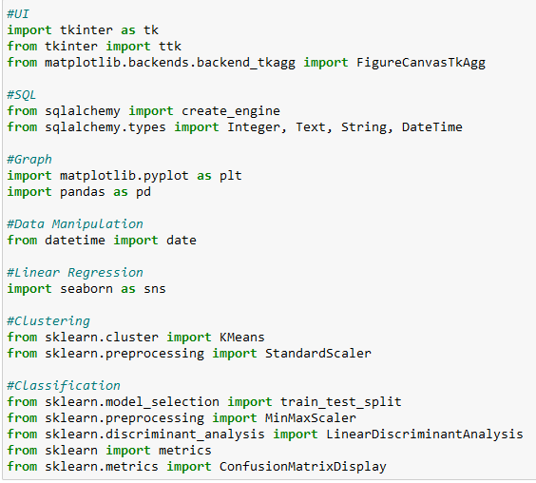
Prototype Code:

This is a collection of all the different libraries I am using for this project. I am using Tkinter for the majority of the UI elements but also Matplotlib canvases to display the graphs once they have been generated. For the integration with SQL, I am using Sqlalchemy. Pyplot and Pandas are used for general graphing and dataframes. The remaining ones are used for the labelled machine learning algorithms.
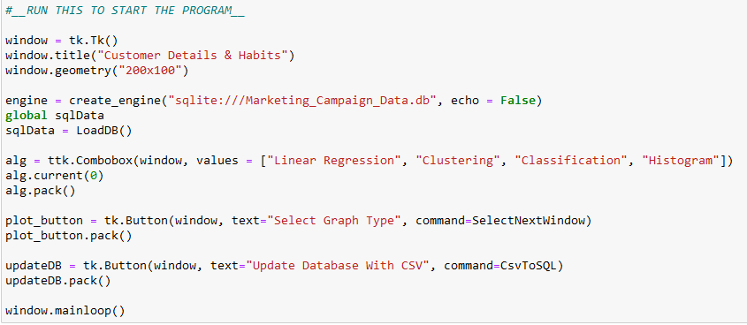
This is the cell that starts the whole program; it creates a Tkinter window, establishes the connection with the database, and loads all the data from the database into a dataframe (sqlData). It then creates a drop-down menu for the user to select what kind of graph they want to create, and two buttons. The first moves the user onto the next window where they can select what data to plot, and the other takes the CSV file and writes it to the database.

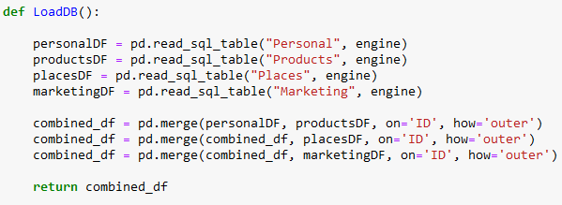
This is the code that loads the data from the database into a dataframe. It reads each table in the database into separate dataframes, and then combines them all into a single dataframe using the ID column as a reference.
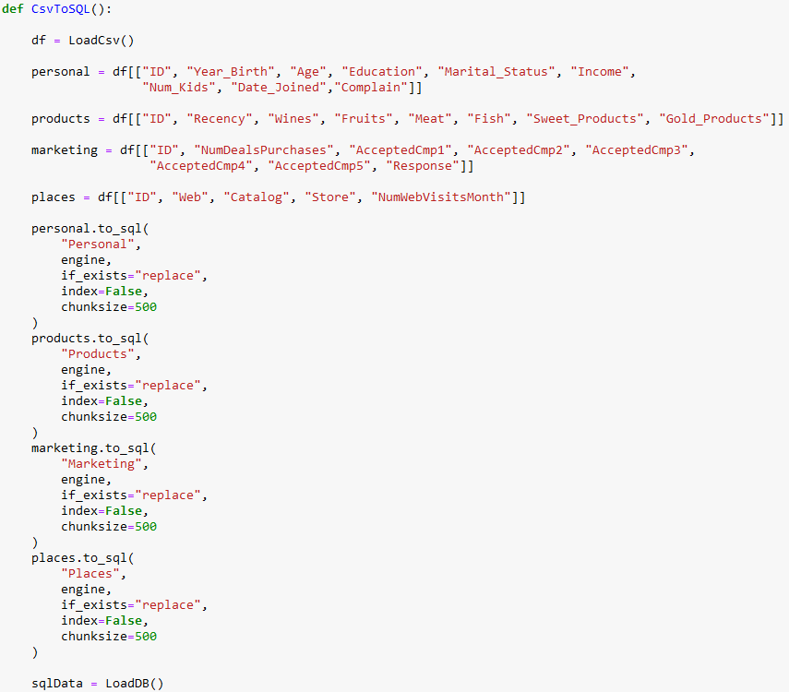
This is the code that writes the CSV to the database. It loads the CSV into a dataframe and then separates the columns into what will become tables, all tables contain the ID column so that they can be reassembled when the program reads the data from the database. After updating the database, the global variable “sqlData” is updated with the new database.
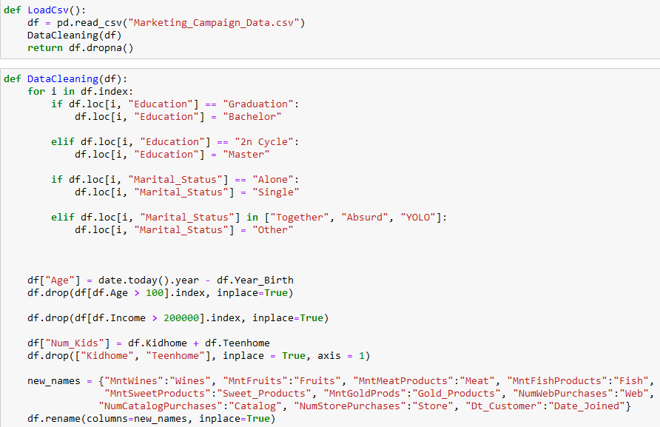
The first function loads the CSV into a dataframe and passes it to the data cleaning function. This function standardises the categorical data as there were some unhelpful entries. All data in the education column becomes one of the following: Basic, Bachelor, Master, PhD. This is similar for the marital status column. It then creates a new column for the age of the customer by using the customer’s year of birth and the current date. Any incomes above £200,000 are then dropped as they are outliers and so important to keep in the database but not helpful when using machine learning. The two columns containing data on the kids in the customer’s house are then combined into a single column and the names of the columns are updated to be easier to read.
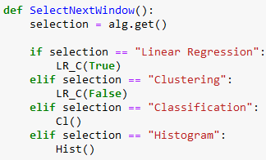
This is the function called when the user presses the button to choose the currently selected type of graph they want in the drop-down menu. Classification and histograms have separate functions as they require different data inputs from the user whereas linear regression and clustering can both only take one set of numerical data for each of the two axes.
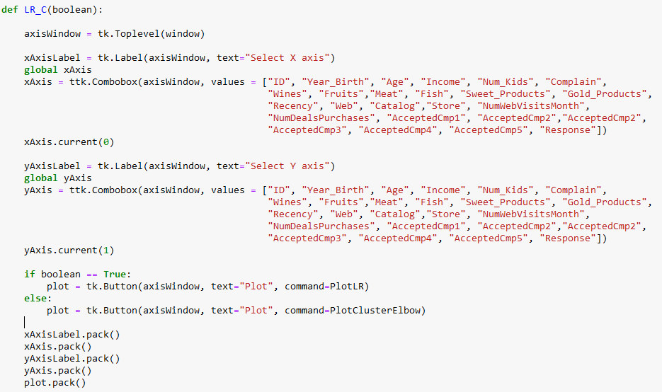
This is the axis selection for linear regression and clustering. Each combobox has an option for any of the numerical data. Depending on the boolean passed the plot button calls the appropriate plotting function for the graph type.
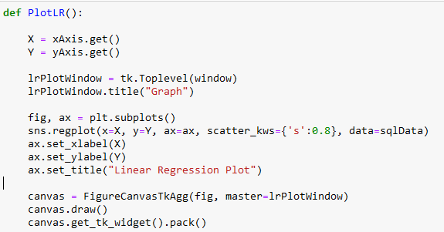
This function opens a new window and plots the linear regression algorithm. It then places the generated graph in a canvas and adds the canvas to the window.
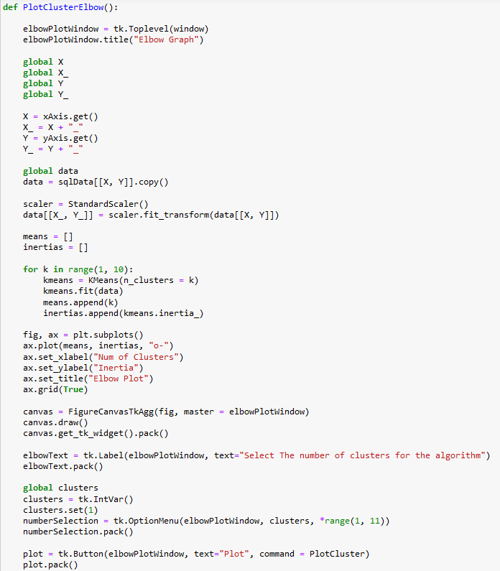
This is the code for the elbow plot, it takes the data inputted by the user and creates the plot. The user can then choose a number of clusters they want to apply to the full algorithm.
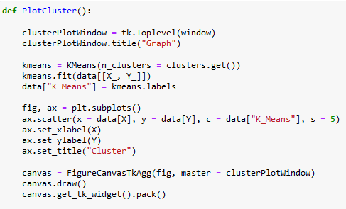
This next function is the plotting function for the K-Means clustering algorithm.
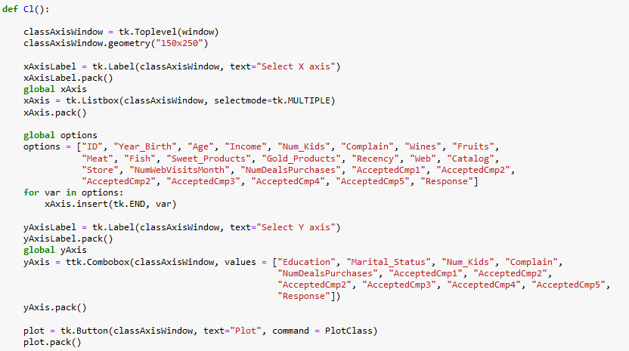
This is the axis selector for the classification algorithm. The x-axis uses a list box that allows the user to select multiple columns of numerical data from the dataframe and then a combobox for the y-axis to select a single type of categorical data or numerical data that doesn’t have the possibility of extreme numbers. The plot button then calls the next function.
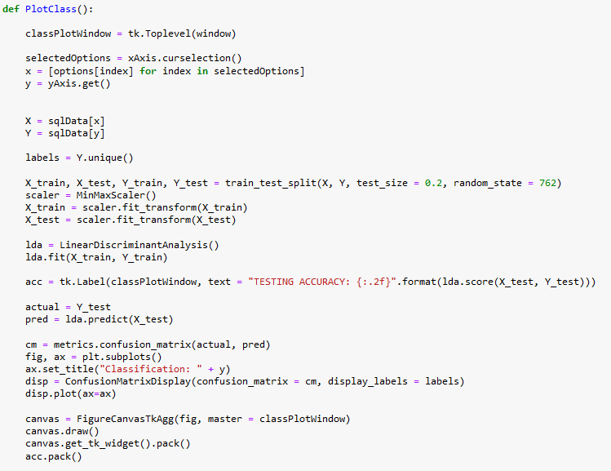
This function creates the confusion matrix from the classification algorithm by splitting the data into train and test sets. The linear discriminant analysis model is then trained on the training set and the test set is then plotted in the confusion matrix and then placed into the canvas and displayed in the window.
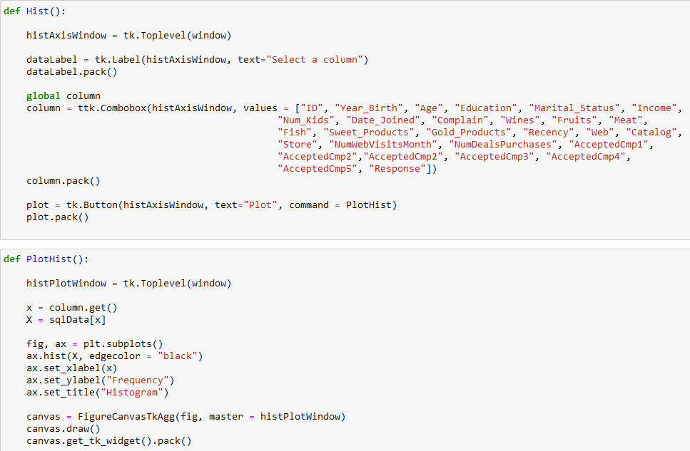
These are the functions for the histogram, the axis window has a single combobox with all the columns available and a button to select the data to plot. The next function plots the histogram in a new window.

