4050 Group Algorithm Engineering Assignment

- Part III -

Cross-Paradigm Engineering Reflection
Isaac Dierker | Noah Pipes | Andrew W. Smith

Part 3.1 – Comparison of Divide-and-Conquer and Checking-Every-Pair in Inversion Counting

Brute force examines every pair (i, j) with i < j, performing Theta(n^2) comparisons. Divide and conquer avoids this by splitting the array, counting inversions within each half recursively, and counting cross inversions during the merge. Because the halves are already sorted when merged, a single comparison that places a right-half element before a left-half element reveals that it forms an inversion with all remaining left-half elements at once. This lets the merge count many inversions per comparison and finish in O(n) time, giving T(n) = 2T(n/2) + O(n) = Theta(n log n). In our experiments, in our run brute force took about 187 times longer than the merge-based counter at n = 20,000 (8.63 s versus 0.046 s). Below n = 64 the brute-force double loop was faster because it has no recursion, slicing, or list-allocation overhead; the two were roughly tied at n = 64 (71 µs versus 64 µs), and the merge-based counter won at every larger size we tested. On the log-log plot the brute-force line has slope about 2 (doubling n roughly quadruples its time) while the merge line has slope just above 1, as Theta(n^2) and Theta(n log n) predict. The exact crossover depends on the interpreter, the hardware, and implementation constants, so it would move on a different machine or language.

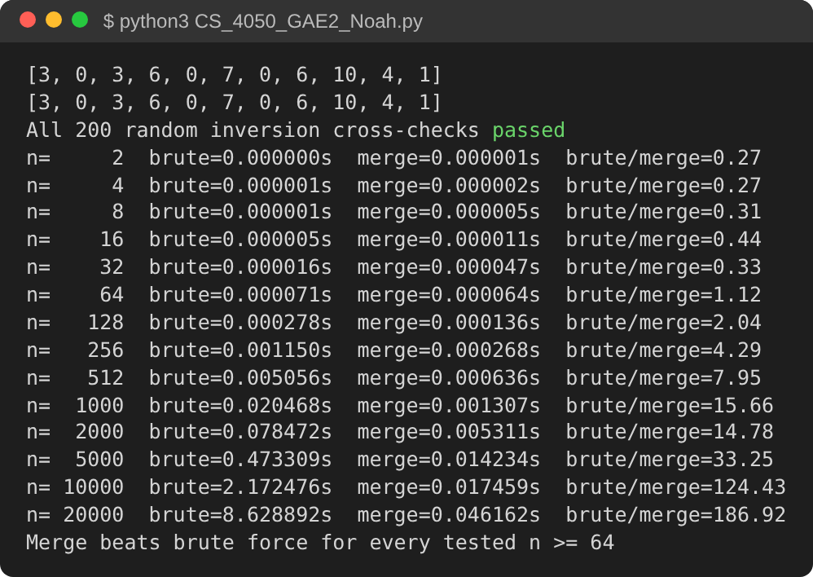
Figure 1. Console output: inversion hand tests, 200 random cross-checks, and the timing sweep. Python 3.13, 4-core Intel Xeon 2.1 GHz; median of 5 runs (3 runs for the largest sizes).
Table 1. Median runtimes of the two inversion counters on random arrays of distinct values (seed 1).
n | Brute force (s) | Merge-and-count (s) | Brute / Merge
2 | 0.000000 | 0.000001 | 0.27
4 | 0.000001 | 0.000002 | 0.27
8 | 0.000001 | 0.000005 | 0.31
16 | 0.000005 | 0.000011 | 0.44
32 | 0.000016 | 0.000047 | 0.33
64 | 0.000071 | 0.000064 | 1.12
128 | 0.000278 | 0.000136 | 2.04
256 | 0.001150 | 0.000268 | 4.29
512 | 0.005056 | 0.000636 | 7.95
1,000 | 0.020468 | 0.001307 | 15.66
2,000 | 0.078472 | 0.005311 | 14.78
5,000 | 0.473309 | 0.014234 | 33.25
10,000 | 2.172476 | 0.017459 | 124.43
20,000 | 8.628892 | 0.046162 | 186.92

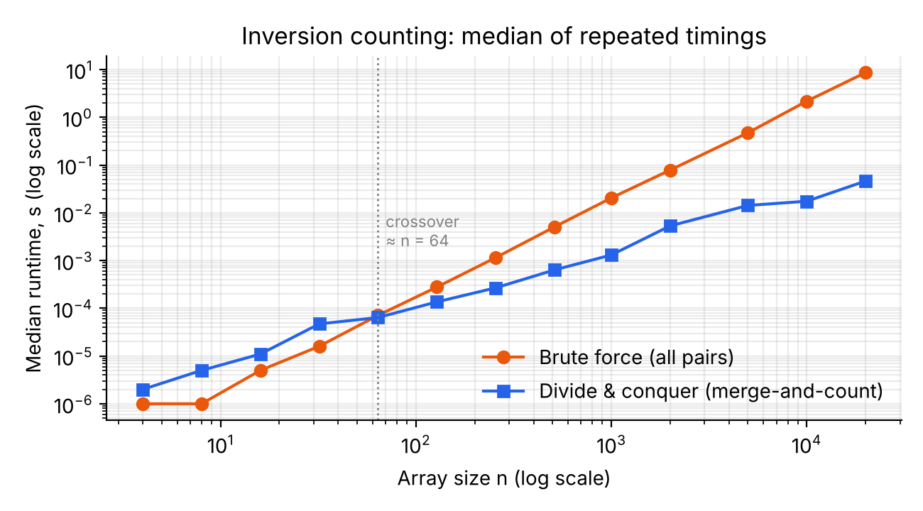
Figure 2. Median runtime versus n on log-log axes. The brute-force slope is about 2 and the merge slope just above 1; the curves cross near n = 64.

Part 3.2 – Comparison of Recursive Subproblems Across Paradigms

In inversion counting, the array is split into two disjoint halves, so the left and right recursive calls operate on different elements and never request the same subarray. Inversions within each half are fully determined by that half alone, and the only dependence between halves, the cross inversions, is handled in the merge after the recursive calls finish. Coin change behaves differently: a subproblem is only the remaining amount, and many different coin sequences reach the same remainder. For D = {1, 3, 4} and A = 30, the naive recursion made 4,728,718 calls to solve only 30 distinct amounts, while the memoized version made 91 calls with 53 cache hits. Independent subproblems call for divide and conquer, since caching would never be reused. Overlapping subproblems call for dynamic programming, since reuse removes the repeated work.
Table 2. Repeated-subproblem experiment for D = {1, 3, 4}. Both solvers solve the same distinct amounts; only the naive one re-solves them.
A | Naive calls | Distinct amounts solved | Memoized calls | Cache hits
5 | 28 | 5 | 16 | 3
10 | 313 | 10 | 31 | 13
15 | 3,466 | 15 | 46 | 23
20 | 38,446 | 20 | 61 | 33
25 | 426,388 | 25 | 76 | 43
30 | 4,728,718 | 30 | 91 | 53
31 | 7,651,225 | 31 | 94 | 55

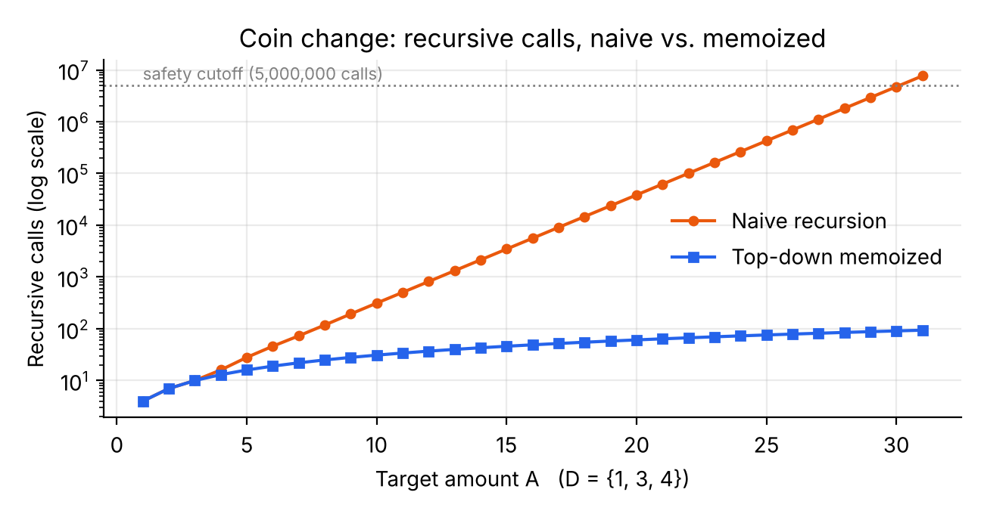
Figure 3. Recursive calls versus A (log scale). Naive calls grow about 1.618x per unit of A; memoized calls grow linearly (3A + 1).

Part 3.3 – The Role of Sorting in the Divide-and-Conquer Improvement

Sorting is what makes the cross-inversion count cheap. After the recursive calls, each half is sorted, so when the merge finds that a right-half element is smaller than the current left-half element, it knows that this right element forms inversions with all remaining left elements, and it adds that whole group with one operation. Sorting each half does not change the cross-inversion count, since that count depends only on which elements are in each half and not on their order within it, so sorting loses no information. Because each call returns a sorted subarray, every merge is a linear two-pointer pass, giving T(n) = 2T(n/2) + O(n) = Theta(n log n). Without sorted halves, counting cross pairs would require Theta(n^2) comparisons. Sorting costs Theta(n log n) anyway, so it adds no asymptotic overhead.

Part 3.4 – Differences in Runtimes with or without Memoization

The naive and memoized solvers evaluate the same recurrence, OPT(a) = 1 + min over c of OPT(a − c), but differ in how often each subproblem is solved. The recurrence has only A + 1 distinct subproblems, yet many coin sequences reach the same remaining amount, so the naive recursion re-solves them repeatedly. For D = {1, 3, 4}, its call count satisfies T(A) = T(A−1) + T(A−3) + T(A−4) + 1 and grows by roughly a factor of 1.618 per unit increase in A. At A = 30 it made 4,728,718 calls, and it exceeded our cutoff at A = 31. The memoized solver caches each amount the first time it is solved, so each of the A distinct amounts is processed once at O(k) cost. At A = 30 it made 91 calls over 30 distinct states with 53 cache hits, matching the 3A + 1 count and giving O(kA) total time. Memoization changes neither the recurrence nor the answer. It removes repeated work, which is possible because the subproblems overlap heavily.
The bottom-up solver shows the same O(kA) bound directly. With D = {1, 5, 10, 25} fixed and A doubled from 2^8 to 2^20, the number of DP states equaled A at every step and the median runtime roughly doubled each time, from 0.06 ms to 0.396 s. Over the same range the bit length of A only grew from 9 to 21, so each extra input bit doubled the work. That is why O(kA) is pseudo-polynomial: it is linear in the value of A but exponential in the size of its encoding.
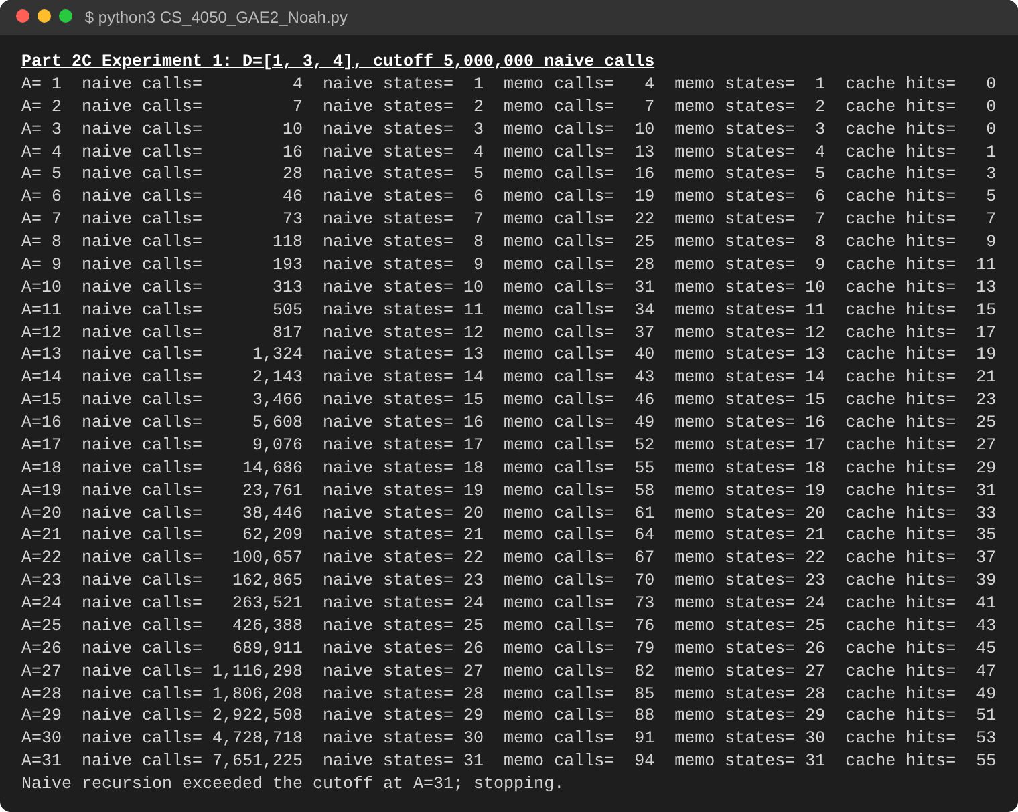
Figure 4. Console output of the instrumented naive and memoized solvers, stopping at the documented 5,000,000-call safety cutoff (A = 31).
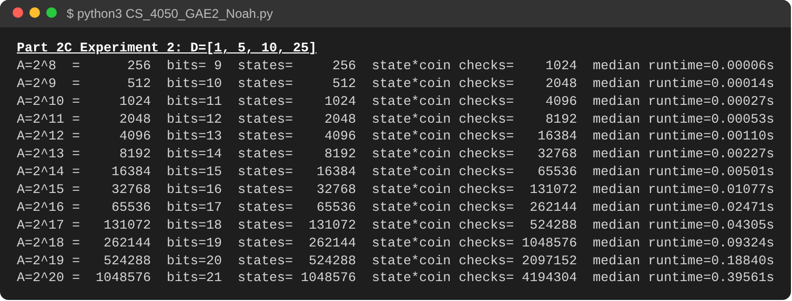
Figure 5. Console output of the pseudo-polynomial experiment (bottom-up DP, A = 2^8 … 2^20). Python 3.13, 4-core Intel Xeon 2.1 GHz; median of 5 runs (3 runs for the largest sizes).
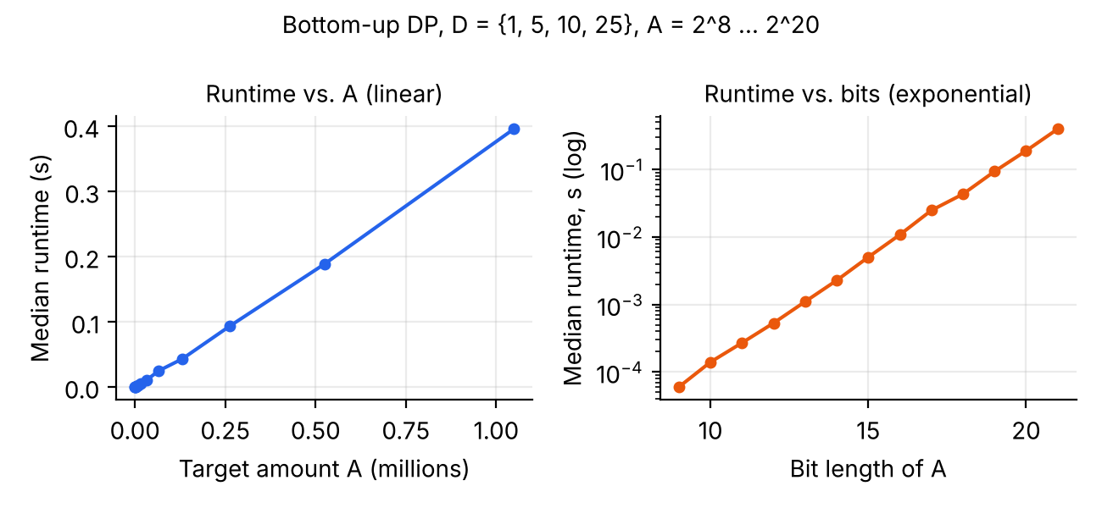
Figure 6. Bottom-up DP runtime is linear in A (left) but grows exponentially in the bit length of A (right).

Part 3.5 – Utility of Baseline Implementations Across Paradigms

In both halves of the assignment, a simple exact implementation served as an oracle for a faster one. For inversion counting, the brute-force pair counter is easy to verify by inspection and shares no logic with the merge-based counter, so we required exact agreement on 11 hand-crafted arrays and 200 random arrays. Disagreements would point to errors in the merge step, such as off-by-one counts or tie handling. For coin change, the naive recursion was the baseline for top-down and bottom-up DP, and all three had to agree on the optimal coin count. A separate validator confirmed that every returned coin list sums to the target, which catches reconstruction errors that count comparison alone would miss. Once validated, DP served as ground truth for the automated greedy search, which checked every system {1, a, b} with b ≤ 10 against bottom-up DP and found 17 systems where greedy is feasible but not optimal, including the required D = {1, 3, 4}, A = 6 (greedy 4+1+1, optimal 3+3), D = {1, 4, 5}, A = 8 (greedy 5+1+1+1, optimal 4+4), and D = {1, 5, 6}, A = 10 (greedy 6+1+1+1+1, optimal 5+5). For example, an early draft of the top-down memoized solver passed the full target amount, instead of the remainder, into its recursive call, so it never reached a base case. Comparing it with the naive baseline on the same small cases exposed the error; the corrected version now agrees with naive recursion on all 12 hand cases and all 100 random cases. Because testing covers only the inputs tried, we paired these checks with correctness arguments for why each algorithm is right in general.
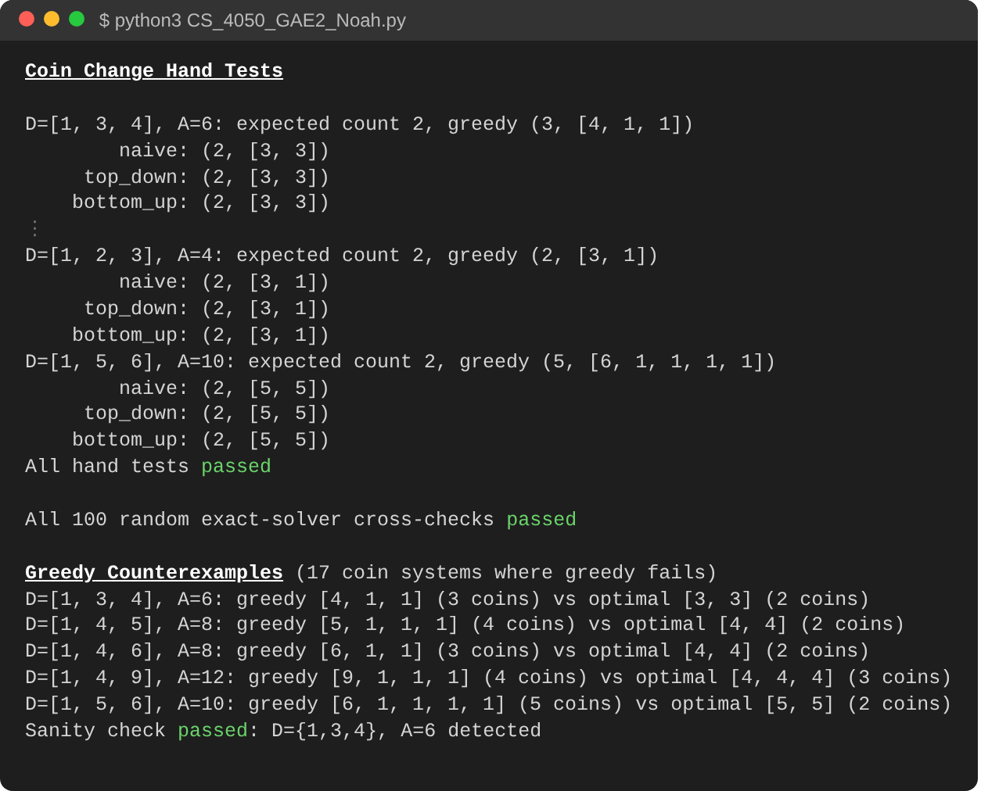
Figure 7. Console output: coin-change hand tests (excerpt), the 100 random three-way exact-solver cross-checks, and the automated greedy counterexample search.

Part 3.6 – Conclusions About Preference in Future Use of Paradigms

Given a new optimization problem, we would first look at what happens when the problem is split. If the input divides into disjoint parts that can be solved independently, and a cheap merge-like step can combine their results (especially when sorted or ordered parts let one comparison settle many cases at once), we would try divide and conquer first, as in inversion counting, where T(n) = 2T(n/2) + O(n) beat the Theta(n^2) pair-checking baseline. If instead the problem has a recurrence over smaller instances of itself, and the naive recursion keeps solving the same subproblems, we would try dynamic programming. Instrumenting the naive solver is the best test: in our coin-change experiment, the naive recursion made 4,728,718 calls to solve only 30 distinct amounts, so memoization reduced the work to O(kA). Failure of a greedy choice, such as D = {1, 3, 4} with A = 6, is further evidence that global optimization over all choices is needed. In either case, we would validate the faster method against a simple baseline on small inputs before trusting it.

