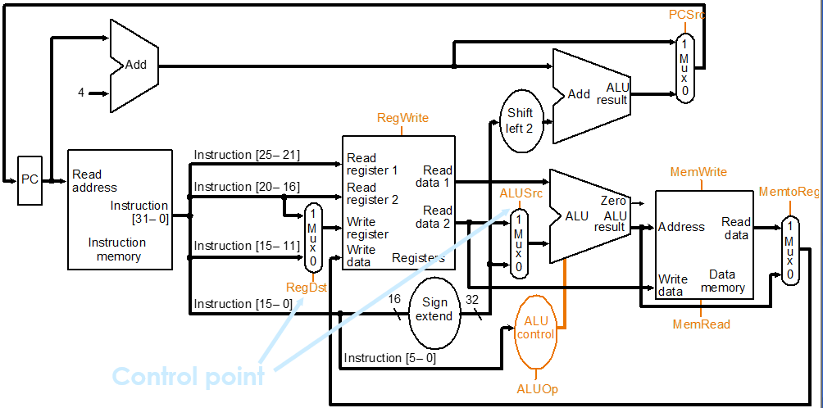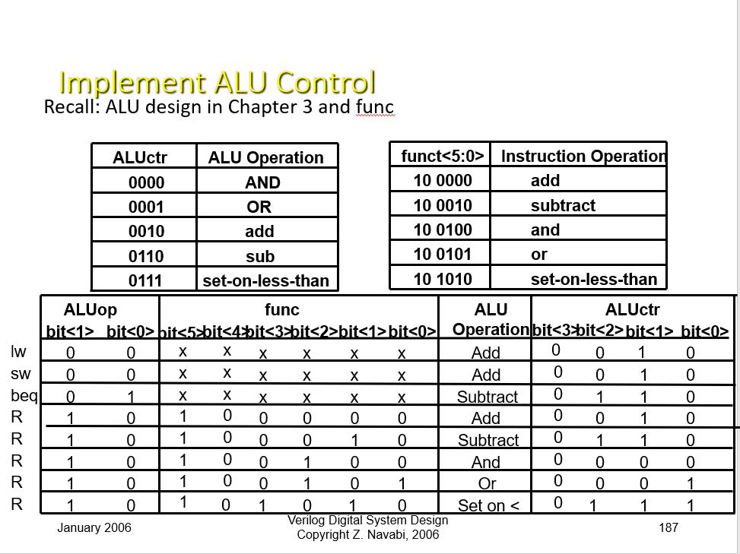1. Design MIPS R2000 ALU and its controller ALU control.

|  |  |
| --- | --- |
| ALU |  |
| ALU_Ctrl |  |
| Testfixture |  |
| Result |  |