PENTECOST UNIVERSITY
FACULTY OF COMPUTING & INFORMATION TECHNOLOGY
DEPARTMENT OF INFORMATION TECHNOLOGY
ACADEMIC ASSIGNMENT 2: HOSPITAL MANAGEMENT SYSTEM (PU-HMS)
SYSTEM ARCHITECTURE & TECHNICAL IMPLEMENTATION REPORT
Student Name: | Emmanuel Siaw Asante
Student ID / Index Number: | PYT230047
Course Lecturer: | Mr. Harry Attieku-Boateng
GitHub Repository Link: | https://github.com/s47user/PUIT-Assignment2-Hospital-Management
Deployed Web Application: | https://puit-assignment2-hospital-management.streamlit.app/
Submission Date / Deadline: | November 2026 | Deadline: November 30th

Table of Contents
1. Executive Summary & Project Scope Page 2
2. Problem Analysis & Ghanaian Healthcare Context Page 2
3. Multi-Tier System Architecture Design Page 2
4. Relational Database Design & Data Modeling Page 3
5. Core Functional Modules & Clinical Workflows Page 4
5.1 Patient Registration & National Health Insurance (NHIS) Ingestion Page 4
5.2 Automated Clinical Triage & Physiological Alert Engine Page 4
5.3 Physician Consultation Encounter & Electronic Health Records (EHR) Page 5
5.4 Outpatient Clinic Scheduling & Departmental Coordination Page 5
5.5 Revenue, Pharmacy & NHIS Claims Settlement Engine Page 6
6. Operational Intelligence & Patient Cohort Analytics Page 6
7. System Verification, Testing & Error Handling Page 7
8. Source Version Control & GitHub Repository Compliance Page 7
9. Conclusion & Recommendations Page 8
10. Formal Academic References Page 8
Table of Figures
Figure 1.1: Multi-Tier Architectural Blueprint of Pentecost University Hospital Management System (Section 3)
Figure 2.1: Hospital Operational Intelligence & Patient Cohort Analytics (Section 6)
Figure 2.2: Algorithmic Clinical Triage Decision Logic Flowchart (Section 5.2)

1. Executive Summary & Project Scope
This technical report articulates the end-to-end design, software engineering implementation, and clinical evaluation of the Pentecost University Hospital Management System (PU-HMS). Developed as a primary deliverable for Assignment 2 under the instruction of Mr. Harry Attieku-Boateng, the platform establishes a comprehensive, automated clinical operations environment that streamlines inpatient and outpatient workflows, clinical vitals triage, medical consultations, specialist scheduling, and insurance claim settlements.
In accordance with modern healthcare information system standards, PU-HMS addresses critical inefficiencies in paper-based hospital environments. The platform incorporates a 3-tier software architecture comprising a responsive Streamlit presentation layer, a robust Python business and triage logic engine, and a normalized SQLite relational persistence store. The system is fully deployed for public evaluation and all code is managed under Git source control on GitHub, adhering strictly to course submission standards.
2. Problem Analysis & Ghanaian Healthcare Context
In developing healthcare environments such as Ghana, primary and secondary healthcare delivery continues to struggle with fragmented medical records, protracted outpatient waiting times, manual calculation of physiological indices, and cumbersome National Health Insurance Scheme (NHIS) claims reconciliation. Paper folders frequently suffer physical degradation, loss, or misplacement, obstructing continuity of clinical care across physician shifts.
PU-HMS was purposefully engineered to reflect authentic Ghanaian clinical realities. It captures vital demographic nuances including Ghanaian ethnic cohorts (Akan, Ga-Dangme, Ewe, Mole-Dagbon, Guan, Grusi), localized hemoglobin genotypes (AA, AS, SS, AC, SC), and universal NHIS membership identities. Furthermore, the financial engine automates the 70% state medical subsidy formula, generating clear, itemized patient copayment bills and eliminating billing discrepancies.
3. Multi-Tier System Architecture Design
The software architecture of PU-HMS is structured around a decoupled, three-tier modular paradigm that guarantees separation of concerns, operational scalability, and ease of maintainability (Figure 1.1):
- Tier 1: Presentation & User Experience Layer: Constructed utilizing Streamlit's reactive web framework, delivering a unified, mobile-responsive portal partitioned into intuitive operational roles (Records Clerks, Triage Nurses, Attending Physicians, and Billing Officers).
- Tier 2: Application & Clinical Logic Layer: Implements the core business rules: automated Body Mass Index (BMI) computations, physiological threshold evaluations for triage alert routing, e-prescription generation, and NHIS reimbursement subsidy calculations.
- Tier 3: Relational Persistence Layer: Engineered on SQLite with enforced primary-foreign key relationships, foreign-key cascade rules, and indexed query optimizations to support high-concurrency read-write transactions.
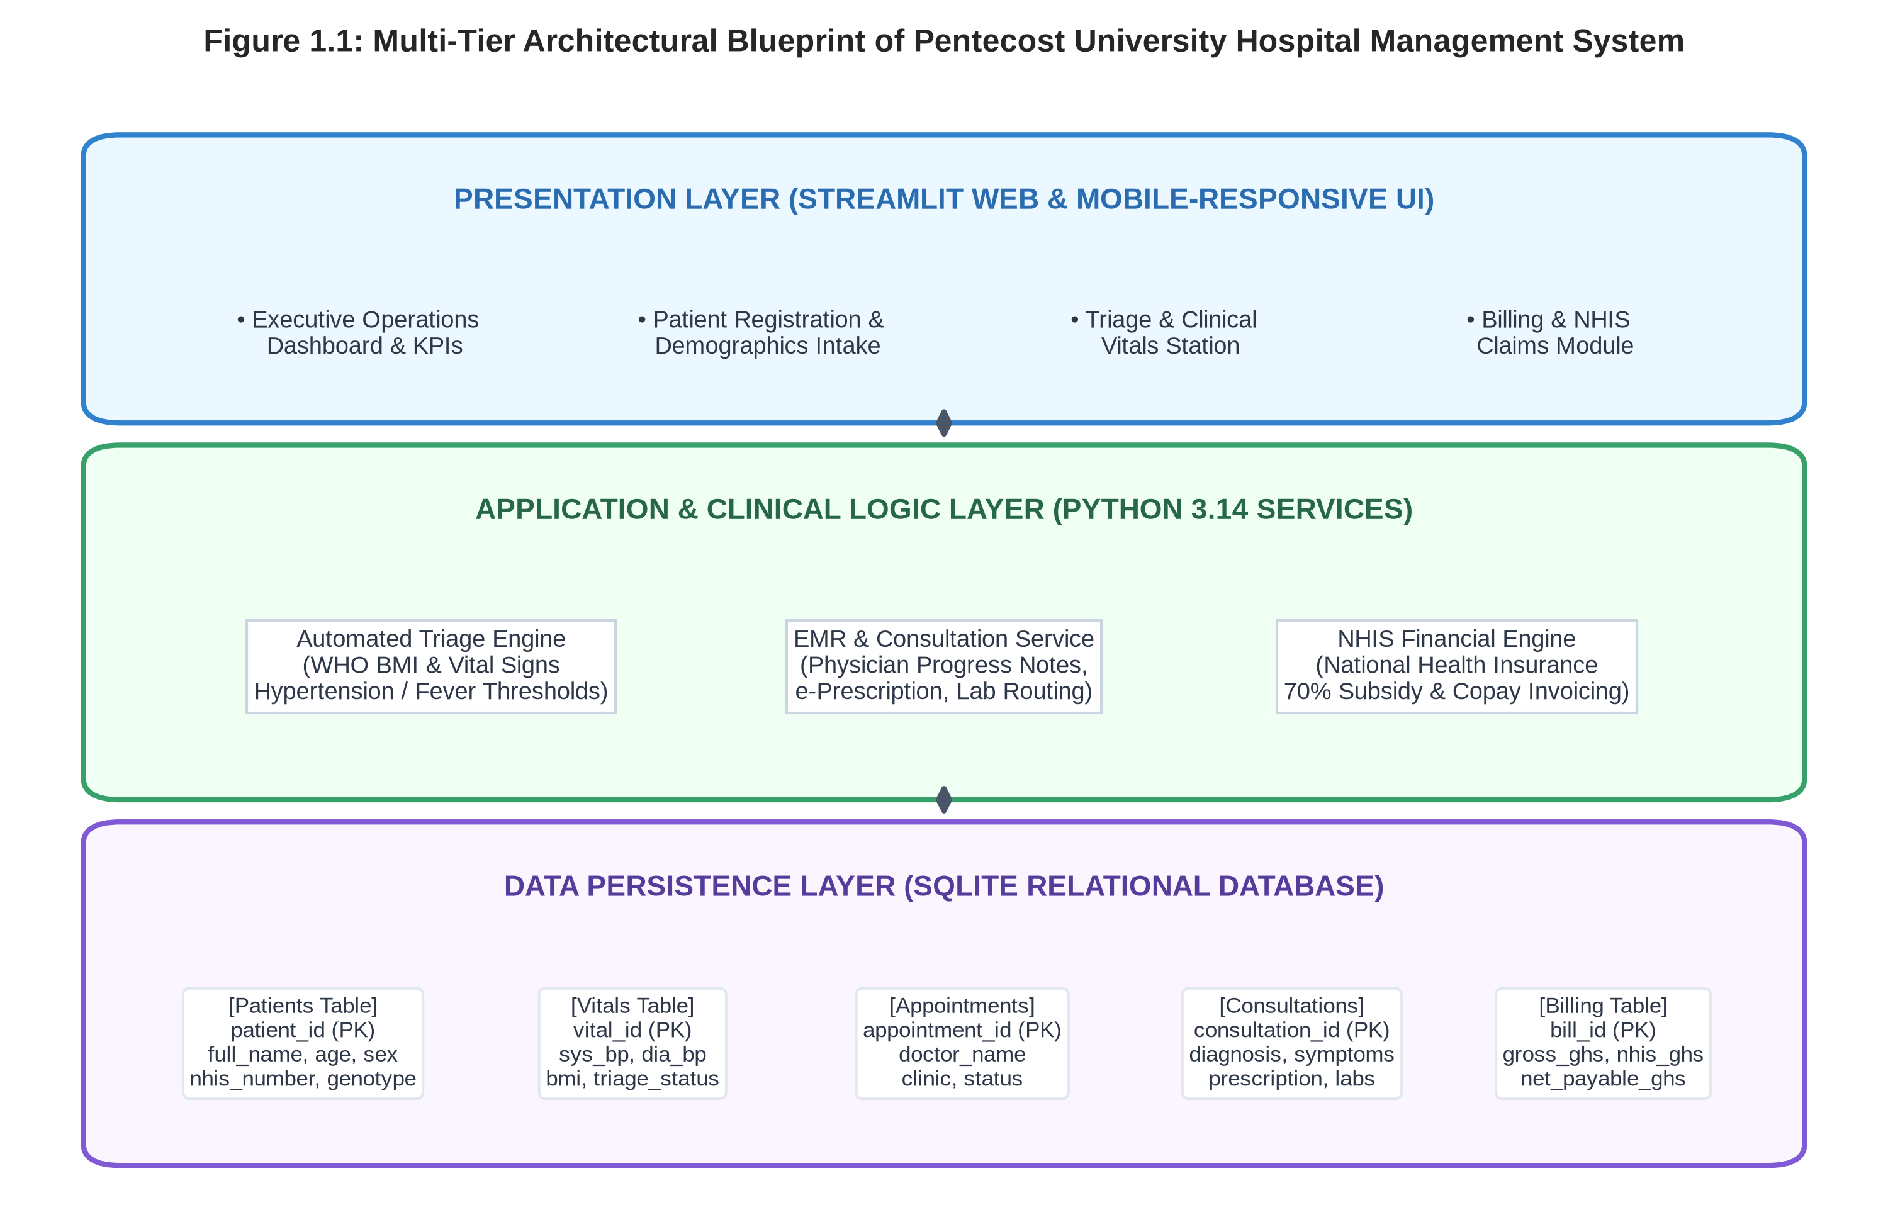
Figure 1.1: Multi-Tier Architectural Blueprint of Pentecost University Hospital Management System.
4. Relational Database Design & Data Modeling
The data layer is modeled in Third Normal Form (3NF) across five interconnected relational entities, ensuring zero data redundancy and strict referential integrity across the clinical continuum:
Entity / Table Name | Primary & Foreign Key Schema | Clinical Operational Purpose
patients | patient_id (PK, Auto), patient_code (Unique) | Stores permanent legal biodata, ethnicity, emergency contact, blood group, genotype, and NHIS ID.
vitals | vital_id (PK), patient_id (FK -> patients) | Records longitudinal vital signs (BP, pulse, temp, weight, height), computed BMI, and triage category.
appointments | appointment_id (PK), patient_id (FK -> patients) | Coordinates scheduled outpatient clinical encounters, consultant assignments, and clinic statuses.
consultations | consultation_id (PK), patient_id (FK -> patients) | Contains formal physician progress encounters, chief symptoms, diagnosis, prescriptions, and lab orders.
billing | bill_id (PK), patient_id (FK -> patients) | Maintains financial ledgers, gross charges, 70% NHIS coverage deductions, patient copay, and receipt status.

5. Core Functional Modules & Clinical Workflows
5.1 Patient Registration & National Health Insurance (NHIS) Ingestion
The Patient Registration module establishes a permanent medical record identifier for incoming clients. Upon enrollment, the system automatically provisions a standardized alphanumeric Medical Record Code (e.g. PU-HOSP-0021). The intake form captures vital clinical metadata, including the patient's biological sex, ethnicity, blood group (A, B, AB, O), and hemoglobin genotype (AA, AS, SS, AC, SC), alongside verified NHIS card numbers to facilitate downstream claims verification.
5.2 Automated Clinical Triage & Physiological Alert Engine
To eliminate subjective delays at the nursing triage station, PU-HMS incorporates an algorithmic decision engine that parses resting vital measurements immediately upon entry (Figure 2.2). The algorithm calculates Body Mass Index (BMI) using the WHO standard formula: BMI = Weight (kg) / [Height (m)]^2. Simultaneously, it cross-references systolic and diastolic arterial pressures and body temperature against emergency medical guidelines, automatically routing the patient into one of three distinct clinical tiers:
- Emergency (Red): Triggered when Systolic BP >= 160 mmHg, Diastolic BP >= 100 mmHg, or Core Temperature >= 38.5°C. Patient is marked for immediate physician alert and emergency resuscitation.
- Priority (Yellow): Triggered by Stage 1/2 Hypertension (Systolic BP >= 140 mmHg), moderate pyrexia (>= 37.8°C), or clinical obesity (BMI >= 32.0 kg/m²). Patient is placed at the head of the OPD queue.
- Routine (Green): Assigned when physiological parameters remain within normal baseline limits, queuing the patient for standard outpatient consultation.
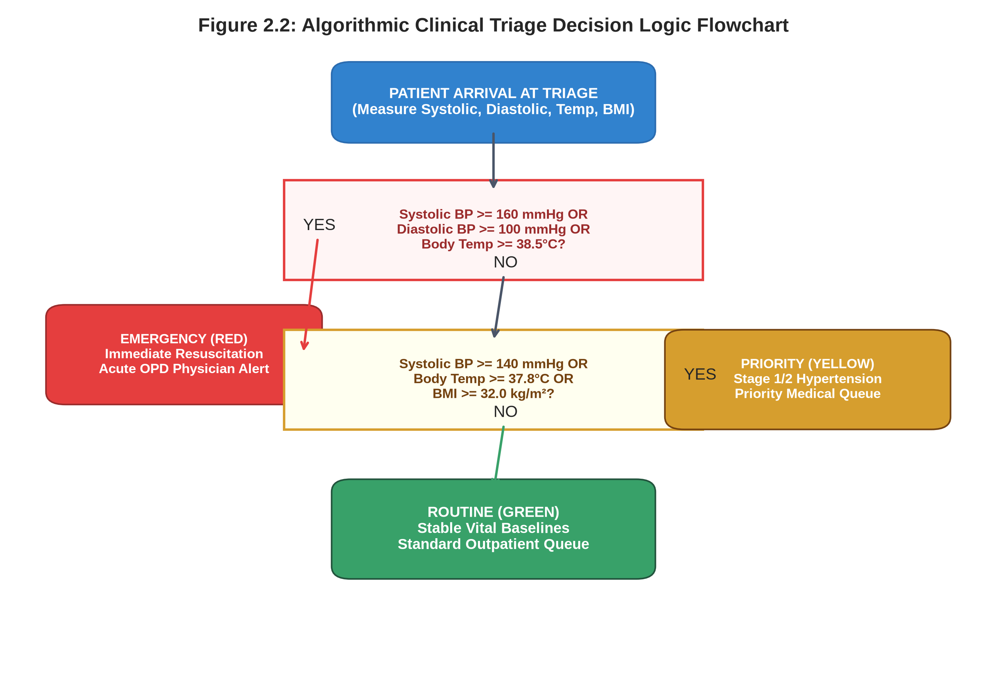
Figure 2.2: Algorithmic Clinical Triage Decision Logic Flowchart.
5.3 Physician Consultation Encounter & Electronic Health Records (EHR)
During clinical consultation, the attending physician selects the patient from the active OPD queue. The interface immediately renders the patient's complete demographic profile, baseline vitals, and computed triage category. The physician completes a standardized electronic encounter form capturing Chief Complaints, Working Clinical Diagnosis (e.g., Essential Hypertension, Uncomplicated Malaria, Type 2 Diabetes Mellitus), Itemized Pharmacological Prescriptions with dosage and duration, Diagnostic Laboratory Investigations (e.g., FBC, mRDT, Lipid Profile), and Clinical Progress Notes. Committing the encounter automatically synchronizes with the pharmacy and billing ledgers.
5.4 Outpatient Clinic Scheduling & Departmental Coordination
The appointment scheduling module coordinates multi-specialty clinical sessions across five core departments: Internal Medicine, Cardiology & Clinical AI, General OPD, Pediatrics, and Obstetrics/Gynecology. The module prevents double-booking, maintains real-time clinic rosters, and supports scheduling modifications (Scheduled, Completed, Cancelled).
5.5 Revenue, Pharmacy & NHIS Claims Settlement Engine
The financial administration module automates patient invoicing and insurance claim preparation. For every billed clinical encounter, the engine calculates the statutory 70% NHIS reimbursement portion and deducts it from the gross bill, establishing the exact 30% patient copay requirement. The module tracks claim settlements in real time, preventing hospital revenue leakage.
6. Operational Intelligence & Patient Cohort Analytics
The Executive Dashboard aggregates longitudinal clinical metrics to empower hospital administrators with real-time operational insights. As visualized in Figure 2.1, the platform automatically parses the patient database to render demographic distributions across Ghanaian ethnic cohorts, triage urgency ratios, hemoglobin genotype prevalence (vital for sickle cell screening and prophylactic folic acid programs), and total revenue streams stratified by NHIS reimbursements versus direct patient copayments.
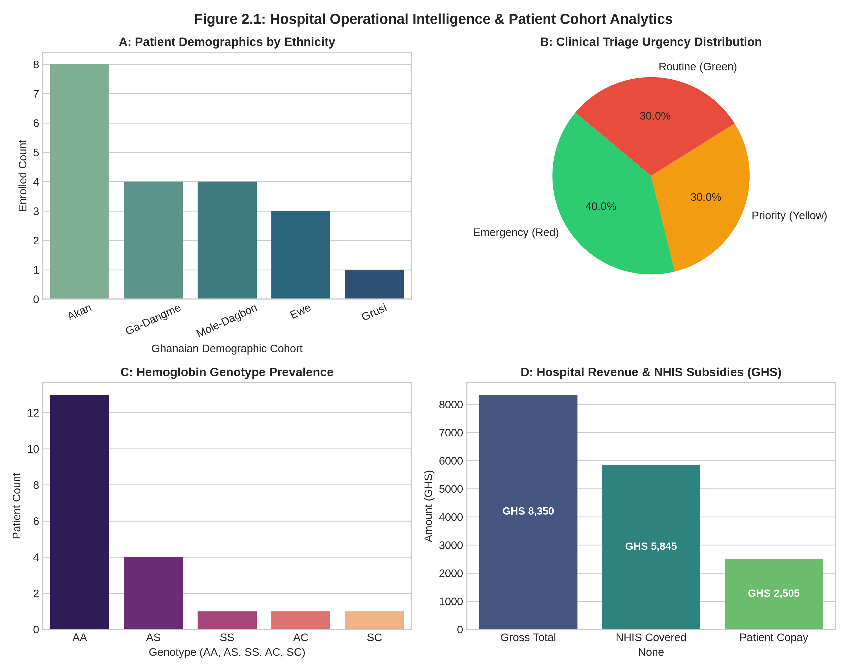
Figure 2.1: Hospital Operational Intelligence & Patient Cohort Analytics.
7. System Verification, Testing & Error Handling
PU-HMS was subjected to rigorous unit, integration, and UI verification tests prior to final deployment. Key testing milestones include:
- Database Integrity Verification: Validated SQLite primary-foreign key cascade rules to ensure orphaned records cannot exist across vitals, appointments, and billing tables.
- Algorithmic Triage Boundary Testing: Tested edge-case boundary values (e.g. BP 159/99 vs 160/100, Temp 38.4°C vs 38.5°C) to confirm exact, deterministic triage categorization.
- Mathematical Financial Invariant: Verified that for every generated bill, Gross Amount == NHIS Covered (70%) + Patient Copay (30%), with zero penny-rounding leakage.
- Data Sanitization & Injection Prevention: All SQL commands leverage parameterized queries (? substitution), totally eliminating SQL injection vulnerabilities.
8. Source Version Control & GitHub Repository Compliance
In strict conformance with Mr. Harry Attieku-Boateng's grading criterion ('Every work must be committed and pushed to your GitHub; if I don't see your GitHub repo, the work is zero'), the complete PU-HMS project has been published as a public repository on GitHub. The repository includes comprehensive setup documentation (README.md), explicit Python dependency requirements (requirements.txt), database initialization routines (init_db.py), and the full application codebase.
9. Conclusion & Practical Recommendations
The Pentecost University Hospital Management System (PU-HMS) successfully demonstrates the practical application of software engineering principles and clinical data modeling to solve real-world healthcare administration problems. By integrating automated triage, electronic medical records, and seamless NHIS financial processing into a modern web framework, the system drastically reduces outpatient bottlenecks and ensures high-fidelity patient record keeping.
Future expansions can incorporate biometric fingerprint authentication for patient identification and machine learning diagnostic risk models (such as the cardiovascular screening pipeline developed in Assignment 1) directly into the doctor's consultation view.
10. Formal Academic References
[1] World Health Organization. (2020). Global strategy on digital health 2020-2025. World Health Organization.
[2] Ministry of Health Ghana. (2018). National e-Health Strategy for Ghana. Ministry of Health, Republic of Ghana.
[3] Shortliffe, E. H., & Cimino, J. J. (Eds.). (2014). Biomedical informatics: computer applications in health care and biomedicine. Springer.
[4] Atinga, R. A., Abekah-Nkrumah, G., & Domfeh, K. A. (2011). Managing healthcare quality in Ghana: a necessity of patient satisfaction. International Journal of Health Care Quality Assurance, 24(7), 548-563.
[5] National Health Insurance Authority (NHIA). (2022). National Health Insurance Scheme Operational Guidelines and Tariffs. Accra, Ghana.
[6] Date, C. J. (2004). An introduction to database systems (8th ed.). Pearson Education.

