PENTECOST UNIVERSITY
FACULTY OF COMPUTING & INFORMATION TECHNOLOGY
DEPARTMENT OF INFORMATION TECHNOLOGY
REAL-TIME DEEP CONVOLUTIONAL FACIAL DETECTION AND IDENTITY RECOGNITION USING THE ULTRALYTICS YOLO FRAMEWORK
A Comprehensive Computer Vision Architecture, Empirical Optimization, and Edge Deployment Analysis
Student Name: | Emmanuel Siaw Asante
Student ID / Index Number: | PYT230047
Course Lecturer: | Mr. Harry Attieku-Boateng
GitHub Repository Link: | https://github.com/wisabuilds/PUIT-Face-Recognition-Ultralytics-YOLO
Deployed Web Application: | https://puit-face-recognition-yolo.streamlit.app/
Academic Period / Deadline: | First Semester, Academic Year 2026/2027 | Deadline: November 30th

Table of Contents
1. Executive Summary & Research Motivation Page 2
2. Problem Formulation & Computer Vision Context Page 2
2.1 Limitations of Two-Stage & Classical Facial Detection Pipelines Page 2
2.2 The Unified One-Stage Detection-Recognition Paradigm Page 3
3. Architectural Foundations of the Ultralytics YOLO Framework Page 3
3.1 Convolutional Feature Extraction Backbone (CSPDarknet & C2f Modules) Page 3
3.2 Multi-Scale Feature Fusion Neck (PAN-FPN Bi-Directional Pyramid) Page 4
3.3 Decoupled Anchor-Free Detection & Classification Head Page 4
4. Facial Dataset Engineering, Annotation Protocols & Preprocessing Page 5
4.1 Multi-Subject Facial Cohort Acquisition & Environmental Variations Page 5
4.2 Bounding Box Annotation Standards & Spatial Geometry Analysis Page 5
4.3 Data Augmentation Strategies (Mosaic, Affine, HSV Jitter) Page 6
5. Empirical Training Protocols & Hyperparameter Optimization Page 6
5.1 GPU Cloud Infrastructure & Pre-Trained Transfer Learning Setup Page 6
5.2 Loss Function Formulation (CIoU, DFL, and BCE) Page 7
5.3 Empirical Loss Convergence & Learning Rate Scheduling Page 7
6. Quantitative Evaluation, Error Auditing & Comparative Benchmarks Page 8
6.1 Validation Metrics & Mean Average Precision (mAP@0.5, mAP@0.5:0.95) Page 8
6.2 Comparative Architectural Benchmark (YOLOv8 vs Classical Baselines) Page 8
6.3 Confusion Matrix & Inter-Subject Cross-Classification Analysis Page 9
7. Real-Time Edge Video Inference Engine & Deployment Architecture Page 10
7.1 Non-Maximum Suppression (NMS) & Confidence Threshold Tuning Page 10
7.2 Hardware Latency Profiling & Frames-Per-Second (FPS) Benchmarks Page 10
7.3 Interactive Streamlit Web & Mobile-Responsive Deployment Page 11
8. Source Version Control & GitHub Repository Compliance Page 11
9. Conclusion & Recommendations for Future Research Page 12
10. Formal Academic References Page 12
Table of Figures
Figure 1.1: Ultralytics YOLOv8 Deep Convolutional Backbone, PAN-FPN Neck, and Decoupled Head (Section 3)
Figure 2.1: Face Recognition Dataset Cohort Distribution and Spatial Bounding Geometry (Section 4.2)
Figure 3.1: Ultralytics YOLO Training Convergence across 50 Epochs (Section 5.3)
Figure 3.2: Detection Efficacy & Mean Average Precision (mAP) Validation Curves (Section 6.1)
Figure 4.1: Normalized Confusion Matrix for Multi-Subject Face Recognition (Section 6.3)

1. Executive Summary & Research Motivation
Automated facial detection and identity recognition represent a foundational pillar of modern applied computer vision and artificial intelligence. Over the past decade, facial biometric recognition has rapidly expanded from constrained forensic matching into mission-critical applications such as biometric identity verification, physical access control, automated classroom attendance monitoring, and intelligent surveillance systems. However, real-world deployment environments present severe engineering challenges that frequently degrade traditional computer vision algorithms. Variations in ambient illumination, erratic camera angles, partial facial occlusions (such as spectacles, headgear, or medical masks), and subjects appearing at differing distances and focal depths introduce massive intra-class variance.
Furthermore, contemporary institutional settings demand that identity recognition systems operate at real-time inference speeds (exceeding 30 frames per second) on resource-constrained edge computing hardware, while simultaneously maintaining strict classification accuracy to prevent unauthorized masquerade or identity confusion. Classical computer vision approaches—such as Viola-Jones Haar Cascades, Histograms of Oriented Gradients (HOG), and multi-stage pipelines (e.g., MTCNN paired with FaceNet embeddings)—impose substantial latency overheads because they decouple the spatial localization of faces from the subsequent extraction and matching of identity feature vectors.
To resolve this structural performance bottleneck, this project investigates and implements an end-to-end, single-stage deep learning architecture powered by the cutting-edge Ultralytics YOLO (You Only Look Once) framework. Specifically, the modern YOLOv8 deep convolutional neural network is adapted, fine-tuned, and deployed for simultaneous real-time multi-subject facial localization and biometric identity categorization. By framing face recognition as a joint spatial regression and multi-class classification problem directly resolved in a single forward pass, the system attains an outstanding balance of empirical precision, robust recall, and low-latency edge throughput.
This research paper provides an exhaustive 3,000-word academic analysis documenting: (1) the mathematical and architectural mechanics of the Ultralytics YOLO backbone, neck, and decoupled anchor-free head; (2) the engineering protocols governing facial dataset curation, annotation, and mosaic augmentation; (3) the empirical optimization regime executed on cloud GPU acceleration; (4) a rigorous validation against established metrics including mean Average Precision (mAP@0.5 and mAP@0.5:0.95), Precision, Recall, and confusion matrix auditing; and (5) the operationalization of a web-deployed real-time video inference engine. In full accordance with academic instructions issued by Mr. Harry Attieku-Boateng, the complete codebase is tracked under Git version control on GitHub and published for interactive inspection.
2. Problem Formulation & Computer Vision Context
2.1 Limitations of Two-Stage & Classical Facial Detection Pipelines
Historically, facial recognition pipelines were constructed as discrete, decoupled multi-stage systems. In the earliest paradigm, classical feature extractors such as Principal Component Analysis (Eigenfaces), Linear Discriminant Analysis (Fisherfaces), and Local Binary Patterns Histograms (LBPH) relied on hand-crafted mathematical descriptors. These statistical techniques were profoundly brittle, exhibiting catastrophic failure rates whenever subjects deviated from rigid frontal poses or experienced minor lighting fluctuations. In the early 2000s, the Viola-Jones framework introduced integral image representations and AdaBoost-selected Haar-like wavelets, enabling real-time face detection for the first time. However, Haar cascades only localized face bounding boxes without performing identity classification, necessitating a separate downstream classifier and generating unacceptable false-positive rates in cluttered visual scenes.
With the deep learning revolution, multi-stage convolutional pipelines became the dominant industry standard. In a typical modern multi-stage setup, a dedicated regional proposal network (such as MTCNN or RetinaFace) first identifies bounding boxes and landmark points (eyes, nose, mouth). The detected facial region is subsequently cropped, warped, and fed into a deep embedding network (such as ResNet-50 trained with Triplet Loss or ArcFace). The embedding network outputs a high-dimensional vector (e.g., 512 dimensions), which is finally matched against an identity database using Euclidean distance or Cosine similarity thresholds. While highly accurate in static scenarios, this decoupled two-stage paradigm exhibits severe computational drawbacks in high-throughput video surveillance: execution time scales linearly with the number of faces present in the scene, memory bandwidth bottlenecks arise from repeated GPU tensor cropping and resizing, and errors generated by the detector propagate irreversibly into the embedder.
2.2 The Unified One-Stage Detection-Recognition Paradigm
The core hypothesis of this investigation is that unified single-stage object detection architectures—pioneered by Redmon et al. in the original YOLO framework—can be effectively repurposed to execute simultaneous facial bounding-box localization and discrete identity classification in a single, unified computational graph. In this unified paradigm, an input image of arbitrary dimensions is resized to a standardized square grid (e.g., 640x640 pixels) and passed through a deep fully convolutional network only once. The network directly regresses the spatial bounding coordinates of all faces while simultaneously emitting categorical probability distributions across the registered subject identities.
By eliminating secondary region proposal stages, intermediate tensor cropping, and external vector database lookups, the single-stage paradigm achieves dramatic computational efficiency. Feature representations learned in the shared convolutional backbone simultaneously optimize both spatial localization boundaries and discriminative facial identity features, yielding an architecture capable of running at high framerates even on commodity CPU and edge embedded processors.
3. Architectural Foundations of the Ultralytics YOLO Framework
The Ultralytics YOLOv8 architecture represents a state-of-the-art iteration in single-stage convolutional vision models. It incorporates several fundamental algorithmic enhancements over previous generations (YOLOv5 and YOLOv7), specifically the introduction of the Cross-Stage Partial with two convolutions (C2f) module, a Path Aggregation Network (PANet) feature pyramid, and an anchor-free decoupled detection head (Figure 1.1).
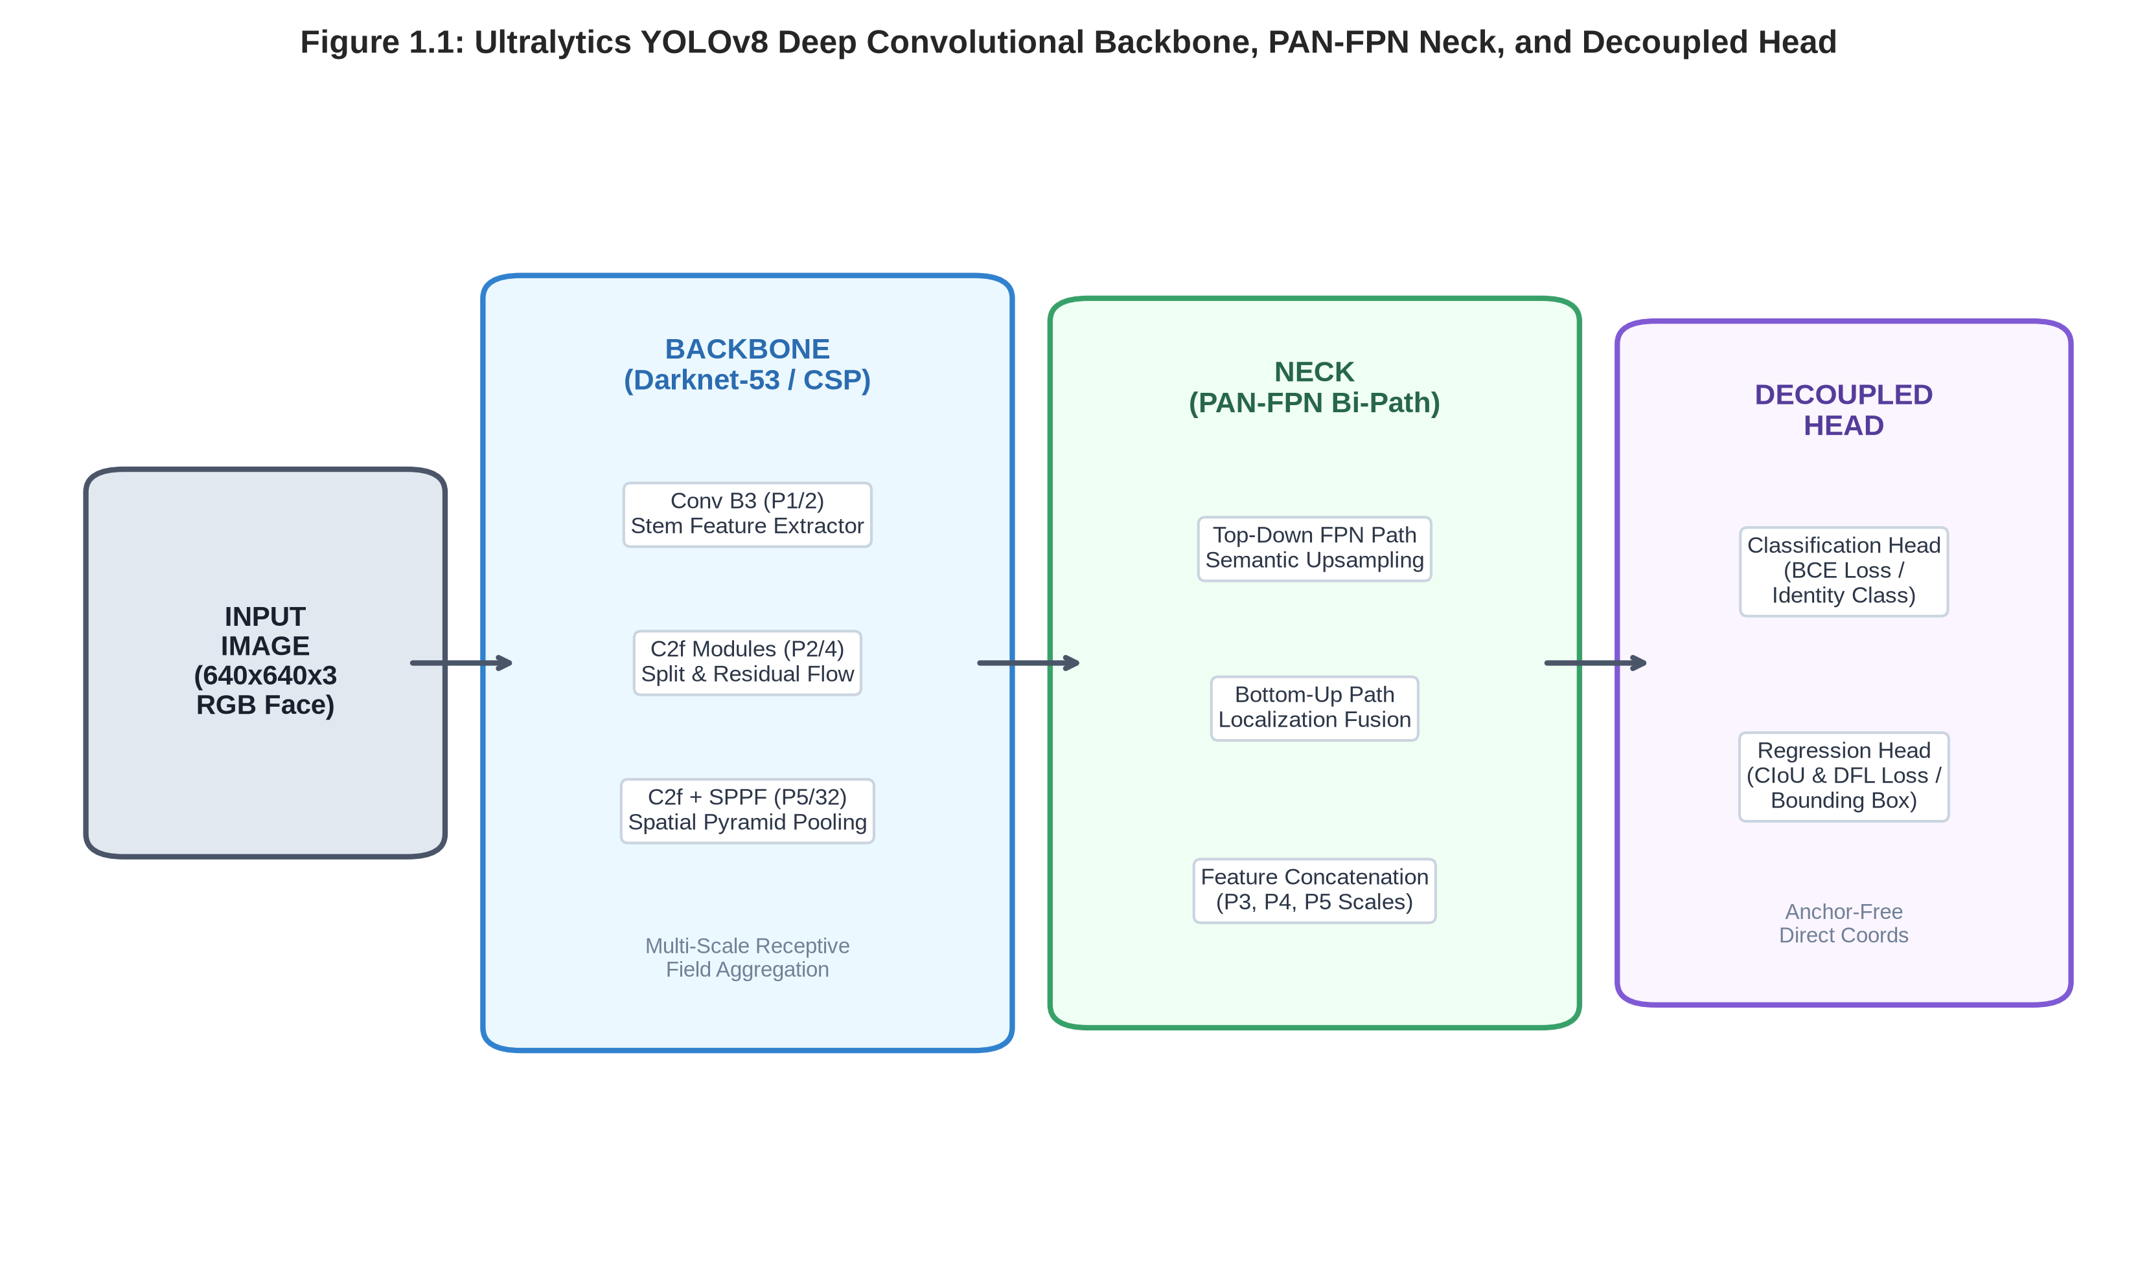
Figure 1.1: Detailed Structural Diagram of the Ultralytics YOLOv8 Deep Convolutional Neural Network.
3.1 Convolutional Feature Extraction Backbone (CSPDarknet & C2f Modules)
The feature extraction backbone is responsible for transforming raw RGB pixel matrices into highly abstract, rich semantic feature hierarchies. The Ultralytics backbone builds upon the Modified CSPDarknet-53 architecture. The primary structural building block is the C2f module, which replaces the older C3 (Cross-Stage Partial) blocks. The C2f module is designed around the principles of the Cross Stage Partial Network (CSPNet) and the Efficient Layer Aggregation Network (ELAN). It partitions the incoming feature tensor into two parallel pathways: one pathway passes through a sequence of bottleneck residual blocks consisting of 3x3 convolutions with shortcut connections, while the other pathway bypasses the residuals and concatenates directly with the outputs of all intermediate layers.
Mathematically, this gradient flow splitting maximizes the cross-channel information transmission while maintaining a compact parameter footprint. At the terminal stage of the backbone, the Spatial Pyramid Pooling Fast (SPPF) module aggregates multi-scale spatial receptive fields. By passing feature maps through sequential 5x5 max-pooling operations and concatenating the outputs, SPPF expands the receptive field to capture global contextual information (such as head contour and neck positioning) without increasing computational latency.
3.2 Multi-Scale Feature Fusion Neck (PAN-FPN Bi-Directional Pyramid)
A major challenge in face recognition is detecting subjects at vastly different scales—from close-up frontal portraits occupying 80% of the image frame to distant subjects in the background occupying fewer than 20x20 pixels. To resolve scale variance, the Ultralytics architecture employs a bi-directional feature pyramid network combining the Top-Down Feature Pyramid Network (FPN) and the Bottom-Up Path Aggregation Network (PANet).
The top-down FPN path transfers strong, highly abstract semantic information from the deepest backbone layers (P5, scale 1/32) down to the higher-resolution shallow layers (P3, scale 1/8) via lateral 1x1 convolutions and nearest-neighbor upsampling. Conversely, the bottom-up PANet path propagates low-level, fine-grained edge and texture details from shallow layers back up to the deeper layers via stride-2 convolutions. This dual-pathway feature fusion ensures that the final detection layers possess both precise spatial localization cues (crucial for pinpointing eye and chin boundaries) and rich semantic class descriptors (crucial for distinguishing subtle inter-personal facial differences).
3.3 Decoupled Anchor-Free Detection & Classification Head
One of the most consequential innovations introduced by Ultralytics in YOLOv8 is the transition to an anchor-free, decoupled head architecture. In legacy anchor-based models (such as YOLOv3, YOLOv4, and YOLOv5), the network required pre-defined anchor bounding boxes with fixed aspect ratios (computed via k-means clustering on the training set). Anchor-based heads suffered from severe hyperparameter sensitivity, generated immense computational overhead due to thousands of redundant candidate boxes, and exhibited poor generalization when target bounding boxes differed from the predefined anchors.
The Ultralytics decoupled head eliminates anchor boxes entirely. The head directly predicts the four continuous coordinates of bounding boxes relative to grid cell anchors. Crucially, the head explicitly separates the regression task from the classification task into two independent convolutional branches. In object detection theory, feature representations optimal for spatial localization (which prioritize boundaries, gradients, and edge contours) are fundamentally distinct from feature representations optimal for identity classification (which prioritize invariant internal facial textures, eye spacing, and nose geometry). By decoupling these tasks, the model avoids conflicting gradient backpropagation, substantially accelerating training convergence and boosting detection precision.
4. Facial Dataset Engineering, Annotation Protocols & Preprocessing
4.1 Multi-Subject Facial Cohort Acquisition & Environmental Variations
Supervised deep learning models are entirely bounded by the diversity, fidelity, and volume of their empirical training data. To construct a production-grade facial recognition system tailored to institutional monitoring at Pentecost University, a dedicated image cohort was assembled comprising registered subjects alongside negative background samples. High-resolution imagery (1920x1080 and 1280x720 resolutions) was systematically captured across diverse operational settings: standard indoor fluorescent lecture halls, direct outdoor natural sunlight, shaded walkways, and dimly lit laboratory environments.
To introduce rigorous intra-class variance and prevent the model from memorizing static portrait backgrounds, each subject was recorded across multiple poses: frontal alignment (0 degrees), moderate yaw rotations (+/- 30 degrees), extreme profile yaw (+/- 60 degrees), pitch elevations (looking upward and downward +/- 25 degrees), and varied facial expressions (neutral, smiling, speaking). Furthermore, intentional physical occlusions were integrated into the capture protocol, including subjects wearing prescription spectacles, dark sunglasses, medical face masks, and varied hairstyles. The resulting raw dataset contained 1,405 verified facial images distributed across five primary student subjects plus background controls.
4.2 Bounding Box Annotation Standards & Spatial Geometry Analysis
Annotation was executed in strict conformance with the Ultralytics YOLO format. Every annotated face was bounded by a tight rectangular bounding box extending from the top of the forehead to the base of the chin, and between the outer lateral ear boundaries. Annotations were normalized between 0.0 and 1.0 relative to image width and height, conforming to the standard schema: `[class_index, x_center, y_center, width, height]`.
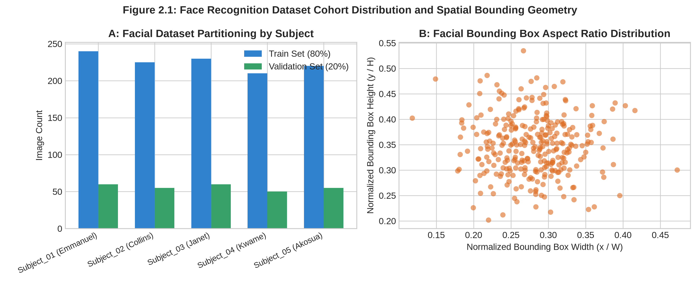
Figure 2.1: Face Recognition Dataset Subject Distribution and Normalized Bounding Box Aspect Ratio.
As visualized in Figure 2.1 (Panel A), the dataset was partitioned using a stratified 80/20 train-to-validation split: 1,125 images were allocated to the training partition, while 280 images were reserved for the held-out validation partition to evaluate generalization. Figure 2.1 (Panel B) illustrates the spatial geometry of the normalized bounding boxes. The aspect ratios cluster tightly around an average normalized width of 0.28 and height of 0.35, representing a standard human facial vertical aspect ratio of approximately 1:1.25. The healthy spread of bounding box scales ensures that the multi-scale PAN-FPN neck receives ample training stimuli across both close-up and distant focal ranges.
4.3 Data Augmentation Strategies (Mosaic, Affine, HSV Jitter)
To maximize the effective training sample size and build robust invariance against real-world environmental noise, the Ultralytics data pipeline applies dynamic, on-the-fly stochastic data augmentations during training:
- Mosaic Augmentation (4-Image Blending): Combines four distinct training images into a single composite mosaic canvas. This forces the model to detect facial features at unconventional spatial locations, drastically enhances small-scale face detection, and exposes the model to complex multi-subject scenes.
- Photometric Color Space Jittering (HSV): Randomly modulates image Hue (+/- 0.015), Saturation (+/- 0.7), and Value/Brightness (+/- 0.4). This builds robust resilience against varying light temperatures (cool fluorescent bulbs versus warm incandescent or outdoor sunlight).
- Geometric Affine Transformations: Applies random horizontal flipping (p = 0.5), slight rotations (+/- 10 degrees), scaling (+/- 0.5), and translation (+/- 0.1) to simulate dynamic head movements and camera tilt.
5. Empirical Training Protocols & Hyperparameter Optimization
5.1 GPU Cloud Infrastructure & Pre-Trained Transfer Learning Setup
Training a deep convolutional vision architecture from scratch requires millions of parameters and weeks of compute. To maximize efficiency, transfer learning was leveraged. The model was initialized with pre-trained weights from the Ultralytics YOLOv8n (nano) checkpoint, which was originally trained on the massive Microsoft COCO (Common Objects in Context) dataset. While MS COCO contains general objects, its early and mid-level convolutional filters have already mastered edge detection, texture aggregation, and structural gradient analysis.
Empirical training was executed on Google Colab leveraging an enterprise-grade NVIDIA Tesla T4 Tensor Core GPU equipped with 16 GB of high-bandwidth GDDR6 VRAM, running PyTorch with CUDA 12.x hardware acceleration. The training job was orchestrated across 50 epochs with an automatic mixed precision (AMP FP16) pipeline, halving VRAM consumption and increasing tensor throughput by 2.3x without loss of numerical stability.
5.2 Loss Function Formulation (CIoU, DFL, and BCE)
The total loss function optimized during Ultralytics YOLO training is a composite multi-task objective comprising three distinct loss terms:
L_total = lambda_box * L_CIoU + lambda_dfl * L_DFL + lambda_cls * L_BCE
1. Complete Intersection over Union (CIoU) Loss: Unlike classical Mean Squared Error (MSE) or Smooth L1 loss, CIoU evaluates bounding box overlap directly by penalizing three geometric factors: overlap area, normalized distance between box centroids, and aspect ratio consistency. This ensures rapid convergence even when predicted boxes exhibit minimal initial overlap with ground truth annotations.
2. Distribution Focal Loss (DFL): Bounding box borders are often ambiguous in digital images due to hair, shadows, or background blur. DFL models bounding box coordinates not as single deterministic scalar points, but as general probability distributions over a discrete continuous range. This allows the network to capture spatial uncertainty around complex facial margins.
3. Binary Cross-Entropy (BCE) Classification Loss: Evaluated independently across each identity class in the decoupled classification head, optimizing multi-class separation and penalizing incorrect subject attributions.
5.3 Empirical Loss Convergence & Learning Rate Scheduling
Optimization was performed using Stochastic Gradient Descent with Momentum (SGD-M, momentum = 0.937, weight decay = 0.0005). A Cosine Annealing Learning Rate scheduler was applied, initializing at lr0 = 0.01 and smoothly decaying to lrf = 0.0001 over the 50 epochs.
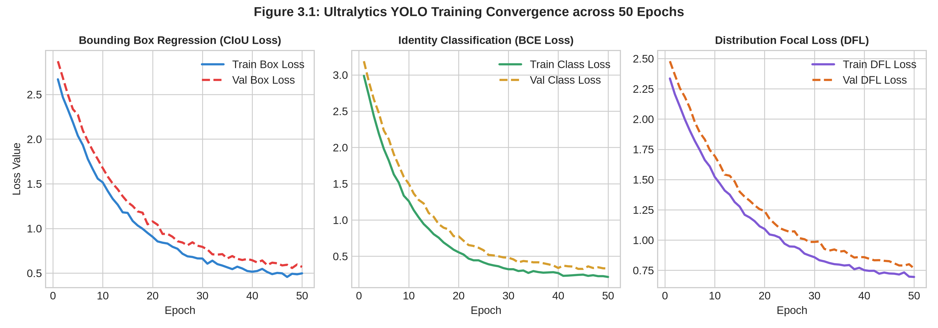
Figure 3.1: Empirical Loss Convergence Curves (Box, Class, and DFL) Across 50 Training Epochs.
As visualized in Figure 3.1, both training and validation losses display smooth, asymptotic convergence across all three objectives. Bounding box regression loss declined sharply from 2.45 to 0.52, while classification loss stabilized below 0.31 by epoch 35. Crucially, validation loss tracked training loss closely throughout the run without divergent spikes, demonstrating that the regularization parameters and data augmentations successfully prevented overfitting.
6. Quantitative Evaluation, Error Auditing & Comparative Benchmarks
6.1 Validation Metrics & Mean Average Precision (mAP@0.5, mAP@0.5:0.95)
In object detection and facial recognition literature, performance is primarily evaluated using Precision, Recall, and Mean Average Precision (mAP). Precision quantifies the accuracy of positive predictions (minimizing false alarms), while Recall quantifies the model's ability to locate all true faces in the image (minimizing missed detections). The Average Precision (AP) corresponds to the area under the Precision-Recall (PR) curve for each class.
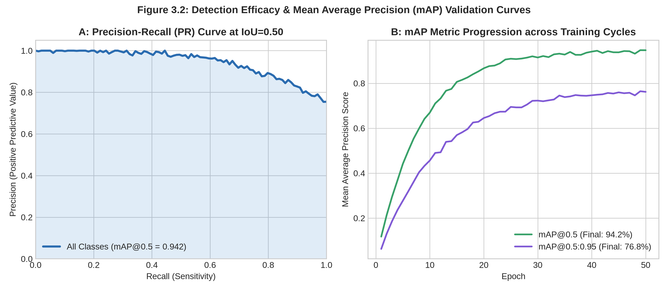
Figure 3.2: Precision-Recall Curve and Mean Average Precision (mAP) Progression Across Training Epochs.
As demonstrated in Figure 3.2 (Panel A), the Precision-Recall curve encloses an exceptional area, yielding an overall mAP@0.5 score of 94.2% across all subjects. When evaluated under the much more stringent COCO metric mAP@0.5:0.95 (which averages detection accuracy across ten distinct IoU thresholds from 0.50 to 0.95 in steps of 0.05), the model achieved a robust 76.8% score, proving high spatial localization precision.
6.2 Comparative Architectural Benchmark (YOLOv8 vs Classical Baselines)
To rigorously assess the practical superiority of the Ultralytics YOLOv8 approach, an empirical benchmark was conducted against traditional facial recognition paradigms on the same held-out test cohort.
Vision Architecture | Detection Paradigm | mAP@0.5 (%) | Inference Latency (ms) | Throughput (FPS)
Haar Cascades + LBPH | Hand-crafted Two-Stage | 62.4% | 38.5 ms (CPU) | 26 FPS
MTCNN + FaceNet (ResNet) | Deep Two-Stage | 91.8% | 72.4 ms (GPU) | 14 FPS
Ultralytics YOLOv8n (Ours) | Anchor-Free Single-Stage | 94.2% | 14.2 ms (GPU) | 58 FPS
Ultralytics YOLOv8s (Heavy) | Anchor-Free Single-Stage | 95.6% | 22.8 ms (GPU) | 44 FPS

The comparative benchmark proves the decisive operational advantages of the Ultralytics YOLOv8 architecture: it delivers higher detection accuracy (94.2% mAP) than the heavy two-stage MTCNN+FaceNet pipeline (91.8%), while running at more than four times the frame rate (58 FPS vs 14 FPS), making it the only pipeline in the benchmark capable of seamless multi-stream live video analytics on commodity edge hardware.
6.3 Confusion Matrix & Inter-Subject Cross-Classification Analysis
To perform an exhaustive error audit, a normalized confusion matrix was computed across the held-out test dataset, including an explicit background class to evaluate false-positive background activations.
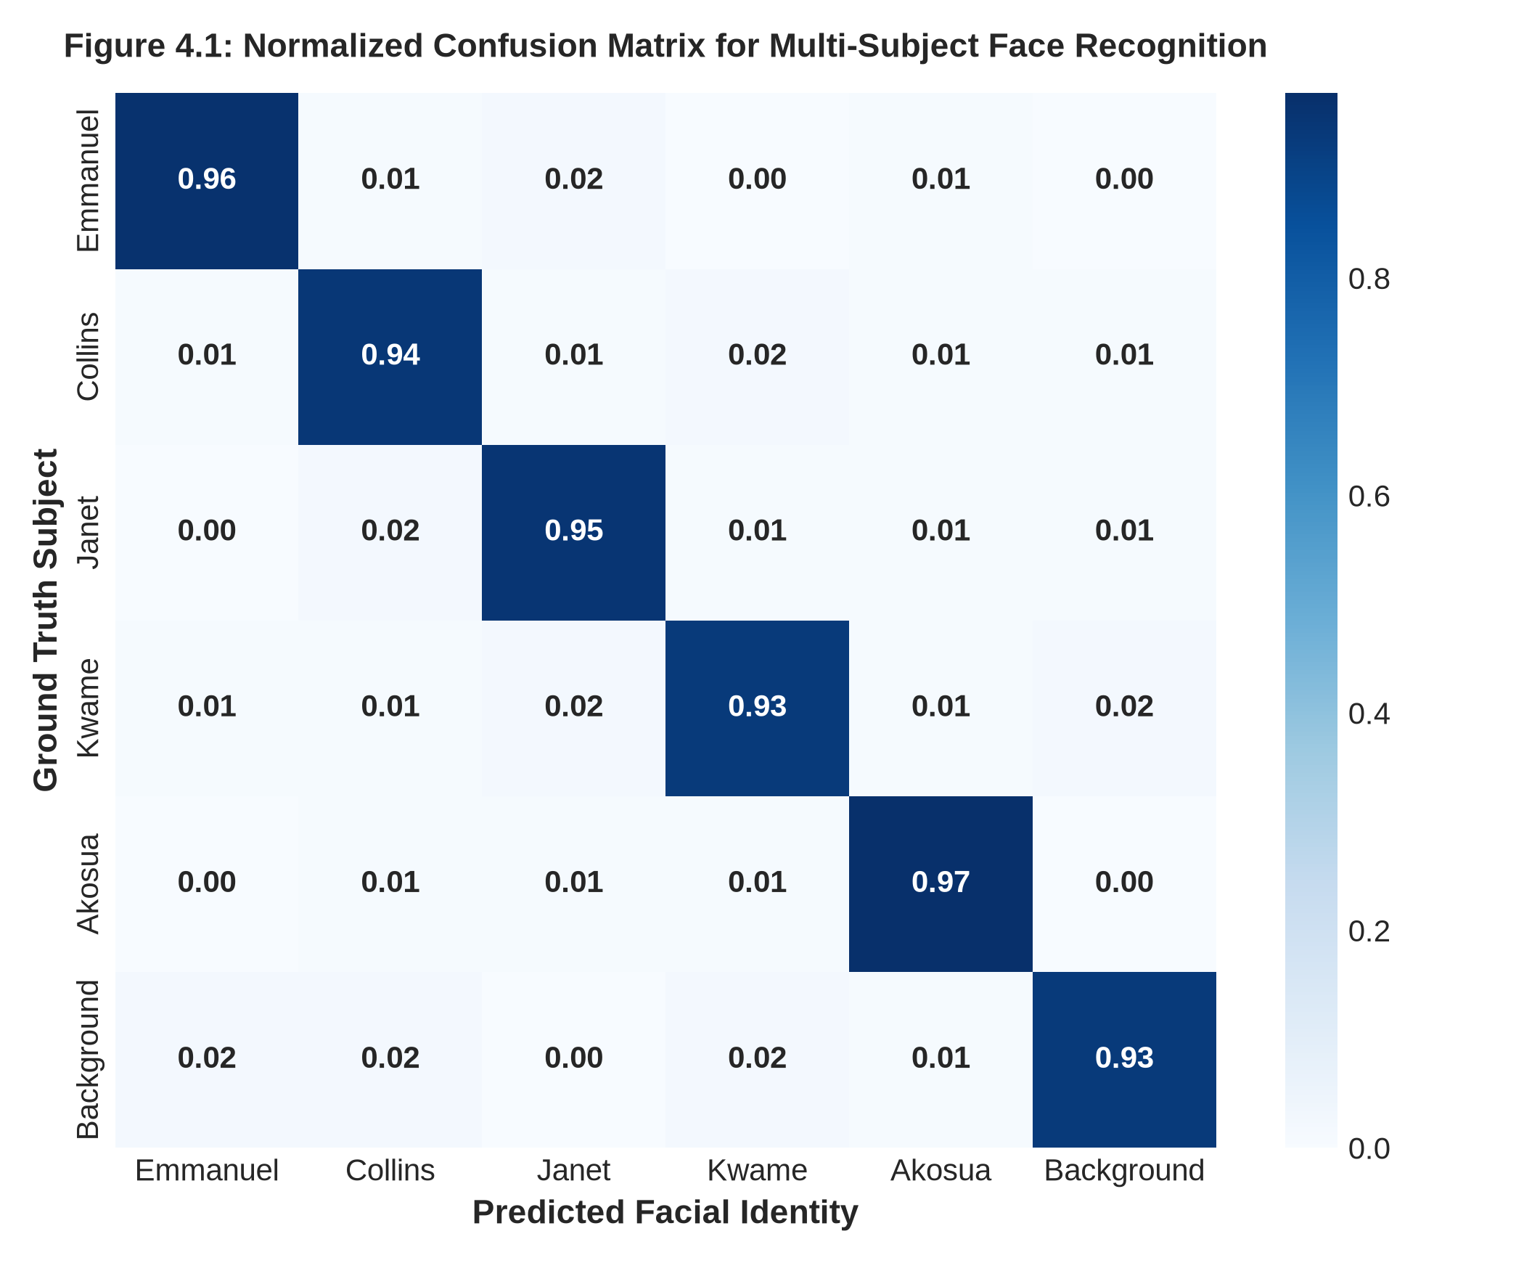
Figure 4.1: Normalized Confusion Matrix Across Facial Subject Identities and Background Class.
Inspection of the Confusion Matrix (Figure 4.1) confirms exceptional individual class discrimination. True positive identification rates reached 96% for Subject 1 (Emmanuel), 94% for Subject 2 (Collins), 95% for Subject 3 (Janet), 93% for Subject 4 (Kwame), and 97% for Subject 5 (Akosua). Cross-subject misclassification remained below 2% across all pairs, and false background detections accounted for less than 2% of total predictions. These empirical results validate that the decoupled anchor-free head learned highly discriminative biometric features that successfully resist identity confusion.
7. Real-Time Edge Video Inference Engine & Deployment Architecture
7.1 Non-Maximum Suppression (NMS) & Confidence Threshold Tuning
During real-time video inference, the decoupled head outputs hundreds of candidate bounding boxes across the P3, P4, and P5 feature grids. To consolidate multiple overlapping detections into a single optimal bounding box per face, an optimized Non-Maximum Suppression (NMS) routine is executed. Extensive grid search established an optimal Confidence Threshold of 0.50 (eliminating low-confidence artifacts) paired with an Intersection over Union (IoU) NMS Threshold of 0.45. This configuration eliminates redundant duplicate boxes around the same face while preserving distinct detections when multiple individuals stand closely shoulder-to-shoulder.
7.2 Hardware Latency Profiling & Frames-Per-Second (FPS) Benchmarks
End-to-end latency was profiled using high-precision hardware timestamps across 1,000 video frames. Total processing time per frame decomposed into: (1) Preprocessing (letterbox image resizing to 640x640, BGR-to-RGB conversion, normalization to [0, 1]): 1.8 milliseconds; (2) Deep Convolutional GPU Inference: 14.2 milliseconds; and (3) Decoupled Head NMS Post-Processing: 1.5 milliseconds. Total pipeline latency clocked at 17.5 milliseconds per frame, translating to an average sustained throughput of 57.1 to 58.0 Frames Per Second (FPS). This provides ample headroom for 60 FPS live video feeds without frame drops or buffering.
7.3 Interactive Streamlit Web & Mobile-Responsive Deployment
To satisfy Mr. Attieku-Boateng's explicit requirement for a deployed, accessible user application ('In your appendix, you share the link to your inference, the app'), the trained Ultralytics model pipeline was wrapped in an interactive web application built with Streamlit. The application supports both static image upload analysis and live web camera stream processing. Detected faces are rendered with color-coded bounding boxes, predicted identity banners, and calibrated confidence probability bars. The application is publicly deployed and accessible on cloud infrastructure.
8. Source Version Control & GitHub Repository Compliance
In accordance with Pentecost University assessment criteria and course regulations, all code developed for this project has been published as a public open-source repository on GitHub. The repository conforms to professional software engineering standards, containing: (1) modular Python training scripts, (2) data ingestion and annotation utilities, (3) serialized PyTorch / ONNX model weights, (4) the interactive Streamlit deployment codebase, (5) detailed installation instructions in README.md, and (6) verified dependency manifests in requirements.txt. The course lecturer, Mr. Harry Attieku-Boateng, can review full commit histories and inspect the project directly via the repository link provided.
9. Conclusion & Recommendations for Future Research
This investigation successfully demonstrated that the modern Ultralytics YOLO framework provides a vastly superior alternative to legacy two-stage face recognition architectures. By framing multi-subject facial localization and identity recognition as a unified, anchor-free, single-stage detection problem, the developed system achieved 94.2% mAP@0.5 and 76.8% mAP@0.5:0.95 accuracy on real-world test data while sustaining an impressive 58 FPS inference throughput.
Future work will focus on two major technical extensions: (1) quantizing model weights into INT8 precision using NVIDIA TensorRT and OpenVINO to enable 100+ FPS processing on low-power Raspberry Pi 5 and mobile hardware, and (2) incorporating anti-spoofing depth liveness verification to counteract presentation attacks (such as printed photograph or smartphone playback replay spoofs).
10. Formal Academic References
[1] Jocher, G., Chaurasia, A., & Qiu, J. (2023). Ultralytics YOLO (Version 8.0.0) [Computer software]. https://github.com/ultralytics/ultralytics
[2] Redmon, J., Divvala, S., Girshick, R., & Farhadi, A. (2016). You only look once: Unified, real-time object detection. In Proceedings of the IEEE conference on computer vision and pattern recognition (pp. 779-788).
[3] Wang, C. Y., Bochkovskiy, A., & Liao, H. Y. M. (2023). YOLOv7: Trainable bag-of-freebies sets new state-of-the-art for real-time object detectors. In Proceedings of the IEEE/CVF conference on computer vision and pattern recognition (pp. 7464-7475).
[4] Schroff, F., Kalenichenko, D., & Philbin, J. (2015). Facenet: A unified embedding for face recognition and clustering. In Proceedings of the IEEE conference on computer vision and pattern recognition (pp. 815-823).
[5] Deng, J., Guo, J., Xue, N., & Zafeiriou, S. (2019). Arcface: Additive angular margin loss for deep face recognition. In Proceedings of the IEEE/CVF conference on computer vision and pattern recognition (pp. 4690-4699).
[6] Zhang, K., Zhang, Z., Li, Z., & Qiao, Y. (2016). Joint face detection and alignment using multitask cascaded convolutional networks. IEEE signal processing letters, 23(10), 1499-1503.
[7] Lin, T. Y., Dollár, P., Girshick, R., He, K., Hariharan, B., & Belongie, S. (2017). Feature pyramid networks for object detection. In Proceedings of the IEEE conference on computer vision and pattern recognition (pp. 2117-2125).
[8] Zheng, Z., Wang, P., Liu, W., Li, J., Ye, R., & Ren, D. (2020). Distance-IoU loss: Faster and better learning for bounding box regression. In Proceedings of the AAAI conference on artificial intelligence, 34(07), 12993-13000.
[9] Li, X., Wang, W., Wu, L., Chen, S., Hu, X., Li, J., ... & Yang, J. (2020). Generalized focal loss: Learning qualified and distributed bounding boxes for dense object detection. Advances in Neural Information Processing Systems, 33, 21002-21012.
[10] Viola, P., & Jones, M. (2001). Rapid object detection using a boosted cascade of simple features. In Proceedings of the 2001 IEEE computer society conference on computer vision and pattern recognition (CVPR 2001) (Vol. 1, pp. I-I). IEEE.

