SEO in the Age of AI
Scenario Planning Case Study | Horizon 2035 | Brief
Team 14: Emran, Arshi, Ashik, Ozlem, Wasay
Scenario Management | Thomas Chermack scenario planning cycle

Abstract
For years, SEO meant ranking on Google, winning the click, and converting on your website. That model still works in places, but it is no longer the full picture. A large share of searches in the EU end without any click to the open web. AI Overviews sit above organic results. Tools like ChatGPT are becoming the first stop for work research.
Team 14 applied Chermack's scenario planning cycle to Brief B. We scanned the external environment (STEEP), separated Givens from Drivers, interviewed two practitioners outside our team, and built a 2x2 matrix with four scenarios set in 2035. This paper is not a prediction. It is a structured way to prepare for different plausible futures in organic discoverability when AI mediates search.

1. Introduction

1.1 Why this project matters
Brief B asks what happens to organic discoverability when AI sits between brands and users. The audience is marketing and communications professionals: brand managers, agency leads, publisher strategists, and B2B marketers who still defend budgets every quarter.
Universities often teach SEO as if traffic is the only KPI. Our data and interviews suggest visibility can mean citation inside an AI answer, not a visit to your site. That shift is strategic, not just technical.

1.2 What we are not claiming
We do not claim Google disappears by 2030 or that SEO vanishes. We map four internally consistent worlds so decision-makers can spot early signals and avoid betting everything on one outdated model.

2. Methodology
We followed Chermack's three phases:
- Phase 1 (Preparation): purpose statement and system picture.
- Phase 2 (Exploration): STEEP scan, Givens vs Drivers, two peer interviews.
- Phase 3 (Development): 2x2 matrix, four scenario narratives, early-warning indicators, critical reflection.
A Given is a condition already in motion that every scenario must assume. A Driver is uncertain in speed or scale and can push futures in different directions.

3. Phase 1: Project Preparation

3.1 Purpose statement
By 2035, marketing teams must decide:
- Budget split: SEO, SEM, content, AI visibility / GEO work.
- Team structure: classic SEO vs citation and entity optimization.
- KPIs: website traffic vs in-platform influence and brand mentions in AI answers.
- Content strategy: volume vs authority, proprietary data, and structured markup.
Our scenarios inform those decisions before a traffic cliff forces them.

3.2 System picture
Chermack asks you to map the field in layers. Figure 1 shows how we drew it. The core is simple to say and hard to fix: staying discoverable when AI mediates search.
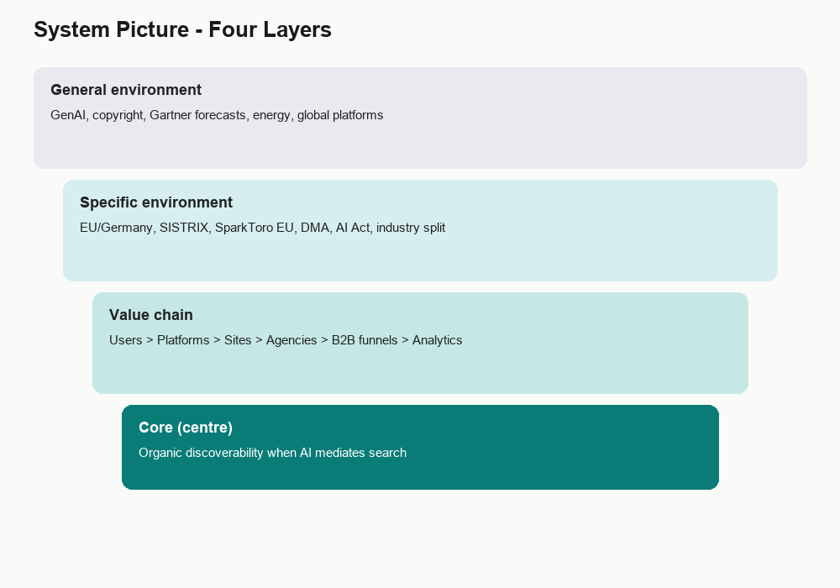
Figure 1: System picture (four layers from general environment to core issue).
- Core: organic discoverability in AI-mediated search.
- Value chain: users, platforms (Google, ChatGPT, Copilot, Perplexity), publishers and brand sites, agencies, B2B funnels, analytics.
- Specific environment: Germany/EU, SISTRIX and SparkToro data, DMA, AI Act, uneven industry impact.
- General environment: GenAI, copyright, Gartner forecasts, data-centre energy, global platform competition.

4. Phase 2: STEEP External Analysis
Research by Arshi and Ashik. Table 1 is our merged factor list.
Dimension | Factor | Evidence | Given / Driver | Source
Social | Zero-click behaviour | 59.7% of EU Google searches end without a click | Given | SparkToro 2024
Social | Reliance on AI answers | AIO on 64.7% of question-based searches | Driver | arXiv 2605.14021
Technological | AI search mainstream | AIO on ~20% of DE queries (~30% long-tail) | Given | SISTRIX
Technological | Shift to AI assistants | Gartner: -25% search volume by 2026 | Driver | Gartner Feb 2024
Technological | Organic CTR erosion | CTR on #1: 27% down to 11% when AIO shows | Driver | SISTRIX
Economic | Reduced open-web traffic | 374 of 1,000 EU searches reach the open web | Given | SparkToro
Economic | Publisher revenue pressure | ~265M lost organic clicks/month in Germany | Driver | SISTRIX
Economic | Small publisher decline | ~60% search referral drop over 2 years | Driver | Axios
Political/Legal | Mass AI search reach | AIO reaches 2B+ users globally | Given | arXiv 2605.14021
Political/Legal | Regulation uncertainty | 11% of AIO claims unsupported by sources | Driver | arXiv 2605.14021
Environmental | AI infrastructure demand | GenAI search needs far more data-centre energy | Driver | IEA, McKinsey, Google

Table 1: STEEP factors for SEO in the Age of AI (2035 horizon).

4.1 Justifying Givens vs Drivers
Givens are measured or deployed facts: EU zero-click at 59.7%, AIO live in Germany, 374 clicks per thousand to the open web, 2B+ users on AIO. Every scenario builds on these.
Drivers are genuine uncertainties: Will AI reliance on question queries keep rising? Will Gartner's 25% volume drop arrive on schedule? Will CTR pain spread into B2B comparison queries? Will EU attribution rules tighten after studies found unsupported claims? Will energy costs slow AI search rollout?
Note: SparkToro also reports higher zero-click in some broader samples (~68% in our earlier reading). We use the EU figure (59.7%) for European scenario logic and cite the source clearly.

4.2 Industry split (SISTRIX)
- Higher impact so far: how-to, health, recipe, education sites.
- Lower impact so far: e-commerce, brand websites, local businesses.

5. Key Data Insights
Figure 2 summarizes the numbers we cite most often in the scenarios.
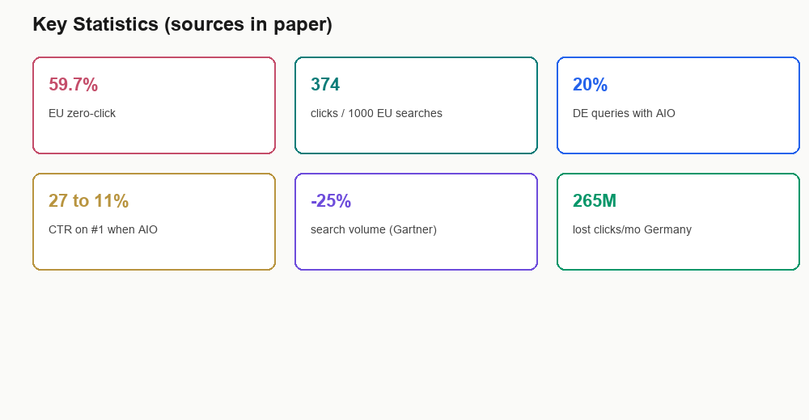
Figure 2: Key statistics (SparkToro, SISTRIX, Gartner).
Zero-click moved from about 60.45% in 2024 toward higher EU readings. When AI Overviews appear, the first organic result loses most of its click power. Publishers in Germany alone may lose hundreds of millions of organic clicks per month at current rollout levels.

6. Stakeholder Interviews
Conducted by Ozlem Ceylan, June 2026. Semi-structured, ~10 minutes each, peers outside Team 14.

6.1 Funda Aydin (B2B marketing, GEA Digital)
Funda has worked 2+ years in marketing at GEA Digital (B2B, industrial engineering). She told us ChatGPT is her first tool for work research, with a visible shift away from Google over about two years.
Key quote: "Visibility will become less about ranking number one in Google and more about becoming a reliable source that AI models repeatedly use."
Other insights:
- ChatGPT feels faster because it pulls from many sites and summarizes.
- For routine marketing she does not always check sources; for legal/technical topics she would.
- B2B still needs deep technical content somewhere trustworthy; the click is optional.
- Companies should optimize to be cited and trusted by AI, not only clicked in search results.
- Biggest concern: a few AI platforms becoming gatekeepers of visibility.

6.2 Lorena Contreras (community manager, SEO background)
Lorena has digital marketing and SEO seminar background; now focused on community enablement. She still opens Google first when she knows what she wants. She uses ChatGPT to structure text, not to replace search.
Key quote: "SEO will still exist in 2035, less about keywords, more about credibility and being visible in AI-generated answers."
Other insights:
- Google AI summaries can answer without a click even when your content built the answer.
- Trust comes from real examples, expert opinions, customer cases, transparent information.
- Traditional blogs matter less; expert content, video, use cases, and data matter more.
- She would not pay for generic articles AI can reproduce.

6.3 How interviews shaped the matrix
Funda represents AI-first discovery and citation logic. Lorena represents hybrid discovery and website value for commercial intent. Both can be true at once for different users and query types. That is why our axes are discovery architecture and value capture, not SEO dead vs SEO fine.

7. Givens and Drivers Summary

7.1 Givens (baseline for all four scenarios)
- 59.7% EU zero-click; 374 clicks per 1,000 EU searches (SparkToro).
- AIO on ~20% of DE queries, often above organic #1 (SISTRIX).
- GenAI embedded in retrieval; not experimental.
- AIO global reach 2B+ users.
- Uneven industry impact already visible.

7.2 Drivers (fed into matrix axes)
- Discovery: AI-native default vs hybrid coexistence (Gartner uncertainty, Funda vs Lorena).
- Value capture: zero-click influence vs website funnels (SparkToro, SISTRIX, publisher pain).

8. Phase 3: The 2x2 Scenario Matrix
We selected two critical uncertainties as axes. They are independent enough to produce four distinct futures.

8.1 Axis 1 (vertical): Discovery architecture
- Top: AI-native discovery dominates (ChatGPT, Copilot, answer engines as default).
- Bottom: Hybrid discovery persists (Google + AI + open web coexist).

8.2 Axis 2 (horizontal): Value capture model
- Left: Website-centric funnels still dominate (traffic to lead/sale).
- Right: Zero-click influence economy (citations, mentions, in-platform authority).
Figure 3 shows the four quadrants. Table 2 matches scenario names to driver combinations.
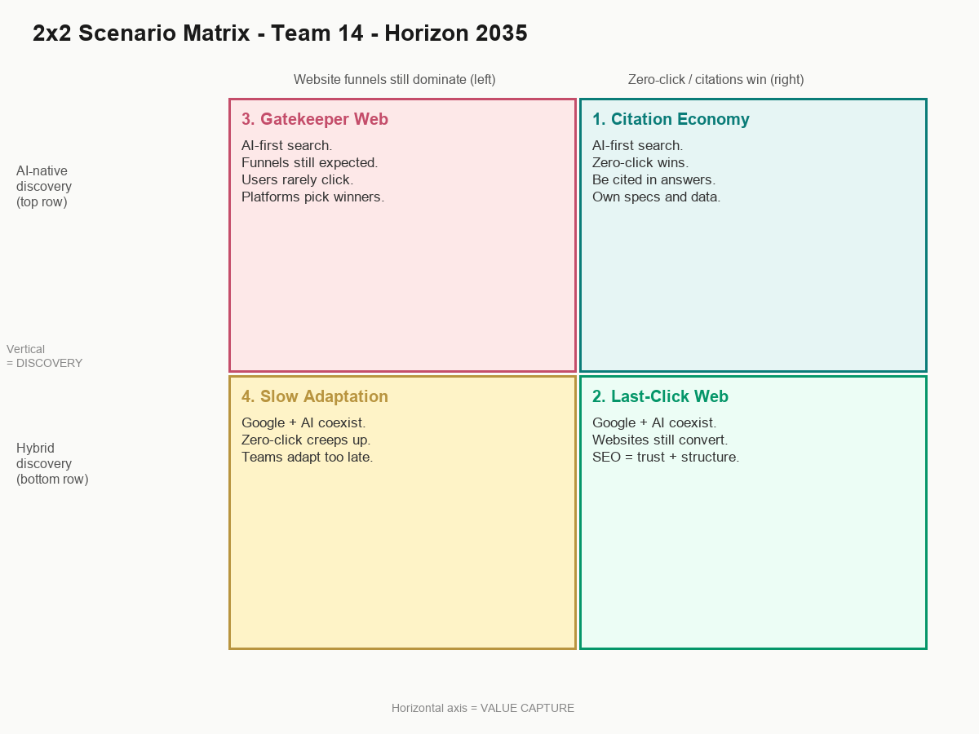
Figure 3: 2x2 scenario matrix (Horizon 2035).
Scenario | Discovery pole | Value capture pole
1. Citation Economy | AI-native | Zero-click influence
2. Last-Click Web | Hybrid | Website funnels
3. Gatekeeper Web | AI-native | Website funnels (expected but broken)
4. Slow Adaptation | Hybrid | Gradual zero-click shift

Table 2: Scenario names and driver combinations.
Process link (STEEP + interviews to axes): Funda pushed us toward AI-native discovery and citation value. Lorena anchored hybrid discovery and website value for commercial intent. SparkToro and SISTRIX gave the scale of zero-click pressure.

9. Four Scenario Narratives (2035)

9.1 Scenario 1: The Citation Economy
Drivers: AI-native discovery + zero-click influence economy.
By 2035 most professional users stopped treating Google as the starting point for work research. ChatGPT, Copilot, and embedded assistants became the default question interface. Search remained for maps, logistics, or when you already knew the exact site.
Marketing fought over citation share: how often your brand, documentation, expert quotes, and structured data appeared inside AI answers. Agencies rebranded SEO into AI visibility or source authority teams. B2B industrial firms adapted better than expected. Buyers still needed technical truth, but the win was becoming the origin layer AI returned to, not chasing a click that might never come.
Publishers struggled. Some survived via licensing or niche authority. Small sites without leverage folded or moved to newsletters and communities.
Early-warning indicators today:
- ChatGPT or Copilot first in B2B research surveys.
- Job postings for GEO / AEO / LLM source optimization.
- EU open-web click share trending below 30%.
- Publisher licensing programs at scale.

9.2 Scenario 2: The Last-Click Web
Drivers: Hybrid discovery + website-centric funnels still dominate.
AI changed search but did not remove the website as the commercial centre. People mixed tools by task. AIO stayed strong on informational queries; high-intent commercial searches still clicked.
SEO evolved as Lorena predicted: credibility architecture, schema, expert authorship, customer proof, fast technical sites. Zero-click hurt, but many B2B teams treated AI answers as top-funnel and invested in onsite experiences summaries could not replace.
Early-warning indicators today:
- AIO concentrated in informational queries; commercial CTR relatively stable.
- Pipeline still attributed to organic website sessions.
- Hybrid tool use: same users on Google and AI weekly.
- Structured data spend rising faster than content volume.

9.3 Scenario 3: The Gatekeeper Web
Drivers: AI-native discovery + website-centric funnels still expected to work.
AI platforms became toll roads. Companies kept investing in landing pages because CRM and boards still used funnel metrics. Users rarely arrived. Traffic flatlined while influence inside AI grew without clean monetization.
This is Funda's gatekeeper fear at scale. A small set of platforms chose trusted sources. Large brands paid for visibility packages. Smaller players faced dark influence: mentioned in AI, invisible in analytics. Agencies heard 'we rank but nobody clicks.'
Early-warning indicators today:
- Few AI platforms dominate B2B product research journeys.
- Publisher referrals down 50%+ without licensing revenue.
- Paid priority-source or enterprise visibility products.
- Brand mentions in AI absent from web analytics.

9.4 Scenario 4: The Slow Adaptation
Drivers: Hybrid discovery + gradual zero-click shift.
Everyone agreed the old SEO playbook was broken. Almost nobody agreed on the replacement fast enough. Google mattered. AI mattered. Behaviour varied by age, sector, and task.
Teams kept hiring for content volume while clicks fell. Generic blogs multiplied. Rankings looked fine while pipeline quality slipped. Mid-size firms suffered most. Agencies sold rebrands and fear. Survivors experimented early with hybrid measurement and expert content.
Early-warning indicators today:
- Flat SEO budgets while AI usage among customers rises.
- Content volume up, conversions and referral traffic down.
- SEO is dead vs SEO is fine camps with no shared metrics.
- Funda-type and Lorena-type behaviours in the same organization.

10. Critical Reflection

10.1 Most plausible scenario
We lean toward Slow Adaptation. Data shows rising zero-click pressure. Interviews show fragmented behaviour. SISTRIX's uneven industry impact suggests change is gradual, not a clean flip.

10.2 Most concerning scenario
Gatekeeper Web. When a few platforms decide visibility, that is a power structure. Firms measuring websites while users never arrive creates dark influence and unfair dependency.

10.3 Strategic responses by scenario
Scenario | If this world emerges, prioritize
Citation Economy | Proprietary data, entities, citation measurement, expert authorship
Last-Click Web | High-intent SEO, technical structure, conversion depth, AI as top-funnel
Gatekeeper Web | Platform diversification, early licensing talks, brand moats AI cannot clone
Slow Adaptation | Parallel experiments, kill generic content, hybrid KPIs before crisis

10.4 What we would do as future professionals
Learn discovery strategy, not SEO alone: citations, structured data, authority, analytics beyond sessions. Push clients to choose which future they prepare for. Take practitioner voices seriously; they often see shifts before dashboards do.

12. References
- SparkToro (2024). Zero-Click Search Study. https://sparktoro.com/blog/2024-zero-click-search-study-for-every-1000-us-google-searches-only-374-clicks-go-to-the-open-web-in-the-eu-its-360/
- SISTRIX. AI Overviews in Germany. https://www.sistrix.com/blog/ai-overviews-in-germany/
- Gartner (19 Feb 2024). Search Engine Volume Will Drop 25 Percent by 2026. https://www.gartner.com/en/newsroom/press-releases/2024-02-19-gartner-predicts-search-engine-volume-will-drop-25-percent-by-2026-due-to-ai-chatbots-and-other-virtual-agents
- arXiv:2605.14021. AI Overview prevalence, claim accuracy, global reach.
- Axios. Small publisher search referral decline (~60% over two years).
- IEA; McKinsey; Google Sustainability Reports. AI infrastructure energy demand.
- Chermack, T. J. Scenario Planning in Organizations.
- Team 14 stakeholder interviews: Funda Aydin (17 June 2026); Lorena Contreras (18 June 2026).

