Saina Kohli 23103084 B3
Lab 1A

Q2.
#include <stdio.h>
int main() {
int n, i;
float sum = 0, average;
printf("Enter the number of elements: ");
scanf("%d", &n);
int arr[n];
printf("Enter %d integers:\n", n);
for (i = 0; i < n; i++) {
scanf("%d", &arr[i]);
sum += arr[i];
}
average = sum / n;
printf("Average = %.2f\n", average);
return 0;
}
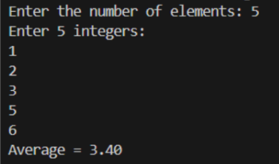

Q3.
#include <stdio.h>
#include <string.h>
int main() {
char str[100];
printf("Enter a string: ");
fgets(str, sizeof(str), stdin);
// Remove newline character if present
str[strcspn(str, "\n")] = '\0';
int len = strlen(str);
printf("Reversed string: ");
for (int i = len - 1; i >= 0; i--) {
putchar(str[i]);
}
printf("\n");
return 0;
}
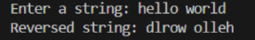
Q4.
git clone https://github.com/DaveGamble/cJSON.git
cd cJSON

