
Life Cycle Activities
Assignment
- A0079973 : Dao Xuan Dung
- A0079995 : Guo Yu
- A0079949 : Jiang Hao Min
- A0079976 : Lee Mingjian Alvin
- A0079953 : Lee Zhong De Rollei
- A0080037 : Zhou Zifeng

SG5103 – CA 1
Software Quality Management
Team 2

Table of Contents

4 QUALITY SYSTEM FOR LIFE CYCLE ACTIVITIES 5
4.1 Introduction 5
4.2 Pre-Contract 6
4.2.1 Gather Initial User Requirement 6
4.2.2 Review Initial Requirement 7
4.2.3 Prepare Proposal 7
4.2.4 Internal Review Proposal 7
4.3 Contract Review 8
4.3.1 Customer Review Proposal 8
4.3.2 Customer Prepare Contract 9
4.3.3 Review Contract 9
4.3.4 Sign off Contract 9
4.4 Project Initiation & Planning 10
4.4.1 Project Start Up 10
4.4.2 Produce Project Plan 10
4.4.3 Produce Quality Plan 10
4.4.4 Setup Project Filing System 11
4.4.5 Risk Analysis & Control 11
4.4.6 Review Project Plan & Quality Plan 11
4.5 Requirements Control 11
4.5.1 Analysis Requirement 11
4.5.2 Document Requirement 11
4.5.3 Internal Review Requirement Specification 12
4.5.4 Customer Review and Sign off Requirement Specification 12
4.6 DESIGN CONTROL 12
4.6.1 Design planning 12
4.6.2 Design input 12
4.6.3 Design method 12
4.6.4 Design outputs 13
4.6.5 Design review, validation and verification 13
4.6.6 Control of design changes 13
4.7 PROGRAMMING & USER DOCUMENT CONTROL 13
4.7.1 Programming planning 13
4.7.2 Programming input 13
4.7.3 Programming Output 14
4.7.4 Code & document review 14
4.7.5 Control development changes 14
4.8 TESTING & VALIDATION 14
4.8.1 Testing plan 14
4.8.2 Testing input 15
4.8.3 Testing output 15
4.8.4 Test & document review 15
4.8.5 Control testing changes 15
4.9 ACCEPTANCE 16
4.9.1 Acceptance plan 16
4.9.2 Acceptance input 16
4.9.3 Acceptance output 17
4.9.4 Control acceptance changes 17
4.10 DELIVERY & INSTALLATION 17
4.10.1 Delivery & installation plan 17
4.10.2 Acceptance input 17
4.10.3 Acceptance output 17
4.10.4 Control acceptance changes 18
4.11 MAINTENANCE 18
4.11.1 Maintenance plan 18
4.11.2 Maintenance input 18
4.11.3 Maintenance output 18
4.11.4 Control Maintenance changes 18

QUALITY SYSTEM FOR LIFE CYCLE ACTIVITIES

Introduction
The main business of Xpress Systems Pte Ltd is to undertake software contracts for Customers. These can be either be new development, enhancements to existing systems, or partial developments (undertaking only part of the life cycle, such as project to produce a requirements specification and a functional specification). From the point view of the QMS, all projects are treated the same – they all involve delivering the requirements specified by the Customer. To achieve the successful delivery of Customer requirement, the project must be organized around a life cycle model featuring the basic activities shown as below.
Pre-Contract Phase:
- File Tender Specification into Company Project Shared Repository
- Study Tender Specification
- Produce RFP(Request for Proposal) work plan
- Conduct Initial Requirements Gathering and Documentation of requirements
- Requirements Feasibility Study and produce proposal
- Review proposal and initial user requirement specifications

Contract Review Phase:
- Review contract
- Contract negotiation meeting
- Update contract
- Contract Sign Off

Project Initiation & Planning
- Project Initiation
- Setup project filing system
- Project start up meeting
- Produce project plan and quality plan
- Review project plan and quality plan
- Project team formation
- Send project team for training (if required)
- Engage subcontractors (if required)
- Engage hardware/software supplier (if required)s

Requirements Control
- User requirements gathering
- Study and Documentation of user requirement specification
- Review user requirement specification (Internal)
- Review user requirement specification (Customer)
- Sign Off user requirement specification

Design Control
- Conduct preliminary design
- Produce user interface design specifications (optional)
- Build and study prototype
- Prototype walk-through with customer
- Formulate system design strategy
- Change Request (if required)

Programming and User Documentation
- Development Environment Setup
- Coding
- Design and Review Unit Test Plan (Test Case/Test Script)
- Perform Unit Test & Document Test Results
- Peer Review/Code Walkthrough

Testing and Validation
- SIT environment setup
- Produce test plan (strategy, test case, script)
- Review test plan
- Perform SIT and document SIT results
- Review SIT results
- Coding (Fix Defects)
- Create SIT Test Report
- Review SIT Test Report

Testing and Validation
- UAT environment setup
- Conduct user training
- Produce Test Plan (Strategy, Test Case, Script)
- Review and Accept Test Plan
- Perform UAT & Document UAT Results
- Review UAT Results
- Coding (Fix Defects)
- Change Request (if required)
- Create UAT Test Report
- Review & Accept UAT Test Report

Delivery and Installation
- Review and accept delivered product
- Produce and review installation plan
- Installation
- Post installation check
- Troubleshoot and fix installation issue
- Handover and user sign off

Maintenance
- Produce maintenance documentation
- Review maintenance documentation (internal)
- Review maintenance documentation (customer)
- Troubleshoot and analyze production issue
- Perform corrective action
- Regression testing in UAT
- Deploy fix to production

Pre-Contract
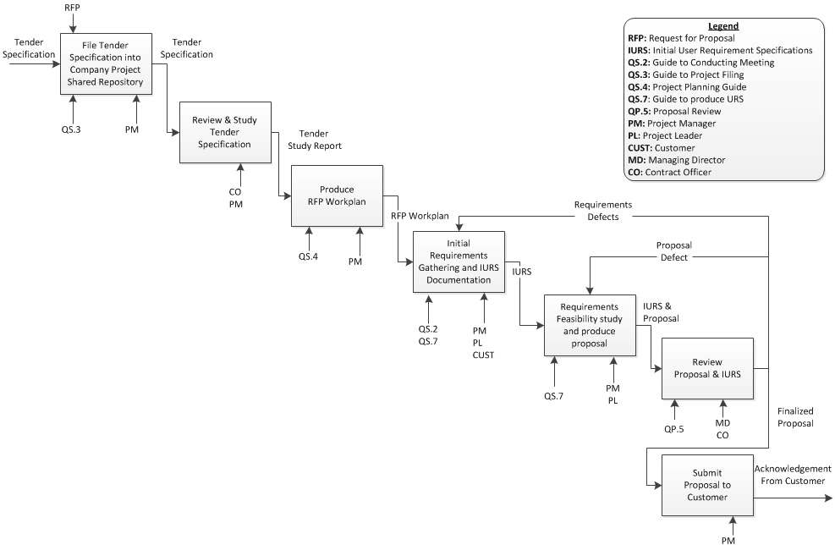
Pre-Contract
PURPOSE | : | - To ensure the RFP process start off in a controlled manner  - To ensure customer initial requirements are captured and properly process  - To produce a good proposal to secure the project
OBJECTIVE | : | To produce an exceptionally good proposal to obtain approval from MD and subsequently secure the project contract from customer
STANDARDS | : | Product Standard  - Proposal  - Tender Study Report  - Initial User Requirement Specification  Process Standard  - Review Tender Specification in details  - Produce a RFP work plan  - Conduct User Requirements Gathering  - Obtain proposal approval from MD
INPUT | : | Tender Specification
OUTPUT | : | - Proposal Approval  - Submission of approved proposal
PROJECT FLOW | : | The pre-contract phase starts when the formal request for proposal and tender specification is received
STEPS |  |  | TOOL/REFRENCE
File Tender Specification into Company Project Shared Repository  - All potential projects’ pre-contract information such as tender specifications and proposal will be filed into a shared repository with version control. |  |  | QS.3: Guide to project filing

Review and Study Tender Specification
- PM and CO will need to review and study the tender specification to understand the requirements and subsequently determine the suitability of the project

Produce RFP Work plan  - To ensure the RFP process is conducted in a controlled manner. The project manager will need to come out with a strategy and a high level work plan to increase the chance of securing the project  - PM also need to assign a project leader to assist him in the RFP process  - PM should also reference the project planning guide in producing the work plan. |  |  | QS.4: Project Planning Guide
Initial Requirements Gathering and IURS Documentation  - To obtain high level project requirements from customer. The project requirements should also cover the legal perspective of the project. |  |  | QS.2: Guide to Conducting Meeting  QS.7: Guide to produce URS
Requirements Feasibility Study and Produce Proposal  - PM will conduct feasibility study on the technical challenges and risk study(high level), if the feasibility study shown that the company may not have the technical expertise to meet the project requirements or the risk is too high, the PM may recommend stoppage to the project and the MD will approve/reject PM’s recommendation  - PM & PL will Study the requirements collected and propose a solution to the requirements  - PM will create a proposal to describe the solution recommended |  |  | QS.7: Guide to produce URS
Review Proposal and IURS  - MD review the proposal with reference to the IURS to ensure the proposal is feasible in terms of timescale and financially viability.  - CO will review |  |  | QP.5: Proposal Review

Submit Proposal to Customer
- Upon approval from MD, PM submit the finalized Proposal to customer for their selection

CONFIGURATION ITEMS | : | Nil
DOCUMENT CONTROL ITEMS | : | Proposal
QUALITY RECORDS | : | - Record of IURS, Proposal Review  - Proposal Approval Record  - Minutes for User requirements gathering

Contract Review

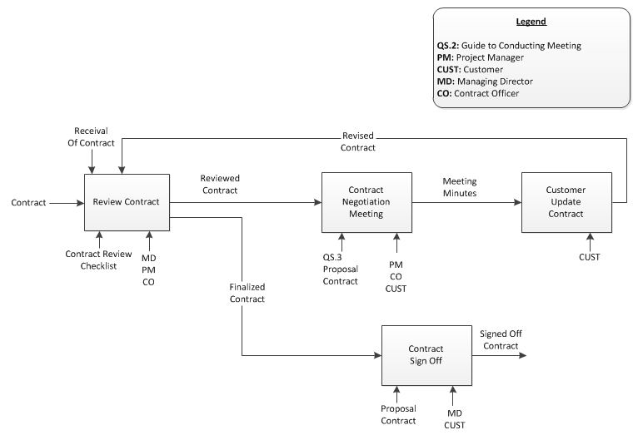
Contract Review
PURPOSE | : | To ensure proper contract review is conducted and company will only enter into the contract if the project are technically feasible within a justifiable timescale and the project is financial viable
OBJECTIVE | : | To get the contract reviewed and sign-off with reasonable agreement
STANDARDS | : | Product Standard  - -  Process Standard  - Review of Contract  - Contract Negotiation
INPUT | : | Contract
OUTPUT | : | Signed-Off Contract
PROJECT FLOW | : | The pre-contract phase starts when the formal request for proposal and tender specification is received

STEPS | TOOL/REFRENCE
Review Contract  - Upon receiving the contract from the customer. MD, PM and CO will review the contract to ensure that the contract adhere to the company policies for project work | Contract Review Checklist

Contract Negotiation
- After the contract review, PM will arrange for a contract negotiation meeting with the customer. The negotiation meeting will allow both parties to validate and clarify any issues regarding the contract.
- All discussion must be documented in the minutes.

Customer Update Contract
- If the contract needs to be updated, customer will do the update and resend it to the company for review.

Contract Sign Off
- Once both party is agreeable with the finalized contract. The contract will be signed off by both party

CONFIGURATION ITEMS | : | Signed-Off Contract
DOCUMENT CONTROL ITEMS | : | -
QUALITY RECORDS | : | - Review records for contract  - Minutes for contract negotiation meeting

**** All phases after project initiation should refer to Project Control

PROJECT INITIATION & PLANNING
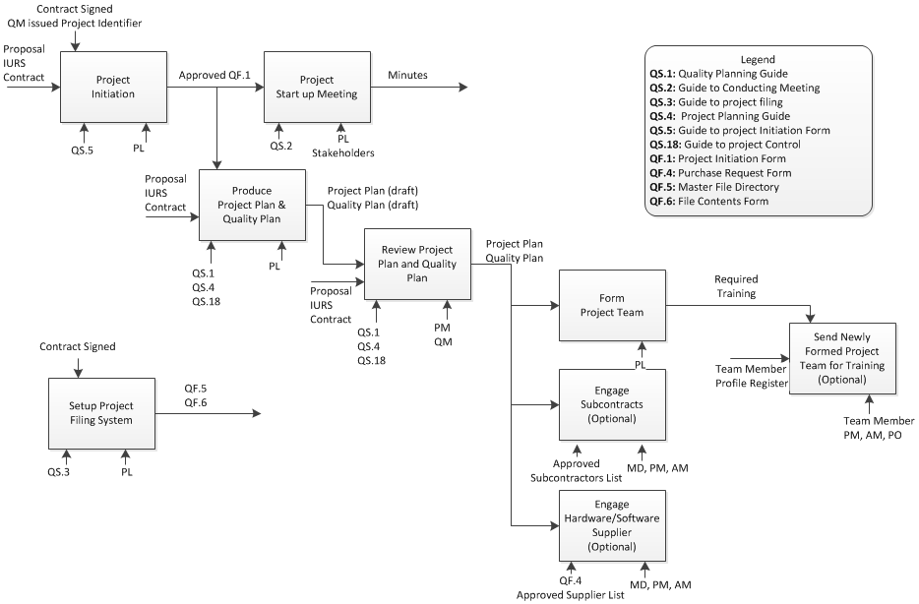
Project Initiation & Planning
PURPOSE | : | - Formally initiate the project  - Project and Quality Planning
OBJECTIVE | : | - To identify all tasks required to achieve project goal and also define how the task will be executed  - To obtain management, stake holders commitment of the terms and references of the project
STANDARDS | : | Product Standard  - -  Process Standard  - Review of Contract  - Contract Negotiation
INPUT | : | - Proposal  - Initial User Requirement Specification  - Contract
OUTPUT | : | - Revised Project Plan  - Risk Plan  - Estimated Project Schedule  - Estimated Project Cost  - Quality Plan  - Change Control Procedure (specified to this project)  - Document Control (specified to this project)
PROJECT FLOW | : | The project initiation and planning phase starts when the contract has been used.

STEPS | TOOL/REFRENCE
Project Initiation  - create project initiation form | QF.1 Project Initiation
Project Setup Meeting  - Conduct Start Up Meeting (kick off) to share with project stakeholders the project background and high level plan | -
Produce Project Plan & Quality Plan  - Upon entering the project into the project register. PL will have to proceed to create the quality plan and project plan.  - The project plan will define the list of tasks required to be performed to achieve the project goal and the type of resources required by each task.  - The quality plan will define | -
Review Project Plan & Quality Plan  - Upon receiving the contract from the customer. MD, PM and CO will | -
Form Project Team  - Upon receiving the contract from the customer. MD, PM and CO will | -
Engage Subcontracts (Optional)  - Upon receiving the contract from the customer. MD, PM and CO will | -
Engage Suppliers (Optional)  - Upon receiving the contract from the customer. MD, PM and CO will | -

CONFIGURATION ITEMS | : | Signed-Off Contract
DOCUMENT CONTROL ITEMS | : | -
QUALITY RECORDS | : | - Review records for contract  - Minutes for contract negotiation meeting

RFP Workplan
Purpose | To ensure the RFP process start-off in an organized and controlled manner, some planning is essential. The planning may cover the following:  - Identify personnel who will be involved in the RFP process  - timeline to meet for proposal creation, review and submission  - Strategy to formulate the proposal
Output | Draft Initial User Requirement Specification
Entry Criteria | Received Request for Proposal from the customer.  Or  Managing Director found the requirement defects.
Process Flow | When received the request of proposal from customer, Project Manager and Bid Team hold a meeting with customers to do an initial requirement gathering. These requirements will be documented as Initial User Requirement Specification.
Exit Criteria | Draft Initial User Requirement Specification completed.
Resource | Project Manager  Bid team  Customers
Guidelines | Guide to Conducting Meetings (XPRESS/QMS/QS.2)
Templates | User Requirement Specification Template

Gather Initial User Requirement
Input | -
Output | Draft Initial User Requirement Specification
Entry Criteria | Received Request for Proposal from the customer.  Or  Managing Director found the requirement defects.
Process Flow | When received the request of proposal from customer, Project Manager and Bid Team hold a meeting with customers to do an initial requirement gathering. These requirements will be documented as Initial User Requirement Specification.
Exit Criteria | Draft Initial User Requirement Specification completed.
Resource | Project Manager  Bid team  Customers
Guidelines | Guide to Conducting Meetings (XPRESS/QMS/QS.2)
Templates | User Requirement Specification Template

Review Initial Requirement
Input | Draft Initial User Requirement Specification
Output | Initial User Requirement Specification
Entry Criteria | Draft initial user requirement specification is created.
Process Flow | Once draft Initial User Requirement Specification is ready, Managing Director will review the Initial User Requirement. If it is incorrect, Project Manager and Bid Team have to re-study the requirement.
Exit Criteria | Initial User Requirement Specification reviewed.
Resource | Managing Director  Project Manager
Guidelines | -
Templates | User Requirement Specification Template

Prepare Proposal
Input | Initial User Requirement Specification
Output | Draft Proposal
Entry Criteria | Initial user requirement specification reviewed.  Or  Managing Director or Contract Officer found the proposal defects.
Process Flow | If the Initial User Requirement Specification is ready, Project Manager and Bid Team will create a draft proposal.
Exit Criteria | Draft Proposal completed.
Resource | Project Manager  Bid team
Guidelines | -
Templates | -

Internal Review Proposal
Input | Draft Proposal
Output | Proposal
Entry Criteria | Draft proposal is created.
Process Flow | When draft proposal is ready, it will be reviewed by Contract Officer and Managing Director. Project Manager and Bid Team need do the necessary changes for the proposal. Contract Officer and Managing Director will approve it when all the changes are done.
Exit Criteria | Draft Proposal has been reviewed.
Resource | Managing Director  Contract Officer
Guidelines | -
Templates | -

Contract Review
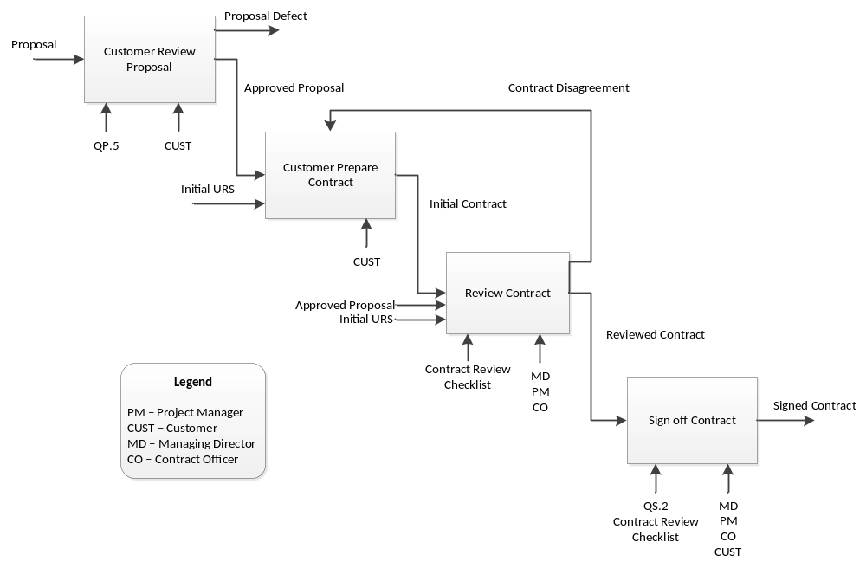

Customer Review Proposal
Input | Proposal
Output | Approved Proposal
Entry Criteria | XPRESS submitted proposal to customers.
Process Flow | Project Manager and Bid Team submit the proposal to the customers. Customers will review the proposal and give the feedback. Based on the customers’ comments, Project Manager and Bid Team will do the necessary changes. Project Manager and Bid Team shall determine and implement effective arrangements for communicating with customers. Also they shall establish the following procedure to define the controls needed for the identification, storage, protection, retrieval, retention and disposition of records. Records shall remain legible, readily identifiable and retrievable. Finally, proposal will be finalized.
Exit Criteria | Proposal approved.
Resource | Customer
Guidelines | -
Templates | -
Procedure | Proposal Review (XPRESS/QM/QP.5)

Customer Prepare Contract
Input | Approved Proposal
Output | Initial Contract
Entry Criteria | Proposal has been approved.  or  XPRESS disagree with the feasibilities of technology, terms of timescale or finance in the contract.
Process Flow | Once draft proposal is finalized, Customers start to prepare contract for this project based the Project Proposal and Initial User Requirement. Then customer will send the contract to XPRESS for review.
Exit Criteria | Initial contract created.
Resource | Customer
Guidelines | -
Templates | -

Review Contract
Input | Initial Contract
Output | Reviewed Contract
Entry Criteria | Contract has been created
Process Flow | Once received the copy of contract, Managing Director, Project Manager and Contract Officer will review the contract based on the Project Proposal and Initial User Requirement Specification. XPRESS only can discuss with customer for the feasibilities of technology, terms of timescale and finance which mention in the contract.
Exit Criteria | Contract reviewed.
Resource | Managing Director  Project Manager  Contract Officer
Guidelines | Contract Review Checklist
Templates | -

Sign off Contract
Input | Reviewed Contract
Output | Signed Contract
Entry Criteria | Contract has been reviewed.
Process Flow | Once XPRESS finish contract review, Customers organizes a meeting with Managing Director, Project Manager and Contract Officer. If both sides agree with this contract, then sign off the contract.
Exit Criteria | Contract signed off.
Resource | Managing Director  Project Manager  Contract Officer  Customer
Guidelines | Guide to Conducting Meetings (XPRESS/QMS/QS.2)  Contract Review Checklist
Templates | -

Project Initiation & Planning

Project Start Up

Purpose | To formally initialize the project.  - produce a project charter to captured  - Project Goals & Objective  - Business cases  - Team members and their responsibilities  - High Level Scope  - Identify stake holders and produce project organization chart  - Conduct 1 or more Project Kick Off Meeting  - To obtain their support from stake holders  - To obtain support from management
Input
Output
Entry Criteria
Process Flow
Exit Criteria
Resource
Guidelines
Templates | - Guide to Conducting Meetings (XPRESS/QMS/QS.2)  - Guide to using Project Initiation Forms (XPRESS/QMS/QS.5)  - Guide to using Work Instruction Forms (XPRESS/QMS/QS.6)  - Project Initiation Form (XPRESS/QMS/QF.1)  - Work Instruction Form (XPRESS/QMS/QF.2)
Quality Records | - Kick Off Meeting Minutes  - Project Charter and Stake Holder Register

Setup Project Filing System
Project Leader setup the filing system for this project. It’s important to keep track of all the information being produced regarding the project, the management and specialist products. There is a need to be able to manage different versions of products and to be retrieve information quickly and reliably. Establishing a sensible and pragmatic project filing system at the start of the project can ease the problems. This task will use the following guideline:
Purpose | Document Control  - To ensure records shall remain legible, readily identifiable and retrievable
Input
Output
Entry Criteria
Process Flow
Exit Criteria
Resource
Guidelines
Templates | - Guide to Project Filing (XPRESS/QMS/QS.3)
Quality Records | Document revision logs

- Guide to Project Filing (XPRESS/QMS/QS.3)

Produce Project Plan
Once sign off the contract, Project Leader prepares the project plan based on the initial User Requirement Specification. Project Plan should determine the design and development stages. Also it need determine the responsibilities and authorities for design and development. This task will use the following guidelines:
- Project Planning Guide (XPRESS/QMS/QS.4)
- Technical Documentation Guide (XPRESS/QMS/QS.10)
- Guide to Writing Style (XPRESS/QMS/QS.11)

Produce Quality Plan
Once sign off the contract, Project Leader prepares the draft quality plan based on the initial User Requirement Specification. Quality Plan should determine the review, verification and validation that are appropriate to each design and development stage. This task will use the following procedure and guideline:
- Quality Planning Procedure (XPRESS/QMS/QP.1)
- Quality Planning Guide (XPRESS/QMS/QS.1)
- Technical Documentation Guide (XPRESS/QMS/QS.10)
- Guide to Writing Style (XPRESS/QMS/QS.11)

Risk Analysis & Control
Based on the project plan and initial User Requirement Specification, Project Leader produces to identify the risk items and corresponding control actions. This task will use the following guideline:
- Guide to Project Control (XPRESS/QMS/QS.18)

Review Project Plan & Quality Plan
When project plan and Quality Plan are ready, Project Manager reviews them and authorizes to the project. If not satisfy, Project Leader will update them based on Project Manager’s comments.

Requirements Control

Analysis Requirement
After project planning and quality planning are done, Project Manager, Project Leader and Customer hold a meeting to gather the requirement item list. Then Project Manager and Project Leader study and determine the requirement. This task will use the following guideline:
- Guide to Producing User Requirement Specification(XPRESS/QMS/QS.7)
- Guide to Conducting Meetings (XPRESS/QMS/QS.2)

Document Requirement
Based on the requirement item studies, Project Leader creates the draft requirement specification. This task will use the following guideline:
- Guide to Producing User Requirement Specification(XPRESS/QMS/QS.7)
- Technical Documentation Guide (XPRESS/QMS/QS.10)
- Guide to Writing Style (XPRESS/QMS/QS.11)

Internal Review Requirement Specification
When the draft requirement specification is ready, Project Manager reviews the draft requirement specification. Project Leader supposes to update if any changes required. This task will use the following guideline:
- Guide to Producing User Requirement Specification(XPRESS/QMS/QS.7)

Customer Review and Sign off Requirement Specification
After internal review for the requirement specification, Project Manager and Project Leader hold a meeting with customer for review. Customer may create review records if any changes or requirement re-study is required. If all the changes are done, customers sign off the User Requirement Specification. This task will use the following guideline and procedure:
- Guide to Conducting Meetings (XPRESS/QMS/QS.2)
- Reviews Procedure (XPRESS/QMS/QP.7)

DESIGN CONTROL

Conduct System Design
Design is the mechanism used to transform the requirements into code. Design phase starts after requirement gathering phase. When design phase finishes, the development phase starts.
The project leader must assign software engineers to do peer review on all outputs of design phase. When the review finishes, the design must be approved by the project leader before development phase.

Design input
The team will design the system based on
- User Requirement Specifications.
- Applicable statutory and regulatory requirements
- Technical Documentation Guide (XPRESS/QMS/QS.10)
- Guide to Writing Style (XPRESS/QMS/QS.11)
- Guide to Conducting Design Reviews (XPRESS/QMS/QS.19)

Design method
- Research requirement specifications
- Identify analysis objects and produce class/collaboration diagrams
- Produce Use Case Realization Report (UCRR)
- Create transition strategy
- Transform analysis reports to design reports with consideration of real hardware, software, framework, technical constraints

Design outputs
Design specification shall be documented, reviewed and approved prior the release. It must
- meet the input requirements for design
- provide appropriate information for purchasing, production and service provision
- contain or reference product acceptance criteria

Design review, validation and verification
The software engineers shall perform peer reviews of the Design Specification
- To evaluate the ability of the results of design meet requirements and
- To identify any problems and propose necessary actions

Customer acceptance of design may not be required, unless explicitly requested by the customer.

Control of design changes
Design changes must comply with change request procedure as documented in Change Request and Approval (XPRESS/QMS/QP.8).
The changes shall be reviewed, verified and validated, and approved before implementation.
The review of design changes shall include evaluation of the effect on changes of parts/products already delivered. Record of these changes shall be maintained

PROGRAMMING & USER DOCUMENT CONTROL

Programming planning
Programming and user documentation control starts after design control is finished. There are three major activities at this phase:
- The software engineers shall develop the source code based on the approved design.
- The project leader shall perform system integration once all components are ready
- The project leader shall assign team member to update user documents.

Programming input
- Approved Design Specifications
- Technical Documentation Guide (XPRESS/QMS/QS.10)
- C Programming Guideline (XPRESS/QMS/QS.8)
- C++ Programming Guideline (XPRESS/QMS/QS.9)
- Guide to Code Walkthroughs (XPRESS/QMS/QS.12)

Programming Output
- Integrated System
- Updated Operation Manual
- Updated User Manual.

Code & document review
The software engineers shall perform code reviews after a module has been committed to ensure code follows C Programming Guideline (XPRESS/QMS/QS.8) and C++ Programming Guideline (XPRESS/QMS/QS.9)
The project leader shall perform document reviews after the user documents have been updated.

Control development changes
Development changes must comply with change request procedure as documented in Change Request and Approval (XPRESS/QMS/QP.8).
When the change requests have been reviewed, verified and validated, and approved, the project leader shall assign the software engineer to perform actual programming and update the user documents affected.
The project leader shall review and approve the code has been changed to make sure it meets requirement

TESTING & VALIDATION

Testing plan
Testing processes aim to achieve customer satisfaction by ensuring delivery of
- Error-free software
- Contractually agreed requirement

These testing below shall be performed to ensure software quality:
- The software engineers shall create test plan prior to the actual programming. The test plan should follow Guide to Test Planning (XPRESS/QMS/QS.14)
- The project leader shall review and approve the test plans
- The project leader shall define testing strategy and create system integration test plan prior to the actual programming
- The project manager shall review and approve the system integration test plan
- The software engineer shall perform automated unit test according to the test plan after the module has been programmed
- The project leader shall perform system integration and testing according to the plan after all modules have been completed
- The software engineers shall capture test results into test reports. The report should follow Guide to test result documentation (XPRESS/QMS/QS.17)

Testing input
- Integrated System
- Requirement Spec
- Operation Manual
- User Manual
- Guide to Test Planning (XPRESS/QMS/QS.14)
- Review Procedure (XPRESS/QMS/QP.7)
- Guide to test result documentation (XPRESS/QMS/QS.17)
- Technical Documentation guideline (XPRESS/QMS/QS.10)

Testing output
- Unit test plans and system integration test plan
- Tested System
- Test reports (unit test, system integration test)

Test & document review
The software engineers shall perform peer-review the test plans and test results. The project leader shall approve these documents
The project leader shall review all system test plan and system integration test results. The project manager shall approve these documents.
The customer is not involved in this system test.

Control testing changes
Any change during testing must comply with change request procedure as documented in Change Request and Approval (XPRESS/QMS/QP.8).
When the change requests have been reviewed, verified and validated, and approved, the project leader shall assign the software engineer to perform test the system according to revised plan.
The project leader shall review and approve test results and update related documents.

ACCEPTANCE

Acceptance plan
The acceptance process shall be documented and agreed by the customer. The project leader shall prepare the acceptance document plan which include
- Part of the Proposal
- Part of the Contract
- Part of the Quality plan
- Part of Requirement Spec
- Acceptance test plan

The project manager shall review the acceptance document plan and work with customer to obtain agreement on the acceptance approach.
The software engineers shall prepare acceptance test plan prior to handling over to customer. The test plan should follow Guide to Test Planning (XPRESS/QMS/QS.14). The project leader shall review and approve the acceptance test plans
The system after tested and approved will be handled over to the customer. The software engineers will validate and fix bugs found by the customer. The software engineers shall produce acceptance test report. The report should follow Guide to test result documentation (XPRESS/QMS/QS.17)
The project manager shall meet with customer to obtain customer acceptance sign off. Upon successful sign off, the system shall be deployed to customer

Acceptance input
- Proposal
- Contract
- Quality plan
- Requirement Spec
- Acceptance test plan
- Operation Manual
- User Manual
- Guide to Test Planning (XPRESS/QMS/QS.14)
- Review Procedure (XPRESS/QMS/QP.7)
- Corrective Action (section 3.6.3)
- Guide to test result documentation (XPRESS/QMS/QS.17)
- Technical Documentation guideline (XPRESS/QMS/QS.10)

Acceptance output
- Tested System
- Test reports (unit test, system integration test)
- Customer acceptance sign off

Control acceptance changes
Any change during testing must comply with change request procedure as documented in Change Request and Approval (XPRESS/QMS/QP.8).
When the customer does not satisfy with the system, the project manager shall analyze the product and take corrective action (section 3.6.3) and preventive action (section 3.6.4)

DELIVERY & INSTALLATION

Delivery & installation plan
Delivery and installation starts after acceptance is finished. Major activities at this phase:
- Project leader shall create installation plan. The project manager shall review and approve installation plan.
- Delivery the hardware / software to the customer. The product shall be delivered on appropriate media and labeled. The customer needs to acknowledge the software has been received.
- Install the new system. The software engineers will take appropriate corrective action (section 3.6.3) to handle any small problem during installation. In case of big disagreement, project manager/MD will negotiate with customer to look for solution.
- The installed system shall be verified by the customer to demonstrate that the correct software was installed and the software operates satisfactorily
- Update and finalize the user manual and operation manual.

Acceptance input
- Updated Installation Plan
- Updated User Manual
- Updated Operation Manual
- Technical Documentation Guide (XPRESS/QMS/QS.10)

Acceptance output
- Production System
- Final User Manual
- Final Operation Manual

Control acceptance changes
Any change during testing must comply with change request procedure as documented in Change Request and Approval (XPRESS/QMS/QP.8).
When the customer does not satisfy with the system, the project manager shall analyze the product and take corrective action (section 3.6.3) and preventive action (section 3.6.4). In case of big disagreement, project manager/MD will negotiate with customer to look for solution.

MAINTENANCE

Maintenance plan
The project manager and customer shall agree on maintenance period as part of contract.
The project team shall provide necessary support to ensure the system works properly during warranty period.
The customer shall provide reasonable detail in bug reports and send to the support team. The project leader will validate the bug and assign the bug to appropriate software engineer.
The software engineer shall reproduce the bug, if it belongs to agreed requirements, he will fix the bug, write unit test to verify the bug has been resolved.
The project leader shall review the fix and deliver the fix to customer. The customer shall verify that the bug has been resolved before the case can be closed. If the bug is not valid, the bug report shall be marked as invalid.

Maintenance input
- Source Codes
- User Guide
- User Requirement Specifications
- Bug reports
- Maintenance Plan

Maintenance output
- Fixed / Closed bug reports
- Fixed unit test

Control Maintenance changes
Any change during testing must comply with change request procedure as documented in Change Request and Approval (XPRESS/QMS/QP.8).

